# 1-Diabetes 130-US Hospitals for Years 1999-2008

## Feature description

Ref: 1 Umpierrez G. E., Isaacs S. D., Bazargan N., You X., Thaler L. M., and Kitabchi A. E., Hyperglycemia: an independent marker of in-hospital mortality in patients with undiagnosed diabetes, *Journal of Clinical Endocrinology and Metabolism*. (2002) **87**, no. 3, 978–982, 2-s2.0-0036962051, <https://doi.org/10.1210/jc.87.3.978>. Table 1

| **Feature name** | **Type** | **Description and values** | **% missing** |
| --- | --- | --- | --- |
| Encounter ID | Numeric | Unique identifier of an encounter | 0% |
| Patient number | Numeric | Unique identifier of a patient | 0% |
| Race | Nominal | Values: Caucasian, Asian, African American, Hispanic, and other | 2% |
| Gender | Nominal | Values: male, female, and unknown/invalid | 0% |
| Age | Nominal | Grouped in 10-year intervals: [0, 10), [10, 20), …, [90, 100) | 0% |
| Weight | Numeric | Weight in pounds. | 97% |
| Admission type | Nominal | Integer identifier corresponding to 9 distinct values, for example, emergency, urgent, elective, newborn, and not available | 0% |
| Discharge disposition | Nominal | Integer identifier corresponding to 29 distinct values, for example, discharged to home, expired, and not available | 0% |
| Admission source | Nominal | Integer identifier corresponding to 21 distinct values, for example, physician referral, emergency room, and transfer from a hospital | 0% |
| Time in hospital | Numeric | Integer number of days between admission and discharge | 0% |
| Payer code | Nominal | Integer identifier corresponding to 23 distinct values, for example, Blue Cross*/*Blue Shield, Medicare, and self-pay | 52% |
| Medical specialty | Nominal | Integer identifier of a specialty of the admitting physician, corresponding to 84 distinct values, for example, cardiology, internal medicine, family*/*general practice, and surgeon | 53% |
| Number of lab procedures | Numeric | Number of lab tests performed during the encounter | 0% |
| Number of procedures | Numeric | Number of procedures (other than lab tests) performed during the encounter | 0% |
| Number of medications | Numeric | Number of distinct generic names administered during the encounter | 0% |
| Number of outpatient visits | Numeric | Number of outpatient visits of the patient in the year preceding the encounter | 0% |
| Number of emergency visits | Numeric | Number of emergency visits of the patient in the year preceding the encounter | 0% |
| Number of inpatient visits | Numeric | Number of inpatient visits of the patient in the year preceding the encounter | 0% |
| Diagnosis 1 | Nominal | The primary diagnosis (coded as first three digits of ICD9); 848 distinct values | 0% |
| Diagnosis 2 | Nominal | Secondary diagnosis (coded as first three digits of ICD9); 923 distinct values | 0% |
| Diagnosis 3 | Nominal | Additional secondary diagnosis (coded as first three digits of ICD9); 954 distinct values | 1% |
| Number of diagnoses | Numeric | Number of diagnoses entered to the system | 0% |
| Glucose serum test result | Nominal | Indicates the range of the result or if the test was not taken. Values: “>200,” “>300,” “normal,” and “none” if not measured | 0% |
| A1c test result | Nominal | Indicates the range of the result or if the test was not taken. Values: “>8” if the result was greater than 8%, “>7” if the result was greater than 7% but less than 8%, “normal” if the result was less than 7%, and “none” if not measured. | 0% |
| Change of medications | Nominal | Indicates if there was a change in diabetic medications (either dosage or generic name). Values: “change” and “no change” | 0% |
| Diabetes medications | Nominal | Indicates if there was any diabetic medication prescribed. Values: “yes” and “no” | 0% |
| 24 features for medications | Nominal | For the generic names: metformin, repaglinide, nateglinide, chlorpropamide, glimepiride, acetohexamide, glipizide, glyburide, tolbutamide, pioglitazone, rosiglitazone, acarbose, miglitol, troglitazone, tolazamide, examide, sitagliptin, insulin, glyburide-metformin, glipizide-metformin, glimepiride-pioglitazone, metformin-rosiglitazone, and metformin-pioglitazone, the feature indicates whether the drug was prescribed or there was a change in the dosage. Values: “up” if the dosage was increased during the encounter, “down” if the dosage was decreased, “steady” if the dosage did not change, and “no” if the drug was not prescribed | 0% |
| Readmitted | Nominal | Days to inpatient readmission. Values: “<30” if the patient was readmitted in less than 30 days, “>30” if the patient was readmitted in more than 30 days, and “No” for no record of readmission. | 0% |

## Missing data: 3.79%

## 3. Distribution Figures

### 3.1 Categorical Variables

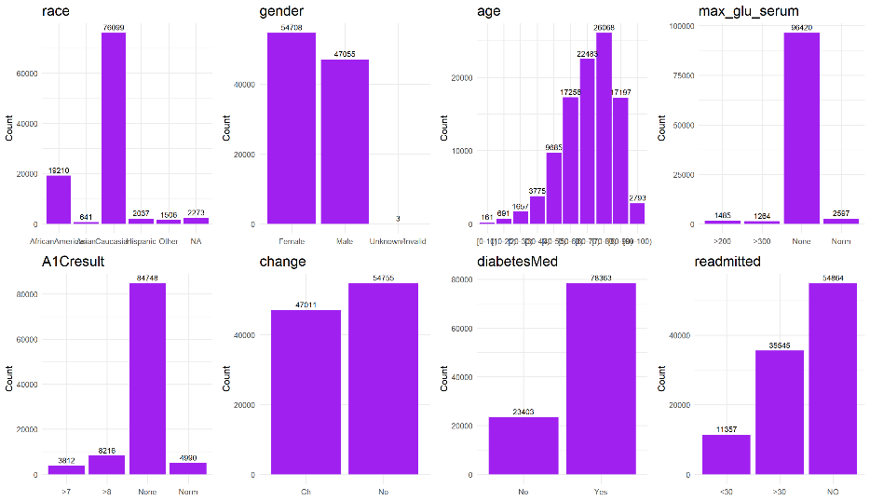

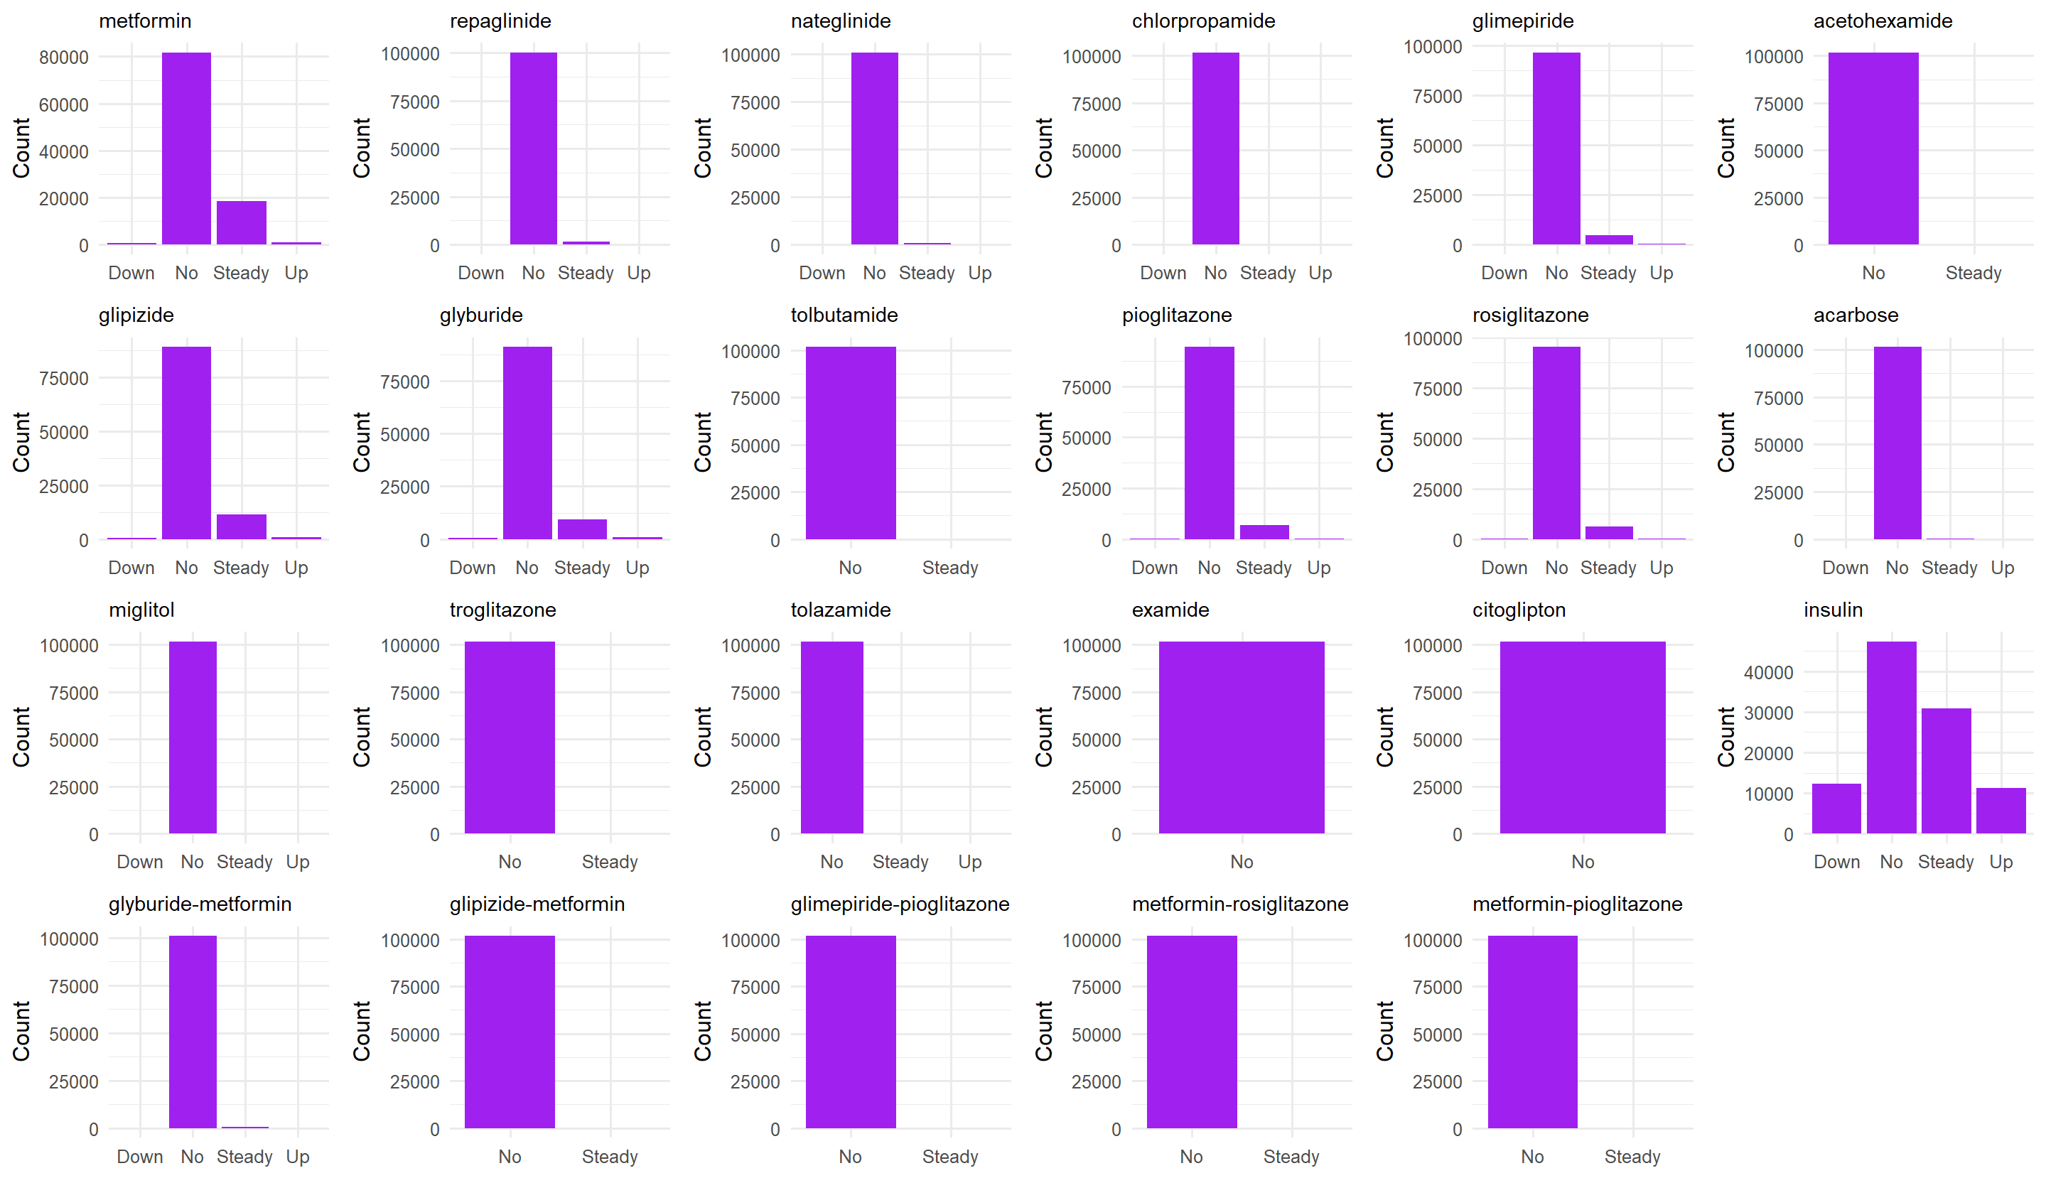

### 3.2 Continuous Variables

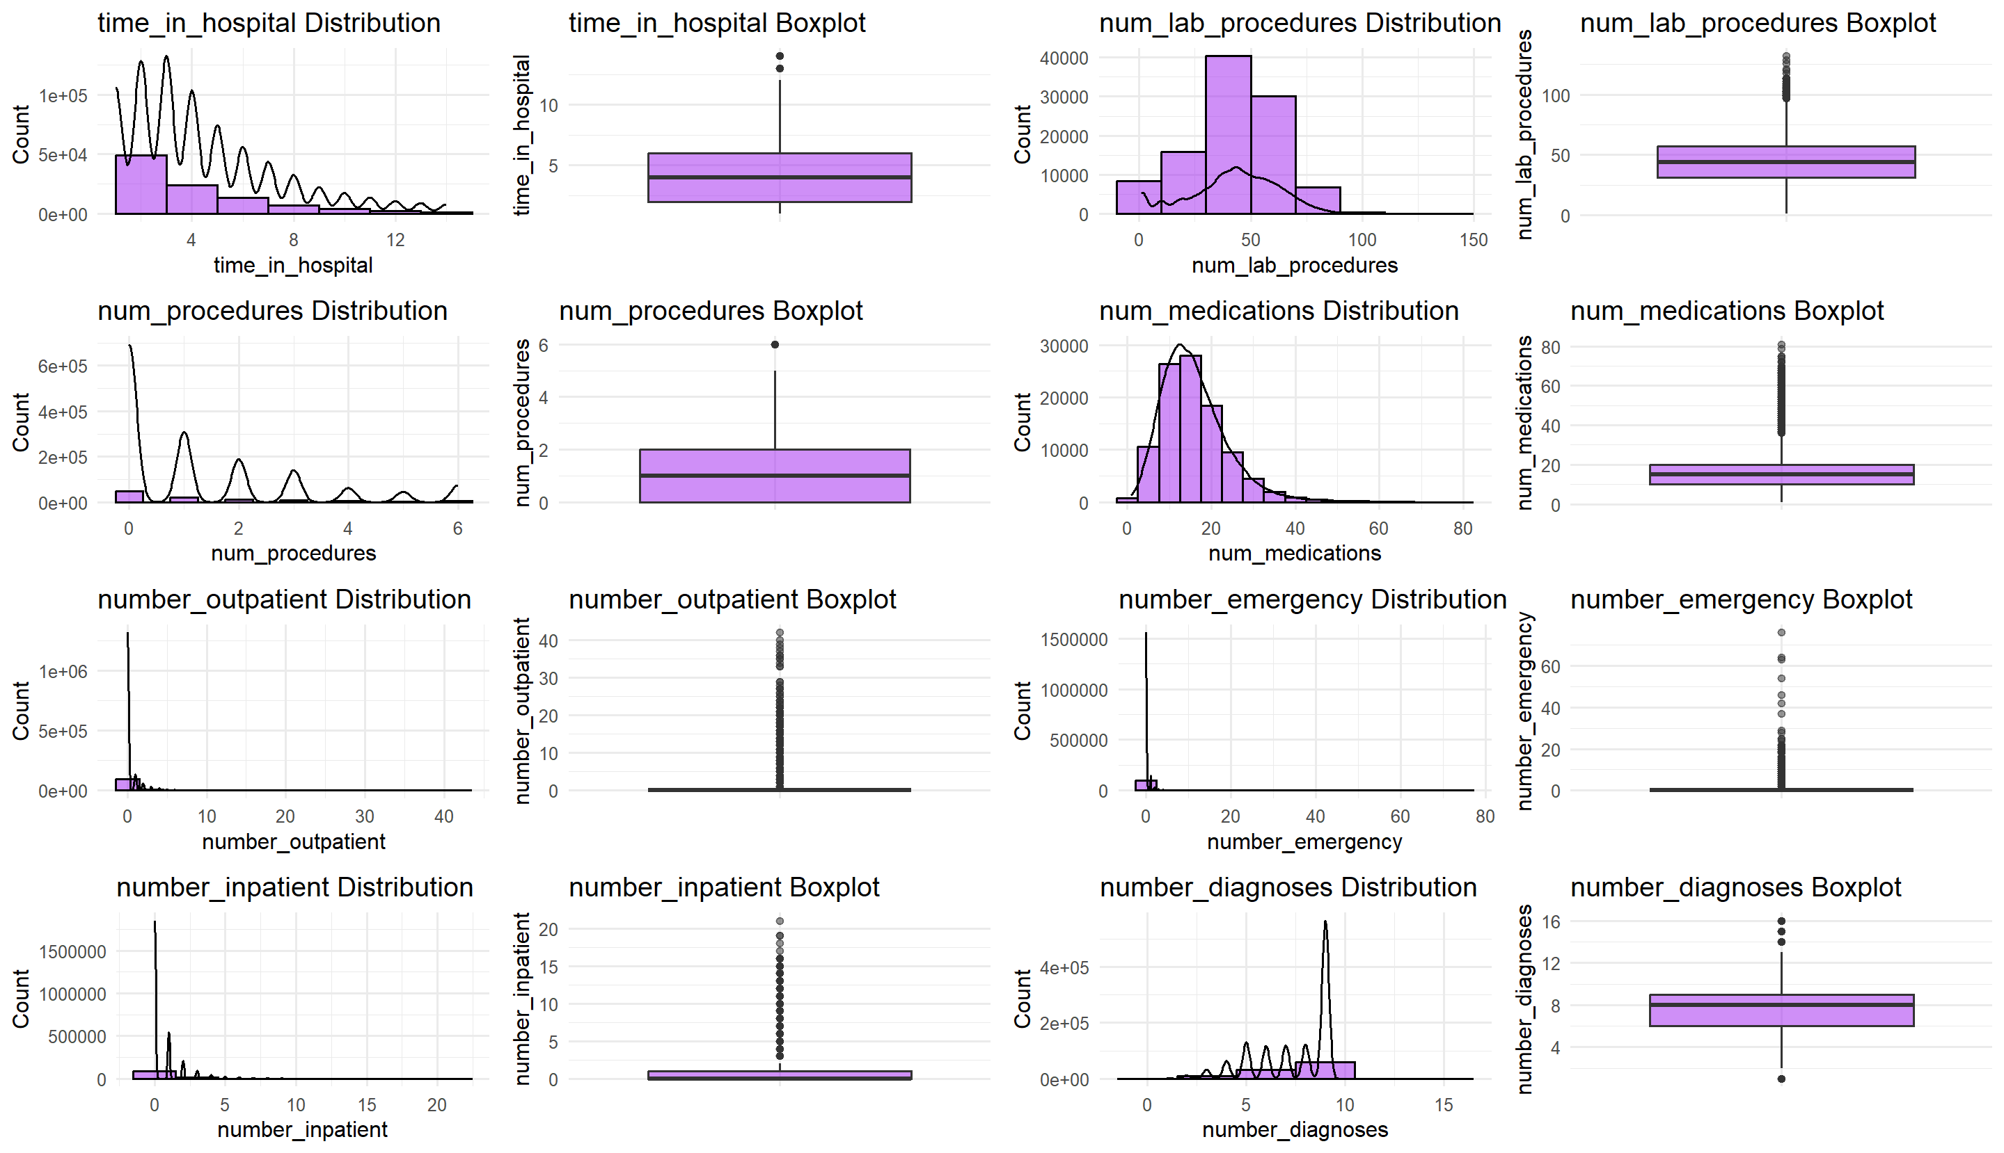

## 4. Baseline characteristics Table

| **Characteristic** | **N** | **Overall**, N = 101,766*1* | **<30**, N = 11,357*1* | **>30**, N = 35,545*1* | **NO**, N = 54,864*1* | **p-value***2* |
| --- | --- | --- | --- | --- | --- | --- |
| encounter_id | 101,766 | 152,388,987 (145,309,694) | 149,771,196 (142,491,960) | 152,753,844 (129,768,924) | 152,685,498 (155,854,859) | <0.001 |
| patient_nbr | 101,766 | 45,505,143 (64,132,729) | 48,139,200 (64,655,460) | 57,902,751 (64,494,846) | 42,381,698 (65,102,150) | <0.001 |
| race | 99,493 |  |  |  |  | <0.001 |
| AfricanAmerican |  | 19,210 (19%) | 2,155 (19%) | 6,634 (19%) | 10,421 (20%) |  |
| Asian |  | 641 (0.6%) | 65 (0.6%) | 161 (0.5%) | 415 (0.8%) |  |
| Caucasian |  | 76,099 (76%) | 8,592 (77%) | 27,124 (77%) | 40,383 (76%) |  |
| Hispanic |  | 2,037 (2.0%) | 212 (1.9%) | 642 (1.8%) | 1,183 (2.2%) |  |
| Other |  | 1,506 (1.5%) | 145 (1.3%) | 446 (1.3%) | 915 (1.7%) |  |
| Unknown |  | 2,273 | 188 | 538 | 1,547 |  |
| gender | 101,766 |  |  |  |  |  |
| Female |  | 54,708 (54%) | 6,152 (54%) | 19,518 (55%) | 29,038 (53%) |  |
| Male |  | 47,055 (46%) | 5,205 (46%) | 16,027 (45%) | 25,823 (47%) |  |
| Unknown/Invalid |  | 3 (<0.1%) | 0 (0%) | 0 (0%) | 3 (<0.1%) |  |
| age | 101,766 |  |  |  |  | <0.001 |
| [0-10) |  | 161 (0.2%) | 3 (<0.1%) | 26 (<0.1%) | 132 (0.2%) |  |
| [10-20) |  | 691 (0.7%) | 40 (0.4%) | 224 (0.6%) | 427 (0.8%) |  |
| [20-30) |  | 1,657 (1.6%) | 236 (2.1%) | 510 (1.4%) | 911 (1.7%) |  |
| [30-40) |  | 3,775 (3.7%) | 424 (3.7%) | 1,187 (3.3%) | 2,164 (3.9%) |  |
| [40-50) |  | 9,685 (9.5%) | 1,027 (9.0%) | 3,278 (9.2%) | 5,380 (9.8%) |  |
| [50-60) |  | 17,256 (17%) | 1,668 (15%) | 5,917 (17%) | 9,671 (18%) |  |
| [60-70) |  | 22,483 (22%) | 2,502 (22%) | 7,897 (22%) | 12,084 (22%) |  |
| [70-80) |  | 26,068 (26%) | 3,069 (27%) | 9,475 (27%) | 13,524 (25%) |  |
| [80-90) |  | 17,197 (17%) | 2,078 (18%) | 6,223 (18%) | 8,896 (16%) |  |
| [90-100) |  | 2,793 (2.7%) | 310 (2.7%) | 808 (2.3%) | 1,675 (3.1%) |  |
| weight | 0 | NA (NA) | NA (NA) | NA (NA) | NA (NA) |  |
| Unknown |  | 101,766 | 11,357 | 35,545 | 54,864 |  |
| admission_type_id | 101,766 |  |  |  |  |  |
| 1 |  | 53,990 (53%) | 6,221 (55%) | 19,309 (54%) | 28,460 (52%) |  |
| 2 |  | 18,480 (18%) | 2,066 (18%) | 6,452 (18%) | 9,962 (18%) |  |
| 3 |  | 18,869 (19%) | 1,961 (17%) | 5,746 (16%) | 11,162 (20%) |  |
| 4 |  | 10 (<0.1%) | 1 (<0.1%) | 2 (<0.1%) | 7 (<0.1%) |  |
| 5 |  | 4,785 (4.7%) | 495 (4.4%) | 1,721 (4.8%) | 2,569 (4.7%) |  |
| 6 |  | 5,291 (5.2%) | 586 (5.2%) | 2,231 (6.3%) | 2,474 (4.5%) |  |
| 7 |  | 21 (<0.1%) | 0 (0%) | 0 (0%) | 21 (<0.1%) |  |
| 8 |  | 320 (0.3%) | 27 (0.2%) | 84 (0.2%) | 209 (0.4%) |  |
| discharge_disposition_id | 101,766 | 1.0 (3.0) | 2.0 (5.0) | 1.0 (2.0) | 1.0 (2.0) | <0.001 |
| admission_source_id | 101,766 | 7.0 (6.0) | 7.0 (6.0) | 7.0 (6.0) | 7.0 (6.0) | <0.001 |
| time_in_hospital | 101,766 | 4.0 (4.0) | 4.0 (4.0) | 4.0 (4.0) | 3.0 (4.0) | <0.001 |
| payer_code | 61,510 |  |  |  |  |  |
| BC |  | 4,655 (7.6%) | 426 (6.3%) | 1,301 (6.0%) | 2,928 (8.9%) |  |
| CH |  | 146 (0.2%) | 13 (0.2%) | 33 (0.2%) | 100 (0.3%) |  |
| CM |  | 1,937 (3.1%) | 198 (2.9%) | 661 (3.0%) | 1,078 (3.3%) |  |
| CP |  | 2,533 (4.1%) | 214 (3.2%) | 781 (3.6%) | 1,538 (4.7%) |  |
| DM |  | 549 (0.9%) | 64 (1.0%) | 220 (1.0%) | 265 (0.8%) |  |
| FR |  | 1 (<0.1%) | 0 (0%) | 0 (0%) | 1 (<0.1%) |  |
| HM |  | 6,274 (10%) | 644 (9.6%) | 2,320 (11%) | 3,310 (10%) |  |
| MC |  | 32,439 (53%) | 3,810 (57%) | 11,982 (55%) | 16,647 (50%) |  |
| MD |  | 3,532 (5.7%) | 416 (6.2%) | 1,259 (5.8%) | 1,857 (5.6%) |  |
| MP |  | 79 (0.1%) | 9 (0.1%) | 39 (0.2%) | 31 (<0.1%) |  |
| OG |  | 1,033 (1.7%) | 136 (2.0%) | 333 (1.5%) | 564 (1.7%) |  |
| OT |  | 95 (0.2%) | 7 (0.1%) | 38 (0.2%) | 50 (0.2%) |  |
| PO |  | 592 (1.0%) | 44 (0.7%) | 144 (0.7%) | 404 (1.2%) |  |
| SI |  | 55 (<0.1%) | 7 (0.1%) | 17 (<0.1%) | 31 (<0.1%) |  |
| SP |  | 5,007 (8.1%) | 510 (7.6%) | 1,869 (8.6%) | 2,628 (7.9%) |  |
| UN |  | 2,448 (4.0%) | 227 (3.4%) | 696 (3.2%) | 1,525 (4.6%) |  |
| WC |  | 135 (0.2%) | 5 (<0.1%) | 24 (0.1%) | 106 (0.3%) |  |
| Unknown |  | 40,256 | 4,627 | 13,828 | 21,801 |  |
| medical_specialty | 51,817 |  |  |  |  |  |
| AllergyandImmunology |  | 7 (<0.1%) | 3 (<0.1%) | 3 (<0.1%) | 1 (<0.1%) |  |
| Anesthesiology |  | 12 (<0.1%) | 1 (<0.1%) | 3 (<0.1%) | 8 (<0.1%) |  |
| Anesthesiology-Pediatric |  | 19 (<0.1%) | 1 (<0.1%) | 5 (<0.1%) | 13 (<0.1%) |  |
| Cardiology |  | 5,352 (10%) | 425 (7.6%) | 1,853 (11%) | 3,074 (11%) |  |
| Cardiology-Pediatric |  | 7 (<0.1%) | 1 (<0.1%) | 4 (<0.1%) | 2 (<0.1%) |  |
| DCPTEAM |  | 6 (<0.1%) | 0 (0%) | 1 (<0.1%) | 5 (<0.1%) |  |
| Dentistry |  | 4 (<0.1%) | 0 (0%) | 3 (<0.1%) | 1 (<0.1%) |  |
| Dermatology |  | 1 (<0.1%) | 0 (0%) | 1 (<0.1%) | 0 (0%) |  |
| Emergency/Trauma |  | 7,565 (15%) | 846 (15%) | 3,006 (17%) | 3,713 (13%) |  |
| Endocrinology |  | 120 (0.2%) | 6 (0.1%) | 39 (0.2%) | 75 (0.3%) |  |
| Endocrinology-Metabolism |  | 8 (<0.1%) | 1 (<0.1%) | 1 (<0.1%) | 6 (<0.1%) |  |
| Family/GeneralPractice |  | 7,440 (14%) | 883 (16%) | 2,663 (15%) | 3,894 (13%) |  |
| Gastroenterology |  | 564 (1.1%) | 62 (1.1%) | 214 (1.2%) | 288 (1.0%) |  |
| Gynecology |  | 58 (0.1%) | 0 (0%) | 10 (<0.1%) | 48 (0.2%) |  |
| Hematology |  | 82 (0.2%) | 26 (0.5%) | 24 (0.1%) | 32 (0.1%) |  |
| Hematology/Oncology |  | 207 (0.4%) | 40 (0.7%) | 64 (0.4%) | 103 (0.4%) |  |
| Hospitalist |  | 57 (0.1%) | 4 (<0.1%) | 19 (0.1%) | 34 (0.1%) |  |
| InfectiousDiseases |  | 37 (<0.1%) | 8 (0.1%) | 12 (<0.1%) | 17 (<0.1%) |  |
| InternalMedicine |  | 14,635 (28%) | 1,646 (30%) | 4,723 (27%) | 8,266 (29%) |  |
| Nephrology |  | 1,613 (3.1%) | 248 (4.4%) | 666 (3.8%) | 699 (2.4%) |  |
| Neurology |  | 203 (0.4%) | 12 (0.2%) | 46 (0.3%) | 145 (0.5%) |  |
| Neurophysiology |  | 1 (<0.1%) | 0 (0%) | 0 (0%) | 1 (<0.1%) |  |
| Obsterics&Gynecology-GynecologicOnco |  | 25 (<0.1%) | 2 (<0.1%) | 5 (<0.1%) | 18 (<0.1%) |  |
| Obstetrics |  | 19 (<0.1%) | 1 (<0.1%) | 2 (<0.1%) | 16 (<0.1%) |  |
| ObstetricsandGynecology |  | 671 (1.3%) | 32 (0.6%) | 110 (0.6%) | 529 (1.8%) |  |
| Oncology |  | 348 (0.7%) | 66 (1.2%) | 100 (0.6%) | 182 (0.6%) |  |
| Ophthalmology |  | 38 (<0.1%) | 2 (<0.1%) | 11 (<0.1%) | 25 (<0.1%) |  |
| Orthopedics |  | 1,400 (2.7%) | 151 (2.7%) | 327 (1.9%) | 922 (3.2%) |  |
| Orthopedics-Reconstructive |  | 1,233 (2.4%) | 92 (1.6%) | 293 (1.7%) | 848 (2.9%) |  |
| Osteopath |  | 39 (<0.1%) | 3 (<0.1%) | 18 (0.1%) | 18 (<0.1%) |  |
| Otolaryngology |  | 125 (0.2%) | 2 (<0.1%) | 29 (0.2%) | 94 (0.3%) |  |
| OutreachServices |  | 12 (<0.1%) | 1 (<0.1%) | 5 (<0.1%) | 6 (<0.1%) |  |
| Pathology |  | 17 (<0.1%) | 1 (<0.1%) | 10 (<0.1%) | 6 (<0.1%) |  |
| Pediatrics |  | 254 (0.5%) | 16 (0.3%) | 79 (0.5%) | 159 (0.5%) |  |
| Pediatrics-AllergyandImmunology |  | 3 (<0.1%) | 0 (0%) | 3 (<0.1%) | 0 (0%) |  |
| Pediatrics-CriticalCare |  | 87 (0.2%) | 3 (<0.1%) | 28 (0.2%) | 56 (0.2%) |  |
| Pediatrics-EmergencyMedicine |  | 3 (<0.1%) | 0 (0%) | 1 (<0.1%) | 2 (<0.1%) |  |
| Pediatrics-Endocrinology |  | 159 (0.3%) | 1 (<0.1%) | 23 (0.1%) | 135 (0.5%) |  |
| Pediatrics-Hematology-Oncology |  | 4 (<0.1%) | 1 (<0.1%) | 0 (0%) | 3 (<0.1%) |  |
| Pediatrics-InfectiousDiseases |  | 1 (<0.1%) | 0 (0%) | 1 (<0.1%) | 0 (0%) |  |
| Pediatrics-Neurology |  | 10 (<0.1%) | 0 (0%) | 4 (<0.1%) | 6 (<0.1%) |  |
| Pediatrics-Pulmonology |  | 25 (<0.1%) | 2 (<0.1%) | 17 (<0.1%) | 6 (<0.1%) |  |
| Perinatology |  | 1 (<0.1%) | 0 (0%) | 0 (0%) | 1 (<0.1%) |  |
| PhysicalMedicineandRehabilitation |  | 391 (0.8%) | 60 (1.1%) | 94 (0.5%) | 237 (0.8%) |  |
| PhysicianNotFound |  | 11 (<0.1%) | 2 (<0.1%) | 4 (<0.1%) | 5 (<0.1%) |  |
| Podiatry |  | 100 (0.2%) | 10 (0.2%) | 48 (0.3%) | 42 (0.1%) |  |
| Proctology |  | 1 (<0.1%) | 0 (0%) | 0 (0%) | 1 (<0.1%) |  |
| Psychiatry |  | 854 (1.6%) | 104 (1.9%) | 262 (1.5%) | 488 (1.7%) |  |
| Psychiatry-Addictive |  | 1 (<0.1%) | 0 (0%) | 0 (0%) | 1 (<0.1%) |  |
| Psychiatry-Child/Adolescent |  | 7 (<0.1%) | 1 (<0.1%) | 2 (<0.1%) | 4 (<0.1%) |  |
| Psychology |  | 101 (0.2%) | 8 (0.1%) | 35 (0.2%) | 58 (0.2%) |  |
| Pulmonology |  | 871 (1.7%) | 96 (1.7%) | 328 (1.9%) | 447 (1.5%) |  |
| Radiologist |  | 1,140 (2.2%) | 103 (1.8%) | 383 (2.2%) | 654 (2.3%) |  |
| Radiology |  | 53 (0.1%) | 8 (0.1%) | 14 (<0.1%) | 31 (0.1%) |  |
| Resident |  | 2 (<0.1%) | 1 (<0.1%) | 1 (<0.1%) | 0 (0%) |  |
| Rheumatology |  | 17 (<0.1%) | 3 (<0.1%) | 5 (<0.1%) | 9 (<0.1%) |  |
| Speech |  | 1 (<0.1%) | 0 (0%) | 0 (0%) | 1 (<0.1%) |  |
| SportsMedicine |  | 1 (<0.1%) | 0 (0%) | 1 (<0.1%) | 0 (0%) |  |
| Surgeon |  | 45 (<0.1%) | 4 (<0.1%) | 8 (<0.1%) | 33 (0.1%) |  |
| Surgery-Cardiovascular |  | 98 (0.2%) | 6 (0.1%) | 24 (0.1%) | 68 (0.2%) |  |
| Surgery-Cardiovascular/Thoracic |  | 652 (1.3%) | 43 (0.8%) | 130 (0.8%) | 479 (1.7%) |  |
| Surgery-Colon&Rectal |  | 11 (<0.1%) | 1 (<0.1%) | 3 (<0.1%) | 7 (<0.1%) |  |
| Surgery-General |  | 3,099 (6.0%) | 342 (6.1%) | 1,046 (6.0%) | 1,711 (5.9%) |  |
| Surgery-Maxillofacial |  | 11 (<0.1%) | 1 (<0.1%) | 2 (<0.1%) | 8 (<0.1%) |  |
| Surgery-Neuro |  | 468 (0.9%) | 32 (0.6%) | 76 (0.4%) | 360 (1.2%) |  |
| Surgery-Pediatric |  | 8 (<0.1%) | 0 (0%) | 2 (<0.1%) | 6 (<0.1%) |  |
| Surgery-Plastic |  | 41 (<0.1%) | 7 (0.1%) | 10 (<0.1%) | 24 (<0.1%) |  |
| Surgery-PlasticwithinHeadandNeck |  | 1 (<0.1%) | 0 (0%) | 1 (<0.1%) | 0 (0%) |  |
| Surgery-Thoracic |  | 109 (0.2%) | 11 (0.2%) | 30 (0.2%) | 68 (0.2%) |  |
| Surgery-Vascular |  | 533 (1.0%) | 74 (1.3%) | 200 (1.2%) | 259 (0.9%) |  |
| SurgicalSpecialty |  | 33 (<0.1%) | 2 (<0.1%) | 9 (<0.1%) | 22 (<0.1%) |  |
| Urology |  | 685 (1.3%) | 68 (1.2%) | 185 (1.1%) | 432 (1.5%) |  |
| Unknown |  | 49,949 | 5,781 | 18,216 | 25,952 |  |
| num_lab_procedures | 101,766 | 44 (26) | 45 (25) | 45 (26) | 44 (26) | <0.001 |
| num_procedures | 101,766 |  |  |  |  | <0.001 |
| 0 |  | 46,652 (46%) | 5,168 (46%) | 17,348 (49%) | 24,136 (44%) |  |
| 1 |  | 20,742 (20%) | 2,532 (22%) | 7,026 (20%) | 11,184 (20%) |  |
| 2 |  | 12,717 (12%) | 1,422 (13%) | 4,219 (12%) | 7,076 (13%) |  |
| 3 |  | 9,443 (9.3%) | 1,009 (8.9%) | 2,999 (8.4%) | 5,435 (9.9%) |  |
| 4 |  | 4,180 (4.1%) | 461 (4.1%) | 1,379 (3.9%) | 2,340 (4.3%) |  |
| 5 |  | 3,078 (3.0%) | 290 (2.6%) | 1,004 (2.8%) | 1,784 (3.3%) |  |
| 6 |  | 4,954 (4.9%) | 475 (4.2%) | 1,570 (4.4%) | 2,909 (5.3%) |  |
| num_medications | 101,766 | 15 (10) | 16 (10) | 15 (9) | 14 (10) | <0.001 |
| number_outpatient | 101,766 | 0.00 (0.00) | 0.00 (0.00) | 0.00 (0.00) | 0.00 (0.00) | <0.001 |
| number_emergency | 101,766 | 0.00 (0.00) | 0.00 (0.00) | 0.00 (0.00) | 0.00 (0.00) | <0.001 |
| number_inpatient | 101,766 | 0.00 (1.00) | 0.00 (2.00) | 0.00 (1.00) | 0.00 (0.00) | <0.001 |
| diag_1 | 101,745 |  |  |  |  |  |
| 10 |  | 1 (<0.1%) | 0 (0%) | 0 (0%) | 1 (<0.1%) |  |
| 11 |  | 10 (<0.1%) | 0 (0%) | 3 (<0.1%) | 7 (<0.1%) |  |
| 110 |  | 2 (<0.1%) | 0 (0%) | 1 (<0.1%) | 1 (<0.1%) |  |
| 112 |  | 73 (<0.1%) | 14 (0.1%) | 26 (<0.1%) | 33 (<0.1%) |  |
| 114 |  | 1 (<0.1%) | 0 (0%) | 1 (<0.1%) | 0 (0%) |  |
| 115 |  | 2 (<0.1%) | 0 (0%) | 0 (0%) | 2 (<0.1%) |  |
| 117 |  | 9 (<0.1%) | 0 (0%) | 4 (<0.1%) | 5 (<0.1%) |  |
| 131 |  | 2 (<0.1%) | 0 (0%) | 2 (<0.1%) | 0 (0%) |  |
| 133 |  | 1 (<0.1%) | 0 (0%) | 0 (0%) | 1 (<0.1%) |  |
| 135 |  | 27 (<0.1%) | 0 (0%) | 16 (<0.1%) | 11 (<0.1%) |  |
| 136 |  | 5 (<0.1%) | 0 (0%) | 1 (<0.1%) | 4 (<0.1%) |  |
| 141 |  | 6 (<0.1%) | 1 (<0.1%) | 2 (<0.1%) | 3 (<0.1%) |  |
| 142 |  | 4 (<0.1%) | 0 (0%) | 2 (<0.1%) | 2 (<0.1%) |  |
| 143 |  | 1 (<0.1%) | 0 (0%) | 0 (0%) | 1 (<0.1%) |  |
| 145 |  | 1 (<0.1%) | 0 (0%) | 1 (<0.1%) | 0 (0%) |  |
| 146 |  | 4 (<0.1%) | 2 (<0.1%) | 1 (<0.1%) | 1 (<0.1%) |  |
| 147 |  | 2 (<0.1%) | 0 (0%) | 1 (<0.1%) | 1 (<0.1%) |  |
| 148 |  | 1 (<0.1%) | 0 (0%) | 1 (<0.1%) | 0 (0%) |  |
| 149 |  | 2 (<0.1%) | 0 (0%) | 0 (0%) | 2 (<0.1%) |  |
| 150 |  | 27 (<0.1%) | 5 (<0.1%) | 11 (<0.1%) | 11 (<0.1%) |  |
| 151 |  | 62 (<0.1%) | 4 (<0.1%) | 16 (<0.1%) | 42 (<0.1%) |  |
| 152 |  | 15 (<0.1%) | 4 (<0.1%) | 3 (<0.1%) | 8 (<0.1%) |  |
| 153 |  | 311 (0.3%) | 31 (0.3%) | 97 (0.3%) | 183 (0.3%) |  |
| 154 |  | 94 (<0.1%) | 7 (<0.1%) | 25 (<0.1%) | 62 (0.1%) |  |
| 155 |  | 54 (<0.1%) | 4 (<0.1%) | 8 (<0.1%) | 42 (<0.1%) |  |
| 156 |  | 18 (<0.1%) | 1 (<0.1%) | 3 (<0.1%) | 14 (<0.1%) |  |
| 157 |  | 114 (0.1%) | 15 (0.1%) | 14 (<0.1%) | 85 (0.2%) |  |
| 158 |  | 12 (<0.1%) | 1 (<0.1%) | 3 (<0.1%) | 8 (<0.1%) |  |
| 160 |  | 1 (<0.1%) | 0 (0%) | 0 (0%) | 1 (<0.1%) |  |
| 161 |  | 12 (<0.1%) | 1 (<0.1%) | 5 (<0.1%) | 6 (<0.1%) |  |
| 162 |  | 425 (0.4%) | 42 (0.4%) | 95 (0.3%) | 288 (0.5%) |  |
| 163 |  | 9 (<0.1%) | 1 (<0.1%) | 3 (<0.1%) | 5 (<0.1%) |  |
| 164 |  | 3 (<0.1%) | 0 (0%) | 0 (0%) | 3 (<0.1%) |  |
| 170 |  | 2 (<0.1%) | 0 (0%) | 1 (<0.1%) | 1 (<0.1%) |  |
| 171 |  | 12 (<0.1%) | 2 (<0.1%) | 5 (<0.1%) | 5 (<0.1%) |  |
| 172 |  | 4 (<0.1%) | 1 (<0.1%) | 1 (<0.1%) | 2 (<0.1%) |  |
| 173 |  | 3 (<0.1%) | 0 (0%) | 1 (<0.1%) | 2 (<0.1%) |  |
| 174 |  | 147 (0.1%) | 11 (<0.1%) | 35 (<0.1%) | 101 (0.2%) |  |
| 175 |  | 5 (<0.1%) | 0 (0%) | 3 (<0.1%) | 2 (<0.1%) |  |
| 179 |  | 4 (<0.1%) | 1 (<0.1%) | 0 (0%) | 3 (<0.1%) |  |
| 180 |  | 6 (<0.1%) | 0 (0%) | 0 (0%) | 6 (<0.1%) |  |
| 182 |  | 108 (0.1%) | 7 (<0.1%) | 16 (<0.1%) | 85 (0.2%) |  |
| 183 |  | 31 (<0.1%) | 4 (<0.1%) | 5 (<0.1%) | 22 (<0.1%) |  |
| 184 |  | 10 (<0.1%) | 0 (0%) | 5 (<0.1%) | 5 (<0.1%) |  |
| 185 |  | 173 (0.2%) | 10 (<0.1%) | 37 (0.1%) | 126 (0.2%) |  |
| 187 |  | 2 (<0.1%) | 0 (0%) | 1 (<0.1%) | 1 (<0.1%) |  |
| 188 |  | 112 (0.1%) | 11 (<0.1%) | 47 (0.1%) | 54 (<0.1%) |  |
| 189 |  | 126 (0.1%) | 10 (<0.1%) | 34 (<0.1%) | 82 (0.1%) |  |
| 191 |  | 45 (<0.1%) | 5 (<0.1%) | 6 (<0.1%) | 34 (<0.1%) |  |
| 192 |  | 4 (<0.1%) | 0 (0%) | 1 (<0.1%) | 3 (<0.1%) |  |
| 193 |  | 28 (<0.1%) | 2 (<0.1%) | 7 (<0.1%) | 19 (<0.1%) |  |
| 194 |  | 2 (<0.1%) | 0 (0%) | 1 (<0.1%) | 1 (<0.1%) |  |
| 195 |  | 9 (<0.1%) | 2 (<0.1%) | 2 (<0.1%) | 5 (<0.1%) |  |
| 196 |  | 25 (<0.1%) | 3 (<0.1%) | 7 (<0.1%) | 15 (<0.1%) |  |
| 197 |  | 320 (0.3%) | 45 (0.4%) | 60 (0.2%) | 215 (0.4%) |  |
| 198 |  | 242 (0.2%) | 33 (0.3%) | 44 (0.1%) | 165 (0.3%) |  |
| 199 |  | 14 (<0.1%) | 3 (<0.1%) | 0 (0%) | 11 (<0.1%) |  |
| 200 |  | 16 (<0.1%) | 4 (<0.1%) | 4 (<0.1%) | 8 (<0.1%) |  |
| 201 |  | 10 (<0.1%) | 1 (<0.1%) | 2 (<0.1%) | 7 (<0.1%) |  |
| 202 |  | 104 (0.1%) | 20 (0.2%) | 29 (<0.1%) | 55 (0.1%) |  |
| 203 |  | 35 (<0.1%) | 5 (<0.1%) | 12 (<0.1%) | 18 (<0.1%) |  |
| 204 |  | 23 (<0.1%) | 7 (<0.1%) | 4 (<0.1%) | 12 (<0.1%) |  |
| 205 |  | 27 (<0.1%) | 1 (<0.1%) | 2 (<0.1%) | 24 (<0.1%) |  |
| 207 |  | 1 (<0.1%) | 0 (0%) | 0 (0%) | 1 (<0.1%) |  |
| 208 |  | 5 (<0.1%) | 2 (<0.1%) | 1 (<0.1%) | 2 (<0.1%) |  |
| 210 |  | 7 (<0.1%) | 0 (0%) | 0 (0%) | 7 (<0.1%) |  |
| 211 |  | 103 (0.1%) | 6 (<0.1%) | 36 (0.1%) | 61 (0.1%) |  |
| 212 |  | 8 (<0.1%) | 0 (0%) | 2 (<0.1%) | 6 (<0.1%) |  |
| 214 |  | 6 (<0.1%) | 0 (0%) | 1 (<0.1%) | 5 (<0.1%) |  |
| 215 |  | 5 (<0.1%) | 0 (0%) | 0 (0%) | 5 (<0.1%) |  |
| 216 |  | 1 (<0.1%) | 0 (0%) | 0 (0%) | 1 (<0.1%) |  |
| 217 |  | 1 (<0.1%) | 0 (0%) | 1 (<0.1%) | 0 (0%) |  |
| 218 |  | 127 (0.1%) | 2 (<0.1%) | 20 (<0.1%) | 105 (0.2%) |  |
| 219 |  | 1 (<0.1%) | 0 (0%) | 0 (0%) | 1 (<0.1%) |  |
| 220 |  | 46 (<0.1%) | 3 (<0.1%) | 4 (<0.1%) | 39 (<0.1%) |  |
| 223 |  | 7 (<0.1%) | 0 (0%) | 2 (<0.1%) | 5 (<0.1%) |  |
| 225 |  | 46 (<0.1%) | 7 (<0.1%) | 8 (<0.1%) | 31 (<0.1%) |  |
| 226 |  | 19 (<0.1%) | 0 (0%) | 5 (<0.1%) | 14 (<0.1%) |  |
| 227 |  | 46 (<0.1%) | 2 (<0.1%) | 10 (<0.1%) | 34 (<0.1%) |  |
| 228 |  | 5 (<0.1%) | 0 (0%) | 3 (<0.1%) | 2 (<0.1%) |  |
| 229 |  | 2 (<0.1%) | 0 (0%) | 0 (0%) | 2 (<0.1%) |  |
| 23 |  | 2 (<0.1%) | 1 (<0.1%) | 1 (<0.1%) | 0 (0%) |  |
| 230 |  | 9 (<0.1%) | 1 (<0.1%) | 1 (<0.1%) | 7 (<0.1%) |  |
| 233 |  | 29 (<0.1%) | 1 (<0.1%) | 9 (<0.1%) | 19 (<0.1%) |  |
| 235 |  | 27 (<0.1%) | 1 (<0.1%) | 2 (<0.1%) | 24 (<0.1%) |  |
| 236 |  | 3 (<0.1%) | 0 (0%) | 2 (<0.1%) | 1 (<0.1%) |  |
| 237 |  | 7 (<0.1%) | 0 (0%) | 1 (<0.1%) | 6 (<0.1%) |  |
| 238 |  | 62 (<0.1%) | 7 (<0.1%) | 23 (<0.1%) | 32 (<0.1%) |  |
| 239 |  | 33 (<0.1%) | 7 (<0.1%) | 6 (<0.1%) | 20 (<0.1%) |  |
| 240 |  | 3 (<0.1%) | 0 (0%) | 1 (<0.1%) | 2 (<0.1%) |  |
| 241 |  | 58 (<0.1%) | 5 (<0.1%) | 9 (<0.1%) | 44 (<0.1%) |  |
| 242 |  | 22 (<0.1%) | 4 (<0.1%) | 8 (<0.1%) | 10 (<0.1%) |  |
| 244 |  | 11 (<0.1%) | 0 (0%) | 4 (<0.1%) | 7 (<0.1%) |  |
| 245 |  | 4 (<0.1%) | 0 (0%) | 1 (<0.1%) | 3 (<0.1%) |  |
| 246 |  | 2 (<0.1%) | 0 (0%) | 1 (<0.1%) | 1 (<0.1%) |  |
| 250 |  | 235 (0.2%) | 16 (0.1%) | 43 (0.1%) | 176 (0.3%) |  |
| 250.01 |  | 61 (<0.1%) | 2 (<0.1%) | 9 (<0.1%) | 50 (<0.1%) |  |
| 250.02 |  | 675 (0.7%) | 53 (0.5%) | 230 (0.6%) | 392 (0.7%) |  |
| 250.03 |  | 201 (0.2%) | 14 (0.1%) | 47 (0.1%) | 140 (0.3%) |  |
| 250.1 |  | 313 (0.3%) | 37 (0.3%) | 108 (0.3%) | 168 (0.3%) |  |
| 250.11 |  | 625 (0.6%) | 88 (0.8%) | 254 (0.7%) | 283 (0.5%) |  |
| 250.12 |  | 417 (0.4%) | 38 (0.3%) | 134 (0.4%) | 245 (0.4%) |  |
| 250.13 |  | 851 (0.8%) | 113 (1.0%) | 296 (0.8%) | 442 (0.8%) |  |
| 250.2 |  | 114 (0.1%) | 7 (<0.1%) | 34 (<0.1%) | 73 (0.1%) |  |
| 250.21 |  | 12 (<0.1%) | 2 (<0.1%) | 4 (<0.1%) | 6 (<0.1%) |  |
| 250.22 |  | 156 (0.2%) | 10 (<0.1%) | 52 (0.1%) | 94 (0.2%) |  |
| 250.23 |  | 29 (<0.1%) | 5 (<0.1%) | 10 (<0.1%) | 14 (<0.1%) |  |
| 250.3 |  | 20 (<0.1%) | 2 (<0.1%) | 9 (<0.1%) | 9 (<0.1%) |  |
| 250.31 |  | 15 (<0.1%) | 4 (<0.1%) | 5 (<0.1%) | 6 (<0.1%) |  |
| 250.32 |  | 17 (<0.1%) | 2 (<0.1%) | 3 (<0.1%) | 12 (<0.1%) |  |
| 250.33 |  | 19 (<0.1%) | 1 (<0.1%) | 6 (<0.1%) | 12 (<0.1%) |  |
| 250.4 |  | 267 (0.3%) | 23 (0.2%) | 132 (0.4%) | 112 (0.2%) |  |
| 250.41 |  | 91 (<0.1%) | 24 (0.2%) | 36 (0.1%) | 31 (<0.1%) |  |
| 250.42 |  | 90 (<0.1%) | 20 (0.2%) | 39 (0.1%) | 31 (<0.1%) |  |
| 250.43 |  | 25 (<0.1%) | 7 (<0.1%) | 9 (<0.1%) | 9 (<0.1%) |  |
| 250.5 |  | 8 (<0.1%) | 0 (0%) | 3 (<0.1%) | 5 (<0.1%) |  |
| 250.51 |  | 1 (<0.1%) | 0 (0%) | 0 (0%) | 1 (<0.1%) |  |
| 250.52 |  | 4 (<0.1%) | 0 (0%) | 4 (<0.1%) | 0 (0%) |  |
| 250.53 |  | 4 (<0.1%) | 0 (0%) | 2 (<0.1%) | 2 (<0.1%) |  |
| 250.6 |  | 1,183 (1.2%) | 219 (1.9%) | 522 (1.5%) | 442 (0.8%) |  |
| 250.7 |  | 871 (0.9%) | 165 (1.5%) | 316 (0.9%) | 390 (0.7%) |  |
| 250.8 |  | 1,680 (1.7%) | 179 (1.6%) | 702 (2.0%) | 799 (1.5%) |  |
| 250.81 |  | 186 (0.2%) | 24 (0.2%) | 67 (0.2%) | 95 (0.2%) |  |
| 250.82 |  | 412 (0.4%) | 63 (0.6%) | 176 (0.5%) | 173 (0.3%) |  |
| 250.83 |  | 95 (<0.1%) | 8 (<0.1%) | 40 (0.1%) | 47 (<0.1%) |  |
| 250.9 |  | 7 (<0.1%) | 0 (0%) | 1 (<0.1%) | 6 (<0.1%) |  |
| 250.91 |  | 4 (<0.1%) | 0 (0%) | 1 (<0.1%) | 3 (<0.1%) |  |
| 250.92 |  | 52 (<0.1%) | 9 (<0.1%) | 19 (<0.1%) | 24 (<0.1%) |  |
| 250.93 |  | 17 (<0.1%) | 2 (<0.1%) | 5 (<0.1%) | 10 (<0.1%) |  |
| 251 |  | 15 (<0.1%) | 2 (<0.1%) | 9 (<0.1%) | 4 (<0.1%) |  |
| 252 |  | 23 (<0.1%) | 2 (<0.1%) | 7 (<0.1%) | 14 (<0.1%) |  |
| 253 |  | 50 (<0.1%) | 5 (<0.1%) | 19 (<0.1%) | 26 (<0.1%) |  |
| 255 |  | 24 (<0.1%) | 4 (<0.1%) | 8 (<0.1%) | 12 (<0.1%) |  |
| 261 |  | 4 (<0.1%) | 0 (0%) | 1 (<0.1%) | 3 (<0.1%) |  |
| 262 |  | 3 (<0.1%) | 1 (<0.1%) | 0 (0%) | 2 (<0.1%) |  |
| 263 |  | 12 (<0.1%) | 4 (<0.1%) | 3 (<0.1%) | 5 (<0.1%) |  |
| 266 |  | 3 (<0.1%) | 0 (0%) | 1 (<0.1%) | 2 (<0.1%) |  |
| 27 |  | 2 (<0.1%) | 1 (<0.1%) | 1 (<0.1%) | 0 (0%) |  |
| 271 |  | 3 (<0.1%) | 3 (<0.1%) | 0 (0%) | 0 (0%) |  |
| 272 |  | 6 (<0.1%) | 0 (0%) | 3 (<0.1%) | 3 (<0.1%) |  |
| 273 |  | 6 (<0.1%) | 0 (0%) | 0 (0%) | 6 (<0.1%) |  |
| 274 |  | 96 (<0.1%) | 11 (<0.1%) | 38 (0.1%) | 47 (<0.1%) |  |
| 275 |  | 53 (<0.1%) | 4 (<0.1%) | 14 (<0.1%) | 35 (<0.1%) |  |
| 276 |  | 1,889 (1.9%) | 257 (2.3%) | 713 (2.0%) | 919 (1.7%) |  |
| 277 |  | 34 (<0.1%) | 4 (<0.1%) | 19 (<0.1%) | 11 (<0.1%) |  |
| 278 |  | 379 (0.4%) | 21 (0.2%) | 45 (0.1%) | 313 (0.6%) |  |
| 279 |  | 2 (<0.1%) | 1 (<0.1%) | 0 (0%) | 1 (<0.1%) |  |
| 280 |  | 319 (0.3%) | 32 (0.3%) | 142 (0.4%) | 145 (0.3%) |  |
| 281 |  | 20 (<0.1%) | 6 (<0.1%) | 5 (<0.1%) | 9 (<0.1%) |  |
| 282 |  | 68 (<0.1%) | 14 (0.1%) | 43 (0.1%) | 11 (<0.1%) |  |
| 283 |  | 28 (<0.1%) | 1 (<0.1%) | 12 (<0.1%) | 15 (<0.1%) |  |
| 284 |  | 61 (<0.1%) | 10 (<0.1%) | 25 (<0.1%) | 26 (<0.1%) |  |
| 285 |  | 365 (0.4%) | 52 (0.5%) | 138 (0.4%) | 175 (0.3%) |  |
| 286 |  | 45 (<0.1%) | 4 (<0.1%) | 15 (<0.1%) | 26 (<0.1%) |  |
| 287 |  | 86 (<0.1%) | 14 (0.1%) | 27 (<0.1%) | 45 (<0.1%) |  |
| 288 |  | 92 (<0.1%) | 14 (0.1%) | 27 (<0.1%) | 51 (<0.1%) |  |
| 289 |  | 19 (<0.1%) | 1 (<0.1%) | 5 (<0.1%) | 13 (<0.1%) |  |
| 290 |  | 86 (<0.1%) | 9 (<0.1%) | 15 (<0.1%) | 62 (0.1%) |  |
| 291 |  | 91 (<0.1%) | 12 (0.1%) | 26 (<0.1%) | 53 (<0.1%) |  |
| 292 |  | 107 (0.1%) | 15 (0.1%) | 46 (0.1%) | 46 (<0.1%) |  |
| 293 |  | 56 (<0.1%) | 10 (<0.1%) | 24 (<0.1%) | 22 (<0.1%) |  |
| 294 |  | 116 (0.1%) | 19 (0.2%) | 27 (<0.1%) | 70 (0.1%) |  |
| 295 |  | 447 (0.4%) | 50 (0.4%) | 193 (0.5%) | 204 (0.4%) |  |
| 296 |  | 896 (0.9%) | 103 (0.9%) | 306 (0.9%) | 487 (0.9%) |  |
| 297 |  | 14 (<0.1%) | 3 (<0.1%) | 4 (<0.1%) | 7 (<0.1%) |  |
| 298 |  | 64 (<0.1%) | 14 (0.1%) | 13 (<0.1%) | 37 (<0.1%) |  |
| 299 |  | 1 (<0.1%) | 1 (<0.1%) | 0 (0%) | 0 (0%) |  |
| 3 |  | 13 (<0.1%) | 0 (0%) | 4 (<0.1%) | 9 (<0.1%) |  |
| 300 |  | 90 (<0.1%) | 10 (<0.1%) | 34 (<0.1%) | 46 (<0.1%) |  |
| 301 |  | 4 (<0.1%) | 0 (0%) | 0 (0%) | 4 (<0.1%) |  |
| 303 |  | 69 (<0.1%) | 6 (<0.1%) | 28 (<0.1%) | 35 (<0.1%) |  |
| 304 |  | 32 (<0.1%) | 0 (0%) | 5 (<0.1%) | 27 (<0.1%) |  |
| 305 |  | 25 (<0.1%) | 2 (<0.1%) | 6 (<0.1%) | 17 (<0.1%) |  |
| 306 |  | 10 (<0.1%) | 2 (<0.1%) | 3 (<0.1%) | 5 (<0.1%) |  |
| 307 |  | 25 (<0.1%) | 3 (<0.1%) | 9 (<0.1%) | 13 (<0.1%) |  |
| 308 |  | 3 (<0.1%) | 0 (0%) | 0 (0%) | 3 (<0.1%) |  |
| 309 |  | 37 (<0.1%) | 5 (<0.1%) | 9 (<0.1%) | 23 (<0.1%) |  |
| 31 |  | 3 (<0.1%) | 1 (<0.1%) | 1 (<0.1%) | 1 (<0.1%) |  |
| 310 |  | 12 (<0.1%) | 2 (<0.1%) | 2 (<0.1%) | 8 (<0.1%) |  |
| 311 |  | 57 (<0.1%) | 7 (<0.1%) | 21 (<0.1%) | 29 (<0.1%) |  |
| 312 |  | 18 (<0.1%) | 3 (<0.1%) | 7 (<0.1%) | 8 (<0.1%) |  |
| 314 |  | 1 (<0.1%) | 0 (0%) | 0 (0%) | 1 (<0.1%) |  |
| 318 |  | 1 (<0.1%) | 0 (0%) | 0 (0%) | 1 (<0.1%) |  |
| 320 |  | 7 (<0.1%) | 0 (0%) | 1 (<0.1%) | 6 (<0.1%) |  |
| 322 |  | 2 (<0.1%) | 0 (0%) | 0 (0%) | 2 (<0.1%) |  |
| 323 |  | 10 (<0.1%) | 0 (0%) | 4 (<0.1%) | 6 (<0.1%) |  |
| 324 |  | 6 (<0.1%) | 0 (0%) | 2 (<0.1%) | 4 (<0.1%) |  |
| 325 |  | 1 (<0.1%) | 0 (0%) | 0 (0%) | 1 (<0.1%) |  |
| 327 |  | 24 (<0.1%) | 2 (<0.1%) | 5 (<0.1%) | 17 (<0.1%) |  |
| 331 |  | 192 (0.2%) | 23 (0.2%) | 50 (0.1%) | 119 (0.2%) |  |
| 332 |  | 55 (<0.1%) | 7 (<0.1%) | 22 (<0.1%) | 26 (<0.1%) |  |
| 333 |  | 35 (<0.1%) | 4 (<0.1%) | 10 (<0.1%) | 21 (<0.1%) |  |
| 334 |  | 2 (<0.1%) | 0 (0%) | 1 (<0.1%) | 1 (<0.1%) |  |
| 335 |  | 9 (<0.1%) | 0 (0%) | 5 (<0.1%) | 4 (<0.1%) |  |
| 336 |  | 3 (<0.1%) | 0 (0%) | 1 (<0.1%) | 2 (<0.1%) |  |
| 337 |  | 10 (<0.1%) | 0 (0%) | 4 (<0.1%) | 6 (<0.1%) |  |
| 338 |  | 20 (<0.1%) | 6 (<0.1%) | 5 (<0.1%) | 9 (<0.1%) |  |
| 34 |  | 7 (<0.1%) | 2 (<0.1%) | 3 (<0.1%) | 2 (<0.1%) |  |
| 340 |  | 45 (<0.1%) | 11 (<0.1%) | 16 (<0.1%) | 18 (<0.1%) |  |
| 341 |  | 7 (<0.1%) | 2 (<0.1%) | 2 (<0.1%) | 3 (<0.1%) |  |
| 342 |  | 8 (<0.1%) | 0 (0%) | 1 (<0.1%) | 7 (<0.1%) |  |
| 344 |  | 6 (<0.1%) | 0 (0%) | 2 (<0.1%) | 4 (<0.1%) |  |
| 345 |  | 113 (0.1%) | 9 (<0.1%) | 38 (0.1%) | 66 (0.1%) |  |
| 346 |  | 82 (<0.1%) | 4 (<0.1%) | 31 (<0.1%) | 47 (<0.1%) |  |
| 347 |  | 1 (<0.1%) | 1 (<0.1%) | 0 (0%) | 0 (0%) |  |
| 348 |  | 152 (0.1%) | 22 (0.2%) | 41 (0.1%) | 89 (0.2%) |  |
| 349 |  | 35 (<0.1%) | 3 (<0.1%) | 12 (<0.1%) | 20 (<0.1%) |  |
| 35 |  | 10 (<0.1%) | 0 (0%) | 4 (<0.1%) | 6 (<0.1%) |  |
| 350 |  | 11 (<0.1%) | 3 (<0.1%) | 2 (<0.1%) | 6 (<0.1%) |  |
| 351 |  | 30 (<0.1%) | 1 (<0.1%) | 9 (<0.1%) | 20 (<0.1%) |  |
| 352 |  | 2 (<0.1%) | 1 (<0.1%) | 0 (0%) | 1 (<0.1%) |  |
| 353 |  | 6 (<0.1%) | 0 (0%) | 3 (<0.1%) | 3 (<0.1%) |  |
| 354 |  | 9 (<0.1%) | 1 (<0.1%) | 3 (<0.1%) | 5 (<0.1%) |  |
| 355 |  | 17 (<0.1%) | 1 (<0.1%) | 5 (<0.1%) | 11 (<0.1%) |  |
| 356 |  | 5 (<0.1%) | 3 (<0.1%) | 1 (<0.1%) | 1 (<0.1%) |  |
| 357 |  | 20 (<0.1%) | 2 (<0.1%) | 7 (<0.1%) | 11 (<0.1%) |  |
| 358 |  | 14 (<0.1%) | 5 (<0.1%) | 2 (<0.1%) | 7 (<0.1%) |  |
| 359 |  | 8 (<0.1%) | 3 (<0.1%) | 3 (<0.1%) | 2 (<0.1%) |  |
| 36 |  | 2 (<0.1%) | 0 (0%) | 1 (<0.1%) | 1 (<0.1%) |  |
| 360 |  | 2 (<0.1%) | 0 (0%) | 0 (0%) | 2 (<0.1%) |  |
| 361 |  | 5 (<0.1%) | 0 (0%) | 2 (<0.1%) | 3 (<0.1%) |  |
| 362 |  | 8 (<0.1%) | 0 (0%) | 3 (<0.1%) | 5 (<0.1%) |  |
| 363 |  | 1 (<0.1%) | 0 (0%) | 0 (0%) | 1 (<0.1%) |  |
| 365 |  | 1 (<0.1%) | 0 (0%) | 1 (<0.1%) | 0 (0%) |  |
| 366 |  | 1 (<0.1%) | 0 (0%) | 1 (<0.1%) | 0 (0%) |  |
| 368 |  | 12 (<0.1%) | 2 (<0.1%) | 6 (<0.1%) | 4 (<0.1%) |  |
| 369 |  | 2 (<0.1%) | 0 (0%) | 2 (<0.1%) | 0 (0%) |  |
| 370 |  | 3 (<0.1%) | 0 (0%) | 1 (<0.1%) | 2 (<0.1%) |  |
| 372 |  | 1 (<0.1%) | 0 (0%) | 1 (<0.1%) | 0 (0%) |  |
| 373 |  | 1 (<0.1%) | 0 (0%) | 1 (<0.1%) | 0 (0%) |  |
| 374 |  | 3 (<0.1%) | 1 (<0.1%) | 1 (<0.1%) | 1 (<0.1%) |  |
| 375 |  | 1 (<0.1%) | 0 (0%) | 1 (<0.1%) | 0 (0%) |  |
| 376 |  | 12 (<0.1%) | 1 (<0.1%) | 4 (<0.1%) | 7 (<0.1%) |  |
| 377 |  | 3 (<0.1%) | 0 (0%) | 1 (<0.1%) | 2 (<0.1%) |  |
| 378 |  | 14 (<0.1%) | 0 (0%) | 1 (<0.1%) | 13 (<0.1%) |  |
| 379 |  | 5 (<0.1%) | 0 (0%) | 2 (<0.1%) | 3 (<0.1%) |  |
| 38 |  | 1,688 (1.7%) | 187 (1.6%) | 554 (1.6%) | 947 (1.7%) |  |
| 380 |  | 20 (<0.1%) | 1 (<0.1%) | 5 (<0.1%) | 14 (<0.1%) |  |
| 381 |  | 1 (<0.1%) | 0 (0%) | 0 (0%) | 1 (<0.1%) |  |
| 382 |  | 4 (<0.1%) | 1 (<0.1%) | 0 (0%) | 3 (<0.1%) |  |
| 383 |  | 9 (<0.1%) | 1 (<0.1%) | 5 (<0.1%) | 3 (<0.1%) |  |
| 384 |  | 2 (<0.1%) | 0 (0%) | 0 (0%) | 2 (<0.1%) |  |
| 385 |  | 2 (<0.1%) | 0 (0%) | 0 (0%) | 2 (<0.1%) |  |
| 386 |  | 145 (0.1%) | 4 (<0.1%) | 56 (0.2%) | 85 (0.2%) |  |
| 388 |  | 5 (<0.1%) | 0 (0%) | 2 (<0.1%) | 3 (<0.1%) |  |
| 389 |  | 1 (<0.1%) | 0 (0%) | 0 (0%) | 1 (<0.1%) |  |
| 39 |  | 2 (<0.1%) | 0 (0%) | 1 (<0.1%) | 1 (<0.1%) |  |
| 391 |  | 1 (<0.1%) | 1 (<0.1%) | 0 (0%) | 0 (0%) |  |
| 394 |  | 11 (<0.1%) | 1 (<0.1%) | 1 (<0.1%) | 9 (<0.1%) |  |
| 395 |  | 5 (<0.1%) | 0 (0%) | 3 (<0.1%) | 2 (<0.1%) |  |
| 396 |  | 30 (<0.1%) | 5 (<0.1%) | 4 (<0.1%) | 21 (<0.1%) |  |
| 397 |  | 5 (<0.1%) | 1 (<0.1%) | 3 (<0.1%) | 1 (<0.1%) |  |
| 398 |  | 128 (0.1%) | 17 (0.1%) | 54 (0.2%) | 57 (0.1%) |  |
| 401 |  | 346 (0.3%) | 36 (0.3%) | 133 (0.4%) | 177 (0.3%) |  |
| 402 |  | 449 (0.4%) | 51 (0.4%) | 169 (0.5%) | 229 (0.4%) |  |
| 403 |  | 513 (0.5%) | 79 (0.7%) | 224 (0.6%) | 210 (0.4%) |  |
| 404 |  | 262 (0.3%) | 33 (0.3%) | 120 (0.3%) | 109 (0.2%) |  |
| 405 |  | 3 (<0.1%) | 0 (0%) | 1 (<0.1%) | 2 (<0.1%) |  |
| 41 |  | 8 (<0.1%) | 0 (0%) | 4 (<0.1%) | 4 (<0.1%) |  |
| 410 |  | 3,614 (3.6%) | 373 (3.3%) | 1,065 (3.0%) | 2,176 (4.0%) |  |
| 411 |  | 254 (0.2%) | 21 (0.2%) | 95 (0.3%) | 138 (0.3%) |  |
| 412 |  | 1 (<0.1%) | 0 (0%) | 0 (0%) | 1 (<0.1%) |  |
| 413 |  | 117 (0.1%) | 12 (0.1%) | 38 (0.1%) | 67 (0.1%) |  |
| 414 |  | 6,581 (6.5%) | 595 (5.2%) | 2,125 (6.0%) | 3,861 (7.0%) |  |
| 415 |  | 449 (0.4%) | 42 (0.4%) | 132 (0.4%) | 275 (0.5%) |  |
| 416 |  | 68 (<0.1%) | 5 (<0.1%) | 31 (<0.1%) | 32 (<0.1%) |  |
| 417 |  | 2 (<0.1%) | 0 (0%) | 0 (0%) | 2 (<0.1%) |  |
| 42 |  | 45 (<0.1%) | 5 (<0.1%) | 14 (<0.1%) | 26 (<0.1%) |  |
| 420 |  | 64 (<0.1%) | 11 (<0.1%) | 13 (<0.1%) | 40 (<0.1%) |  |
| 421 |  | 41 (<0.1%) | 6 (<0.1%) | 13 (<0.1%) | 22 (<0.1%) |  |
| 422 |  | 2 (<0.1%) | 0 (0%) | 1 (<0.1%) | 1 (<0.1%) |  |
| 423 |  | 72 (<0.1%) | 11 (<0.1%) | 22 (<0.1%) | 39 (<0.1%) |  |
| 424 |  | 183 (0.2%) | 21 (0.2%) | 47 (0.1%) | 115 (0.2%) |  |
| 425 |  | 86 (<0.1%) | 6 (<0.1%) | 28 (<0.1%) | 52 (<0.1%) |  |
| 426 |  | 288 (0.3%) | 28 (0.2%) | 81 (0.2%) | 179 (0.3%) |  |
| 427 |  | 2,766 (2.7%) | 252 (2.2%) | 974 (2.7%) | 1,540 (2.8%) |  |
| 428 |  | 6,862 (6.7%) | 968 (8.5%) | 3,089 (8.7%) | 2,805 (5.1%) |  |
| 429 |  | 37 (<0.1%) | 6 (<0.1%) | 11 (<0.1%) | 20 (<0.1%) |  |
| 430 |  | 32 (<0.1%) | 2 (<0.1%) | 3 (<0.1%) | 27 (<0.1%) |  |
| 431 |  | 172 (0.2%) | 10 (<0.1%) | 38 (0.1%) | 124 (0.2%) |  |
| 432 |  | 92 (<0.1%) | 10 (<0.1%) | 16 (<0.1%) | 66 (0.1%) |  |
| 433 |  | 789 (0.8%) | 78 (0.7%) | 268 (0.8%) | 443 (0.8%) |  |
| 434 |  | 2,028 (2.0%) | 329 (2.9%) | 588 (1.7%) | 1,111 (2.0%) |  |
| 435 |  | 1,016 (1.0%) | 78 (0.7%) | 371 (1.0%) | 567 (1.0%) |  |
| 436 |  | 175 (0.2%) | 20 (0.2%) | 55 (0.2%) | 100 (0.2%) |  |
| 437 |  | 90 (<0.1%) | 10 (<0.1%) | 33 (<0.1%) | 47 (<0.1%) |  |
| 438 |  | 85 (<0.1%) | 17 (0.1%) | 24 (<0.1%) | 44 (<0.1%) |  |
| 440 |  | 840 (0.8%) | 133 (1.2%) | 304 (0.9%) | 403 (0.7%) |  |
| 441 |  | 129 (0.1%) | 12 (0.1%) | 39 (0.1%) | 78 (0.1%) |  |
| 442 |  | 34 (<0.1%) | 3 (<0.1%) | 6 (<0.1%) | 25 (<0.1%) |  |
| 443 |  | 110 (0.1%) | 24 (0.2%) | 48 (0.1%) | 38 (<0.1%) |  |
| 444 |  | 156 (0.2%) | 25 (0.2%) | 52 (0.1%) | 79 (0.1%) |  |
| 445 |  | 7 (<0.1%) | 2 (<0.1%) | 3 (<0.1%) | 2 (<0.1%) |  |
| 446 |  | 23 (<0.1%) | 2 (<0.1%) | 8 (<0.1%) | 13 (<0.1%) |  |
| 447 |  | 63 (<0.1%) | 11 (<0.1%) | 25 (<0.1%) | 27 (<0.1%) |  |
| 448 |  | 2 (<0.1%) | 0 (0%) | 0 (0%) | 2 (<0.1%) |  |
| 451 |  | 40 (<0.1%) | 4 (<0.1%) | 17 (<0.1%) | 19 (<0.1%) |  |
| 452 |  | 5 (<0.1%) | 1 (<0.1%) | 1 (<0.1%) | 3 (<0.1%) |  |
| 453 |  | 546 (0.5%) | 60 (0.5%) | 182 (0.5%) | 304 (0.6%) |  |
| 454 |  | 9 (<0.1%) | 0 (0%) | 3 (<0.1%) | 6 (<0.1%) |  |
| 455 |  | 94 (<0.1%) | 7 (<0.1%) | 37 (0.1%) | 50 (<0.1%) |  |
| 456 |  | 24 (<0.1%) | 2 (<0.1%) | 9 (<0.1%) | 13 (<0.1%) |  |
| 457 |  | 12 (<0.1%) | 4 (<0.1%) | 2 (<0.1%) | 6 (<0.1%) |  |
| 458 |  | 426 (0.4%) | 41 (0.4%) | 170 (0.5%) | 215 (0.4%) |  |
| 459 |  | 97 (<0.1%) | 8 (<0.1%) | 37 (0.1%) | 52 (<0.1%) |  |
| 461 |  | 20 (<0.1%) | 1 (<0.1%) | 4 (<0.1%) | 15 (<0.1%) |  |
| 462 |  | 11 (<0.1%) | 0 (0%) | 2 (<0.1%) | 9 (<0.1%) |  |
| 463 |  | 5 (<0.1%) | 0 (0%) | 1 (<0.1%) | 4 (<0.1%) |  |
| 464 |  | 10 (<0.1%) | 2 (<0.1%) | 1 (<0.1%) | 7 (<0.1%) |  |
| 465 |  | 48 (<0.1%) | 4 (<0.1%) | 15 (<0.1%) | 29 (<0.1%) |  |
| 466 |  | 236 (0.2%) | 25 (0.2%) | 91 (0.3%) | 120 (0.2%) |  |
| 47 |  | 26 (<0.1%) | 2 (<0.1%) | 3 (<0.1%) | 21 (<0.1%) |  |
| 470 |  | 4 (<0.1%) | 0 (0%) | 0 (0%) | 4 (<0.1%) |  |
| 471 |  | 1 (<0.1%) | 0 (0%) | 1 (<0.1%) | 0 (0%) |  |
| 473 |  | 23 (<0.1%) | 3 (<0.1%) | 9 (<0.1%) | 11 (<0.1%) |  |
| 474 |  | 4 (<0.1%) | 0 (0%) | 0 (0%) | 4 (<0.1%) |  |
| 475 |  | 14 (<0.1%) | 3 (<0.1%) | 2 (<0.1%) | 9 (<0.1%) |  |
| 477 |  | 1 (<0.1%) | 0 (0%) | 0 (0%) | 1 (<0.1%) |  |
| 478 |  | 32 (<0.1%) | 5 (<0.1%) | 8 (<0.1%) | 19 (<0.1%) |  |
| 48 |  | 2 (<0.1%) | 1 (<0.1%) | 0 (0%) | 1 (<0.1%) |  |
| 480 |  | 18 (<0.1%) | 1 (<0.1%) | 7 (<0.1%) | 10 (<0.1%) |  |
| 481 |  | 70 (<0.1%) | 3 (<0.1%) | 30 (<0.1%) | 37 (<0.1%) |  |
| 482 |  | 339 (0.3%) | 43 (0.4%) | 130 (0.4%) | 166 (0.3%) |  |
| 483 |  | 5 (<0.1%) | 0 (0%) | 1 (<0.1%) | 4 (<0.1%) |  |
| 485 |  | 42 (<0.1%) | 4 (<0.1%) | 16 (<0.1%) | 22 (<0.1%) |  |
| 486 |  | 3,508 (3.4%) | 314 (2.8%) | 1,369 (3.9%) | 1,825 (3.3%) |  |
| 487 |  | 102 (0.1%) | 9 (<0.1%) | 35 (<0.1%) | 58 (0.1%) |  |
| 49 |  | 5 (<0.1%) | 0 (0%) | 0 (0%) | 5 (<0.1%) |  |
| 490 |  | 90 (<0.1%) | 8 (<0.1%) | 35 (<0.1%) | 47 (<0.1%) |  |
| 491 |  | 2,275 (2.2%) | 287 (2.5%) | 1,073 (3.0%) | 915 (1.7%) |  |
| 492 |  | 32 (<0.1%) | 3 (<0.1%) | 13 (<0.1%) | 16 (<0.1%) |  |
| 493 |  | 1,056 (1.0%) | 98 (0.9%) | 506 (1.4%) | 452 (0.8%) |  |
| 494 |  | 24 (<0.1%) | 4 (<0.1%) | 14 (<0.1%) | 6 (<0.1%) |  |
| 495 |  | 5 (<0.1%) | 0 (0%) | 2 (<0.1%) | 3 (<0.1%) |  |
| 496 |  | 80 (<0.1%) | 8 (<0.1%) | 38 (0.1%) | 34 (<0.1%) |  |
| 5 |  | 9 (<0.1%) | 1 (<0.1%) | 5 (<0.1%) | 3 (<0.1%) |  |
| 500 |  | 2 (<0.1%) | 0 (0%) | 2 (<0.1%) | 0 (0%) |  |
| 501 |  | 3 (<0.1%) | 0 (0%) | 1 (<0.1%) | 2 (<0.1%) |  |
| 506 |  | 3 (<0.1%) | 2 (<0.1%) | 1 (<0.1%) | 0 (0%) |  |
| 507 |  | 610 (0.6%) | 90 (0.8%) | 143 (0.4%) | 377 (0.7%) |  |
| 508 |  | 5 (<0.1%) | 2 (<0.1%) | 1 (<0.1%) | 2 (<0.1%) |  |
| 510 |  | 33 (<0.1%) | 1 (<0.1%) | 8 (<0.1%) | 24 (<0.1%) |  |
| 511 |  | 270 (0.3%) | 41 (0.4%) | 85 (0.2%) | 144 (0.3%) |  |
| 512 |  | 46 (<0.1%) | 8 (<0.1%) | 14 (<0.1%) | 24 (<0.1%) |  |
| 513 |  | 16 (<0.1%) | 1 (<0.1%) | 4 (<0.1%) | 11 (<0.1%) |  |
| 514 |  | 43 (<0.1%) | 9 (<0.1%) | 15 (<0.1%) | 19 (<0.1%) |  |
| 515 |  | 126 (0.1%) | 14 (0.1%) | 47 (0.1%) | 65 (0.1%) |  |
| 516 |  | 34 (<0.1%) | 4 (<0.1%) | 10 (<0.1%) | 20 (<0.1%) |  |
| 518 |  | 1,115 (1.1%) | 110 (1.0%) | 367 (1.0%) | 638 (1.2%) |  |
| 519 |  | 46 (<0.1%) | 5 (<0.1%) | 13 (<0.1%) | 28 (<0.1%) |  |
| 52 |  | 2 (<0.1%) | 1 (<0.1%) | 0 (0%) | 1 (<0.1%) |  |
| 521 |  | 11 (<0.1%) | 0 (0%) | 5 (<0.1%) | 6 (<0.1%) |  |
| 522 |  | 26 (<0.1%) | 0 (0%) | 14 (<0.1%) | 12 (<0.1%) |  |
| 523 |  | 1 (<0.1%) | 0 (0%) | 0 (0%) | 1 (<0.1%) |  |
| 524 |  | 4 (<0.1%) | 0 (0%) | 0 (0%) | 4 (<0.1%) |  |
| 526 |  | 7 (<0.1%) | 3 (<0.1%) | 3 (<0.1%) | 1 (<0.1%) |  |
| 527 |  | 26 (<0.1%) | 1 (<0.1%) | 6 (<0.1%) | 19 (<0.1%) |  |
| 528 |  | 20 (<0.1%) | 0 (0%) | 6 (<0.1%) | 14 (<0.1%) |  |
| 529 |  | 4 (<0.1%) | 1 (<0.1%) | 1 (<0.1%) | 2 (<0.1%) |  |
| 53 |  | 55 (<0.1%) | 7 (<0.1%) | 19 (<0.1%) | 29 (<0.1%) |  |
| 530 |  | 531 (0.5%) | 49 (0.4%) | 175 (0.5%) | 307 (0.6%) |  |
| 531 |  | 276 (0.3%) | 23 (0.2%) | 113 (0.3%) | 140 (0.3%) |  |
| 532 |  | 219 (0.2%) | 16 (0.1%) | 68 (0.2%) | 135 (0.2%) |  |
| 533 |  | 22 (<0.1%) | 2 (<0.1%) | 9 (<0.1%) | 11 (<0.1%) |  |
| 534 |  | 24 (<0.1%) | 2 (<0.1%) | 7 (<0.1%) | 15 (<0.1%) |  |
| 535 |  | 450 (0.4%) | 39 (0.3%) | 184 (0.5%) | 227 (0.4%) |  |
| 536 |  | 150 (0.1%) | 21 (0.2%) | 57 (0.2%) | 72 (0.1%) |  |
| 537 |  | 111 (0.1%) | 18 (0.2%) | 52 (0.1%) | 41 (<0.1%) |  |
| 54 |  | 12 (<0.1%) | 1 (<0.1%) | 3 (<0.1%) | 8 (<0.1%) |  |
| 540 |  | 198 (0.2%) | 7 (<0.1%) | 38 (0.1%) | 153 (0.3%) |  |
| 541 |  | 9 (<0.1%) | 1 (<0.1%) | 1 (<0.1%) | 7 (<0.1%) |  |
| 542 |  | 2 (<0.1%) | 0 (0%) | 0 (0%) | 2 (<0.1%) |  |
| 543 |  | 1 (<0.1%) | 1 (<0.1%) | 0 (0%) | 0 (0%) |  |
| 550 |  | 53 (<0.1%) | 6 (<0.1%) | 11 (<0.1%) | 36 (<0.1%) |  |
| 551 |  | 8 (<0.1%) | 1 (<0.1%) | 2 (<0.1%) | 5 (<0.1%) |  |
| 552 |  | 234 (0.2%) | 21 (0.2%) | 72 (0.2%) | 141 (0.3%) |  |
| 553 |  | 141 (0.1%) | 9 (<0.1%) | 44 (0.1%) | 88 (0.2%) |  |
| 555 |  | 52 (<0.1%) | 3 (<0.1%) | 17 (<0.1%) | 32 (<0.1%) |  |
| 556 |  | 46 (<0.1%) | 2 (<0.1%) | 15 (<0.1%) | 29 (<0.1%) |  |
| 557 |  | 196 (0.2%) | 18 (0.2%) | 58 (0.2%) | 120 (0.2%) |  |
| 558 |  | 335 (0.3%) | 42 (0.4%) | 126 (0.4%) | 167 (0.3%) |  |
| 560 |  | 876 (0.9%) | 92 (0.8%) | 326 (0.9%) | 458 (0.8%) |  |
| 562 |  | 989 (1.0%) | 89 (0.8%) | 363 (1.0%) | 537 (1.0%) |  |
| 564 |  | 147 (0.1%) | 17 (0.1%) | 52 (0.1%) | 78 (0.1%) |  |
| 565 |  | 12 (<0.1%) | 1 (<0.1%) | 4 (<0.1%) | 7 (<0.1%) |  |
| 566 |  | 85 (<0.1%) | 1 (<0.1%) | 28 (<0.1%) | 56 (0.1%) |  |
| 567 |  | 57 (<0.1%) | 14 (0.1%) | 23 (<0.1%) | 20 (<0.1%) |  |
| 568 |  | 32 (<0.1%) | 3 (<0.1%) | 13 (<0.1%) | 16 (<0.1%) |  |
| 569 |  | 286 (0.3%) | 28 (0.2%) | 116 (0.3%) | 142 (0.3%) |  |
| 57 |  | 1 (<0.1%) | 0 (0%) | 0 (0%) | 1 (<0.1%) |  |
| 570 |  | 6 (<0.1%) | 1 (<0.1%) | 2 (<0.1%) | 3 (<0.1%) |  |
| 571 |  | 277 (0.3%) | 45 (0.4%) | 81 (0.2%) | 151 (0.3%) |  |
| 572 |  | 239 (0.2%) | 49 (0.4%) | 89 (0.3%) | 101 (0.2%) |  |
| 573 |  | 41 (<0.1%) | 3 (<0.1%) | 17 (<0.1%) | 21 (<0.1%) |  |
| 574 |  | 965 (0.9%) | 84 (0.7%) | 284 (0.8%) | 597 (1.1%) |  |
| 575 |  | 215 (0.2%) | 25 (0.2%) | 73 (0.2%) | 117 (0.2%) |  |
| 576 |  | 97 (<0.1%) | 15 (0.1%) | 37 (0.1%) | 45 (<0.1%) |  |
| 577 |  | 1,057 (1.0%) | 142 (1.3%) | 404 (1.1%) | 511 (0.9%) |  |
| 578 |  | 663 (0.7%) | 71 (0.6%) | 262 (0.7%) | 330 (0.6%) |  |
| 579 |  | 7 (<0.1%) | 0 (0%) | 5 (<0.1%) | 2 (<0.1%) |  |
| 58 |  | 2 (<0.1%) | 0 (0%) | 2 (<0.1%) | 0 (0%) |  |
| 580 |  | 2 (<0.1%) | 1 (<0.1%) | 0 (0%) | 1 (<0.1%) |  |
| 581 |  | 19 (<0.1%) | 2 (<0.1%) | 8 (<0.1%) | 9 (<0.1%) |  |
| 582 |  | 2 (<0.1%) | 0 (0%) | 0 (0%) | 2 (<0.1%) |  |
| 583 |  | 5 (<0.1%) | 0 (0%) | 5 (<0.1%) | 0 (0%) |  |
| 584 |  | 1,520 (1.5%) | 202 (1.8%) | 524 (1.5%) | 794 (1.4%) |  |
| 585 |  | 75 (<0.1%) | 10 (<0.1%) | 30 (<0.1%) | 35 (<0.1%) |  |
| 586 |  | 21 (<0.1%) | 5 (<0.1%) | 7 (<0.1%) | 9 (<0.1%) |  |
| 588 |  | 9 (<0.1%) | 2 (<0.1%) | 5 (<0.1%) | 2 (<0.1%) |  |
| 590 |  | 335 (0.3%) | 23 (0.2%) | 112 (0.3%) | 200 (0.4%) |  |
| 591 |  | 19 (<0.1%) | 2 (<0.1%) | 7 (<0.1%) | 10 (<0.1%) |  |
| 592 |  | 350 (0.3%) | 35 (0.3%) | 89 (0.3%) | 226 (0.4%) |  |
| 593 |  | 101 (<0.1%) | 21 (0.2%) | 31 (<0.1%) | 49 (<0.1%) |  |
| 594 |  | 14 (<0.1%) | 2 (<0.1%) | 2 (<0.1%) | 10 (<0.1%) |  |
| 595 |  | 95 (<0.1%) | 9 (<0.1%) | 39 (0.1%) | 47 (<0.1%) |  |
| 596 |  | 48 (<0.1%) | 3 (<0.1%) | 21 (<0.1%) | 24 (<0.1%) |  |
| 598 |  | 5 (<0.1%) | 1 (<0.1%) | 0 (0%) | 4 (<0.1%) |  |
| 599 |  | 1,595 (1.6%) | 171 (1.5%) | 617 (1.7%) | 807 (1.5%) |  |
| 600 |  | 207 (0.2%) | 24 (0.2%) | 58 (0.2%) | 125 (0.2%) |  |
| 601 |  | 16 (<0.1%) | 0 (0%) | 2 (<0.1%) | 14 (<0.1%) |  |
| 602 |  | 3 (<0.1%) | 0 (0%) | 0 (0%) | 3 (<0.1%) |  |
| 603 |  | 3 (<0.1%) | 0 (0%) | 0 (0%) | 3 (<0.1%) |  |
| 604 |  | 37 (<0.1%) | 4 (<0.1%) | 14 (<0.1%) | 19 (<0.1%) |  |
| 605 |  | 1 (<0.1%) | 0 (0%) | 0 (0%) | 1 (<0.1%) |  |
| 607 |  | 21 (<0.1%) | 1 (<0.1%) | 8 (<0.1%) | 12 (<0.1%) |  |
| 608 |  | 68 (<0.1%) | 9 (<0.1%) | 19 (<0.1%) | 40 (<0.1%) |  |
| 61 |  | 1 (<0.1%) | 0 (0%) | 0 (0%) | 1 (<0.1%) |  |
| 610 |  | 2 (<0.1%) | 0 (0%) | 1 (<0.1%) | 1 (<0.1%) |  |
| 611 |  | 34 (<0.1%) | 4 (<0.1%) | 8 (<0.1%) | 22 (<0.1%) |  |
| 614 |  | 21 (<0.1%) | 1 (<0.1%) | 6 (<0.1%) | 14 (<0.1%) |  |
| 615 |  | 2 (<0.1%) | 0 (0%) | 2 (<0.1%) | 0 (0%) |  |
| 616 |  | 24 (<0.1%) | 0 (0%) | 11 (<0.1%) | 13 (<0.1%) |  |
| 617 |  | 19 (<0.1%) | 1 (<0.1%) | 7 (<0.1%) | 11 (<0.1%) |  |
| 618 |  | 161 (0.2%) | 5 (<0.1%) | 28 (<0.1%) | 128 (0.2%) |  |
| 619 |  | 5 (<0.1%) | 1 (<0.1%) | 0 (0%) | 4 (<0.1%) |  |
| 620 |  | 47 (<0.1%) | 1 (<0.1%) | 15 (<0.1%) | 31 (<0.1%) |  |
| 621 |  | 22 (<0.1%) | 0 (0%) | 4 (<0.1%) | 18 (<0.1%) |  |
| 622 |  | 5 (<0.1%) | 0 (0%) | 0 (0%) | 5 (<0.1%) |  |
| 623 |  | 4 (<0.1%) | 1 (<0.1%) | 1 (<0.1%) | 2 (<0.1%) |  |
| 625 |  | 64 (<0.1%) | 3 (<0.1%) | 9 (<0.1%) | 52 (<0.1%) |  |
| 626 |  | 79 (<0.1%) | 4 (<0.1%) | 9 (<0.1%) | 66 (0.1%) |  |
| 627 |  | 18 (<0.1%) | 1 (<0.1%) | 1 (<0.1%) | 16 (<0.1%) |  |
| 632 |  | 3 (<0.1%) | 0 (0%) | 1 (<0.1%) | 2 (<0.1%) |  |
| 633 |  | 4 (<0.1%) | 0 (0%) | 0 (0%) | 4 (<0.1%) |  |
| 634 |  | 2 (<0.1%) | 0 (0%) | 1 (<0.1%) | 1 (<0.1%) |  |
| 637 |  | 1 (<0.1%) | 0 (0%) | 0 (0%) | 1 (<0.1%) |  |
| 640 |  | 1 (<0.1%) | 0 (0%) | 1 (<0.1%) | 0 (0%) |  |
| 641 |  | 9 (<0.1%) | 0 (0%) | 2 (<0.1%) | 7 (<0.1%) |  |
| 642 |  | 64 (<0.1%) | 6 (<0.1%) | 9 (<0.1%) | 49 (<0.1%) |  |
| 643 |  | 5 (<0.1%) | 3 (<0.1%) | 1 (<0.1%) | 1 (<0.1%) |  |
| 644 |  | 27 (<0.1%) | 4 (<0.1%) | 3 (<0.1%) | 20 (<0.1%) |  |
| 645 |  | 2 (<0.1%) | 0 (0%) | 0 (0%) | 2 (<0.1%) |  |
| 646 |  | 10 (<0.1%) | 3 (<0.1%) | 3 (<0.1%) | 4 (<0.1%) |  |
| 647 |  | 5 (<0.1%) | 0 (0%) | 2 (<0.1%) | 3 (<0.1%) |  |
| 648 |  | 285 (0.3%) | 21 (0.2%) | 70 (0.2%) | 194 (0.4%) |  |
| 649 |  | 1 (<0.1%) | 0 (0%) | 0 (0%) | 1 (<0.1%) |  |
| 652 |  | 13 (<0.1%) | 0 (0%) | 1 (<0.1%) | 12 (<0.1%) |  |
| 653 |  | 2 (<0.1%) | 0 (0%) | 0 (0%) | 2 (<0.1%) |  |
| 654 |  | 92 (<0.1%) | 1 (<0.1%) | 5 (<0.1%) | 86 (0.2%) |  |
| 655 |  | 5 (<0.1%) | 0 (0%) | 0 (0%) | 5 (<0.1%) |  |
| 656 |  | 21 (<0.1%) | 0 (0%) | 3 (<0.1%) | 18 (<0.1%) |  |
| 657 |  | 2 (<0.1%) | 0 (0%) | 0 (0%) | 2 (<0.1%) |  |
| 658 |  | 26 (<0.1%) | 2 (<0.1%) | 4 (<0.1%) | 20 (<0.1%) |  |
| 659 |  | 32 (<0.1%) | 1 (<0.1%) | 2 (<0.1%) | 29 (<0.1%) |  |
| 66 |  | 6 (<0.1%) | 0 (0%) | 4 (<0.1%) | 2 (<0.1%) |  |
| 660 |  | 12 (<0.1%) | 1 (<0.1%) | 1 (<0.1%) | 10 (<0.1%) |  |
| 661 |  | 25 (<0.1%) | 0 (0%) | 2 (<0.1%) | 23 (<0.1%) |  |
| 663 |  | 7 (<0.1%) | 0 (0%) | 1 (<0.1%) | 6 (<0.1%) |  |
| 664 |  | 20 (<0.1%) | 0 (0%) | 0 (0%) | 20 (<0.1%) |  |
| 665 |  | 3 (<0.1%) | 0 (0%) | 0 (0%) | 3 (<0.1%) |  |
| 669 |  | 3 (<0.1%) | 0 (0%) | 1 (<0.1%) | 2 (<0.1%) |  |
| 671 |  | 1 (<0.1%) | 0 (0%) | 0 (0%) | 1 (<0.1%) |  |
| 674 |  | 4 (<0.1%) | 0 (0%) | 0 (0%) | 4 (<0.1%) |  |
| 680 |  | 14 (<0.1%) | 1 (<0.1%) | 3 (<0.1%) | 10 (<0.1%) |  |
| 681 |  | 112 (0.1%) | 13 (0.1%) | 42 (0.1%) | 57 (0.1%) |  |
| 682 |  | 2,042 (2.0%) | 183 (1.6%) | 774 (2.2%) | 1,085 (2.0%) |  |
| 683 |  | 2 (<0.1%) | 0 (0%) | 0 (0%) | 2 (<0.1%) |  |
| 684 |  | 1 (<0.1%) | 0 (0%) | 0 (0%) | 1 (<0.1%) |  |
| 685 |  | 6 (<0.1%) | 1 (<0.1%) | 1 (<0.1%) | 4 (<0.1%) |  |
| 686 |  | 8 (<0.1%) | 0 (0%) | 4 (<0.1%) | 4 (<0.1%) |  |
| 690 |  | 1 (<0.1%) | 0 (0%) | 0 (0%) | 1 (<0.1%) |  |
| 691 |  | 1 (<0.1%) | 0 (0%) | 0 (0%) | 1 (<0.1%) |  |
| 692 |  | 5 (<0.1%) | 0 (0%) | 2 (<0.1%) | 3 (<0.1%) |  |
| 693 |  | 23 (<0.1%) | 2 (<0.1%) | 14 (<0.1%) | 7 (<0.1%) |  |
| 694 |  | 6 (<0.1%) | 1 (<0.1%) | 2 (<0.1%) | 3 (<0.1%) |  |
| 695 |  | 12 (<0.1%) | 1 (<0.1%) | 5 (<0.1%) | 6 (<0.1%) |  |
| 696 |  | 6 (<0.1%) | 2 (<0.1%) | 2 (<0.1%) | 2 (<0.1%) |  |
| 698 |  | 1 (<0.1%) | 0 (0%) | 1 (<0.1%) | 0 (0%) |  |
| 7 |  | 2 (<0.1%) | 0 (0%) | 1 (<0.1%) | 1 (<0.1%) |  |
| 70 |  | 46 (<0.1%) | 6 (<0.1%) | 16 (<0.1%) | 24 (<0.1%) |  |
| 700 |  | 1 (<0.1%) | 0 (0%) | 1 (<0.1%) | 0 (0%) |  |
| 703 |  | 2 (<0.1%) | 0 (0%) | 1 (<0.1%) | 1 (<0.1%) |  |
| 704 |  | 1 (<0.1%) | 0 (0%) | 1 (<0.1%) | 0 (0%) |  |
| 705 |  | 10 (<0.1%) | 1 (<0.1%) | 6 (<0.1%) | 3 (<0.1%) |  |
| 706 |  | 3 (<0.1%) | 0 (0%) | 1 (<0.1%) | 2 (<0.1%) |  |
| 707 |  | 257 (0.3%) | 43 (0.4%) | 100 (0.3%) | 114 (0.2%) |  |
| 708 |  | 8 (<0.1%) | 0 (0%) | 3 (<0.1%) | 5 (<0.1%) |  |
| 709 |  | 8 (<0.1%) | 2 (<0.1%) | 4 (<0.1%) | 2 (<0.1%) |  |
| 710 |  | 25 (<0.1%) | 3 (<0.1%) | 8 (<0.1%) | 14 (<0.1%) |  |
| 711 |  | 66 (<0.1%) | 9 (<0.1%) | 24 (<0.1%) | 33 (<0.1%) |  |
| 714 |  | 40 (<0.1%) | 6 (<0.1%) | 17 (<0.1%) | 17 (<0.1%) |  |
| 715 |  | 2,151 (2.1%) | 215 (1.9%) | 568 (1.6%) | 1,368 (2.5%) |  |
| 716 |  | 55 (<0.1%) | 5 (<0.1%) | 17 (<0.1%) | 33 (<0.1%) |  |
| 717 |  | 7 (<0.1%) | 1 (<0.1%) | 3 (<0.1%) | 3 (<0.1%) |  |
| 718 |  | 17 (<0.1%) | 3 (<0.1%) | 3 (<0.1%) | 11 (<0.1%) |  |
| 719 |  | 55 (<0.1%) | 6 (<0.1%) | 22 (<0.1%) | 27 (<0.1%) |  |
| 720 |  | 4 (<0.1%) | 0 (0%) | 0 (0%) | 4 (<0.1%) |  |
| 721 |  | 178 (0.2%) | 13 (0.1%) | 51 (0.1%) | 114 (0.2%) |  |
| 722 |  | 771 (0.8%) | 50 (0.4%) | 186 (0.5%) | 535 (1.0%) |  |
| 723 |  | 77 (<0.1%) | 4 (<0.1%) | 23 (<0.1%) | 50 (<0.1%) |  |
| 724 |  | 440 (0.4%) | 40 (0.4%) | 141 (0.4%) | 259 (0.5%) |  |
| 725 |  | 12 (<0.1%) | 0 (0%) | 6 (<0.1%) | 6 (<0.1%) |  |
| 726 |  | 91 (<0.1%) | 3 (<0.1%) | 30 (<0.1%) | 58 (0.1%) |  |
| 727 |  | 48 (<0.1%) | 5 (<0.1%) | 12 (<0.1%) | 31 (<0.1%) |  |
| 728 |  | 127 (0.1%) | 14 (0.1%) | 39 (0.1%) | 74 (0.1%) |  |
| 729 |  | 106 (0.1%) | 11 (<0.1%) | 42 (0.1%) | 53 (<0.1%) |  |
| 730 |  | 230 (0.2%) | 30 (0.3%) | 108 (0.3%) | 92 (0.2%) |  |
| 731 |  | 4 (<0.1%) | 3 (<0.1%) | 0 (0%) | 1 (<0.1%) |  |
| 732 |  | 2 (<0.1%) | 0 (0%) | 0 (0%) | 2 (<0.1%) |  |
| 733 |  | 367 (0.4%) | 41 (0.4%) | 149 (0.4%) | 177 (0.3%) |  |
| 734 |  | 4 (<0.1%) | 0 (0%) | 1 (<0.1%) | 3 (<0.1%) |  |
| 735 |  | 2 (<0.1%) | 0 (0%) | 1 (<0.1%) | 1 (<0.1%) |  |
| 736 |  | 14 (<0.1%) | 2 (<0.1%) | 5 (<0.1%) | 7 (<0.1%) |  |
| 737 |  | 8 (<0.1%) | 2 (<0.1%) | 1 (<0.1%) | 5 (<0.1%) |  |
| 738 |  | 56 (<0.1%) | 5 (<0.1%) | 14 (<0.1%) | 37 (<0.1%) |  |
| 745 |  | 7 (<0.1%) | 0 (0%) | 4 (<0.1%) | 3 (<0.1%) |  |
| 746 |  | 7 (<0.1%) | 0 (0%) | 0 (0%) | 7 (<0.1%) |  |
| 747 |  | 7 (<0.1%) | 0 (0%) | 1 (<0.1%) | 6 (<0.1%) |  |
| 75 |  | 2 (<0.1%) | 0 (0%) | 1 (<0.1%) | 1 (<0.1%) |  |
| 751 |  | 5 (<0.1%) | 0 (0%) | 2 (<0.1%) | 3 (<0.1%) |  |
| 753 |  | 5 (<0.1%) | 1 (<0.1%) | 2 (<0.1%) | 2 (<0.1%) |  |
| 756 |  | 15 (<0.1%) | 3 (<0.1%) | 2 (<0.1%) | 10 (<0.1%) |  |
| 759 |  | 5 (<0.1%) | 0 (0%) | 1 (<0.1%) | 4 (<0.1%) |  |
| 78 |  | 9 (<0.1%) | 0 (0%) | 2 (<0.1%) | 7 (<0.1%) |  |
| 780 |  | 2,019 (2.0%) | 191 (1.7%) | 730 (2.1%) | 1,098 (2.0%) |  |
| 781 |  | 109 (0.1%) | 16 (0.1%) | 34 (<0.1%) | 59 (0.1%) |  |
| 782 |  | 84 (<0.1%) | 7 (<0.1%) | 22 (<0.1%) | 55 (0.1%) |  |
| 783 |  | 29 (<0.1%) | 3 (<0.1%) | 7 (<0.1%) | 19 (<0.1%) |  |
| 784 |  | 151 (0.1%) | 9 (<0.1%) | 60 (0.2%) | 82 (0.1%) |  |
| 785 |  | 101 (<0.1%) | 11 (<0.1%) | 23 (<0.1%) | 67 (0.1%) |  |
| 786 |  | 4,016 (3.9%) | 291 (2.6%) | 1,418 (4.0%) | 2,307 (4.2%) |  |
| 787 |  | 267 (0.3%) | 49 (0.4%) | 101 (0.3%) | 117 (0.2%) |  |
| 788 |  | 39 (<0.1%) | 6 (<0.1%) | 16 (<0.1%) | 17 (<0.1%) |  |
| 789 |  | 561 (0.6%) | 65 (0.6%) | 225 (0.6%) | 271 (0.5%) |  |
| 79 |  | 86 (<0.1%) | 8 (<0.1%) | 26 (<0.1%) | 52 (<0.1%) |  |
| 790 |  | 144 (0.1%) | 27 (0.2%) | 42 (0.1%) | 75 (0.1%) |  |
| 791 |  | 1 (<0.1%) | 0 (0%) | 0 (0%) | 1 (<0.1%) |  |
| 792 |  | 5 (<0.1%) | 1 (<0.1%) | 2 (<0.1%) | 2 (<0.1%) |  |
| 793 |  | 4 (<0.1%) | 0 (0%) | 0 (0%) | 4 (<0.1%) |  |
| 794 |  | 26 (<0.1%) | 2 (<0.1%) | 6 (<0.1%) | 18 (<0.1%) |  |
| 795 |  | 3 (<0.1%) | 0 (0%) | 1 (<0.1%) | 2 (<0.1%) |  |
| 796 |  | 6 (<0.1%) | 1 (<0.1%) | 1 (<0.1%) | 4 (<0.1%) |  |
| 797 |  | 3 (<0.1%) | 0 (0%) | 1 (<0.1%) | 2 (<0.1%) |  |
| 799 |  | 68 (<0.1%) | 8 (<0.1%) | 31 (<0.1%) | 29 (<0.1%) |  |
| 8 |  | 515 (0.5%) | 71 (0.6%) | 193 (0.5%) | 251 (0.5%) |  |
| 800 |  | 6 (<0.1%) | 0 (0%) | 1 (<0.1%) | 5 (<0.1%) |  |
| 801 |  | 33 (<0.1%) | 2 (<0.1%) | 6 (<0.1%) | 25 (<0.1%) |  |
| 802 |  | 30 (<0.1%) | 2 (<0.1%) | 9 (<0.1%) | 19 (<0.1%) |  |
| 803 |  | 3 (<0.1%) | 0 (0%) | 1 (<0.1%) | 2 (<0.1%) |  |
| 804 |  | 1 (<0.1%) | 0 (0%) | 0 (0%) | 1 (<0.1%) |  |
| 805 |  | 188 (0.2%) | 20 (0.2%) | 66 (0.2%) | 102 (0.2%) |  |
| 806 |  | 6 (<0.1%) | 1 (<0.1%) | 2 (<0.1%) | 3 (<0.1%) |  |
| 807 |  | 83 (<0.1%) | 7 (<0.1%) | 22 (<0.1%) | 54 (<0.1%) |  |
| 808 |  | 136 (0.1%) | 22 (0.2%) | 41 (0.1%) | 73 (0.1%) |  |
| 810 |  | 10 (<0.1%) | 0 (0%) | 2 (<0.1%) | 8 (<0.1%) |  |
| 812 |  | 235 (0.2%) | 24 (0.2%) | 68 (0.2%) | 143 (0.3%) |  |
| 813 |  | 83 (<0.1%) | 7 (<0.1%) | 17 (<0.1%) | 59 (0.1%) |  |
| 814 |  | 5 (<0.1%) | 0 (0%) | 0 (0%) | 5 (<0.1%) |  |
| 815 |  | 7 (<0.1%) | 1 (<0.1%) | 0 (0%) | 6 (<0.1%) |  |
| 816 |  | 9 (<0.1%) | 1 (<0.1%) | 2 (<0.1%) | 6 (<0.1%) |  |
| 817 |  | 1 (<0.1%) | 0 (0%) | 0 (0%) | 1 (<0.1%) |  |
| 82 |  | 7 (<0.1%) | 3 (<0.1%) | 0 (0%) | 4 (<0.1%) |  |
| 820 |  | 1,082 (1.1%) | 171 (1.5%) | 297 (0.8%) | 614 (1.1%) |  |
| 821 |  | 145 (0.1%) | 16 (0.1%) | 37 (0.1%) | 92 (0.2%) |  |
| 822 |  | 50 (<0.1%) | 5 (<0.1%) | 8 (<0.1%) | 37 (<0.1%) |  |
| 823 |  | 127 (0.1%) | 14 (0.1%) | 32 (<0.1%) | 81 (0.1%) |  |
| 824 |  | 316 (0.3%) | 44 (0.4%) | 77 (0.2%) | 195 (0.4%) |  |
| 825 |  | 23 (<0.1%) | 2 (<0.1%) | 6 (<0.1%) | 15 (<0.1%) |  |
| 826 |  | 3 (<0.1%) | 1 (<0.1%) | 2 (<0.1%) | 0 (0%) |  |
| 827 |  | 1 (<0.1%) | 0 (0%) | 1 (<0.1%) | 0 (0%) |  |
| 831 |  | 8 (<0.1%) | 0 (0%) | 0 (0%) | 8 (<0.1%) |  |
| 832 |  | 1 (<0.1%) | 0 (0%) | 0 (0%) | 1 (<0.1%) |  |
| 833 |  | 1 (<0.1%) | 0 (0%) | 0 (0%) | 1 (<0.1%) |  |
| 834 |  | 1 (<0.1%) | 0 (0%) | 0 (0%) | 1 (<0.1%) |  |
| 835 |  | 5 (<0.1%) | 0 (0%) | 2 (<0.1%) | 3 (<0.1%) |  |
| 836 |  | 6 (<0.1%) | 0 (0%) | 1 (<0.1%) | 5 (<0.1%) |  |
| 837 |  | 1 (<0.1%) | 0 (0%) | 1 (<0.1%) | 0 (0%) |  |
| 838 |  | 1 (<0.1%) | 0 (0%) | 1 (<0.1%) | 0 (0%) |  |
| 839 |  | 1 (<0.1%) | 0 (0%) | 1 (<0.1%) | 0 (0%) |  |
| 84 |  | 1 (<0.1%) | 0 (0%) | 0 (0%) | 1 (<0.1%) |  |
| 840 |  | 14 (<0.1%) | 0 (0%) | 9 (<0.1%) | 5 (<0.1%) |  |
| 842 |  | 1 (<0.1%) | 0 (0%) | 0 (0%) | 1 (<0.1%) |  |
| 843 |  | 12 (<0.1%) | 0 (0%) | 3 (<0.1%) | 9 (<0.1%) |  |
| 844 |  | 29 (<0.1%) | 1 (<0.1%) | 4 (<0.1%) | 24 (<0.1%) |  |
| 845 |  | 10 (<0.1%) | 0 (0%) | 7 (<0.1%) | 3 (<0.1%) |  |
| 846 |  | 4 (<0.1%) | 0 (0%) | 1 (<0.1%) | 3 (<0.1%) |  |
| 847 |  | 12 (<0.1%) | 1 (<0.1%) | 7 (<0.1%) | 4 (<0.1%) |  |
| 848 |  | 2 (<0.1%) | 0 (0%) | 0 (0%) | 2 (<0.1%) |  |
| 850 |  | 56 (<0.1%) | 2 (<0.1%) | 7 (<0.1%) | 47 (<0.1%) |  |
| 851 |  | 35 (<0.1%) | 3 (<0.1%) | 10 (<0.1%) | 22 (<0.1%) |  |
| 852 |  | 110 (0.1%) | 15 (0.1%) | 17 (<0.1%) | 78 (0.1%) |  |
| 853 |  | 18 (<0.1%) | 4 (<0.1%) | 5 (<0.1%) | 9 (<0.1%) |  |
| 854 |  | 5 (<0.1%) | 1 (<0.1%) | 0 (0%) | 4 (<0.1%) |  |
| 860 |  | 37 (<0.1%) | 6 (<0.1%) | 5 (<0.1%) | 26 (<0.1%) |  |
| 861 |  | 13 (<0.1%) | 1 (<0.1%) | 1 (<0.1%) | 11 (<0.1%) |  |
| 862 |  | 3 (<0.1%) | 0 (0%) | 0 (0%) | 3 (<0.1%) |  |
| 863 |  | 4 (<0.1%) | 0 (0%) | 1 (<0.1%) | 3 (<0.1%) |  |
| 864 |  | 8 (<0.1%) | 0 (0%) | 3 (<0.1%) | 5 (<0.1%) |  |
| 865 |  | 8 (<0.1%) | 0 (0%) | 0 (0%) | 8 (<0.1%) |  |
| 866 |  | 7 (<0.1%) | 0 (0%) | 2 (<0.1%) | 5 (<0.1%) |  |
| 867 |  | 14 (<0.1%) | 0 (0%) | 4 (<0.1%) | 10 (<0.1%) |  |
| 868 |  | 3 (<0.1%) | 0 (0%) | 1 (<0.1%) | 2 (<0.1%) |  |
| 870 |  | 1 (<0.1%) | 0 (0%) | 0 (0%) | 1 (<0.1%) |  |
| 871 |  | 2 (<0.1%) | 0 (0%) | 0 (0%) | 2 (<0.1%) |  |
| 873 |  | 18 (<0.1%) | 0 (0%) | 6 (<0.1%) | 12 (<0.1%) |  |
| 875 |  | 2 (<0.1%) | 0 (0%) | 0 (0%) | 2 (<0.1%) |  |
| 878 |  | 2 (<0.1%) | 0 (0%) | 2 (<0.1%) | 0 (0%) |  |
| 879 |  | 3 (<0.1%) | 0 (0%) | 1 (<0.1%) | 2 (<0.1%) |  |
| 88 |  | 9 (<0.1%) | 1 (<0.1%) | 2 (<0.1%) | 6 (<0.1%) |  |
| 880 |  | 2 (<0.1%) | 0 (0%) | 0 (0%) | 2 (<0.1%) |  |
| 881 |  | 5 (<0.1%) | 0 (0%) | 1 (<0.1%) | 4 (<0.1%) |  |
| 882 |  | 10 (<0.1%) | 1 (<0.1%) | 0 (0%) | 9 (<0.1%) |  |
| 883 |  | 6 (<0.1%) | 0 (0%) | 1 (<0.1%) | 5 (<0.1%) |  |
| 885 |  | 1 (<0.1%) | 0 (0%) | 0 (0%) | 1 (<0.1%) |  |
| 886 |  | 4 (<0.1%) | 0 (0%) | 2 (<0.1%) | 2 (<0.1%) |  |
| 890 |  | 6 (<0.1%) | 1 (<0.1%) | 2 (<0.1%) | 3 (<0.1%) |  |
| 891 |  | 10 (<0.1%) | 0 (0%) | 5 (<0.1%) | 5 (<0.1%) |  |
| 892 |  | 11 (<0.1%) | 0 (0%) | 6 (<0.1%) | 5 (<0.1%) |  |
| 893 |  | 5 (<0.1%) | 0 (0%) | 2 (<0.1%) | 3 (<0.1%) |  |
| 895 |  | 1 (<0.1%) | 0 (0%) | 1 (<0.1%) | 0 (0%) |  |
| 897 |  | 2 (<0.1%) | 0 (0%) | 0 (0%) | 2 (<0.1%) |  |
| 9 |  | 46 (<0.1%) | 2 (<0.1%) | 23 (<0.1%) | 21 (<0.1%) |  |
| 903 |  | 1 (<0.1%) | 0 (0%) | 0 (0%) | 1 (<0.1%) |  |
| 904 |  | 2 (<0.1%) | 2 (<0.1%) | 0 (0%) | 0 (0%) |  |
| 906 |  | 1 (<0.1%) | 1 (<0.1%) | 0 (0%) | 0 (0%) |  |
| 911 |  | 1 (<0.1%) | 0 (0%) | 0 (0%) | 1 (<0.1%) |  |
| 913 |  | 2 (<0.1%) | 0 (0%) | 0 (0%) | 2 (<0.1%) |  |
| 914 |  | 2 (<0.1%) | 0 (0%) | 1 (<0.1%) | 1 (<0.1%) |  |
| 915 |  | 1 (<0.1%) | 0 (0%) | 0 (0%) | 1 (<0.1%) |  |
| 916 |  | 4 (<0.1%) | 0 (0%) | 3 (<0.1%) | 1 (<0.1%) |  |
| 917 |  | 3 (<0.1%) | 0 (0%) | 2 (<0.1%) | 1 (<0.1%) |  |
| 919 |  | 1 (<0.1%) | 0 (0%) | 1 (<0.1%) | 0 (0%) |  |
| 920 |  | 22 (<0.1%) | 2 (<0.1%) | 10 (<0.1%) | 10 (<0.1%) |  |
| 921 |  | 3 (<0.1%) | 0 (0%) | 0 (0%) | 3 (<0.1%) |  |
| 922 |  | 41 (<0.1%) | 7 (<0.1%) | 11 (<0.1%) | 23 (<0.1%) |  |
| 923 |  | 4 (<0.1%) | 0 (0%) | 2 (<0.1%) | 2 (<0.1%) |  |
| 924 |  | 55 (<0.1%) | 5 (<0.1%) | 29 (<0.1%) | 21 (<0.1%) |  |
| 928 |  | 3 (<0.1%) | 1 (<0.1%) | 1 (<0.1%) | 1 (<0.1%) |  |
| 933 |  | 14 (<0.1%) | 1 (<0.1%) | 7 (<0.1%) | 6 (<0.1%) |  |
| 934 |  | 6 (<0.1%) | 1 (<0.1%) | 2 (<0.1%) | 3 (<0.1%) |  |
| 935 |  | 13 (<0.1%) | 3 (<0.1%) | 2 (<0.1%) | 8 (<0.1%) |  |
| 936 |  | 3 (<0.1%) | 0 (0%) | 1 (<0.1%) | 2 (<0.1%) |  |
| 939 |  | 1 (<0.1%) | 0 (0%) | 0 (0%) | 1 (<0.1%) |  |
| 94 |  | 7 (<0.1%) | 2 (<0.1%) | 1 (<0.1%) | 4 (<0.1%) |  |
| 941 |  | 2 (<0.1%) | 0 (0%) | 0 (0%) | 2 (<0.1%) |  |
| 942 |  | 5 (<0.1%) | 1 (<0.1%) | 3 (<0.1%) | 1 (<0.1%) |  |
| 944 |  | 2 (<0.1%) | 0 (0%) | 2 (<0.1%) | 0 (0%) |  |
| 945 |  | 12 (<0.1%) | 0 (0%) | 4 (<0.1%) | 8 (<0.1%) |  |
| 952 |  | 9 (<0.1%) | 1 (<0.1%) | 3 (<0.1%) | 5 (<0.1%) |  |
| 955 |  | 1 (<0.1%) | 0 (0%) | 0 (0%) | 1 (<0.1%) |  |
| 957 |  | 1 (<0.1%) | 0 (0%) | 0 (0%) | 1 (<0.1%) |  |
| 958 |  | 20 (<0.1%) | 1 (<0.1%) | 4 (<0.1%) | 15 (<0.1%) |  |
| 959 |  | 44 (<0.1%) | 5 (<0.1%) | 13 (<0.1%) | 26 (<0.1%) |  |
| 962 |  | 57 (<0.1%) | 10 (<0.1%) | 15 (<0.1%) | 32 (<0.1%) |  |
| 963 |  | 3 (<0.1%) | 0 (0%) | 1 (<0.1%) | 2 (<0.1%) |  |
| 964 |  | 8 (<0.1%) | 2 (<0.1%) | 0 (0%) | 6 (<0.1%) |  |
| 965 |  | 54 (<0.1%) | 8 (<0.1%) | 15 (<0.1%) | 31 (<0.1%) |  |
| 966 |  | 12 (<0.1%) | 4 (<0.1%) | 3 (<0.1%) | 5 (<0.1%) |  |
| 967 |  | 17 (<0.1%) | 6 (<0.1%) | 5 (<0.1%) | 6 (<0.1%) |  |
| 968 |  | 8 (<0.1%) | 1 (<0.1%) | 3 (<0.1%) | 4 (<0.1%) |  |
| 969 |  | 58 (<0.1%) | 8 (<0.1%) | 23 (<0.1%) | 27 (<0.1%) |  |
| 97 |  | 1 (<0.1%) | 0 (0%) | 1 (<0.1%) | 0 (0%) |  |
| 970 |  | 8 (<0.1%) | 0 (0%) | 2 (<0.1%) | 6 (<0.1%) |  |
| 971 |  | 3 (<0.1%) | 1 (<0.1%) | 2 (<0.1%) | 0 (0%) |  |
| 972 |  | 17 (<0.1%) | 3 (<0.1%) | 6 (<0.1%) | 8 (<0.1%) |  |
| 973 |  | 2 (<0.1%) | 1 (<0.1%) | 0 (0%) | 1 (<0.1%) |  |
| 974 |  | 1 (<0.1%) | 1 (<0.1%) | 0 (0%) | 0 (0%) |  |
| 975 |  | 2 (<0.1%) | 0 (0%) | 1 (<0.1%) | 1 (<0.1%) |  |
| 976 |  | 1 (<0.1%) | 0 (0%) | 0 (0%) | 1 (<0.1%) |  |
| 977 |  | 13 (<0.1%) | 0 (0%) | 4 (<0.1%) | 9 (<0.1%) |  |
| 98 |  | 1 (<0.1%) | 0 (0%) | 0 (0%) | 1 (<0.1%) |  |
| 980 |  | 2 (<0.1%) | 0 (0%) | 2 (<0.1%) | 0 (0%) |  |
| 982 |  | 1 (<0.1%) | 0 (0%) | 0 (0%) | 1 (<0.1%) |  |
| 983 |  | 5 (<0.1%) | 0 (0%) | 2 (<0.1%) | 3 (<0.1%) |  |
| 986 |  | 3 (<0.1%) | 0 (0%) | 0 (0%) | 3 (<0.1%) |  |
| 987 |  | 3 (<0.1%) | 0 (0%) | 2 (<0.1%) | 1 (<0.1%) |  |
| 988 |  | 1 (<0.1%) | 0 (0%) | 1 (<0.1%) | 0 (0%) |  |
| 989 |  | 11 (<0.1%) | 1 (<0.1%) | 2 (<0.1%) | 8 (<0.1%) |  |
| 990 |  | 2 (<0.1%) | 0 (0%) | 2 (<0.1%) | 0 (0%) |  |
| 991 |  | 7 (<0.1%) | 0 (0%) | 3 (<0.1%) | 4 (<0.1%) |  |
| 992 |  | 9 (<0.1%) | 0 (0%) | 3 (<0.1%) | 6 (<0.1%) |  |
| 994 |  | 1 (<0.1%) | 0 (0%) | 0 (0%) | 1 (<0.1%) |  |
| 995 |  | 78 (<0.1%) | 8 (<0.1%) | 27 (<0.1%) | 43 (<0.1%) |  |
| 996 |  | 1,967 (1.9%) | 264 (2.3%) | 771 (2.2%) | 932 (1.7%) |  |
| 997 |  | 424 (0.4%) | 40 (0.4%) | 148 (0.4%) | 236 (0.4%) |  |
| 998 |  | 784 (0.8%) | 87 (0.8%) | 264 (0.7%) | 433 (0.8%) |  |
| 999 |  | 29 (<0.1%) | 2 (<0.1%) | 10 (<0.1%) | 17 (<0.1%) |  |
| E909 |  | 1 (<0.1%) | 0 (0%) | 0 (0%) | 1 (<0.1%) |  |
| V07 |  | 1 (<0.1%) | 0 (0%) | 0 (0%) | 1 (<0.1%) |  |
| V25 |  | 1 (<0.1%) | 0 (0%) | 1 (<0.1%) | 0 (0%) |  |
| V26 |  | 2 (<0.1%) | 0 (0%) | 0 (0%) | 2 (<0.1%) |  |
| V43 |  | 1 (<0.1%) | 0 (0%) | 1 (<0.1%) | 0 (0%) |  |
| V45 |  | 5 (<0.1%) | 0 (0%) | 1 (<0.1%) | 4 (<0.1%) |  |
| V51 |  | 1 (<0.1%) | 0 (0%) | 0 (0%) | 1 (<0.1%) |  |
| V53 |  | 44 (<0.1%) | 1 (<0.1%) | 10 (<0.1%) | 33 (<0.1%) |  |
| V54 |  | 45 (<0.1%) | 2 (<0.1%) | 15 (<0.1%) | 28 (<0.1%) |  |
| V55 |  | 71 (<0.1%) | 2 (<0.1%) | 29 (<0.1%) | 40 (<0.1%) |  |
| V56 |  | 16 (<0.1%) | 1 (<0.1%) | 8 (<0.1%) | 7 (<0.1%) |  |
| V57 |  | 1,207 (1.2%) | 163 (1.4%) | 425 (1.2%) | 619 (1.1%) |  |
| V58 |  | 228 (0.2%) | 95 (0.8%) | 67 (0.2%) | 66 (0.1%) |  |
| V60 |  | 1 (<0.1%) | 1 (<0.1%) | 0 (0%) | 0 (0%) |  |
| V63 |  | 8 (<0.1%) | 1 (<0.1%) | 1 (<0.1%) | 6 (<0.1%) |  |
| V66 |  | 2 (<0.1%) | 0 (0%) | 0 (0%) | 2 (<0.1%) |  |
| V67 |  | 1 (<0.1%) | 0 (0%) | 1 (<0.1%) | 0 (0%) |  |
| V70 |  | 1 (<0.1%) | 0 (0%) | 0 (0%) | 1 (<0.1%) |  |
| V71 |  | 9 (<0.1%) | 0 (0%) | 2 (<0.1%) | 7 (<0.1%) |  |
| Unknown |  | 21 | 5 | 4 | 12 |  |
| diag_2 | 101,408 |  |  |  |  |  |
| 11 |  | 3 (<0.1%) | 1 (<0.1%) | 1 (<0.1%) | 1 (<0.1%) |  |
| 110 |  | 8 (<0.1%) | 2 (<0.1%) | 3 (<0.1%) | 3 (<0.1%) |  |
| 111 |  | 1 (<0.1%) | 0 (0%) | 0 (0%) | 1 (<0.1%) |  |
| 112 |  | 201 (0.2%) | 28 (0.2%) | 75 (0.2%) | 98 (0.2%) |  |
| 114 |  | 1 (<0.1%) | 1 (<0.1%) | 0 (0%) | 0 (0%) |  |
| 115 |  | 1 (<0.1%) | 0 (0%) | 1 (<0.1%) | 0 (0%) |  |
| 117 |  | 10 (<0.1%) | 1 (<0.1%) | 4 (<0.1%) | 5 (<0.1%) |  |
| 123 |  | 1 (<0.1%) | 0 (0%) | 0 (0%) | 1 (<0.1%) |  |
| 130 |  | 1 (<0.1%) | 0 (0%) | 0 (0%) | 1 (<0.1%) |  |
| 131 |  | 3 (<0.1%) | 0 (0%) | 0 (0%) | 3 (<0.1%) |  |
| 135 |  | 115 (0.1%) | 15 (0.1%) | 46 (0.1%) | 54 (<0.1%) |  |
| 136 |  | 6 (<0.1%) | 3 (<0.1%) | 0 (0%) | 3 (<0.1%) |  |
| 137 |  | 1 (<0.1%) | 0 (0%) | 0 (0%) | 1 (<0.1%) |  |
| 138 |  | 22 (<0.1%) | 2 (<0.1%) | 10 (<0.1%) | 10 (<0.1%) |  |
| 140 |  | 1 (<0.1%) | 0 (0%) | 0 (0%) | 1 (<0.1%) |  |
| 141 |  | 2 (<0.1%) | 0 (0%) | 2 (<0.1%) | 0 (0%) |  |
| 145 |  | 1 (<0.1%) | 0 (0%) | 0 (0%) | 1 (<0.1%) |  |
| 150 |  | 35 (<0.1%) | 10 (<0.1%) | 11 (<0.1%) | 14 (<0.1%) |  |
| 151 |  | 24 (<0.1%) | 2 (<0.1%) | 8 (<0.1%) | 14 (<0.1%) |  |
| 152 |  | 13 (<0.1%) | 6 (<0.1%) | 3 (<0.1%) | 4 (<0.1%) |  |
| 153 |  | 107 (0.1%) | 19 (0.2%) | 37 (0.1%) | 51 (<0.1%) |  |
| 154 |  | 45 (<0.1%) | 6 (<0.1%) | 21 (<0.1%) | 18 (<0.1%) |  |
| 155 |  | 33 (<0.1%) | 2 (<0.1%) | 11 (<0.1%) | 20 (<0.1%) |  |
| 156 |  | 16 (<0.1%) | 5 (<0.1%) | 3 (<0.1%) | 8 (<0.1%) |  |
| 157 |  | 85 (<0.1%) | 13 (0.1%) | 18 (<0.1%) | 54 (<0.1%) |  |
| 162 |  | 401 (0.4%) | 58 (0.5%) | 102 (0.3%) | 241 (0.4%) |  |
| 163 |  | 1 (<0.1%) | 0 (0%) | 0 (0%) | 1 (<0.1%) |  |
| 164 |  | 1 (<0.1%) | 0 (0%) | 0 (0%) | 1 (<0.1%) |  |
| 171 |  | 2 (<0.1%) | 0 (0%) | 1 (<0.1%) | 1 (<0.1%) |  |
| 172 |  | 8 (<0.1%) | 1 (<0.1%) | 2 (<0.1%) | 5 (<0.1%) |  |
| 173 |  | 1 (<0.1%) | 0 (0%) | 0 (0%) | 1 (<0.1%) |  |
| 174 |  | 27 (<0.1%) | 2 (<0.1%) | 10 (<0.1%) | 15 (<0.1%) |  |
| 179 |  | 2 (<0.1%) | 1 (<0.1%) | 0 (0%) | 1 (<0.1%) |  |
| 180 |  | 1 (<0.1%) | 0 (0%) | 0 (0%) | 1 (<0.1%) |  |
| 182 |  | 1 (<0.1%) | 0 (0%) | 1 (<0.1%) | 0 (0%) |  |
| 183 |  | 14 (<0.1%) | 3 (<0.1%) | 7 (<0.1%) | 4 (<0.1%) |  |
| 185 |  | 27 (<0.1%) | 1 (<0.1%) | 8 (<0.1%) | 18 (<0.1%) |  |
| 186 |  | 1 (<0.1%) | 1 (<0.1%) | 0 (0%) | 0 (0%) |  |
| 188 |  | 10 (<0.1%) | 0 (0%) | 1 (<0.1%) | 9 (<0.1%) |  |
| 189 |  | 48 (<0.1%) | 4 (<0.1%) | 20 (<0.1%) | 24 (<0.1%) |  |
| 191 |  | 14 (<0.1%) | 2 (<0.1%) | 4 (<0.1%) | 8 (<0.1%) |  |
| 192 |  | 1 (<0.1%) | 0 (0%) | 0 (0%) | 1 (<0.1%) |  |
| 193 |  | 4 (<0.1%) | 1 (<0.1%) | 0 (0%) | 3 (<0.1%) |  |
| 195 |  | 1 (<0.1%) | 0 (0%) | 0 (0%) | 1 (<0.1%) |  |
| 196 |  | 213 (0.2%) | 24 (0.2%) | 68 (0.2%) | 121 (0.2%) |  |
| 197 |  | 410 (0.4%) | 57 (0.5%) | 100 (0.3%) | 253 (0.5%) |  |
| 198 |  | 320 (0.3%) | 49 (0.4%) | 85 (0.2%) | 186 (0.3%) |  |
| 199 |  | 13 (<0.1%) | 1 (<0.1%) | 3 (<0.1%) | 9 (<0.1%) |  |
| 200 |  | 19 (<0.1%) | 4 (<0.1%) | 7 (<0.1%) | 8 (<0.1%) |  |
| 201 |  | 20 (<0.1%) | 3 (<0.1%) | 6 (<0.1%) | 11 (<0.1%) |  |
| 202 |  | 182 (0.2%) | 43 (0.4%) | 62 (0.2%) | 77 (0.1%) |  |
| 203 |  | 90 (<0.1%) | 19 (0.2%) | 23 (<0.1%) | 48 (<0.1%) |  |
| 204 |  | 117 (0.1%) | 14 (0.1%) | 47 (0.1%) | 56 (0.1%) |  |
| 205 |  | 58 (<0.1%) | 16 (0.1%) | 22 (<0.1%) | 20 (<0.1%) |  |
| 208 |  | 8 (<0.1%) | 1 (<0.1%) | 0 (0%) | 7 (<0.1%) |  |
| 211 |  | 54 (<0.1%) | 6 (<0.1%) | 14 (<0.1%) | 34 (<0.1%) |  |
| 212 |  | 1 (<0.1%) | 0 (0%) | 0 (0%) | 1 (<0.1%) |  |
| 214 |  | 8 (<0.1%) | 1 (<0.1%) | 2 (<0.1%) | 5 (<0.1%) |  |
| 215 |  | 2 (<0.1%) | 0 (0%) | 1 (<0.1%) | 1 (<0.1%) |  |
| 217 |  | 3 (<0.1%) | 0 (0%) | 1 (<0.1%) | 2 (<0.1%) |  |
| 218 |  | 44 (<0.1%) | 0 (0%) | 8 (<0.1%) | 36 (<0.1%) |  |
| 220 |  | 8 (<0.1%) | 1 (<0.1%) | 1 (<0.1%) | 6 (<0.1%) |  |
| 223 |  | 1 (<0.1%) | 0 (0%) | 1 (<0.1%) | 0 (0%) |  |
| 225 |  | 5 (<0.1%) | 0 (0%) | 2 (<0.1%) | 3 (<0.1%) |  |
| 226 |  | 2 (<0.1%) | 0 (0%) | 1 (<0.1%) | 1 (<0.1%) |  |
| 227 |  | 6 (<0.1%) | 0 (0%) | 1 (<0.1%) | 5 (<0.1%) |  |
| 228 |  | 2 (<0.1%) | 0 (0%) | 0 (0%) | 2 (<0.1%) |  |
| 232 |  | 1 (<0.1%) | 0 (0%) | 1 (<0.1%) | 0 (0%) |  |
| 233 |  | 12 (<0.1%) | 1 (<0.1%) | 2 (<0.1%) | 9 (<0.1%) |  |
| 235 |  | 1 (<0.1%) | 0 (0%) | 0 (0%) | 1 (<0.1%) |  |
| 238 |  | 17 (<0.1%) | 3 (<0.1%) | 5 (<0.1%) | 9 (<0.1%) |  |
| 239 |  | 3 (<0.1%) | 0 (0%) | 0 (0%) | 3 (<0.1%) |  |
| 240 |  | 2 (<0.1%) | 0 (0%) | 0 (0%) | 2 (<0.1%) |  |
| 241 |  | 11 (<0.1%) | 0 (0%) | 4 (<0.1%) | 7 (<0.1%) |  |
| 242 |  | 94 (<0.1%) | 12 (0.1%) | 37 (0.1%) | 45 (<0.1%) |  |
| 244 |  | 151 (0.1%) | 17 (0.2%) | 39 (0.1%) | 95 (0.2%) |  |
| 245 |  | 5 (<0.1%) | 1 (<0.1%) | 1 (<0.1%) | 3 (<0.1%) |  |
| 246 |  | 4 (<0.1%) | 0 (0%) | 1 (<0.1%) | 3 (<0.1%) |  |
| 250 |  | 6,071 (6.0%) | 446 (3.9%) | 1,680 (4.7%) | 3,945 (7.2%) |  |
| 250.01 |  | 1,523 (1.5%) | 196 (1.7%) | 524 (1.5%) | 803 (1.5%) |  |
| 250.02 |  | 2,074 (2.0%) | 221 (2.0%) | 759 (2.1%) | 1,094 (2.0%) |  |
| 250.03 |  | 233 (0.2%) | 37 (0.3%) | 96 (0.3%) | 100 (0.2%) |  |
| 250.1 |  | 17 (<0.1%) | 6 (<0.1%) | 3 (<0.1%) | 8 (<0.1%) |  |
| 250.11 |  | 79 (<0.1%) | 7 (<0.1%) | 31 (<0.1%) | 41 (<0.1%) |  |
| 250.12 |  | 96 (<0.1%) | 14 (0.1%) | 29 (<0.1%) | 53 (<0.1%) |  |
| 250.13 |  | 104 (0.1%) | 20 (0.2%) | 33 (<0.1%) | 51 (<0.1%) |  |
| 250.2 |  | 12 (<0.1%) | 1 (<0.1%) | 2 (<0.1%) | 9 (<0.1%) |  |
| 250.21 |  | 4 (<0.1%) | 1 (<0.1%) | 1 (<0.1%) | 2 (<0.1%) |  |
| 250.22 |  | 38 (<0.1%) | 3 (<0.1%) | 19 (<0.1%) | 16 (<0.1%) |  |
| 250.23 |  | 3 (<0.1%) | 0 (0%) | 0 (0%) | 3 (<0.1%) |  |
| 250.3 |  | 2 (<0.1%) | 0 (0%) | 1 (<0.1%) | 1 (<0.1%) |  |
| 250.31 |  | 1 (<0.1%) | 1 (<0.1%) | 0 (0%) | 0 (0%) |  |
| 250.32 |  | 4 (<0.1%) | 0 (0%) | 0 (0%) | 4 (<0.1%) |  |
| 250.33 |  | 5 (<0.1%) | 0 (0%) | 3 (<0.1%) | 2 (<0.1%) |  |
| 250.4 |  | 170 (0.2%) | 21 (0.2%) | 79 (0.2%) | 70 (0.1%) |  |
| 250.41 |  | 228 (0.2%) | 57 (0.5%) | 91 (0.3%) | 80 (0.1%) |  |
| 250.42 |  | 103 (0.1%) | 14 (0.1%) | 49 (0.1%) | 40 (<0.1%) |  |
| 250.43 |  | 37 (<0.1%) | 10 (<0.1%) | 17 (<0.1%) | 10 (<0.1%) |  |
| 250.5 |  | 65 (<0.1%) | 9 (<0.1%) | 22 (<0.1%) | 34 (<0.1%) |  |
| 250.51 |  | 66 (<0.1%) | 9 (<0.1%) | 22 (<0.1%) | 35 (<0.1%) |  |
| 250.52 |  | 56 (<0.1%) | 12 (0.1%) | 19 (<0.1%) | 25 (<0.1%) |  |
| 250.53 |  | 25 (<0.1%) | 6 (<0.1%) | 11 (<0.1%) | 8 (<0.1%) |  |
| 250.6 |  | 895 (0.9%) | 145 (1.3%) | 350 (1.0%) | 400 (0.7%) |  |
| 250.7 |  | 130 (0.1%) | 28 (0.2%) | 53 (0.1%) | 49 (<0.1%) |  |
| 250.8 |  | 205 (0.2%) | 22 (0.2%) | 88 (0.2%) | 95 (0.2%) |  |
| 250.81 |  | 94 (<0.1%) | 16 (0.1%) | 43 (0.1%) | 35 (<0.1%) |  |
| 250.82 |  | 177 (0.2%) | 23 (0.2%) | 74 (0.2%) | 80 (0.1%) |  |
| 250.83 |  | 39 (<0.1%) | 5 (<0.1%) | 18 (<0.1%) | 16 (<0.1%) |  |
| 250.9 |  | 7 (<0.1%) | 0 (0%) | 1 (<0.1%) | 6 (<0.1%) |  |
| 250.91 |  | 8 (<0.1%) | 0 (0%) | 1 (<0.1%) | 7 (<0.1%) |  |
| 250.92 |  | 201 (0.2%) | 21 (0.2%) | 68 (0.2%) | 112 (0.2%) |  |
| 250.93 |  | 22 (<0.1%) | 3 (<0.1%) | 10 (<0.1%) | 9 (<0.1%) |  |
| 251 |  | 10 (<0.1%) | 0 (0%) | 4 (<0.1%) | 6 (<0.1%) |  |
| 252 |  | 21 (<0.1%) | 1 (<0.1%) | 5 (<0.1%) | 15 (<0.1%) |  |
| 253 |  | 42 (<0.1%) | 2 (<0.1%) | 16 (<0.1%) | 24 (<0.1%) |  |
| 255 |  | 69 (<0.1%) | 12 (0.1%) | 22 (<0.1%) | 35 (<0.1%) |  |
| 256 |  | 1 (<0.1%) | 0 (0%) | 1 (<0.1%) | 0 (0%) |  |
| 258 |  | 4 (<0.1%) | 1 (<0.1%) | 1 (<0.1%) | 2 (<0.1%) |  |
| 259 |  | 3 (<0.1%) | 0 (0%) | 0 (0%) | 3 (<0.1%) |  |
| 260 |  | 10 (<0.1%) | 2 (<0.1%) | 2 (<0.1%) | 6 (<0.1%) |  |
| 261 |  | 16 (<0.1%) | 2 (<0.1%) | 6 (<0.1%) | 8 (<0.1%) |  |
| 262 |  | 13 (<0.1%) | 1 (<0.1%) | 4 (<0.1%) | 8 (<0.1%) |  |
| 263 |  | 171 (0.2%) | 19 (0.2%) | 44 (0.1%) | 108 (0.2%) |  |
| 266 |  | 8 (<0.1%) | 0 (0%) | 5 (<0.1%) | 3 (<0.1%) |  |
| 268 |  | 1 (<0.1%) | 0 (0%) | 0 (0%) | 1 (<0.1%) |  |
| 269 |  | 2 (<0.1%) | 0 (0%) | 0 (0%) | 2 (<0.1%) |  |
| 27 |  | 3 (<0.1%) | 0 (0%) | 1 (<0.1%) | 2 (<0.1%) |  |
| 270 |  | 1 (<0.1%) | 0 (0%) | 1 (<0.1%) | 0 (0%) |  |
| 271 |  | 1 (<0.1%) | 0 (0%) | 0 (0%) | 1 (<0.1%) |  |
| 272 |  | 420 (0.4%) | 20 (0.2%) | 109 (0.3%) | 291 (0.5%) |  |
| 273 |  | 8 (<0.1%) | 0 (0%) | 3 (<0.1%) | 5 (<0.1%) |  |
| 274 |  | 26 (<0.1%) | 1 (<0.1%) | 8 (<0.1%) | 17 (<0.1%) |  |
| 275 |  | 35 (<0.1%) | 0 (0%) | 11 (<0.1%) | 24 (<0.1%) |  |
| 276 |  | 6,752 (6.7%) | 810 (7.2%) | 2,392 (6.7%) | 3,550 (6.5%) |  |
| 277 |  | 61 (<0.1%) | 5 (<0.1%) | 33 (<0.1%) | 23 (<0.1%) |  |
| 278 |  | 270 (0.3%) | 14 (0.1%) | 79 (0.2%) | 177 (0.3%) |  |
| 279 |  | 11 (<0.1%) | 1 (<0.1%) | 4 (<0.1%) | 6 (<0.1%) |  |
| 280 |  | 606 (0.6%) | 64 (0.6%) | 229 (0.6%) | 313 (0.6%) |  |
| 281 |  | 18 (<0.1%) | 3 (<0.1%) | 5 (<0.1%) | 10 (<0.1%) |  |
| 282 |  | 50 (<0.1%) | 4 (<0.1%) | 21 (<0.1%) | 25 (<0.1%) |  |
| 283 |  | 20 (<0.1%) | 3 (<0.1%) | 7 (<0.1%) | 10 (<0.1%) |  |
| 284 |  | 168 (0.2%) | 16 (0.1%) | 63 (0.2%) | 89 (0.2%) |  |
| 285 |  | 1,520 (1.5%) | 141 (1.2%) | 503 (1.4%) | 876 (1.6%) |  |
| 286 |  | 117 (0.1%) | 11 (<0.1%) | 47 (0.1%) | 59 (0.1%) |  |
| 287 |  | 311 (0.3%) | 32 (0.3%) | 107 (0.3%) | 172 (0.3%) |  |
| 288 |  | 75 (<0.1%) | 7 (<0.1%) | 29 (<0.1%) | 39 (<0.1%) |  |
| 289 |  | 41 (<0.1%) | 0 (0%) | 18 (<0.1%) | 23 (<0.1%) |  |
| 290 |  | 49 (<0.1%) | 6 (<0.1%) | 9 (<0.1%) | 34 (<0.1%) |  |
| 291 |  | 74 (<0.1%) | 5 (<0.1%) | 23 (<0.1%) | 46 (<0.1%) |  |
| 292 |  | 97 (<0.1%) | 17 (0.2%) | 33 (<0.1%) | 47 (<0.1%) |  |
| 293 |  | 76 (<0.1%) | 11 (<0.1%) | 21 (<0.1%) | 44 (<0.1%) |  |
| 294 |  | 157 (0.2%) | 16 (0.1%) | 37 (0.1%) | 104 (0.2%) |  |
| 295 |  | 408 (0.4%) | 37 (0.3%) | 136 (0.4%) | 235 (0.4%) |  |
| 296 |  | 165 (0.2%) | 26 (0.2%) | 38 (0.1%) | 101 (0.2%) |  |
| 297 |  | 6 (<0.1%) | 1 (<0.1%) | 2 (<0.1%) | 3 (<0.1%) |  |
| 298 |  | 20 (<0.1%) | 3 (<0.1%) | 3 (<0.1%) | 14 (<0.1%) |  |
| 299 |  | 8 (<0.1%) | 0 (0%) | 1 (<0.1%) | 7 (<0.1%) |  |
| 300 |  | 147 (0.1%) | 12 (0.1%) | 55 (0.2%) | 80 (0.1%) |  |
| 301 |  | 64 (<0.1%) | 3 (<0.1%) | 30 (<0.1%) | 31 (<0.1%) |  |
| 302 |  | 1 (<0.1%) | 0 (0%) | 0 (0%) | 1 (<0.1%) |  |
| 303 |  | 287 (0.3%) | 36 (0.3%) | 113 (0.3%) | 138 (0.3%) |  |
| 304 |  | 171 (0.2%) | 27 (0.2%) | 73 (0.2%) | 71 (0.1%) |  |
| 305 |  | 702 (0.7%) | 64 (0.6%) | 226 (0.6%) | 412 (0.8%) |  |
| 306 |  | 4 (<0.1%) | 0 (0%) | 1 (<0.1%) | 3 (<0.1%) |  |
| 307 |  | 13 (<0.1%) | 4 (<0.1%) | 1 (<0.1%) | 8 (<0.1%) |  |
| 308 |  | 3 (<0.1%) | 0 (0%) | 1 (<0.1%) | 2 (<0.1%) |  |
| 309 |  | 51 (<0.1%) | 4 (<0.1%) | 19 (<0.1%) | 28 (<0.1%) |  |
| 31 |  | 4 (<0.1%) | 0 (0%) | 1 (<0.1%) | 3 (<0.1%) |  |
| 310 |  | 5 (<0.1%) | 0 (0%) | 1 (<0.1%) | 4 (<0.1%) |  |
| 311 |  | 82 (<0.1%) | 12 (0.1%) | 26 (<0.1%) | 44 (<0.1%) |  |
| 312 |  | 24 (<0.1%) | 2 (<0.1%) | 7 (<0.1%) | 15 (<0.1%) |  |
| 314 |  | 12 (<0.1%) | 0 (0%) | 3 (<0.1%) | 9 (<0.1%) |  |
| 316 |  | 1 (<0.1%) | 0 (0%) | 0 (0%) | 1 (<0.1%) |  |
| 317 |  | 10 (<0.1%) | 0 (0%) | 6 (<0.1%) | 4 (<0.1%) |  |
| 318 |  | 2 (<0.1%) | 0 (0%) | 2 (<0.1%) | 0 (0%) |  |
| 319 |  | 18 (<0.1%) | 3 (<0.1%) | 6 (<0.1%) | 9 (<0.1%) |  |
| 320 |  | 4 (<0.1%) | 2 (<0.1%) | 1 (<0.1%) | 1 (<0.1%) |  |
| 322 |  | 7 (<0.1%) | 0 (0%) | 2 (<0.1%) | 5 (<0.1%) |  |
| 323 |  | 5 (<0.1%) | 0 (0%) | 1 (<0.1%) | 4 (<0.1%) |  |
| 324 |  | 9 (<0.1%) | 0 (0%) | 4 (<0.1%) | 5 (<0.1%) |  |
| 325 |  | 1 (<0.1%) | 0 (0%) | 0 (0%) | 1 (<0.1%) |  |
| 327 |  | 36 (<0.1%) | 0 (0%) | 17 (<0.1%) | 19 (<0.1%) |  |
| 331 |  | 108 (0.1%) | 10 (<0.1%) | 29 (<0.1%) | 69 (0.1%) |  |
| 332 |  | 43 (<0.1%) | 10 (<0.1%) | 19 (<0.1%) | 14 (<0.1%) |  |
| 333 |  | 16 (<0.1%) | 0 (0%) | 6 (<0.1%) | 10 (<0.1%) |  |
| 335 |  | 11 (<0.1%) | 2 (<0.1%) | 2 (<0.1%) | 7 (<0.1%) |  |
| 336 |  | 6 (<0.1%) | 1 (<0.1%) | 0 (0%) | 5 (<0.1%) |  |
| 337 |  | 52 (<0.1%) | 10 (<0.1%) | 12 (<0.1%) | 30 (<0.1%) |  |
| 338 |  | 15 (<0.1%) | 2 (<0.1%) | 3 (<0.1%) | 10 (<0.1%) |  |
| 34 |  | 10 (<0.1%) | 0 (0%) | 5 (<0.1%) | 5 (<0.1%) |  |
| 340 |  | 119 (0.1%) | 14 (0.1%) | 45 (0.1%) | 60 (0.1%) |  |
| 341 |  | 2 (<0.1%) | 1 (<0.1%) | 1 (<0.1%) | 0 (0%) |  |
| 342 |  | 223 (0.2%) | 51 (0.5%) | 50 (0.1%) | 122 (0.2%) |  |
| 343 |  | 6 (<0.1%) | 1 (<0.1%) | 2 (<0.1%) | 3 (<0.1%) |  |
| 344 |  | 67 (<0.1%) | 5 (<0.1%) | 25 (<0.1%) | 37 (<0.1%) |  |
| 345 |  | 43 (<0.1%) | 7 (<0.1%) | 14 (<0.1%) | 22 (<0.1%) |  |
| 346 |  | 22 (<0.1%) | 1 (<0.1%) | 12 (<0.1%) | 9 (<0.1%) |  |
| 347 |  | 1 (<0.1%) | 0 (0%) | 0 (0%) | 1 (<0.1%) |  |
| 348 |  | 140 (0.1%) | 19 (0.2%) | 21 (<0.1%) | 100 (0.2%) |  |
| 349 |  | 35 (<0.1%) | 5 (<0.1%) | 6 (<0.1%) | 24 (<0.1%) |  |
| 35 |  | 1 (<0.1%) | 0 (0%) | 0 (0%) | 1 (<0.1%) |  |
| 350 |  | 1 (<0.1%) | 0 (0%) | 0 (0%) | 1 (<0.1%) |  |
| 351 |  | 3 (<0.1%) | 0 (0%) | 1 (<0.1%) | 2 (<0.1%) |  |
| 352 |  | 2 (<0.1%) | 0 (0%) | 1 (<0.1%) | 1 (<0.1%) |  |
| 353 |  | 1 (<0.1%) | 0 (0%) | 0 (0%) | 1 (<0.1%) |  |
| 354 |  | 10 (<0.1%) | 1 (<0.1%) | 5 (<0.1%) | 4 (<0.1%) |  |
| 355 |  | 4 (<0.1%) | 0 (0%) | 2 (<0.1%) | 2 (<0.1%) |  |
| 356 |  | 13 (<0.1%) | 0 (0%) | 5 (<0.1%) | 8 (<0.1%) |  |
| 357 |  | 78 (<0.1%) | 8 (<0.1%) | 26 (<0.1%) | 44 (<0.1%) |  |
| 358 |  | 29 (<0.1%) | 4 (<0.1%) | 9 (<0.1%) | 16 (<0.1%) |  |
| 359 |  | 14 (<0.1%) | 0 (0%) | 2 (<0.1%) | 12 (<0.1%) |  |
| 360 |  | 4 (<0.1%) | 0 (0%) | 1 (<0.1%) | 3 (<0.1%) |  |
| 362 |  | 30 (<0.1%) | 1 (<0.1%) | 12 (<0.1%) | 17 (<0.1%) |  |
| 364 |  | 1 (<0.1%) | 1 (<0.1%) | 0 (0%) | 0 (0%) |  |
| 365 |  | 8 (<0.1%) | 0 (0%) | 4 (<0.1%) | 4 (<0.1%) |  |
| 366 |  | 2 (<0.1%) | 0 (0%) | 2 (<0.1%) | 0 (0%) |  |
| 368 |  | 22 (<0.1%) | 3 (<0.1%) | 10 (<0.1%) | 9 (<0.1%) |  |
| 369 |  | 7 (<0.1%) | 0 (0%) | 5 (<0.1%) | 2 (<0.1%) |  |
| 372 |  | 5 (<0.1%) | 0 (0%) | 2 (<0.1%) | 3 (<0.1%) |  |
| 373 |  | 3 (<0.1%) | 0 (0%) | 1 (<0.1%) | 2 (<0.1%) |  |
| 374 |  | 1 (<0.1%) | 0 (0%) | 0 (0%) | 1 (<0.1%) |  |
| 376 |  | 3 (<0.1%) | 0 (0%) | 1 (<0.1%) | 2 (<0.1%) |  |
| 377 |  | 3 (<0.1%) | 1 (<0.1%) | 1 (<0.1%) | 1 (<0.1%) |  |
| 378 |  | 13 (<0.1%) | 0 (0%) | 4 (<0.1%) | 9 (<0.1%) |  |
| 379 |  | 3 (<0.1%) | 0 (0%) | 0 (0%) | 3 (<0.1%) |  |
| 38 |  | 475 (0.5%) | 61 (0.5%) | 160 (0.5%) | 254 (0.5%) |  |
| 380 |  | 8 (<0.1%) | 0 (0%) | 4 (<0.1%) | 4 (<0.1%) |  |
| 381 |  | 2 (<0.1%) | 0 (0%) | 1 (<0.1%) | 1 (<0.1%) |  |
| 382 |  | 13 (<0.1%) | 1 (<0.1%) | 5 (<0.1%) | 7 (<0.1%) |  |
| 383 |  | 3 (<0.1%) | 0 (0%) | 1 (<0.1%) | 2 (<0.1%) |  |
| 386 |  | 22 (<0.1%) | 0 (0%) | 6 (<0.1%) | 16 (<0.1%) |  |
| 388 |  | 1 (<0.1%) | 0 (0%) | 1 (<0.1%) | 0 (0%) |  |
| 389 |  | 6 (<0.1%) | 0 (0%) | 1 (<0.1%) | 5 (<0.1%) |  |
| 394 |  | 21 (<0.1%) | 3 (<0.1%) | 7 (<0.1%) | 11 (<0.1%) |  |
| 395 |  | 3 (<0.1%) | 0 (0%) | 1 (<0.1%) | 2 (<0.1%) |  |
| 396 |  | 179 (0.2%) | 19 (0.2%) | 82 (0.2%) | 78 (0.1%) |  |
| 397 |  | 68 (<0.1%) | 6 (<0.1%) | 31 (<0.1%) | 31 (<0.1%) |  |
| 398 |  | 39 (<0.1%) | 4 (<0.1%) | 9 (<0.1%) | 26 (<0.1%) |  |
| 40 |  | 12 (<0.1%) | 0 (0%) | 8 (<0.1%) | 4 (<0.1%) |  |
| 401 |  | 3,736 (3.7%) | 268 (2.4%) | 1,035 (2.9%) | 2,433 (4.5%) |  |
| 402 |  | 335 (0.3%) | 37 (0.3%) | 119 (0.3%) | 179 (0.3%) |  |
| 403 |  | 2,823 (2.8%) | 429 (3.8%) | 1,286 (3.6%) | 1,108 (2.0%) |  |
| 404 |  | 203 (0.2%) | 26 (0.2%) | 89 (0.3%) | 88 (0.2%) |  |
| 405 |  | 3 (<0.1%) | 1 (<0.1%) | 1 (<0.1%) | 1 (<0.1%) |  |
| 41 |  | 379 (0.4%) | 32 (0.3%) | 137 (0.4%) | 210 (0.4%) |  |
| 410 |  | 549 (0.5%) | 64 (0.6%) | 181 (0.5%) | 304 (0.6%) |  |
| 411 |  | 2,566 (2.5%) | 249 (2.2%) | 923 (2.6%) | 1,394 (2.6%) |  |
| 412 |  | 102 (0.1%) | 6 (<0.1%) | 25 (<0.1%) | 71 (0.1%) |  |
| 413 |  | 1,042 (1.0%) | 87 (0.8%) | 378 (1.1%) | 577 (1.1%) |  |
| 414 |  | 2,650 (2.6%) | 220 (1.9%) | 899 (2.5%) | 1,531 (2.8%) |  |
| 415 |  | 107 (0.1%) | 10 (<0.1%) | 35 (<0.1%) | 62 (0.1%) |  |
| 416 |  | 96 (<0.1%) | 9 (<0.1%) | 40 (0.1%) | 47 (<0.1%) |  |
| 42 |  | 85 (<0.1%) | 10 (<0.1%) | 27 (<0.1%) | 48 (<0.1%) |  |
| 420 |  | 25 (<0.1%) | 1 (<0.1%) | 7 (<0.1%) | 17 (<0.1%) |  |
| 421 |  | 21 (<0.1%) | 2 (<0.1%) | 7 (<0.1%) | 12 (<0.1%) |  |
| 422 |  | 4 (<0.1%) | 0 (0%) | 0 (0%) | 4 (<0.1%) |  |
| 423 |  | 16 (<0.1%) | 1 (<0.1%) | 7 (<0.1%) | 8 (<0.1%) |  |
| 424 |  | 1,071 (1.1%) | 110 (1.0%) | 385 (1.1%) | 576 (1.1%) |  |
| 425 |  | 1,434 (1.4%) | 175 (1.5%) | 596 (1.7%) | 663 (1.2%) |  |
| 426 |  | 301 (0.3%) | 23 (0.2%) | 99 (0.3%) | 179 (0.3%) |  |
| 427 |  | 5,036 (5.0%) | 563 (5.0%) | 1,829 (5.2%) | 2,644 (4.8%) |  |
| 428 |  | 6,662 (6.6%) | 842 (7.4%) | 2,680 (7.6%) | 3,140 (5.7%) |  |
| 429 |  | 32 (<0.1%) | 0 (0%) | 10 (<0.1%) | 22 (<0.1%) |  |
| 430 |  | 6 (<0.1%) | 0 (0%) | 3 (<0.1%) | 3 (<0.1%) |  |
| 431 |  | 16 (<0.1%) | 2 (<0.1%) | 2 (<0.1%) | 12 (<0.1%) |  |
| 432 |  | 22 (<0.1%) | 3 (<0.1%) | 4 (<0.1%) | 15 (<0.1%) |  |
| 433 |  | 150 (0.1%) | 21 (0.2%) | 47 (0.1%) | 82 (0.2%) |  |
| 434 |  | 187 (0.2%) | 26 (0.2%) | 52 (0.1%) | 109 (0.2%) |  |
| 435 |  | 93 (<0.1%) | 9 (<0.1%) | 32 (<0.1%) | 52 (<0.1%) |  |
| 436 |  | 25 (<0.1%) | 2 (<0.1%) | 4 (<0.1%) | 19 (<0.1%) |  |
| 437 |  | 69 (<0.1%) | 7 (<0.1%) | 17 (<0.1%) | 45 (<0.1%) |  |
| 438 |  | 263 (0.3%) | 32 (0.3%) | 94 (0.3%) | 137 (0.3%) |  |
| 440 |  | 406 (0.4%) | 82 (0.7%) | 132 (0.4%) | 192 (0.4%) |  |
| 441 |  | 41 (<0.1%) | 3 (<0.1%) | 15 (<0.1%) | 23 (<0.1%) |  |
| 442 |  | 16 (<0.1%) | 1 (<0.1%) | 5 (<0.1%) | 10 (<0.1%) |  |
| 443 |  | 76 (<0.1%) | 9 (<0.1%) | 31 (<0.1%) | 36 (<0.1%) |  |
| 444 |  | 106 (0.1%) | 16 (0.1%) | 43 (0.1%) | 47 (<0.1%) |  |
| 446 |  | 32 (<0.1%) | 5 (<0.1%) | 7 (<0.1%) | 20 (<0.1%) |  |
| 447 |  | 26 (<0.1%) | 4 (<0.1%) | 8 (<0.1%) | 14 (<0.1%) |  |
| 448 |  | 3 (<0.1%) | 0 (0%) | 3 (<0.1%) | 0 (0%) |  |
| 451 |  | 32 (<0.1%) | 2 (<0.1%) | 13 (<0.1%) | 17 (<0.1%) |  |
| 452 |  | 7 (<0.1%) | 2 (<0.1%) | 1 (<0.1%) | 4 (<0.1%) |  |
| 453 |  | 346 (0.3%) | 50 (0.4%) | 97 (0.3%) | 199 (0.4%) |  |
| 454 |  | 6 (<0.1%) | 2 (<0.1%) | 2 (<0.1%) | 2 (<0.1%) |  |
| 455 |  | 32 (<0.1%) | 1 (<0.1%) | 13 (<0.1%) | 18 (<0.1%) |  |
| 456 |  | 76 (<0.1%) | 10 (<0.1%) | 24 (<0.1%) | 42 (<0.1%) |  |
| 457 |  | 7 (<0.1%) | 1 (<0.1%) | 3 (<0.1%) | 3 (<0.1%) |  |
| 458 |  | 145 (0.1%) | 13 (0.1%) | 45 (0.1%) | 87 (0.2%) |  |
| 459 |  | 53 (<0.1%) | 4 (<0.1%) | 28 (<0.1%) | 21 (<0.1%) |  |
| 46 |  | 1 (<0.1%) | 0 (0%) | 0 (0%) | 1 (<0.1%) |  |
| 460 |  | 1 (<0.1%) | 0 (0%) | 0 (0%) | 1 (<0.1%) |  |
| 461 |  | 10 (<0.1%) | 0 (0%) | 2 (<0.1%) | 8 (<0.1%) |  |
| 462 |  | 16 (<0.1%) | 0 (0%) | 4 (<0.1%) | 12 (<0.1%) |  |
| 463 |  | 3 (<0.1%) | 0 (0%) | 0 (0%) | 3 (<0.1%) |  |
| 464 |  | 2 (<0.1%) | 0 (0%) | 1 (<0.1%) | 1 (<0.1%) |  |
| 465 |  | 55 (<0.1%) | 11 (<0.1%) | 16 (<0.1%) | 28 (<0.1%) |  |
| 466 |  | 107 (0.1%) | 8 (<0.1%) | 45 (0.1%) | 54 (<0.1%) |  |
| 470 |  | 3 (<0.1%) | 0 (0%) | 1 (<0.1%) | 2 (<0.1%) |  |
| 472 |  | 2 (<0.1%) | 0 (0%) | 0 (0%) | 2 (<0.1%) |  |
| 473 |  | 39 (<0.1%) | 1 (<0.1%) | 15 (<0.1%) | 23 (<0.1%) |  |
| 474 |  | 2 (<0.1%) | 1 (<0.1%) | 0 (0%) | 1 (<0.1%) |  |
| 475 |  | 1 (<0.1%) | 0 (0%) | 1 (<0.1%) | 0 (0%) |  |
| 477 |  | 3 (<0.1%) | 0 (0%) | 1 (<0.1%) | 2 (<0.1%) |  |
| 478 |  | 30 (<0.1%) | 1 (<0.1%) | 11 (<0.1%) | 18 (<0.1%) |  |
| 480 |  | 5 (<0.1%) | 1 (<0.1%) | 3 (<0.1%) | 1 (<0.1%) |  |
| 481 |  | 39 (<0.1%) | 2 (<0.1%) | 13 (<0.1%) | 24 (<0.1%) |  |
| 482 |  | 106 (0.1%) | 10 (<0.1%) | 33 (<0.1%) | 63 (0.1%) |  |
| 483 |  | 2 (<0.1%) | 0 (0%) | 2 (<0.1%) | 0 (0%) |  |
| 484 |  | 4 (<0.1%) | 1 (<0.1%) | 1 (<0.1%) | 2 (<0.1%) |  |
| 485 |  | 10 (<0.1%) | 0 (0%) | 2 (<0.1%) | 8 (<0.1%) |  |
| 486 |  | 1,379 (1.4%) | 142 (1.3%) | 482 (1.4%) | 755 (1.4%) |  |
| 487 |  | 18 (<0.1%) | 1 (<0.1%) | 6 (<0.1%) | 11 (<0.1%) |  |
| 490 |  | 53 (<0.1%) | 3 (<0.1%) | 30 (<0.1%) | 20 (<0.1%) |  |
| 491 |  | 1,545 (1.5%) | 201 (1.8%) | 698 (2.0%) | 646 (1.2%) |  |
| 492 |  | 222 (0.2%) | 25 (0.2%) | 68 (0.2%) | 129 (0.2%) |  |
| 493 |  | 881 (0.9%) | 70 (0.6%) | 336 (0.9%) | 475 (0.9%) |  |
| 494 |  | 12 (<0.1%) | 2 (<0.1%) | 4 (<0.1%) | 6 (<0.1%) |  |
| 495 |  | 5 (<0.1%) | 1 (<0.1%) | 2 (<0.1%) | 2 (<0.1%) |  |
| 496 |  | 3,305 (3.3%) | 368 (3.2%) | 1,341 (3.8%) | 1,596 (2.9%) |  |
| 5 |  | 1 (<0.1%) | 0 (0%) | 1 (<0.1%) | 0 (0%) |  |
| 500 |  | 5 (<0.1%) | 2 (<0.1%) | 2 (<0.1%) | 1 (<0.1%) |  |
| 501 |  | 4 (<0.1%) | 0 (0%) | 3 (<0.1%) | 1 (<0.1%) |  |
| 506 |  | 1 (<0.1%) | 0 (0%) | 1 (<0.1%) | 0 (0%) |  |
| 507 |  | 195 (0.2%) | 15 (0.1%) | 46 (0.1%) | 134 (0.2%) |  |
| 508 |  | 6 (<0.1%) | 0 (0%) | 2 (<0.1%) | 4 (<0.1%) |  |
| 510 |  | 11 (<0.1%) | 1 (<0.1%) | 3 (<0.1%) | 7 (<0.1%) |  |
| 511 |  | 519 (0.5%) | 66 (0.6%) | 164 (0.5%) | 289 (0.5%) |  |
| 512 |  | 46 (<0.1%) | 4 (<0.1%) | 13 (<0.1%) | 29 (<0.1%) |  |
| 513 |  | 5 (<0.1%) | 1 (<0.1%) | 4 (<0.1%) | 0 (0%) |  |
| 514 |  | 12 (<0.1%) | 1 (<0.1%) | 2 (<0.1%) | 9 (<0.1%) |  |
| 515 |  | 162 (0.2%) | 16 (0.1%) | 58 (0.2%) | 88 (0.2%) |  |
| 516 |  | 29 (<0.1%) | 5 (<0.1%) | 5 (<0.1%) | 19 (<0.1%) |  |
| 517 |  | 11 (<0.1%) | 0 (0%) | 6 (<0.1%) | 5 (<0.1%) |  |
| 518 |  | 1,355 (1.3%) | 138 (1.2%) | 403 (1.1%) | 814 (1.5%) |  |
| 519 |  | 30 (<0.1%) | 0 (0%) | 17 (<0.1%) | 13 (<0.1%) |  |
| 52 |  | 1 (<0.1%) | 0 (0%) | 1 (<0.1%) | 0 (0%) |  |
| 520 |  | 1 (<0.1%) | 0 (0%) | 0 (0%) | 1 (<0.1%) |  |
| 521 |  | 5 (<0.1%) | 0 (0%) | 0 (0%) | 5 (<0.1%) |  |
| 522 |  | 4 (<0.1%) | 1 (<0.1%) | 0 (0%) | 3 (<0.1%) |  |
| 523 |  | 1 (<0.1%) | 0 (0%) | 0 (0%) | 1 (<0.1%) |  |
| 524 |  | 8 (<0.1%) | 0 (0%) | 0 (0%) | 8 (<0.1%) |  |
| 527 |  | 4 (<0.1%) | 0 (0%) | 3 (<0.1%) | 1 (<0.1%) |  |
| 528 |  | 7 (<0.1%) | 1 (<0.1%) | 3 (<0.1%) | 3 (<0.1%) |  |
| 529 |  | 1 (<0.1%) | 0 (0%) | 0 (0%) | 1 (<0.1%) |  |
| 53 |  | 32 (<0.1%) | 4 (<0.1%) | 10 (<0.1%) | 18 (<0.1%) |  |
| 530 |  | 290 (0.3%) | 32 (0.3%) | 81 (0.2%) | 177 (0.3%) |  |
| 531 |  | 46 (<0.1%) | 6 (<0.1%) | 11 (<0.1%) | 29 (<0.1%) |  |
| 532 |  | 26 (<0.1%) | 4 (<0.1%) | 6 (<0.1%) | 16 (<0.1%) |  |
| 533 |  | 9 (<0.1%) | 1 (<0.1%) | 4 (<0.1%) | 4 (<0.1%) |  |
| 534 |  | 2 (<0.1%) | 0 (0%) | 0 (0%) | 2 (<0.1%) |  |
| 535 |  | 193 (0.2%) | 21 (0.2%) | 85 (0.2%) | 87 (0.2%) |  |
| 536 |  | 198 (0.2%) | 39 (0.3%) | 89 (0.3%) | 70 (0.1%) |  |
| 537 |  | 30 (<0.1%) | 7 (<0.1%) | 8 (<0.1%) | 15 (<0.1%) |  |
| 54 |  | 10 (<0.1%) | 1 (<0.1%) | 1 (<0.1%) | 8 (<0.1%) |  |
| 540 |  | 12 (<0.1%) | 0 (0%) | 4 (<0.1%) | 8 (<0.1%) |  |
| 542 |  | 3 (<0.1%) | 0 (0%) | 0 (0%) | 3 (<0.1%) |  |
| 543 |  | 2 (<0.1%) | 0 (0%) | 1 (<0.1%) | 1 (<0.1%) |  |
| 550 |  | 15 (<0.1%) | 0 (0%) | 6 (<0.1%) | 9 (<0.1%) |  |
| 552 |  | 49 (<0.1%) | 5 (<0.1%) | 14 (<0.1%) | 30 (<0.1%) |  |
| 553 |  | 77 (<0.1%) | 3 (<0.1%) | 25 (<0.1%) | 49 (<0.1%) |  |
| 555 |  | 22 (<0.1%) | 1 (<0.1%) | 6 (<0.1%) | 15 (<0.1%) |  |
| 556 |  | 18 (<0.1%) | 2 (<0.1%) | 4 (<0.1%) | 12 (<0.1%) |  |
| 557 |  | 38 (<0.1%) | 2 (<0.1%) | 11 (<0.1%) | 25 (<0.1%) |  |
| 558 |  | 108 (0.1%) | 7 (<0.1%) | 43 (0.1%) | 58 (0.1%) |  |
| 560 |  | 394 (0.4%) | 40 (0.4%) | 105 (0.3%) | 249 (0.5%) |  |
| 562 |  | 142 (0.1%) | 11 (<0.1%) | 44 (0.1%) | 87 (0.2%) |  |
| 564 |  | 80 (<0.1%) | 8 (<0.1%) | 33 (<0.1%) | 39 (<0.1%) |  |
| 565 |  | 9 (<0.1%) | 1 (<0.1%) | 5 (<0.1%) | 3 (<0.1%) |  |
| 566 |  | 21 (<0.1%) | 1 (<0.1%) | 5 (<0.1%) | 15 (<0.1%) |  |
| 567 |  | 92 (<0.1%) | 9 (<0.1%) | 38 (0.1%) | 45 (<0.1%) |  |
| 568 |  | 69 (<0.1%) | 3 (<0.1%) | 20 (<0.1%) | 46 (<0.1%) |  |
| 569 |  | 175 (0.2%) | 17 (0.2%) | 59 (0.2%) | 99 (0.2%) |  |
| 570 |  | 14 (<0.1%) | 3 (<0.1%) | 5 (<0.1%) | 6 (<0.1%) |  |
| 571 |  | 414 (0.4%) | 65 (0.6%) | 182 (0.5%) | 167 (0.3%) |  |
| 572 |  | 83 (<0.1%) | 18 (0.2%) | 18 (<0.1%) | 47 (<0.1%) |  |
| 573 |  | 46 (<0.1%) | 9 (<0.1%) | 14 (<0.1%) | 23 (<0.1%) |  |
| 574 |  | 346 (0.3%) | 27 (0.2%) | 89 (0.3%) | 230 (0.4%) |  |
| 575 |  | 64 (<0.1%) | 4 (<0.1%) | 23 (<0.1%) | 37 (<0.1%) |  |
| 576 |  | 84 (<0.1%) | 9 (<0.1%) | 29 (<0.1%) | 46 (<0.1%) |  |
| 577 |  | 401 (0.4%) | 64 (0.6%) | 145 (0.4%) | 192 (0.4%) |  |
| 578 |  | 350 (0.3%) | 38 (0.3%) | 112 (0.3%) | 200 (0.4%) |  |
| 579 |  | 9 (<0.1%) | 0 (0%) | 4 (<0.1%) | 5 (<0.1%) |  |
| 580 |  | 1 (<0.1%) | 0 (0%) | 0 (0%) | 1 (<0.1%) |  |
| 581 |  | 80 (<0.1%) | 9 (<0.1%) | 41 (0.1%) | 30 (<0.1%) |  |
| 583 |  | 21 (<0.1%) | 2 (<0.1%) | 9 (<0.1%) | 10 (<0.1%) |  |
| 584 |  | 1,649 (1.6%) | 190 (1.7%) | 562 (1.6%) | 897 (1.6%) |  |
| 585 |  | 1,871 (1.8%) | 272 (2.4%) | 820 (2.3%) | 779 (1.4%) |  |
| 586 |  | 10 (<0.1%) | 1 (<0.1%) | 4 (<0.1%) | 5 (<0.1%) |  |
| 588 |  | 5 (<0.1%) | 0 (0%) | 1 (<0.1%) | 4 (<0.1%) |  |
| 590 |  | 134 (0.1%) | 15 (0.1%) | 37 (0.1%) | 82 (0.2%) |  |
| 591 |  | 233 (0.2%) | 22 (0.2%) | 69 (0.2%) | 142 (0.3%) |  |
| 592 |  | 77 (<0.1%) | 9 (<0.1%) | 25 (<0.1%) | 43 (<0.1%) |  |
| 593 |  | 122 (0.1%) | 16 (0.1%) | 46 (0.1%) | 60 (0.1%) |  |
| 594 |  | 7 (<0.1%) | 1 (<0.1%) | 0 (0%) | 6 (<0.1%) |  |
| 595 |  | 67 (<0.1%) | 8 (<0.1%) | 29 (<0.1%) | 30 (<0.1%) |  |
| 596 |  | 60 (<0.1%) | 10 (<0.1%) | 16 (<0.1%) | 34 (<0.1%) |  |
| 598 |  | 5 (<0.1%) | 0 (0%) | 1 (<0.1%) | 4 (<0.1%) |  |
| 599 |  | 3,288 (3.2%) | 371 (3.3%) | 1,163 (3.3%) | 1,754 (3.2%) |  |
| 600 |  | 38 (<0.1%) | 1 (<0.1%) | 18 (<0.1%) | 19 (<0.1%) |  |
| 601 |  | 22 (<0.1%) | 1 (<0.1%) | 8 (<0.1%) | 13 (<0.1%) |  |
| 602 |  | 2 (<0.1%) | 0 (0%) | 1 (<0.1%) | 1 (<0.1%) |  |
| 603 |  | 3 (<0.1%) | 0 (0%) | 0 (0%) | 3 (<0.1%) |  |
| 604 |  | 6 (<0.1%) | 0 (0%) | 1 (<0.1%) | 5 (<0.1%) |  |
| 605 |  | 1 (<0.1%) | 0 (0%) | 0 (0%) | 1 (<0.1%) |  |
| 607 |  | 14 (<0.1%) | 0 (0%) | 4 (<0.1%) | 10 (<0.1%) |  |
| 608 |  | 10 (<0.1%) | 3 (<0.1%) | 3 (<0.1%) | 4 (<0.1%) |  |
| 610 |  | 2 (<0.1%) | 0 (0%) | 1 (<0.1%) | 1 (<0.1%) |  |
| 611 |  | 23 (<0.1%) | 2 (<0.1%) | 9 (<0.1%) | 12 (<0.1%) |  |
| 614 |  | 20 (<0.1%) | 1 (<0.1%) | 7 (<0.1%) | 12 (<0.1%) |  |
| 615 |  | 1 (<0.1%) | 0 (0%) | 0 (0%) | 1 (<0.1%) |  |
| 616 |  | 23 (<0.1%) | 1 (<0.1%) | 4 (<0.1%) | 18 (<0.1%) |  |
| 617 |  | 20 (<0.1%) | 1 (<0.1%) | 4 (<0.1%) | 15 (<0.1%) |  |
| 618 |  | 35 (<0.1%) | 1 (<0.1%) | 4 (<0.1%) | 30 (<0.1%) |  |
| 619 |  | 7 (<0.1%) | 2 (<0.1%) | 2 (<0.1%) | 3 (<0.1%) |  |
| 620 |  | 29 (<0.1%) | 1 (<0.1%) | 4 (<0.1%) | 24 (<0.1%) |  |
| 621 |  | 8 (<0.1%) | 0 (0%) | 0 (0%) | 8 (<0.1%) |  |
| 622 |  | 2 (<0.1%) | 0 (0%) | 1 (<0.1%) | 1 (<0.1%) |  |
| 623 |  | 5 (<0.1%) | 0 (0%) | 1 (<0.1%) | 4 (<0.1%) |  |
| 625 |  | 47 (<0.1%) | 6 (<0.1%) | 5 (<0.1%) | 36 (<0.1%) |  |
| 626 |  | 27 (<0.1%) | 0 (0%) | 5 (<0.1%) | 22 (<0.1%) |  |
| 627 |  | 12 (<0.1%) | 1 (<0.1%) | 4 (<0.1%) | 7 (<0.1%) |  |
| 634 |  | 2 (<0.1%) | 0 (0%) | 1 (<0.1%) | 1 (<0.1%) |  |
| 641 |  | 2 (<0.1%) | 0 (0%) | 0 (0%) | 2 (<0.1%) |  |
| 642 |  | 27 (<0.1%) | 0 (0%) | 7 (<0.1%) | 20 (<0.1%) |  |
| 644 |  | 5 (<0.1%) | 0 (0%) | 1 (<0.1%) | 4 (<0.1%) |  |
| 645 |  | 3 (<0.1%) | 0 (0%) | 0 (0%) | 3 (<0.1%) |  |
| 646 |  | 7 (<0.1%) | 1 (<0.1%) | 0 (0%) | 6 (<0.1%) |  |
| 647 |  | 5 (<0.1%) | 0 (0%) | 0 (0%) | 5 (<0.1%) |  |
| 648 |  | 338 (0.3%) | 14 (0.1%) | 35 (<0.1%) | 289 (0.5%) |  |
| 649 |  | 2 (<0.1%) | 1 (<0.1%) | 0 (0%) | 1 (<0.1%) |  |
| 652 |  | 4 (<0.1%) | 0 (0%) | 2 (<0.1%) | 2 (<0.1%) |  |
| 654 |  | 2 (<0.1%) | 1 (<0.1%) | 0 (0%) | 1 (<0.1%) |  |
| 656 |  | 3 (<0.1%) | 0 (0%) | 0 (0%) | 3 (<0.1%) |  |
| 658 |  | 1 (<0.1%) | 0 (0%) | 0 (0%) | 1 (<0.1%) |  |
| 659 |  | 3 (<0.1%) | 0 (0%) | 0 (0%) | 3 (<0.1%) |  |
| 66 |  | 1 (<0.1%) | 0 (0%) | 1 (<0.1%) | 0 (0%) |  |
| 661 |  | 2 (<0.1%) | 0 (0%) | 0 (0%) | 2 (<0.1%) |  |
| 663 |  | 2 (<0.1%) | 0 (0%) | 0 (0%) | 2 (<0.1%) |  |
| 664 |  | 4 (<0.1%) | 0 (0%) | 0 (0%) | 4 (<0.1%) |  |
| 665 |  | 1 (<0.1%) | 0 (0%) | 0 (0%) | 1 (<0.1%) |  |
| 670 |  | 1 (<0.1%) | 0 (0%) | 0 (0%) | 1 (<0.1%) |  |
| 674 |  | 1 (<0.1%) | 0 (0%) | 0 (0%) | 1 (<0.1%) |  |
| 680 |  | 23 (<0.1%) | 3 (<0.1%) | 8 (<0.1%) | 12 (<0.1%) |  |
| 681 |  | 39 (<0.1%) | 6 (<0.1%) | 16 (<0.1%) | 17 (<0.1%) |  |
| 682 |  | 1,433 (1.4%) | 190 (1.7%) | 577 (1.6%) | 666 (1.2%) |  |
| 683 |  | 1 (<0.1%) | 0 (0%) | 0 (0%) | 1 (<0.1%) |  |
| 684 |  | 6 (<0.1%) | 1 (<0.1%) | 4 (<0.1%) | 1 (<0.1%) |  |
| 685 |  | 6 (<0.1%) | 0 (0%) | 4 (<0.1%) | 2 (<0.1%) |  |
| 686 |  | 6 (<0.1%) | 0 (0%) | 1 (<0.1%) | 5 (<0.1%) |  |
| 691 |  | 3 (<0.1%) | 0 (0%) | 1 (<0.1%) | 2 (<0.1%) |  |
| 692 |  | 5 (<0.1%) | 1 (<0.1%) | 1 (<0.1%) | 3 (<0.1%) |  |
| 693 |  | 11 (<0.1%) | 1 (<0.1%) | 5 (<0.1%) | 5 (<0.1%) |  |
| 694 |  | 6 (<0.1%) | 0 (0%) | 5 (<0.1%) | 1 (<0.1%) |  |
| 695 |  | 2 (<0.1%) | 0 (0%) | 2 (<0.1%) | 0 (0%) |  |
| 696 |  | 14 (<0.1%) | 1 (<0.1%) | 6 (<0.1%) | 7 (<0.1%) |  |
| 698 |  | 5 (<0.1%) | 0 (0%) | 1 (<0.1%) | 4 (<0.1%) |  |
| 7 |  | 1 (<0.1%) | 0 (0%) | 1 (<0.1%) | 0 (0%) |  |
| 70 |  | 273 (0.3%) | 37 (0.3%) | 87 (0.2%) | 149 (0.3%) |  |
| 701 |  | 7 (<0.1%) | 0 (0%) | 1 (<0.1%) | 6 (<0.1%) |  |
| 702 |  | 1 (<0.1%) | 0 (0%) | 0 (0%) | 1 (<0.1%) |  |
| 703 |  | 1 (<0.1%) | 0 (0%) | 0 (0%) | 1 (<0.1%) |  |
| 704 |  | 1 (<0.1%) | 0 (0%) | 0 (0%) | 1 (<0.1%) |  |
| 705 |  | 8 (<0.1%) | 2 (<0.1%) | 4 (<0.1%) | 2 (<0.1%) |  |
| 706 |  | 10 (<0.1%) | 0 (0%) | 6 (<0.1%) | 4 (<0.1%) |  |
| 707 |  | 1,999 (2.0%) | 285 (2.5%) | 818 (2.3%) | 896 (1.6%) |  |
| 709 |  | 9 (<0.1%) | 1 (<0.1%) | 3 (<0.1%) | 5 (<0.1%) |  |
| 710 |  | 165 (0.2%) | 15 (0.1%) | 62 (0.2%) | 88 (0.2%) |  |
| 711 |  | 43 (<0.1%) | 5 (<0.1%) | 18 (<0.1%) | 20 (<0.1%) |  |
| 712 |  | 6 (<0.1%) | 1 (<0.1%) | 2 (<0.1%) | 3 (<0.1%) |  |
| 713 |  | 6 (<0.1%) | 0 (0%) | 2 (<0.1%) | 4 (<0.1%) |  |
| 714 |  | 39 (<0.1%) | 4 (<0.1%) | 12 (<0.1%) | 23 (<0.1%) |  |
| 715 |  | 122 (0.1%) | 7 (<0.1%) | 40 (0.1%) | 75 (0.1%) |  |
| 716 |  | 21 (<0.1%) | 2 (<0.1%) | 1 (<0.1%) | 18 (<0.1%) |  |
| 717 |  | 11 (<0.1%) | 1 (<0.1%) | 2 (<0.1%) | 8 (<0.1%) |  |
| 718 |  | 12 (<0.1%) | 0 (0%) | 1 (<0.1%) | 11 (<0.1%) |  |
| 719 |  | 90 (<0.1%) | 6 (<0.1%) | 41 (0.1%) | 43 (<0.1%) |  |
| 721 |  | 62 (<0.1%) | 10 (<0.1%) | 18 (<0.1%) | 34 (<0.1%) |  |
| 722 |  | 139 (0.1%) | 12 (0.1%) | 35 (<0.1%) | 92 (0.2%) |  |
| 723 |  | 58 (<0.1%) | 3 (<0.1%) | 14 (<0.1%) | 41 (<0.1%) |  |
| 724 |  | 144 (0.1%) | 17 (0.2%) | 31 (<0.1%) | 96 (0.2%) |  |
| 725 |  | 4 (<0.1%) | 0 (0%) | 1 (<0.1%) | 3 (<0.1%) |  |
| 726 |  | 27 (<0.1%) | 2 (<0.1%) | 8 (<0.1%) | 17 (<0.1%) |  |
| 727 |  | 26 (<0.1%) | 3 (<0.1%) | 8 (<0.1%) | 15 (<0.1%) |  |
| 728 |  | 130 (0.1%) | 8 (<0.1%) | 46 (0.1%) | 76 (0.1%) |  |
| 729 |  | 92 (<0.1%) | 6 (<0.1%) | 33 (<0.1%) | 53 (<0.1%) |  |
| 730 |  | 246 (0.2%) | 31 (0.3%) | 102 (0.3%) | 113 (0.2%) |  |
| 731 |  | 80 (<0.1%) | 10 (<0.1%) | 35 (<0.1%) | 35 (<0.1%) |  |
| 733 |  | 186 (0.2%) | 29 (0.3%) | 68 (0.2%) | 89 (0.2%) |  |
| 734 |  | 1 (<0.1%) | 0 (0%) | 0 (0%) | 1 (<0.1%) |  |
| 736 |  | 18 (<0.1%) | 2 (<0.1%) | 6 (<0.1%) | 10 (<0.1%) |  |
| 737 |  | 11 (<0.1%) | 0 (0%) | 2 (<0.1%) | 9 (<0.1%) |  |
| 738 |  | 25 (<0.1%) | 3 (<0.1%) | 7 (<0.1%) | 15 (<0.1%) |  |
| 741 |  | 9 (<0.1%) | 0 (0%) | 4 (<0.1%) | 5 (<0.1%) |  |
| 742 |  | 3 (<0.1%) | 2 (<0.1%) | 0 (0%) | 1 (<0.1%) |  |
| 745 |  | 15 (<0.1%) | 2 (<0.1%) | 4 (<0.1%) | 9 (<0.1%) |  |
| 746 |  | 16 (<0.1%) | 1 (<0.1%) | 4 (<0.1%) | 11 (<0.1%) |  |
| 747 |  | 5 (<0.1%) | 1 (<0.1%) | 1 (<0.1%) | 3 (<0.1%) |  |
| 748 |  | 1 (<0.1%) | 0 (0%) | 0 (0%) | 1 (<0.1%) |  |
| 75 |  | 2 (<0.1%) | 0 (0%) | 1 (<0.1%) | 1 (<0.1%) |  |
| 750 |  | 8 (<0.1%) | 2 (<0.1%) | 1 (<0.1%) | 5 (<0.1%) |  |
| 751 |  | 3 (<0.1%) | 0 (0%) | 1 (<0.1%) | 2 (<0.1%) |  |
| 752 |  | 1 (<0.1%) | 0 (0%) | 0 (0%) | 1 (<0.1%) |  |
| 753 |  | 18 (<0.1%) | 1 (<0.1%) | 4 (<0.1%) | 13 (<0.1%) |  |
| 754 |  | 1 (<0.1%) | 0 (0%) | 0 (0%) | 1 (<0.1%) |  |
| 755 |  | 2 (<0.1%) | 0 (0%) | 0 (0%) | 2 (<0.1%) |  |
| 756 |  | 13 (<0.1%) | 0 (0%) | 1 (<0.1%) | 12 (<0.1%) |  |
| 758 |  | 7 (<0.1%) | 0 (0%) | 4 (<0.1%) | 3 (<0.1%) |  |
| 759 |  | 6 (<0.1%) | 0 (0%) | 0 (0%) | 6 (<0.1%) |  |
| 78 |  | 2 (<0.1%) | 0 (0%) | 2 (<0.1%) | 0 (0%) |  |
| 780 |  | 1,491 (1.5%) | 147 (1.3%) | 526 (1.5%) | 818 (1.5%) |  |
| 781 |  | 123 (0.1%) | 11 (<0.1%) | 42 (0.1%) | 70 (0.1%) |  |
| 782 |  | 74 (<0.1%) | 1 (<0.1%) | 22 (<0.1%) | 51 (<0.1%) |  |
| 783 |  | 24 (<0.1%) | 1 (<0.1%) | 7 (<0.1%) | 16 (<0.1%) |  |
| 784 |  | 185 (0.2%) | 24 (0.2%) | 56 (0.2%) | 105 (0.2%) |  |
| 785 |  | 516 (0.5%) | 77 (0.7%) | 149 (0.4%) | 290 (0.5%) |  |
| 786 |  | 644 (0.6%) | 48 (0.4%) | 216 (0.6%) | 380 (0.7%) |  |
| 787 |  | 208 (0.2%) | 20 (0.2%) | 61 (0.2%) | 127 (0.2%) |  |
| 788 |  | 389 (0.4%) | 38 (0.3%) | 118 (0.3%) | 233 (0.4%) |  |
| 789 |  | 343 (0.3%) | 46 (0.4%) | 111 (0.3%) | 186 (0.3%) |  |
| 79 |  | 29 (<0.1%) | 1 (<0.1%) | 7 (<0.1%) | 21 (<0.1%) |  |
| 790 |  | 225 (0.2%) | 31 (0.3%) | 94 (0.3%) | 100 (0.2%) |  |
| 791 |  | 6 (<0.1%) | 0 (0%) | 1 (<0.1%) | 5 (<0.1%) |  |
| 792 |  | 12 (<0.1%) | 2 (<0.1%) | 7 (<0.1%) | 3 (<0.1%) |  |
| 793 |  | 5 (<0.1%) | 0 (0%) | 0 (0%) | 5 (<0.1%) |  |
| 794 |  | 60 (<0.1%) | 5 (<0.1%) | 14 (<0.1%) | 41 (<0.1%) |  |
| 795 |  | 2 (<0.1%) | 0 (0%) | 0 (0%) | 2 (<0.1%) |  |
| 796 |  | 8 (<0.1%) | 1 (<0.1%) | 2 (<0.1%) | 5 (<0.1%) |  |
| 797 |  | 2 (<0.1%) | 0 (0%) | 1 (<0.1%) | 1 (<0.1%) |  |
| 799 |  | 315 (0.3%) | 39 (0.3%) | 101 (0.3%) | 175 (0.3%) |  |
| 8 |  | 199 (0.2%) | 28 (0.2%) | 81 (0.2%) | 90 (0.2%) |  |
| 800 |  | 1 (<0.1%) | 0 (0%) | 0 (0%) | 1 (<0.1%) |  |
| 801 |  | 4 (<0.1%) | 0 (0%) | 0 (0%) | 4 (<0.1%) |  |
| 802 |  | 25 (<0.1%) | 5 (<0.1%) | 4 (<0.1%) | 16 (<0.1%) |  |
| 805 |  | 79 (<0.1%) | 8 (<0.1%) | 29 (<0.1%) | 42 (<0.1%) |  |
| 806 |  | 4 (<0.1%) | 0 (0%) | 0 (0%) | 4 (<0.1%) |  |
| 807 |  | 46 (<0.1%) | 0 (0%) | 9 (<0.1%) | 37 (<0.1%) |  |
| 808 |  | 46 (<0.1%) | 9 (<0.1%) | 10 (<0.1%) | 27 (<0.1%) |  |
| 810 |  | 4 (<0.1%) | 0 (0%) | 0 (0%) | 4 (<0.1%) |  |
| 811 |  | 1 (<0.1%) | 0 (0%) | 1 (<0.1%) | 0 (0%) |  |
| 812 |  | 39 (<0.1%) | 4 (<0.1%) | 12 (<0.1%) | 23 (<0.1%) |  |
| 813 |  | 23 (<0.1%) | 2 (<0.1%) | 0 (0%) | 21 (<0.1%) |  |
| 814 |  | 2 (<0.1%) | 0 (0%) | 1 (<0.1%) | 1 (<0.1%) |  |
| 815 |  | 3 (<0.1%) | 0 (0%) | 1 (<0.1%) | 2 (<0.1%) |  |
| 816 |  | 12 (<0.1%) | 0 (0%) | 2 (<0.1%) | 10 (<0.1%) |  |
| 820 |  | 55 (<0.1%) | 13 (0.1%) | 10 (<0.1%) | 32 (<0.1%) |  |
| 821 |  | 20 (<0.1%) | 2 (<0.1%) | 3 (<0.1%) | 15 (<0.1%) |  |
| 822 |  | 4 (<0.1%) | 0 (0%) | 1 (<0.1%) | 3 (<0.1%) |  |
| 823 |  | 14 (<0.1%) | 1 (<0.1%) | 4 (<0.1%) | 9 (<0.1%) |  |
| 824 |  | 19 (<0.1%) | 2 (<0.1%) | 2 (<0.1%) | 15 (<0.1%) |  |
| 825 |  | 9 (<0.1%) | 2 (<0.1%) | 3 (<0.1%) | 4 (<0.1%) |  |
| 826 |  | 4 (<0.1%) | 2 (<0.1%) | 2 (<0.1%) | 0 (0%) |  |
| 831 |  | 4 (<0.1%) | 1 (<0.1%) | 0 (0%) | 3 (<0.1%) |  |
| 832 |  | 1 (<0.1%) | 0 (0%) | 0 (0%) | 1 (<0.1%) |  |
| 833 |  | 1 (<0.1%) | 0 (0%) | 0 (0%) | 1 (<0.1%) |  |
| 836 |  | 8 (<0.1%) | 0 (0%) | 2 (<0.1%) | 6 (<0.1%) |  |
| 837 |  | 3 (<0.1%) | 0 (0%) | 0 (0%) | 3 (<0.1%) |  |
| 840 |  | 15 (<0.1%) | 2 (<0.1%) | 5 (<0.1%) | 8 (<0.1%) |  |
| 842 |  | 3 (<0.1%) | 0 (0%) | 0 (0%) | 3 (<0.1%) |  |
| 843 |  | 1 (<0.1%) | 0 (0%) | 0 (0%) | 1 (<0.1%) |  |
| 844 |  | 5 (<0.1%) | 0 (0%) | 1 (<0.1%) | 4 (<0.1%) |  |
| 845 |  | 8 (<0.1%) | 2 (<0.1%) | 2 (<0.1%) | 4 (<0.1%) |  |
| 846 |  | 1 (<0.1%) | 0 (0%) | 1 (<0.1%) | 0 (0%) |  |
| 847 |  | 6 (<0.1%) | 0 (0%) | 1 (<0.1%) | 5 (<0.1%) |  |
| 850 |  | 30 (<0.1%) | 3 (<0.1%) | 4 (<0.1%) | 23 (<0.1%) |  |
| 851 |  | 5 (<0.1%) | 0 (0%) | 2 (<0.1%) | 3 (<0.1%) |  |
| 852 |  | 16 (<0.1%) | 1 (<0.1%) | 2 (<0.1%) | 13 (<0.1%) |  |
| 853 |  | 2 (<0.1%) | 0 (0%) | 0 (0%) | 2 (<0.1%) |  |
| 860 |  | 20 (<0.1%) | 1 (<0.1%) | 3 (<0.1%) | 16 (<0.1%) |  |
| 861 |  | 9 (<0.1%) | 0 (0%) | 1 (<0.1%) | 8 (<0.1%) |  |
| 862 |  | 3 (<0.1%) | 0 (0%) | 3 (<0.1%) | 0 (0%) |  |
| 863 |  | 1 (<0.1%) | 0 (0%) | 0 (0%) | 1 (<0.1%) |  |
| 864 |  | 6 (<0.1%) | 0 (0%) | 1 (<0.1%) | 5 (<0.1%) |  |
| 865 |  | 5 (<0.1%) | 1 (<0.1%) | 0 (0%) | 4 (<0.1%) |  |
| 866 |  | 2 (<0.1%) | 0 (0%) | 0 (0%) | 2 (<0.1%) |  |
| 867 |  | 10 (<0.1%) | 1 (<0.1%) | 3 (<0.1%) | 6 (<0.1%) |  |
| 868 |  | 5 (<0.1%) | 0 (0%) | 1 (<0.1%) | 4 (<0.1%) |  |
| 869 |  | 2 (<0.1%) | 0 (0%) | 0 (0%) | 2 (<0.1%) |  |
| 870 |  | 3 (<0.1%) | 0 (0%) | 0 (0%) | 3 (<0.1%) |  |
| 871 |  | 1 (<0.1%) | 0 (0%) | 0 (0%) | 1 (<0.1%) |  |
| 872 |  | 2 (<0.1%) | 0 (0%) | 0 (0%) | 2 (<0.1%) |  |
| 873 |  | 41 (<0.1%) | 3 (<0.1%) | 7 (<0.1%) | 31 (<0.1%) |  |
| 879 |  | 1 (<0.1%) | 0 (0%) | 1 (<0.1%) | 0 (0%) |  |
| 88 |  | 1 (<0.1%) | 0 (0%) | 0 (0%) | 1 (<0.1%) |  |
| 880 |  | 1 (<0.1%) | 0 (0%) | 0 (0%) | 1 (<0.1%) |  |
| 881 |  | 11 (<0.1%) | 0 (0%) | 2 (<0.1%) | 9 (<0.1%) |  |
| 882 |  | 7 (<0.1%) | 0 (0%) | 2 (<0.1%) | 5 (<0.1%) |  |
| 883 |  | 8 (<0.1%) | 0 (0%) | 3 (<0.1%) | 5 (<0.1%) |  |
| 884 |  | 1 (<0.1%) | 0 (0%) | 1 (<0.1%) | 0 (0%) |  |
| 891 |  | 6 (<0.1%) | 1 (<0.1%) | 1 (<0.1%) | 4 (<0.1%) |  |
| 892 |  | 7 (<0.1%) | 0 (0%) | 2 (<0.1%) | 5 (<0.1%) |  |
| 893 |  | 1 (<0.1%) | 0 (0%) | 1 (<0.1%) | 0 (0%) |  |
| 894 |  | 1 (<0.1%) | 1 (<0.1%) | 0 (0%) | 0 (0%) |  |
| 9 |  | 7 (<0.1%) | 1 (<0.1%) | 1 (<0.1%) | 5 (<0.1%) |  |
| 905 |  | 12 (<0.1%) | 1 (<0.1%) | 4 (<0.1%) | 7 (<0.1%) |  |
| 906 |  | 2 (<0.1%) | 0 (0%) | 0 (0%) | 2 (<0.1%) |  |
| 907 |  | 5 (<0.1%) | 0 (0%) | 0 (0%) | 5 (<0.1%) |  |
| 908 |  | 1 (<0.1%) | 0 (0%) | 1 (<0.1%) | 0 (0%) |  |
| 909 |  | 5 (<0.1%) | 0 (0%) | 2 (<0.1%) | 3 (<0.1%) |  |
| 910 |  | 6 (<0.1%) | 0 (0%) | 1 (<0.1%) | 5 (<0.1%) |  |
| 911 |  | 2 (<0.1%) | 0 (0%) | 1 (<0.1%) | 1 (<0.1%) |  |
| 912 |  | 1 (<0.1%) | 0 (0%) | 1 (<0.1%) | 0 (0%) |  |
| 913 |  | 3 (<0.1%) | 1 (<0.1%) | 0 (0%) | 2 (<0.1%) |  |
| 915 |  | 1 (<0.1%) | 0 (0%) | 0 (0%) | 1 (<0.1%) |  |
| 916 |  | 2 (<0.1%) | 0 (0%) | 1 (<0.1%) | 1 (<0.1%) |  |
| 917 |  | 1 (<0.1%) | 0 (0%) | 1 (<0.1%) | 0 (0%) |  |
| 918 |  | 2 (<0.1%) | 0 (0%) | 1 (<0.1%) | 1 (<0.1%) |  |
| 919 |  | 3 (<0.1%) | 0 (0%) | 1 (<0.1%) | 2 (<0.1%) |  |
| 920 |  | 24 (<0.1%) | 3 (<0.1%) | 6 (<0.1%) | 15 (<0.1%) |  |
| 921 |  | 4 (<0.1%) | 0 (0%) | 3 (<0.1%) | 1 (<0.1%) |  |
| 922 |  | 8 (<0.1%) | 1 (<0.1%) | 1 (<0.1%) | 6 (<0.1%) |  |
| 923 |  | 9 (<0.1%) | 0 (0%) | 4 (<0.1%) | 5 (<0.1%) |  |
| 924 |  | 24 (<0.1%) | 2 (<0.1%) | 7 (<0.1%) | 15 (<0.1%) |  |
| 927 |  | 1 (<0.1%) | 0 (0%) | 0 (0%) | 1 (<0.1%) |  |
| 933 |  | 3 (<0.1%) | 1 (<0.1%) | 1 (<0.1%) | 1 (<0.1%) |  |
| 934 |  | 6 (<0.1%) | 2 (<0.1%) | 0 (0%) | 4 (<0.1%) |  |
| 94 |  | 26 (<0.1%) | 3 (<0.1%) | 15 (<0.1%) | 8 (<0.1%) |  |
| 942 |  | 1 (<0.1%) | 0 (0%) | 0 (0%) | 1 (<0.1%) |  |
| 944 |  | 1 (<0.1%) | 0 (0%) | 0 (0%) | 1 (<0.1%) |  |
| 945 |  | 3 (<0.1%) | 0 (0%) | 2 (<0.1%) | 1 (<0.1%) |  |
| 947 |  | 1 (<0.1%) | 0 (0%) | 0 (0%) | 1 (<0.1%) |  |
| 948 |  | 1 (<0.1%) | 0 (0%) | 0 (0%) | 1 (<0.1%) |  |
| 952 |  | 2 (<0.1%) | 0 (0%) | 0 (0%) | 2 (<0.1%) |  |
| 953 |  | 1 (<0.1%) | 0 (0%) | 0 (0%) | 1 (<0.1%) |  |
| 955 |  | 1 (<0.1%) | 0 (0%) | 0 (0%) | 1 (<0.1%) |  |
| 958 |  | 15 (<0.1%) | 3 (<0.1%) | 4 (<0.1%) | 8 (<0.1%) |  |
| 959 |  | 12 (<0.1%) | 2 (<0.1%) | 6 (<0.1%) | 4 (<0.1%) |  |
| 96 |  | 1 (<0.1%) | 1 (<0.1%) | 0 (0%) | 0 (0%) |  |
| 962 |  | 1 (<0.1%) | 0 (0%) | 0 (0%) | 1 (<0.1%) |  |
| 963 |  | 1 (<0.1%) | 0 (0%) | 1 (<0.1%) | 0 (0%) |  |
| 965 |  | 3 (<0.1%) | 0 (0%) | 2 (<0.1%) | 1 (<0.1%) |  |
| 967 |  | 2 (<0.1%) | 0 (0%) | 1 (<0.1%) | 1 (<0.1%) |  |
| 968 |  | 1 (<0.1%) | 0 (0%) | 1 (<0.1%) | 0 (0%) |  |
| 969 |  | 6 (<0.1%) | 0 (0%) | 2 (<0.1%) | 4 (<0.1%) |  |
| 972 |  | 3 (<0.1%) | 0 (0%) | 1 (<0.1%) | 2 (<0.1%) |  |
| 974 |  | 1 (<0.1%) | 0 (0%) | 1 (<0.1%) | 0 (0%) |  |
| 975 |  | 1 (<0.1%) | 1 (<0.1%) | 0 (0%) | 0 (0%) |  |
| 977 |  | 1 (<0.1%) | 0 (0%) | 1 (<0.1%) | 0 (0%) |  |
| 980 |  | 2 (<0.1%) | 1 (<0.1%) | 0 (0%) | 1 (<0.1%) |  |
| 987 |  | 1 (<0.1%) | 0 (0%) | 1 (<0.1%) | 0 (0%) |  |
| 989 |  | 4 (<0.1%) | 1 (<0.1%) | 0 (0%) | 3 (<0.1%) |  |
| 99 |  | 1 (<0.1%) | 0 (0%) | 0 (0%) | 1 (<0.1%) |  |
| 990 |  | 1 (<0.1%) | 0 (0%) | 0 (0%) | 1 (<0.1%) |  |
| 991 |  | 3 (<0.1%) | 0 (0%) | 2 (<0.1%) | 1 (<0.1%) |  |
| 992 |  | 2 (<0.1%) | 0 (0%) | 1 (<0.1%) | 1 (<0.1%) |  |
| 994 |  | 1 (<0.1%) | 0 (0%) | 1 (<0.1%) | 0 (0%) |  |
| 995 |  | 114 (0.1%) | 20 (0.2%) | 31 (<0.1%) | 63 (0.1%) |  |
| 996 |  | 454 (0.4%) | 67 (0.6%) | 167 (0.5%) | 220 (0.4%) |  |
| 997 |  | 381 (0.4%) | 41 (0.4%) | 102 (0.3%) | 238 (0.4%) |  |
| 998 |  | 571 (0.6%) | 63 (0.6%) | 158 (0.4%) | 350 (0.6%) |  |
| 999 |  | 34 (<0.1%) | 1 (<0.1%) | 8 (<0.1%) | 25 (<0.1%) |  |
| E812 |  | 8 (<0.1%) | 0 (0%) | 2 (<0.1%) | 6 (<0.1%) |  |
| E813 |  | 1 (<0.1%) | 0 (0%) | 1 (<0.1%) | 0 (0%) |  |
| E814 |  | 2 (<0.1%) | 1 (<0.1%) | 0 (0%) | 1 (<0.1%) |  |
| E816 |  | 3 (<0.1%) | 0 (0%) | 1 (<0.1%) | 2 (<0.1%) |  |
| E817 |  | 1 (<0.1%) | 0 (0%) | 1 (<0.1%) | 0 (0%) |  |
| E818 |  | 1 (<0.1%) | 0 (0%) | 1 (<0.1%) | 0 (0%) |  |
| E819 |  | 2 (<0.1%) | 0 (0%) | 1 (<0.1%) | 1 (<0.1%) |  |
| E821 |  | 2 (<0.1%) | 0 (0%) | 0 (0%) | 2 (<0.1%) |  |
| E826 |  | 1 (<0.1%) | 0 (0%) | 0 (0%) | 1 (<0.1%) |  |
| E829 |  | 1 (<0.1%) | 0 (0%) | 1 (<0.1%) | 0 (0%) |  |
| E849 |  | 54 (<0.1%) | 8 (<0.1%) | 20 (<0.1%) | 26 (<0.1%) |  |
| E850 |  | 1 (<0.1%) | 0 (0%) | 0 (0%) | 1 (<0.1%) |  |
| E853 |  | 2 (<0.1%) | 0 (0%) | 2 (<0.1%) | 0 (0%) |  |
| E854 |  | 1 (<0.1%) | 0 (0%) | 1 (<0.1%) | 0 (0%) |  |
| E858 |  | 4 (<0.1%) | 1 (<0.1%) | 0 (0%) | 3 (<0.1%) |  |
| E868 |  | 1 (<0.1%) | 0 (0%) | 0 (0%) | 1 (<0.1%) |  |
| E870 |  | 3 (<0.1%) | 0 (0%) | 1 (<0.1%) | 2 (<0.1%) |  |
| E878 |  | 113 (0.1%) | 17 (0.2%) | 39 (0.1%) | 57 (0.1%) |  |
| E879 |  | 20 (<0.1%) | 4 (<0.1%) | 6 (<0.1%) | 10 (<0.1%) |  |
| E880 |  | 19 (<0.1%) | 3 (<0.1%) | 1 (<0.1%) | 15 (<0.1%) |  |
| E881 |  | 4 (<0.1%) | 0 (0%) | 2 (<0.1%) | 2 (<0.1%) |  |
| E882 |  | 1 (<0.1%) | 0 (0%) | 0 (0%) | 1 (<0.1%) |  |
| E883 |  | 1 (<0.1%) | 0 (0%) | 0 (0%) | 1 (<0.1%) |  |
| E884 |  | 21 (<0.1%) | 3 (<0.1%) | 5 (<0.1%) | 13 (<0.1%) |  |
| E885 |  | 112 (0.1%) | 17 (0.2%) | 22 (<0.1%) | 73 (0.1%) |  |
| E887 |  | 3 (<0.1%) | 0 (0%) | 2 (<0.1%) | 1 (<0.1%) |  |
| E888 |  | 109 (0.1%) | 21 (0.2%) | 32 (<0.1%) | 56 (0.1%) |  |
| E890 |  | 1 (<0.1%) | 0 (0%) | 0 (0%) | 1 (<0.1%) |  |
| E900 |  | 1 (<0.1%) | 0 (0%) | 1 (<0.1%) | 0 (0%) |  |
| E905 |  | 3 (<0.1%) | 0 (0%) | 0 (0%) | 3 (<0.1%) |  |
| E906 |  | 3 (<0.1%) | 0 (0%) | 0 (0%) | 3 (<0.1%) |  |
| E915 |  | 1 (<0.1%) | 0 (0%) | 1 (<0.1%) | 0 (0%) |  |
| E916 |  | 2 (<0.1%) | 0 (0%) | 0 (0%) | 2 (<0.1%) |  |
| E917 |  | 6 (<0.1%) | 0 (0%) | 1 (<0.1%) | 5 (<0.1%) |  |
| E918 |  | 1 (<0.1%) | 0 (0%) | 0 (0%) | 1 (<0.1%) |  |
| E919 |  | 1 (<0.1%) | 0 (0%) | 0 (0%) | 1 (<0.1%) |  |
| E924 |  | 3 (<0.1%) | 1 (<0.1%) | 0 (0%) | 2 (<0.1%) |  |
| E927 |  | 6 (<0.1%) | 0 (0%) | 2 (<0.1%) | 4 (<0.1%) |  |
| E928 |  | 15 (<0.1%) | 1 (<0.1%) | 8 (<0.1%) | 6 (<0.1%) |  |
| E929 |  | 1 (<0.1%) | 0 (0%) | 1 (<0.1%) | 0 (0%) |  |
| E930 |  | 8 (<0.1%) | 1 (<0.1%) | 2 (<0.1%) | 5 (<0.1%) |  |
| E931 |  | 3 (<0.1%) | 0 (0%) | 1 (<0.1%) | 2 (<0.1%) |  |
| E932 |  | 38 (<0.1%) | 4 (<0.1%) | 12 (<0.1%) | 22 (<0.1%) |  |
| E933 |  | 5 (<0.1%) | 0 (0%) | 3 (<0.1%) | 2 (<0.1%) |  |
| E934 |  | 10 (<0.1%) | 1 (<0.1%) | 6 (<0.1%) | 3 (<0.1%) |  |
| E935 |  | 24 (<0.1%) | 2 (<0.1%) | 11 (<0.1%) | 11 (<0.1%) |  |
| E936 |  | 7 (<0.1%) | 1 (<0.1%) | 5 (<0.1%) | 1 (<0.1%) |  |
| E937 |  | 5 (<0.1%) | 1 (<0.1%) | 1 (<0.1%) | 3 (<0.1%) |  |
| E938 |  | 1 (<0.1%) | 0 (0%) | 0 (0%) | 1 (<0.1%) |  |
| E939 |  | 13 (<0.1%) | 1 (<0.1%) | 5 (<0.1%) | 7 (<0.1%) |  |
| E941 |  | 2 (<0.1%) | 0 (0%) | 2 (<0.1%) | 0 (0%) |  |
| E942 |  | 34 (<0.1%) | 2 (<0.1%) | 16 (<0.1%) | 16 (<0.1%) |  |
| E944 |  | 11 (<0.1%) | 0 (0%) | 5 (<0.1%) | 6 (<0.1%) |  |
| E945 |  | 1 (<0.1%) | 1 (<0.1%) | 0 (0%) | 0 (0%) |  |
| E947 |  | 21 (<0.1%) | 4 (<0.1%) | 13 (<0.1%) | 4 (<0.1%) |  |
| E950 |  | 10 (<0.1%) | 4 (<0.1%) | 2 (<0.1%) | 4 (<0.1%) |  |
| E965 |  | 1 (<0.1%) | 0 (0%) | 0 (0%) | 1 (<0.1%) |  |
| E968 |  | 1 (<0.1%) | 0 (0%) | 0 (0%) | 1 (<0.1%) |  |
| E980 |  | 1 (<0.1%) | 0 (0%) | 0 (0%) | 1 (<0.1%) |  |
| V02 |  | 4 (<0.1%) | 0 (0%) | 2 (<0.1%) | 2 (<0.1%) |  |
| V03 |  | 1 (<0.1%) | 0 (0%) | 0 (0%) | 1 (<0.1%) |  |
| V08 |  | 7 (<0.1%) | 1 (<0.1%) | 2 (<0.1%) | 4 (<0.1%) |  |
| V09 |  | 10 (<0.1%) | 3 (<0.1%) | 3 (<0.1%) | 4 (<0.1%) |  |
| V10 |  | 101 (<0.1%) | 3 (<0.1%) | 31 (<0.1%) | 67 (0.1%) |  |
| V11 |  | 2 (<0.1%) | 0 (0%) | 0 (0%) | 2 (<0.1%) |  |
| V12 |  | 67 (<0.1%) | 7 (<0.1%) | 21 (<0.1%) | 39 (<0.1%) |  |
| V13 |  | 1 (<0.1%) | 0 (0%) | 0 (0%) | 1 (<0.1%) |  |
| V14 |  | 3 (<0.1%) | 0 (0%) | 0 (0%) | 3 (<0.1%) |  |
| V15 |  | 128 (0.1%) | 12 (0.1%) | 46 (0.1%) | 70 (0.1%) |  |
| V16 |  | 2 (<0.1%) | 0 (0%) | 0 (0%) | 2 (<0.1%) |  |
| V17 |  | 9 (<0.1%) | 1 (<0.1%) | 3 (<0.1%) | 5 (<0.1%) |  |
| V18 |  | 8 (<0.1%) | 1 (<0.1%) | 0 (0%) | 7 (<0.1%) |  |
| V23 |  | 3 (<0.1%) | 0 (0%) | 0 (0%) | 3 (<0.1%) |  |
| V25 |  | 1 (<0.1%) | 0 (0%) | 0 (0%) | 1 (<0.1%) |  |
| V42 |  | 264 (0.3%) | 29 (0.3%) | 94 (0.3%) | 141 (0.3%) |  |
| V43 |  | 130 (0.1%) | 8 (<0.1%) | 47 (0.1%) | 75 (0.1%) |  |
| V44 |  | 11 (<0.1%) | 2 (<0.1%) | 6 (<0.1%) | 3 (<0.1%) |  |
| V45 |  | 408 (0.4%) | 40 (0.4%) | 138 (0.4%) | 230 (0.4%) |  |
| V46 |  | 11 (<0.1%) | 0 (0%) | 7 (<0.1%) | 4 (<0.1%) |  |
| V49 |  | 39 (<0.1%) | 9 (<0.1%) | 20 (<0.1%) | 10 (<0.1%) |  |
| V50 |  | 1 (<0.1%) | 0 (0%) | 0 (0%) | 1 (<0.1%) |  |
| V53 |  | 2 (<0.1%) | 0 (0%) | 1 (<0.1%) | 1 (<0.1%) |  |
| V54 |  | 78 (<0.1%) | 7 (<0.1%) | 28 (<0.1%) | 43 (<0.1%) |  |
| V55 |  | 2 (<0.1%) | 0 (0%) | 1 (<0.1%) | 1 (<0.1%) |  |
| V57 |  | 9 (<0.1%) | 0 (0%) | 6 (<0.1%) | 3 (<0.1%) |  |
| V58 |  | 157 (0.2%) | 20 (0.2%) | 63 (0.2%) | 74 (0.1%) |  |
| V60 |  | 1 (<0.1%) | 0 (0%) | 0 (0%) | 1 (<0.1%) |  |
| V61 |  | 2 (<0.1%) | 1 (<0.1%) | 0 (0%) | 1 (<0.1%) |  |
| V62 |  | 66 (<0.1%) | 7 (<0.1%) | 15 (<0.1%) | 44 (<0.1%) |  |
| V63 |  | 30 (<0.1%) | 5 (<0.1%) | 4 (<0.1%) | 21 (<0.1%) |  |
| V64 |  | 27 (<0.1%) | 3 (<0.1%) | 4 (<0.1%) | 20 (<0.1%) |  |
| V65 |  | 23 (<0.1%) | 1 (<0.1%) | 4 (<0.1%) | 18 (<0.1%) |  |
| V66 |  | 5 (<0.1%) | 0 (0%) | 1 (<0.1%) | 4 (<0.1%) |  |
| V69 |  | 1 (<0.1%) | 0 (0%) | 0 (0%) | 1 (<0.1%) |  |
| V70 |  | 7 (<0.1%) | 0 (0%) | 3 (<0.1%) | 4 (<0.1%) |  |
| V72 |  | 13 (<0.1%) | 0 (0%) | 1 (<0.1%) | 12 (<0.1%) |  |
| V85 |  | 169 (0.2%) | 22 (0.2%) | 36 (0.1%) | 111 (0.2%) |  |
| V86 |  | 2 (<0.1%) | 0 (0%) | 1 (<0.1%) | 1 (<0.1%) |  |
| Unknown |  | 358 | 29 | 74 | 255 |  |
| diag_3 | 100,343 |  |  |  |  |  |
| 11 |  | 2 (<0.1%) | 1 (<0.1%) | 0 (0%) | 1 (<0.1%) |  |
| 110 |  | 20 (<0.1%) | 2 (<0.1%) | 6 (<0.1%) | 12 (<0.1%) |  |
| 111 |  | 1 (<0.1%) | 1 (<0.1%) | 0 (0%) | 0 (0%) |  |
| 112 |  | 206 (0.2%) | 22 (0.2%) | 73 (0.2%) | 111 (0.2%) |  |
| 115 |  | 1 (<0.1%) | 0 (0%) | 0 (0%) | 1 (<0.1%) |  |
| 117 |  | 7 (<0.1%) | 3 (<0.1%) | 2 (<0.1%) | 2 (<0.1%) |  |
| 122 |  | 1 (<0.1%) | 0 (0%) | 0 (0%) | 1 (<0.1%) |  |
| 123 |  | 1 (<0.1%) | 0 (0%) | 0 (0%) | 1 (<0.1%) |  |
| 131 |  | 6 (<0.1%) | 1 (<0.1%) | 0 (0%) | 5 (<0.1%) |  |
| 132 |  | 3 (<0.1%) | 0 (0%) | 2 (<0.1%) | 1 (<0.1%) |  |
| 135 |  | 64 (<0.1%) | 5 (<0.1%) | 24 (<0.1%) | 35 (<0.1%) |  |
| 136 |  | 2 (<0.1%) | 0 (0%) | 0 (0%) | 2 (<0.1%) |  |
| 138 |  | 21 (<0.1%) | 6 (<0.1%) | 3 (<0.1%) | 12 (<0.1%) |  |
| 139 |  | 2 (<0.1%) | 0 (0%) | 1 (<0.1%) | 1 (<0.1%) |  |
| 14 |  | 1 (<0.1%) | 0 (0%) | 0 (0%) | 1 (<0.1%) |  |
| 141 |  | 4 (<0.1%) | 1 (<0.1%) | 2 (<0.1%) | 1 (<0.1%) |  |
| 146 |  | 1 (<0.1%) | 0 (0%) | 1 (<0.1%) | 0 (0%) |  |
| 148 |  | 1 (<0.1%) | 0 (0%) | 1 (<0.1%) | 0 (0%) |  |
| 150 |  | 13 (<0.1%) | 3 (<0.1%) | 0 (0%) | 10 (<0.1%) |  |
| 151 |  | 10 (<0.1%) | 0 (0%) | 2 (<0.1%) | 8 (<0.1%) |  |
| 152 |  | 3 (<0.1%) | 1 (<0.1%) | 0 (0%) | 2 (<0.1%) |  |
| 153 |  | 55 (<0.1%) | 7 (<0.1%) | 17 (<0.1%) | 31 (<0.1%) |  |
| 154 |  | 13 (<0.1%) | 2 (<0.1%) | 4 (<0.1%) | 7 (<0.1%) |  |
| 155 |  | 12 (<0.1%) | 3 (<0.1%) | 1 (<0.1%) | 8 (<0.1%) |  |
| 156 |  | 4 (<0.1%) | 3 (<0.1%) | 1 (<0.1%) | 0 (0%) |  |
| 157 |  | 38 (<0.1%) | 6 (<0.1%) | 10 (<0.1%) | 22 (<0.1%) |  |
| 158 |  | 1 (<0.1%) | 1 (<0.1%) | 0 (0%) | 0 (0%) |  |
| 161 |  | 3 (<0.1%) | 0 (0%) | 1 (<0.1%) | 2 (<0.1%) |  |
| 162 |  | 181 (0.2%) | 30 (0.3%) | 50 (0.1%) | 101 (0.2%) |  |
| 163 |  | 5 (<0.1%) | 0 (0%) | 2 (<0.1%) | 3 (<0.1%) |  |
| 164 |  | 1 (<0.1%) | 0 (0%) | 1 (<0.1%) | 0 (0%) |  |
| 17 |  | 1 (<0.1%) | 0 (0%) | 0 (0%) | 1 (<0.1%) |  |
| 170 |  | 4 (<0.1%) | 0 (0%) | 0 (0%) | 4 (<0.1%) |  |
| 171 |  | 4 (<0.1%) | 0 (0%) | 1 (<0.1%) | 3 (<0.1%) |  |
| 172 |  | 5 (<0.1%) | 0 (0%) | 2 (<0.1%) | 3 (<0.1%) |  |
| 173 |  | 2 (<0.1%) | 0 (0%) | 0 (0%) | 2 (<0.1%) |  |
| 174 |  | 43 (<0.1%) | 9 (<0.1%) | 16 (<0.1%) | 18 (<0.1%) |  |
| 175 |  | 1 (<0.1%) | 0 (0%) | 0 (0%) | 1 (<0.1%) |  |
| 179 |  | 7 (<0.1%) | 1 (<0.1%) | 3 (<0.1%) | 3 (<0.1%) |  |
| 180 |  | 4 (<0.1%) | 0 (0%) | 3 (<0.1%) | 1 (<0.1%) |  |
| 182 |  | 5 (<0.1%) | 0 (0%) | 2 (<0.1%) | 3 (<0.1%) |  |
| 183 |  | 14 (<0.1%) | 2 (<0.1%) | 6 (<0.1%) | 6 (<0.1%) |  |
| 185 |  | 51 (<0.1%) | 6 (<0.1%) | 15 (<0.1%) | 30 (<0.1%) |  |
| 186 |  | 1 (<0.1%) | 0 (0%) | 1 (<0.1%) | 0 (0%) |  |
| 188 |  | 15 (<0.1%) | 2 (<0.1%) | 4 (<0.1%) | 9 (<0.1%) |  |
| 189 |  | 27 (<0.1%) | 3 (<0.1%) | 4 (<0.1%) | 20 (<0.1%) |  |
| 191 |  | 5 (<0.1%) | 0 (0%) | 0 (0%) | 5 (<0.1%) |  |
| 192 |  | 2 (<0.1%) | 1 (<0.1%) | 0 (0%) | 1 (<0.1%) |  |
| 193 |  | 1 (<0.1%) | 0 (0%) | 0 (0%) | 1 (<0.1%) |  |
| 195 |  | 1 (<0.1%) | 0 (0%) | 1 (<0.1%) | 0 (0%) |  |
| 196 |  | 105 (0.1%) | 17 (0.2%) | 32 (<0.1%) | 56 (0.1%) |  |
| 197 |  | 385 (0.4%) | 68 (0.6%) | 92 (0.3%) | 225 (0.4%) |  |
| 198 |  | 238 (0.2%) | 27 (0.2%) | 49 (0.1%) | 162 (0.3%) |  |
| 199 |  | 45 (<0.1%) | 10 (<0.1%) | 11 (<0.1%) | 24 (<0.1%) |  |
| 200 |  | 9 (<0.1%) | 2 (<0.1%) | 3 (<0.1%) | 4 (<0.1%) |  |
| 201 |  | 12 (<0.1%) | 1 (<0.1%) | 7 (<0.1%) | 4 (<0.1%) |  |
| 202 |  | 122 (0.1%) | 15 (0.1%) | 38 (0.1%) | 69 (0.1%) |  |
| 203 |  | 67 (<0.1%) | 5 (<0.1%) | 31 (<0.1%) | 31 (<0.1%) |  |
| 204 |  | 66 (<0.1%) | 7 (<0.1%) | 24 (<0.1%) | 35 (<0.1%) |  |
| 205 |  | 19 (<0.1%) | 1 (<0.1%) | 5 (<0.1%) | 13 (<0.1%) |  |
| 208 |  | 10 (<0.1%) | 1 (<0.1%) | 3 (<0.1%) | 6 (<0.1%) |  |
| 211 |  | 100 (<0.1%) | 12 (0.1%) | 29 (<0.1%) | 59 (0.1%) |  |
| 214 |  | 3 (<0.1%) | 0 (0%) | 1 (<0.1%) | 2 (<0.1%) |  |
| 215 |  | 1 (<0.1%) | 1 (<0.1%) | 0 (0%) | 0 (0%) |  |
| 216 |  | 2 (<0.1%) | 0 (0%) | 2 (<0.1%) | 0 (0%) |  |
| 217 |  | 1 (<0.1%) | 0 (0%) | 0 (0%) | 1 (<0.1%) |  |
| 218 |  | 53 (<0.1%) | 4 (<0.1%) | 9 (<0.1%) | 40 (<0.1%) |  |
| 220 |  | 5 (<0.1%) | 0 (0%) | 2 (<0.1%) | 3 (<0.1%) |  |
| 223 |  | 2 (<0.1%) | 1 (<0.1%) | 0 (0%) | 1 (<0.1%) |  |
| 225 |  | 7 (<0.1%) | 1 (<0.1%) | 3 (<0.1%) | 3 (<0.1%) |  |
| 226 |  | 1 (<0.1%) | 0 (0%) | 1 (<0.1%) | 0 (0%) |  |
| 227 |  | 6 (<0.1%) | 0 (0%) | 3 (<0.1%) | 3 (<0.1%) |  |
| 228 |  | 7 (<0.1%) | 0 (0%) | 1 (<0.1%) | 6 (<0.1%) |  |
| 230 |  | 1 (<0.1%) | 0 (0%) | 1 (<0.1%) | 0 (0%) |  |
| 233 |  | 5 (<0.1%) | 1 (<0.1%) | 1 (<0.1%) | 3 (<0.1%) |  |
| 235 |  | 4 (<0.1%) | 0 (0%) | 1 (<0.1%) | 3 (<0.1%) |  |
| 236 |  | 1 (<0.1%) | 1 (<0.1%) | 0 (0%) | 0 (0%) |  |
| 238 |  | 36 (<0.1%) | 8 (<0.1%) | 10 (<0.1%) | 18 (<0.1%) |  |
| 239 |  | 6 (<0.1%) | 0 (0%) | 0 (0%) | 6 (<0.1%) |  |
| 240 |  | 5 (<0.1%) | 0 (0%) | 1 (<0.1%) | 4 (<0.1%) |  |
| 241 |  | 10 (<0.1%) | 1 (<0.1%) | 1 (<0.1%) | 8 (<0.1%) |  |
| 242 |  | 77 (<0.1%) | 7 (<0.1%) | 27 (<0.1%) | 43 (<0.1%) |  |
| 243 |  | 1 (<0.1%) | 0 (0%) | 1 (<0.1%) | 0 (0%) |  |
| 244 |  | 540 (0.5%) | 46 (0.4%) | 171 (0.5%) | 323 (0.6%) |  |
| 245 |  | 3 (<0.1%) | 0 (0%) | 0 (0%) | 3 (<0.1%) |  |
| 246 |  | 6 (<0.1%) | 0 (0%) | 0 (0%) | 6 (<0.1%) |  |
| 250 |  | 11,555 (12%) | 984 (8.7%) | 3,566 (10%) | 7,005 (13%) |  |
| 250.01 |  | 915 (0.9%) | 113 (1.0%) | 354 (1.0%) | 448 (0.8%) |  |
| 250.02 |  | 1,369 (1.4%) | 180 (1.6%) | 518 (1.5%) | 671 (1.2%) |  |
| 250.03 |  | 134 (0.1%) | 17 (0.2%) | 57 (0.2%) | 60 (0.1%) |  |
| 250.1 |  | 20 (<0.1%) | 1 (<0.1%) | 6 (<0.1%) | 13 (<0.1%) |  |
| 250.11 |  | 18 (<0.1%) | 3 (<0.1%) | 9 (<0.1%) | 6 (<0.1%) |  |
| 250.12 |  | 39 (<0.1%) | 6 (<0.1%) | 13 (<0.1%) | 20 (<0.1%) |  |
| 250.13 |  | 12 (<0.1%) | 1 (<0.1%) | 5 (<0.1%) | 6 (<0.1%) |  |
| 250.2 |  | 8 (<0.1%) | 0 (0%) | 2 (<0.1%) | 6 (<0.1%) |  |
| 250.21 |  | 4 (<0.1%) | 0 (0%) | 3 (<0.1%) | 1 (<0.1%) |  |
| 250.22 |  | 15 (<0.1%) | 1 (<0.1%) | 8 (<0.1%) | 6 (<0.1%) |  |
| 250.23 |  | 2 (<0.1%) | 0 (0%) | 2 (<0.1%) | 0 (0%) |  |
| 250.3 |  | 2 (<0.1%) | 0 (0%) | 0 (0%) | 2 (<0.1%) |  |
| 250.31 |  | 1 (<0.1%) | 0 (0%) | 0 (0%) | 1 (<0.1%) |  |
| 250.4 |  | 429 (0.4%) | 64 (0.6%) | 194 (0.6%) | 171 (0.3%) |  |
| 250.41 |  | 199 (0.2%) | 32 (0.3%) | 97 (0.3%) | 70 (0.1%) |  |
| 250.42 |  | 130 (0.1%) | 31 (0.3%) | 49 (0.1%) | 50 (<0.1%) |  |
| 250.43 |  | 59 (<0.1%) | 10 (<0.1%) | 20 (<0.1%) | 29 (<0.1%) |  |
| 250.5 |  | 111 (0.1%) | 13 (0.1%) | 47 (0.1%) | 51 (<0.1%) |  |
| 250.51 |  | 128 (0.1%) | 22 (0.2%) | 48 (0.1%) | 58 (0.1%) |  |
| 250.52 |  | 74 (<0.1%) | 9 (<0.1%) | 16 (<0.1%) | 49 (<0.1%) |  |
| 250.53 |  | 35 (<0.1%) | 8 (<0.1%) | 17 (<0.1%) | 10 (<0.1%) |  |
| 250.6 |  | 1,080 (1.1%) | 192 (1.7%) | 458 (1.3%) | 430 (0.8%) |  |
| 250.7 |  | 141 (0.1%) | 26 (0.2%) | 54 (0.2%) | 61 (0.1%) |  |
| 250.8 |  | 316 (0.3%) | 45 (0.4%) | 132 (0.4%) | 139 (0.3%) |  |
| 250.81 |  | 50 (<0.1%) | 10 (<0.1%) | 21 (<0.1%) | 19 (<0.1%) |  |
| 250.82 |  | 113 (0.1%) | 17 (0.2%) | 52 (0.1%) | 44 (<0.1%) |  |
| 250.83 |  | 20 (<0.1%) | 4 (<0.1%) | 6 (<0.1%) | 10 (<0.1%) |  |
| 250.9 |  | 9 (<0.1%) | 1 (<0.1%) | 2 (<0.1%) | 6 (<0.1%) |  |
| 250.91 |  | 6 (<0.1%) | 2 (<0.1%) | 2 (<0.1%) | 2 (<0.1%) |  |
| 250.92 |  | 149 (0.1%) | 19 (0.2%) | 60 (0.2%) | 70 (0.1%) |  |
| 250.93 |  | 14 (<0.1%) | 2 (<0.1%) | 4 (<0.1%) | 8 (<0.1%) |  |
| 251 |  | 7 (<0.1%) | 1 (<0.1%) | 0 (0%) | 6 (<0.1%) |  |
| 252 |  | 24 (<0.1%) | 4 (<0.1%) | 9 (<0.1%) | 11 (<0.1%) |  |
| 253 |  | 47 (<0.1%) | 3 (<0.1%) | 17 (<0.1%) | 27 (<0.1%) |  |
| 255 |  | 69 (<0.1%) | 16 (0.1%) | 19 (<0.1%) | 34 (<0.1%) |  |
| 256 |  | 5 (<0.1%) | 1 (<0.1%) | 0 (0%) | 4 (<0.1%) |  |
| 258 |  | 3 (<0.1%) | 0 (0%) | 2 (<0.1%) | 1 (<0.1%) |  |
| 259 |  | 4 (<0.1%) | 0 (0%) | 0 (0%) | 4 (<0.1%) |  |
| 260 |  | 9 (<0.1%) | 0 (0%) | 6 (<0.1%) | 3 (<0.1%) |  |
| 261 |  | 15 (<0.1%) | 4 (<0.1%) | 1 (<0.1%) | 10 (<0.1%) |  |
| 262 |  | 8 (<0.1%) | 1 (<0.1%) | 3 (<0.1%) | 4 (<0.1%) |  |
| 263 |  | 252 (0.3%) | 39 (0.3%) | 79 (0.2%) | 134 (0.2%) |  |
| 265 |  | 1 (<0.1%) | 0 (0%) | 0 (0%) | 1 (<0.1%) |  |
| 266 |  | 17 (<0.1%) | 2 (<0.1%) | 8 (<0.1%) | 7 (<0.1%) |  |
| 268 |  | 3 (<0.1%) | 0 (0%) | 1 (<0.1%) | 2 (<0.1%) |  |
| 27 |  | 1 (<0.1%) | 0 (0%) | 0 (0%) | 1 (<0.1%) |  |
| 270 |  | 7 (<0.1%) | 0 (0%) | 3 (<0.1%) | 4 (<0.1%) |  |
| 271 |  | 2 (<0.1%) | 0 (0%) | 0 (0%) | 2 (<0.1%) |  |
| 272 |  | 1,969 (2.0%) | 135 (1.2%) | 562 (1.6%) | 1,272 (2.4%) |  |
| 273 |  | 12 (<0.1%) | 4 (<0.1%) | 5 (<0.1%) | 3 (<0.1%) |  |
| 274 |  | 68 (<0.1%) | 4 (<0.1%) | 17 (<0.1%) | 47 (<0.1%) |  |
| 275 |  | 84 (<0.1%) | 8 (<0.1%) | 30 (<0.1%) | 46 (<0.1%) |  |
| 276 |  | 5,175 (5.2%) | 603 (5.4%) | 1,791 (5.1%) | 2,781 (5.2%) |  |
| 277 |  | 38 (<0.1%) | 4 (<0.1%) | 11 (<0.1%) | 23 (<0.1%) |  |
| 278 |  | 680 (0.7%) | 51 (0.5%) | 210 (0.6%) | 419 (0.8%) |  |
| 279 |  | 10 (<0.1%) | 2 (<0.1%) | 5 (<0.1%) | 3 (<0.1%) |  |
| 280 |  | 398 (0.4%) | 51 (0.5%) | 163 (0.5%) | 184 (0.3%) |  |
| 281 |  | 36 (<0.1%) | 4 (<0.1%) | 10 (<0.1%) | 22 (<0.1%) |  |
| 282 |  | 41 (<0.1%) | 5 (<0.1%) | 17 (<0.1%) | 19 (<0.1%) |  |
| 283 |  | 12 (<0.1%) | 3 (<0.1%) | 4 (<0.1%) | 5 (<0.1%) |  |
| 284 |  | 138 (0.1%) | 26 (0.2%) | 58 (0.2%) | 54 (0.1%) |  |
| 285 |  | 1,200 (1.2%) | 127 (1.1%) | 414 (1.2%) | 659 (1.2%) |  |
| 286 |  | 125 (0.1%) | 19 (0.2%) | 41 (0.1%) | 65 (0.1%) |  |
| 287 |  | 388 (0.4%) | 39 (0.3%) | 133 (0.4%) | 216 (0.4%) |  |
| 288 |  | 113 (0.1%) | 9 (<0.1%) | 36 (0.1%) | 68 (0.1%) |  |
| 289 |  | 39 (<0.1%) | 3 (<0.1%) | 15 (<0.1%) | 21 (<0.1%) |  |
| 290 |  | 81 (<0.1%) | 5 (<0.1%) | 26 (<0.1%) | 50 (<0.1%) |  |
| 291 |  | 43 (<0.1%) | 5 (<0.1%) | 13 (<0.1%) | 25 (<0.1%) |  |
| 292 |  | 64 (<0.1%) | 9 (<0.1%) | 19 (<0.1%) | 36 (<0.1%) |  |
| 293 |  | 81 (<0.1%) | 8 (<0.1%) | 23 (<0.1%) | 50 (<0.1%) |  |
| 294 |  | 315 (0.3%) | 41 (0.4%) | 100 (0.3%) | 174 (0.3%) |  |
| 295 |  | 305 (0.3%) | 37 (0.3%) | 119 (0.3%) | 149 (0.3%) |  |
| 296 |  | 214 (0.2%) | 27 (0.2%) | 79 (0.2%) | 108 (0.2%) |  |
| 297 |  | 6 (<0.1%) | 1 (<0.1%) | 4 (<0.1%) | 1 (<0.1%) |  |
| 298 |  | 38 (<0.1%) | 6 (<0.1%) | 12 (<0.1%) | 20 (<0.1%) |  |
| 299 |  | 4 (<0.1%) | 0 (0%) | 1 (<0.1%) | 3 (<0.1%) |  |
| 3 |  | 2 (<0.1%) | 0 (0%) | 2 (<0.1%) | 0 (0%) |  |
| 300 |  | 241 (0.2%) | 30 (0.3%) | 94 (0.3%) | 117 (0.2%) |  |
| 301 |  | 89 (<0.1%) | 12 (0.1%) | 36 (0.1%) | 41 (<0.1%) |  |
| 303 |  | 207 (0.2%) | 24 (0.2%) | 84 (0.2%) | 99 (0.2%) |  |
| 304 |  | 159 (0.2%) | 29 (0.3%) | 62 (0.2%) | 68 (0.1%) |  |
| 305 |  | 924 (0.9%) | 80 (0.7%) | 289 (0.8%) | 555 (1.0%) |  |
| 306 |  | 5 (<0.1%) | 1 (<0.1%) | 1 (<0.1%) | 3 (<0.1%) |  |
| 307 |  | 16 (<0.1%) | 0 (0%) | 8 (<0.1%) | 8 (<0.1%) |  |
| 308 |  | 1 (<0.1%) | 0 (0%) | 1 (<0.1%) | 0 (0%) |  |
| 309 |  | 45 (<0.1%) | 7 (<0.1%) | 10 (<0.1%) | 28 (<0.1%) |  |
| 310 |  | 12 (<0.1%) | 3 (<0.1%) | 3 (<0.1%) | 6 (<0.1%) |  |
| 311 |  | 217 (0.2%) | 21 (0.2%) | 83 (0.2%) | 113 (0.2%) |  |
| 312 |  | 14 (<0.1%) | 5 (<0.1%) | 5 (<0.1%) | 4 (<0.1%) |  |
| 313 |  | 4 (<0.1%) | 1 (<0.1%) | 2 (<0.1%) | 1 (<0.1%) |  |
| 314 |  | 3 (<0.1%) | 1 (<0.1%) | 0 (0%) | 2 (<0.1%) |  |
| 315 |  | 1 (<0.1%) | 0 (0%) | 0 (0%) | 1 (<0.1%) |  |
| 317 |  | 11 (<0.1%) | 0 (0%) | 3 (<0.1%) | 8 (<0.1%) |  |
| 318 |  | 9 (<0.1%) | 1 (<0.1%) | 2 (<0.1%) | 6 (<0.1%) |  |
| 319 |  | 27 (<0.1%) | 3 (<0.1%) | 6 (<0.1%) | 18 (<0.1%) |  |
| 323 |  | 4 (<0.1%) | 0 (0%) | 2 (<0.1%) | 2 (<0.1%) |  |
| 327 |  | 80 (<0.1%) | 4 (<0.1%) | 30 (<0.1%) | 46 (<0.1%) |  |
| 331 |  | 185 (0.2%) | 28 (0.2%) | 49 (0.1%) | 108 (0.2%) |  |
| 332 |  | 88 (<0.1%) | 13 (0.1%) | 30 (<0.1%) | 45 (<0.1%) |  |
| 333 |  | 31 (<0.1%) | 2 (<0.1%) | 10 (<0.1%) | 19 (<0.1%) |  |
| 334 |  | 5 (<0.1%) | 1 (<0.1%) | 2 (<0.1%) | 2 (<0.1%) |  |
| 335 |  | 4 (<0.1%) | 0 (0%) | 0 (0%) | 4 (<0.1%) |  |
| 336 |  | 5 (<0.1%) | 1 (<0.1%) | 1 (<0.1%) | 3 (<0.1%) |  |
| 337 |  | 97 (<0.1%) | 12 (0.1%) | 45 (0.1%) | 40 (<0.1%) |  |
| 338 |  | 33 (<0.1%) | 4 (<0.1%) | 9 (<0.1%) | 20 (<0.1%) |  |
| 34 |  | 6 (<0.1%) | 0 (0%) | 1 (<0.1%) | 5 (<0.1%) |  |
| 340 |  | 60 (<0.1%) | 7 (<0.1%) | 22 (<0.1%) | 31 (<0.1%) |  |
| 341 |  | 2 (<0.1%) | 1 (<0.1%) | 1 (<0.1%) | 0 (0%) |  |
| 342 |  | 164 (0.2%) | 33 (0.3%) | 32 (<0.1%) | 99 (0.2%) |  |
| 343 |  | 19 (<0.1%) | 3 (<0.1%) | 5 (<0.1%) | 11 (<0.1%) |  |
| 344 |  | 59 (<0.1%) | 3 (<0.1%) | 14 (<0.1%) | 42 (<0.1%) |  |
| 345 |  | 39 (<0.1%) | 5 (<0.1%) | 13 (<0.1%) | 21 (<0.1%) |  |
| 346 |  | 34 (<0.1%) | 5 (<0.1%) | 7 (<0.1%) | 22 (<0.1%) |  |
| 347 |  | 4 (<0.1%) | 1 (<0.1%) | 0 (0%) | 3 (<0.1%) |  |
| 348 |  | 87 (<0.1%) | 5 (<0.1%) | 18 (<0.1%) | 64 (0.1%) |  |
| 349 |  | 16 (<0.1%) | 2 (<0.1%) | 4 (<0.1%) | 10 (<0.1%) |  |
| 35 |  | 4 (<0.1%) | 0 (0%) | 3 (<0.1%) | 1 (<0.1%) |  |
| 350 |  | 2 (<0.1%) | 0 (0%) | 1 (<0.1%) | 1 (<0.1%) |  |
| 351 |  | 11 (<0.1%) | 0 (0%) | 4 (<0.1%) | 7 (<0.1%) |  |
| 353 |  | 3 (<0.1%) | 0 (0%) | 0 (0%) | 3 (<0.1%) |  |
| 354 |  | 9 (<0.1%) | 0 (0%) | 5 (<0.1%) | 4 (<0.1%) |  |
| 355 |  | 18 (<0.1%) | 0 (0%) | 5 (<0.1%) | 13 (<0.1%) |  |
| 356 |  | 26 (<0.1%) | 1 (<0.1%) | 17 (<0.1%) | 8 (<0.1%) |  |
| 357 |  | 394 (0.4%) | 59 (0.5%) | 134 (0.4%) | 201 (0.4%) |  |
| 358 |  | 17 (<0.1%) | 0 (0%) | 5 (<0.1%) | 12 (<0.1%) |  |
| 359 |  | 7 (<0.1%) | 0 (0%) | 6 (<0.1%) | 1 (<0.1%) |  |
| 360 |  | 2 (<0.1%) | 0 (0%) | 1 (<0.1%) | 1 (<0.1%) |  |
| 361 |  | 1 (<0.1%) | 0 (0%) | 0 (0%) | 1 (<0.1%) |  |
| 362 |  | 66 (<0.1%) | 6 (<0.1%) | 21 (<0.1%) | 39 (<0.1%) |  |
| 365 |  | 19 (<0.1%) | 3 (<0.1%) | 6 (<0.1%) | 10 (<0.1%) |  |
| 365.44 |  | 1 (<0.1%) | 1 (<0.1%) | 0 (0%) | 0 (0%) |  |
| 366 |  | 6 (<0.1%) | 0 (0%) | 5 (<0.1%) | 1 (<0.1%) |  |
| 368 |  | 33 (<0.1%) | 2 (<0.1%) | 9 (<0.1%) | 22 (<0.1%) |  |
| 369 |  | 25 (<0.1%) | 1 (<0.1%) | 10 (<0.1%) | 14 (<0.1%) |  |
| 370 |  | 1 (<0.1%) | 0 (0%) | 0 (0%) | 1 (<0.1%) |  |
| 372 |  | 8 (<0.1%) | 1 (<0.1%) | 4 (<0.1%) | 3 (<0.1%) |  |
| 373 |  | 3 (<0.1%) | 0 (0%) | 0 (0%) | 3 (<0.1%) |  |
| 374 |  | 2 (<0.1%) | 0 (0%) | 0 (0%) | 2 (<0.1%) |  |
| 376 |  | 2 (<0.1%) | 0 (0%) | 0 (0%) | 2 (<0.1%) |  |
| 377 |  | 2 (<0.1%) | 0 (0%) | 1 (<0.1%) | 1 (<0.1%) |  |
| 378 |  | 12 (<0.1%) | 1 (<0.1%) | 6 (<0.1%) | 5 (<0.1%) |  |
| 379 |  | 6 (<0.1%) | 1 (<0.1%) | 2 (<0.1%) | 3 (<0.1%) |  |
| 38 |  | 162 (0.2%) | 18 (0.2%) | 55 (0.2%) | 89 (0.2%) |  |
| 380 |  | 10 (<0.1%) | 1 (<0.1%) | 5 (<0.1%) | 4 (<0.1%) |  |
| 381 |  | 1 (<0.1%) | 0 (0%) | 0 (0%) | 1 (<0.1%) |  |
| 382 |  | 14 (<0.1%) | 2 (<0.1%) | 7 (<0.1%) | 5 (<0.1%) |  |
| 383 |  | 7 (<0.1%) | 1 (<0.1%) | 2 (<0.1%) | 4 (<0.1%) |  |
| 384 |  | 2 (<0.1%) | 0 (0%) | 0 (0%) | 2 (<0.1%) |  |
| 385 |  | 1 (<0.1%) | 0 (0%) | 0 (0%) | 1 (<0.1%) |  |
| 386 |  | 20 (<0.1%) | 0 (0%) | 5 (<0.1%) | 15 (<0.1%) |  |
| 387 |  | 1 (<0.1%) | 0 (0%) | 0 (0%) | 1 (<0.1%) |  |
| 388 |  | 5 (<0.1%) | 0 (0%) | 2 (<0.1%) | 3 (<0.1%) |  |
| 389 |  | 13 (<0.1%) | 1 (<0.1%) | 5 (<0.1%) | 7 (<0.1%) |  |
| 391 |  | 1 (<0.1%) | 1 (<0.1%) | 0 (0%) | 0 (0%) |  |
| 394 |  | 17 (<0.1%) | 3 (<0.1%) | 7 (<0.1%) | 7 (<0.1%) |  |
| 395 |  | 1 (<0.1%) | 0 (0%) | 0 (0%) | 1 (<0.1%) |  |
| 396 |  | 229 (0.2%) | 33 (0.3%) | 90 (0.3%) | 106 (0.2%) |  |
| 397 |  | 150 (0.1%) | 12 (0.1%) | 67 (0.2%) | 71 (0.1%) |  |
| 398 |  | 28 (<0.1%) | 4 (<0.1%) | 9 (<0.1%) | 15 (<0.1%) |  |
| 401 |  | 8,289 (8.3%) | 688 (6.1%) | 2,485 (7.1%) | 5,116 (9.5%) |  |
| 402 |  | 375 (0.4%) | 27 (0.2%) | 135 (0.4%) | 213 (0.4%) |  |
| 403 |  | 2,357 (2.3%) | 385 (3.4%) | 987 (2.8%) | 985 (1.8%) |  |
| 404 |  | 124 (0.1%) | 18 (0.2%) | 39 (0.1%) | 67 (0.1%) |  |
| 405 |  | 9 (<0.1%) | 1 (<0.1%) | 4 (<0.1%) | 4 (<0.1%) |  |
| 41 |  | 727 (0.7%) | 58 (0.5%) | 255 (0.7%) | 414 (0.8%) |  |
| 410 |  | 209 (0.2%) | 19 (0.2%) | 54 (0.2%) | 136 (0.3%) |  |
| 411 |  | 399 (0.4%) | 39 (0.3%) | 149 (0.4%) | 211 (0.4%) |  |
| 412 |  | 346 (0.3%) | 34 (0.3%) | 114 (0.3%) | 198 (0.4%) |  |
| 413 |  | 329 (0.3%) | 22 (0.2%) | 129 (0.4%) | 178 (0.3%) |  |
| 414 |  | 3,664 (3.7%) | 338 (3.0%) | 1,351 (3.8%) | 1,975 (3.7%) |  |
| 415 |  | 33 (<0.1%) | 4 (<0.1%) | 5 (<0.1%) | 24 (<0.1%) |  |
| 416 |  | 170 (0.2%) | 19 (0.2%) | 71 (0.2%) | 80 (0.1%) |  |
| 417 |  | 3 (<0.1%) | 0 (0%) | 1 (<0.1%) | 2 (<0.1%) |  |
| 42 |  | 23 (<0.1%) | 8 (<0.1%) | 4 (<0.1%) | 11 (<0.1%) |  |
| 420 |  | 10 (<0.1%) | 3 (<0.1%) | 1 (<0.1%) | 6 (<0.1%) |  |
| 421 |  | 6 (<0.1%) | 0 (0%) | 3 (<0.1%) | 3 (<0.1%) |  |
| 423 |  | 25 (<0.1%) | 2 (<0.1%) | 10 (<0.1%) | 13 (<0.1%) |  |
| 424 |  | 1,063 (1.1%) | 109 (1.0%) | 440 (1.2%) | 514 (1.0%) |  |
| 425 |  | 1,136 (1.1%) | 131 (1.2%) | 474 (1.3%) | 531 (1.0%) |  |
| 426 |  | 272 (0.3%) | 26 (0.2%) | 101 (0.3%) | 145 (0.3%) |  |
| 427 |  | 3,955 (3.9%) | 459 (4.1%) | 1,504 (4.3%) | 1,992 (3.7%) |  |
| 428 |  | 4,577 (4.6%) | 560 (5.0%) | 1,872 (5.3%) | 2,145 (4.0%) |  |
| 429 |  | 66 (<0.1%) | 6 (<0.1%) | 26 (<0.1%) | 34 (<0.1%) |  |
| 430 |  | 2 (<0.1%) | 0 (0%) | 0 (0%) | 2 (<0.1%) |  |
| 431 |  | 7 (<0.1%) | 0 (0%) | 2 (<0.1%) | 5 (<0.1%) |  |
| 432 |  | 10 (<0.1%) | 1 (<0.1%) | 3 (<0.1%) | 6 (<0.1%) |  |
| 433 |  | 143 (0.1%) | 17 (0.2%) | 56 (0.2%) | 70 (0.1%) |  |
| 434 |  | 56 (<0.1%) | 7 (<0.1%) | 16 (<0.1%) | 33 (<0.1%) |  |
| 435 |  | 58 (<0.1%) | 6 (<0.1%) | 21 (<0.1%) | 31 (<0.1%) |  |
| 436 |  | 8 (<0.1%) | 1 (<0.1%) | 1 (<0.1%) | 6 (<0.1%) |  |
| 437 |  | 87 (<0.1%) | 8 (<0.1%) | 20 (<0.1%) | 59 (0.1%) |  |
| 438 |  | 318 (0.3%) | 44 (0.4%) | 111 (0.3%) | 163 (0.3%) |  |
| 440 |  | 221 (0.2%) | 34 (0.3%) | 83 (0.2%) | 104 (0.2%) |  |
| 441 |  | 54 (<0.1%) | 6 (<0.1%) | 16 (<0.1%) | 32 (<0.1%) |  |
| 442 |  | 24 (<0.1%) | 2 (<0.1%) | 9 (<0.1%) | 13 (<0.1%) |  |
| 443 |  | 205 (0.2%) | 24 (0.2%) | 89 (0.3%) | 92 (0.2%) |  |
| 444 |  | 44 (<0.1%) | 8 (<0.1%) | 22 (<0.1%) | 14 (<0.1%) |  |
| 445 |  | 3 (<0.1%) | 0 (0%) | 3 (<0.1%) | 0 (0%) |  |
| 446 |  | 28 (<0.1%) | 3 (<0.1%) | 9 (<0.1%) | 16 (<0.1%) |  |
| 447 |  | 39 (<0.1%) | 8 (<0.1%) | 11 (<0.1%) | 20 (<0.1%) |  |
| 448 |  | 1 (<0.1%) | 0 (0%) | 1 (<0.1%) | 0 (0%) |  |
| 451 |  | 9 (<0.1%) | 1 (<0.1%) | 4 (<0.1%) | 4 (<0.1%) |  |
| 452 |  | 4 (<0.1%) | 2 (<0.1%) | 1 (<0.1%) | 1 (<0.1%) |  |
| 453 |  | 211 (0.2%) | 37 (0.3%) | 69 (0.2%) | 105 (0.2%) |  |
| 454 |  | 13 (<0.1%) | 0 (0%) | 9 (<0.1%) | 4 (<0.1%) |  |
| 455 |  | 81 (<0.1%) | 6 (<0.1%) | 31 (<0.1%) | 44 (<0.1%) |  |
| 456 |  | 38 (<0.1%) | 4 (<0.1%) | 19 (<0.1%) | 15 (<0.1%) |  |
| 457 |  | 22 (<0.1%) | 3 (<0.1%) | 11 (<0.1%) | 8 (<0.1%) |  |
| 458 |  | 285 (0.3%) | 25 (0.2%) | 98 (0.3%) | 162 (0.3%) |  |
| 459 |  | 104 (0.1%) | 13 (0.1%) | 44 (0.1%) | 47 (<0.1%) |  |
| 460 |  | 2 (<0.1%) | 0 (0%) | 1 (<0.1%) | 1 (<0.1%) |  |
| 461 |  | 21 (<0.1%) | 2 (<0.1%) | 4 (<0.1%) | 15 (<0.1%) |  |
| 462 |  | 17 (<0.1%) | 1 (<0.1%) | 5 (<0.1%) | 11 (<0.1%) |  |
| 463 |  | 1 (<0.1%) | 0 (0%) | 0 (0%) | 1 (<0.1%) |  |
| 464 |  | 5 (<0.1%) | 0 (0%) | 1 (<0.1%) | 4 (<0.1%) |  |
| 465 |  | 71 (<0.1%) | 5 (<0.1%) | 27 (<0.1%) | 39 (<0.1%) |  |
| 466 |  | 132 (0.1%) | 9 (<0.1%) | 64 (0.2%) | 59 (0.1%) |  |
| 47 |  | 1 (<0.1%) | 0 (0%) | 0 (0%) | 1 (<0.1%) |  |
| 470 |  | 3 (<0.1%) | 0 (0%) | 1 (<0.1%) | 2 (<0.1%) |  |
| 472 |  | 5 (<0.1%) | 0 (0%) | 2 (<0.1%) | 3 (<0.1%) |  |
| 473 |  | 57 (<0.1%) | 2 (<0.1%) | 21 (<0.1%) | 34 (<0.1%) |  |
| 475 |  | 1 (<0.1%) | 0 (0%) | 1 (<0.1%) | 0 (0%) |  |
| 477 |  | 16 (<0.1%) | 2 (<0.1%) | 4 (<0.1%) | 10 (<0.1%) |  |
| 478 |  | 32 (<0.1%) | 1 (<0.1%) | 7 (<0.1%) | 24 (<0.1%) |  |
| 480 |  | 2 (<0.1%) | 0 (0%) | 1 (<0.1%) | 1 (<0.1%) |  |
| 481 |  | 5 (<0.1%) | 0 (0%) | 5 (<0.1%) | 0 (0%) |  |
| 482 |  | 56 (<0.1%) | 7 (<0.1%) | 23 (<0.1%) | 26 (<0.1%) |  |
| 483 |  | 2 (<0.1%) | 0 (0%) | 1 (<0.1%) | 1 (<0.1%) |  |
| 484 |  | 1 (<0.1%) | 0 (0%) | 1 (<0.1%) | 0 (0%) |  |
| 485 |  | 1 (<0.1%) | 0 (0%) | 0 (0%) | 1 (<0.1%) |  |
| 486 |  | 568 (0.6%) | 74 (0.7%) | 199 (0.6%) | 295 (0.5%) |  |
| 487 |  | 17 (<0.1%) | 2 (<0.1%) | 5 (<0.1%) | 10 (<0.1%) |  |
| 49 |  | 1 (<0.1%) | 1 (<0.1%) | 0 (0%) | 0 (0%) |  |
| 490 |  | 56 (<0.1%) | 2 (<0.1%) | 26 (<0.1%) | 28 (<0.1%) |  |
| 491 |  | 574 (0.6%) | 67 (0.6%) | 242 (0.7%) | 265 (0.5%) |  |
| 492 |  | 169 (0.2%) | 15 (0.1%) | 53 (0.2%) | 101 (0.2%) |  |
| 493 |  | 694 (0.7%) | 74 (0.7%) | 269 (0.8%) | 351 (0.7%) |  |
| 494 |  | 14 (<0.1%) | 2 (<0.1%) | 5 (<0.1%) | 7 (<0.1%) |  |
| 495 |  | 4 (<0.1%) | 0 (0%) | 2 (<0.1%) | 2 (<0.1%) |  |
| 496 |  | 2,605 (2.6%) | 350 (3.1%) | 999 (2.8%) | 1,256 (2.3%) |  |
| 5 |  | 3 (<0.1%) | 0 (0%) | 1 (<0.1%) | 2 (<0.1%) |  |
| 500 |  | 4 (<0.1%) | 0 (0%) | 2 (<0.1%) | 2 (<0.1%) |  |
| 501 |  | 13 (<0.1%) | 1 (<0.1%) | 7 (<0.1%) | 5 (<0.1%) |  |
| 506 |  | 5 (<0.1%) | 2 (<0.1%) | 1 (<0.1%) | 2 (<0.1%) |  |
| 507 |  | 84 (<0.1%) | 11 (<0.1%) | 15 (<0.1%) | 58 (0.1%) |  |
| 508 |  | 5 (<0.1%) | 0 (0%) | 2 (<0.1%) | 3 (<0.1%) |  |
| 510 |  | 5 (<0.1%) | 0 (0%) | 2 (<0.1%) | 3 (<0.1%) |  |
| 511 |  | 380 (0.4%) | 63 (0.6%) | 120 (0.3%) | 197 (0.4%) |  |
| 512 |  | 37 (<0.1%) | 5 (<0.1%) | 11 (<0.1%) | 21 (<0.1%) |  |
| 514 |  | 13 (<0.1%) | 1 (<0.1%) | 9 (<0.1%) | 3 (<0.1%) |  |
| 515 |  | 155 (0.2%) | 16 (0.1%) | 66 (0.2%) | 73 (0.1%) |  |
| 516 |  | 13 (<0.1%) | 0 (0%) | 7 (<0.1%) | 6 (<0.1%) |  |
| 517 |  | 42 (<0.1%) | 4 (<0.1%) | 19 (<0.1%) | 19 (<0.1%) |  |
| 518 |  | 854 (0.9%) | 106 (0.9%) | 275 (0.8%) | 473 (0.9%) |  |
| 519 |  | 33 (<0.1%) | 3 (<0.1%) | 16 (<0.1%) | 14 (<0.1%) |  |
| 521 |  | 13 (<0.1%) | 3 (<0.1%) | 5 (<0.1%) | 5 (<0.1%) |  |
| 522 |  | 12 (<0.1%) | 3 (<0.1%) | 5 (<0.1%) | 4 (<0.1%) |  |
| 523 |  | 4 (<0.1%) | 1 (<0.1%) | 0 (0%) | 3 (<0.1%) |  |
| 524 |  | 1 (<0.1%) | 1 (<0.1%) | 0 (0%) | 0 (0%) |  |
| 525 |  | 3 (<0.1%) | 0 (0%) | 1 (<0.1%) | 2 (<0.1%) |  |
| 527 |  | 6 (<0.1%) | 0 (0%) | 2 (<0.1%) | 4 (<0.1%) |  |
| 528 |  | 4 (<0.1%) | 1 (<0.1%) | 1 (<0.1%) | 2 (<0.1%) |  |
| 529 |  | 3 (<0.1%) | 0 (0%) | 0 (0%) | 3 (<0.1%) |  |
| 53 |  | 25 (<0.1%) | 4 (<0.1%) | 7 (<0.1%) | 14 (<0.1%) |  |
| 530 |  | 625 (0.6%) | 55 (0.5%) | 231 (0.7%) | 339 (0.6%) |  |
| 531 |  | 50 (<0.1%) | 5 (<0.1%) | 20 (<0.1%) | 25 (<0.1%) |  |
| 532 |  | 28 (<0.1%) | 4 (<0.1%) | 7 (<0.1%) | 17 (<0.1%) |  |
| 533 |  | 23 (<0.1%) | 2 (<0.1%) | 7 (<0.1%) | 14 (<0.1%) |  |
| 534 |  | 3 (<0.1%) | 1 (<0.1%) | 0 (0%) | 2 (<0.1%) |  |
| 535 |  | 285 (0.3%) | 29 (0.3%) | 119 (0.3%) | 137 (0.3%) |  |
| 536 |  | 267 (0.3%) | 66 (0.6%) | 130 (0.4%) | 71 (0.1%) |  |
| 537 |  | 31 (<0.1%) | 0 (0%) | 15 (<0.1%) | 16 (<0.1%) |  |
| 538 |  | 1 (<0.1%) | 0 (0%) | 0 (0%) | 1 (<0.1%) |  |
| 54 |  | 14 (<0.1%) | 0 (0%) | 5 (<0.1%) | 9 (<0.1%) |  |
| 540 |  | 1 (<0.1%) | 0 (0%) | 0 (0%) | 1 (<0.1%) |  |
| 542 |  | 1 (<0.1%) | 0 (0%) | 0 (0%) | 1 (<0.1%) |  |
| 543 |  | 4 (<0.1%) | 0 (0%) | 0 (0%) | 4 (<0.1%) |  |
| 550 |  | 4 (<0.1%) | 1 (<0.1%) | 1 (<0.1%) | 2 (<0.1%) |  |
| 552 |  | 15 (<0.1%) | 2 (<0.1%) | 2 (<0.1%) | 11 (<0.1%) |  |
| 553 |  | 141 (0.1%) | 9 (<0.1%) | 49 (0.1%) | 83 (0.2%) |  |
| 555 |  | 29 (<0.1%) | 2 (<0.1%) | 14 (<0.1%) | 13 (<0.1%) |  |
| 556 |  | 16 (<0.1%) | 0 (0%) | 8 (<0.1%) | 8 (<0.1%) |  |
| 557 |  | 13 (<0.1%) | 4 (<0.1%) | 2 (<0.1%) | 7 (<0.1%) |  |
| 558 |  | 108 (0.1%) | 13 (0.1%) | 41 (0.1%) | 54 (0.1%) |  |
| 560 |  | 306 (0.3%) | 38 (0.3%) | 85 (0.2%) | 183 (0.3%) |  |
| 562 |  | 189 (0.2%) | 19 (0.2%) | 68 (0.2%) | 102 (0.2%) |  |
| 564 |  | 127 (0.1%) | 13 (0.1%) | 44 (0.1%) | 70 (0.1%) |  |
| 565 |  | 4 (<0.1%) | 0 (0%) | 3 (<0.1%) | 1 (<0.1%) |  |
| 566 |  | 5 (<0.1%) | 0 (0%) | 0 (0%) | 5 (<0.1%) |  |
| 567 |  | 23 (<0.1%) | 2 (<0.1%) | 8 (<0.1%) | 13 (<0.1%) |  |
| 568 |  | 62 (<0.1%) | 4 (<0.1%) | 13 (<0.1%) | 45 (<0.1%) |  |
| 569 |  | 107 (0.1%) | 14 (0.1%) | 30 (<0.1%) | 63 (0.1%) |  |
| 57 |  | 1 (<0.1%) | 0 (0%) | 0 (0%) | 1 (<0.1%) |  |
| 570 |  | 13 (<0.1%) | 2 (<0.1%) | 1 (<0.1%) | 10 (<0.1%) |  |
| 571 |  | 310 (0.3%) | 43 (0.4%) | 117 (0.3%) | 150 (0.3%) |  |
| 572 |  | 51 (<0.1%) | 7 (<0.1%) | 15 (<0.1%) | 29 (<0.1%) |  |
| 573 |  | 52 (<0.1%) | 8 (<0.1%) | 17 (<0.1%) | 27 (<0.1%) |  |
| 574 |  | 136 (0.1%) | 14 (0.1%) | 42 (0.1%) | 80 (0.1%) |  |
| 575 |  | 43 (<0.1%) | 4 (<0.1%) | 13 (<0.1%) | 26 (<0.1%) |  |
| 576 |  | 45 (<0.1%) | 6 (<0.1%) | 13 (<0.1%) | 26 (<0.1%) |  |
| 577 |  | 149 (0.1%) | 28 (0.2%) | 50 (0.1%) | 71 (0.1%) |  |
| 578 |  | 250 (0.2%) | 35 (0.3%) | 98 (0.3%) | 117 (0.2%) |  |
| 579 |  | 9 (<0.1%) | 0 (0%) | 5 (<0.1%) | 4 (<0.1%) |  |
| 580 |  | 9 (<0.1%) | 2 (<0.1%) | 5 (<0.1%) | 2 (<0.1%) |  |
| 581 |  | 97 (<0.1%) | 30 (0.3%) | 35 (<0.1%) | 32 (<0.1%) |  |
| 582 |  | 12 (<0.1%) | 2 (<0.1%) | 4 (<0.1%) | 6 (<0.1%) |  |
| 583 |  | 92 (<0.1%) | 10 (<0.1%) | 43 (0.1%) | 39 (<0.1%) |  |
| 584 |  | 963 (1.0%) | 127 (1.1%) | 352 (1.0%) | 484 (0.9%) |  |
| 585 |  | 1,992 (2.0%) | 336 (3.0%) | 855 (2.4%) | 801 (1.5%) |  |
| 586 |  | 15 (<0.1%) | 1 (<0.1%) | 4 (<0.1%) | 10 (<0.1%) |  |
| 588 |  | 26 (<0.1%) | 2 (<0.1%) | 9 (<0.1%) | 15 (<0.1%) |  |
| 590 |  | 47 (<0.1%) | 4 (<0.1%) | 18 (<0.1%) | 25 (<0.1%) |  |
| 591 |  | 140 (0.1%) | 16 (0.1%) | 52 (0.1%) | 72 (0.1%) |  |
| 592 |  | 65 (<0.1%) | 7 (<0.1%) | 20 (<0.1%) | 38 (<0.1%) |  |
| 593 |  | 339 (0.3%) | 35 (0.3%) | 124 (0.4%) | 180 (0.3%) |  |
| 594 |  | 9 (<0.1%) | 0 (0%) | 3 (<0.1%) | 6 (<0.1%) |  |
| 595 |  | 51 (<0.1%) | 7 (<0.1%) | 20 (<0.1%) | 24 (<0.1%) |  |
| 596 |  | 88 (<0.1%) | 14 (0.1%) | 27 (<0.1%) | 47 (<0.1%) |  |
| 597 |  | 2 (<0.1%) | 1 (<0.1%) | 1 (<0.1%) | 0 (0%) |  |
| 598 |  | 14 (<0.1%) | 2 (<0.1%) | 4 (<0.1%) | 8 (<0.1%) |  |
| 599 |  | 1,941 (1.9%) | 239 (2.1%) | 695 (2.0%) | 1,007 (1.9%) |  |
| 600 |  | 79 (<0.1%) | 5 (<0.1%) | 23 (<0.1%) | 51 (<0.1%) |  |
| 601 |  | 20 (<0.1%) | 1 (<0.1%) | 5 (<0.1%) | 14 (<0.1%) |  |
| 602 |  | 1 (<0.1%) | 1 (<0.1%) | 0 (0%) | 0 (0%) |  |
| 603 |  | 1 (<0.1%) | 0 (0%) | 1 (<0.1%) | 0 (0%) |  |
| 604 |  | 4 (<0.1%) | 1 (<0.1%) | 2 (<0.1%) | 1 (<0.1%) |  |
| 605 |  | 6 (<0.1%) | 1 (<0.1%) | 1 (<0.1%) | 4 (<0.1%) |  |
| 607 |  | 10 (<0.1%) | 2 (<0.1%) | 1 (<0.1%) | 7 (<0.1%) |  |
| 608 |  | 13 (<0.1%) | 2 (<0.1%) | 7 (<0.1%) | 4 (<0.1%) |  |
| 610 |  | 8 (<0.1%) | 0 (0%) | 2 (<0.1%) | 6 (<0.1%) |  |
| 611 |  | 17 (<0.1%) | 0 (0%) | 4 (<0.1%) | 13 (<0.1%) |  |
| 614 |  | 31 (<0.1%) | 4 (<0.1%) | 7 (<0.1%) | 20 (<0.1%) |  |
| 616 |  | 28 (<0.1%) | 1 (<0.1%) | 4 (<0.1%) | 23 (<0.1%) |  |
| 617 |  | 25 (<0.1%) | 2 (<0.1%) | 4 (<0.1%) | 19 (<0.1%) |  |
| 618 |  | 30 (<0.1%) | 1 (<0.1%) | 4 (<0.1%) | 25 (<0.1%) |  |
| 619 |  | 6 (<0.1%) | 2 (<0.1%) | 2 (<0.1%) | 2 (<0.1%) |  |
| 620 |  | 29 (<0.1%) | 0 (0%) | 9 (<0.1%) | 20 (<0.1%) |  |
| 621 |  | 13 (<0.1%) | 0 (0%) | 2 (<0.1%) | 11 (<0.1%) |  |
| 622 |  | 1 (<0.1%) | 0 (0%) | 1 (<0.1%) | 0 (0%) |  |
| 623 |  | 5 (<0.1%) | 0 (0%) | 1 (<0.1%) | 4 (<0.1%) |  |
| 624 |  | 2 (<0.1%) | 0 (0%) | 0 (0%) | 2 (<0.1%) |  |
| 625 |  | 49 (<0.1%) | 2 (<0.1%) | 8 (<0.1%) | 39 (<0.1%) |  |
| 626 |  | 30 (<0.1%) | 0 (0%) | 8 (<0.1%) | 22 (<0.1%) |  |
| 627 |  | 17 (<0.1%) | 0 (0%) | 6 (<0.1%) | 11 (<0.1%) |  |
| 641 |  | 2 (<0.1%) | 0 (0%) | 0 (0%) | 2 (<0.1%) |  |
| 642 |  | 33 (<0.1%) | 0 (0%) | 6 (<0.1%) | 27 (<0.1%) |  |
| 643 |  | 2 (<0.1%) | 0 (0%) | 2 (<0.1%) | 0 (0%) |  |
| 644 |  | 6 (<0.1%) | 0 (0%) | 1 (<0.1%) | 5 (<0.1%) |  |
| 646 |  | 18 (<0.1%) | 1 (<0.1%) | 8 (<0.1%) | 9 (<0.1%) |  |
| 647 |  | 12 (<0.1%) | 0 (0%) | 3 (<0.1%) | 9 (<0.1%) |  |
| 648 |  | 107 (0.1%) | 9 (<0.1%) | 24 (<0.1%) | 74 (0.1%) |  |
| 649 |  | 8 (<0.1%) | 0 (0%) | 1 (<0.1%) | 7 (<0.1%) |  |
| 652 |  | 7 (<0.1%) | 0 (0%) | 0 (0%) | 7 (<0.1%) |  |
| 653 |  | 4 (<0.1%) | 0 (0%) | 1 (<0.1%) | 3 (<0.1%) |  |
| 654 |  | 13 (<0.1%) | 0 (0%) | 1 (<0.1%) | 12 (<0.1%) |  |
| 655 |  | 3 (<0.1%) | 0 (0%) | 0 (0%) | 3 (<0.1%) |  |
| 656 |  | 11 (<0.1%) | 0 (0%) | 1 (<0.1%) | 10 (<0.1%) |  |
| 657 |  | 1 (<0.1%) | 0 (0%) | 0 (0%) | 1 (<0.1%) |  |
| 658 |  | 7 (<0.1%) | 0 (0%) | 0 (0%) | 7 (<0.1%) |  |
| 659 |  | 27 (<0.1%) | 0 (0%) | 4 (<0.1%) | 23 (<0.1%) |  |
| 66 |  | 1 (<0.1%) | 0 (0%) | 1 (<0.1%) | 0 (0%) |  |
| 660 |  | 6 (<0.1%) | 1 (<0.1%) | 0 (0%) | 5 (<0.1%) |  |
| 661 |  | 4 (<0.1%) | 0 (0%) | 1 (<0.1%) | 3 (<0.1%) |  |
| 663 |  | 14 (<0.1%) | 0 (0%) | 1 (<0.1%) | 13 (<0.1%) |  |
| 664 |  | 14 (<0.1%) | 0 (0%) | 2 (<0.1%) | 12 (<0.1%) |  |
| 665 |  | 5 (<0.1%) | 0 (0%) | 0 (0%) | 5 (<0.1%) |  |
| 669 |  | 1 (<0.1%) | 0 (0%) | 0 (0%) | 1 (<0.1%) |  |
| 670 |  | 2 (<0.1%) | 0 (0%) | 0 (0%) | 2 (<0.1%) |  |
| 671 |  | 1 (<0.1%) | 0 (0%) | 0 (0%) | 1 (<0.1%) |  |
| 674 |  | 1 (<0.1%) | 0 (0%) | 0 (0%) | 1 (<0.1%) |  |
| 680 |  | 12 (<0.1%) | 1 (<0.1%) | 5 (<0.1%) | 6 (<0.1%) |  |
| 681 |  | 75 (<0.1%) | 10 (<0.1%) | 32 (<0.1%) | 33 (<0.1%) |  |
| 682 |  | 887 (0.9%) | 113 (1.0%) | 388 (1.1%) | 386 (0.7%) |  |
| 684 |  | 1 (<0.1%) | 0 (0%) | 1 (<0.1%) | 0 (0%) |  |
| 685 |  | 3 (<0.1%) | 0 (0%) | 0 (0%) | 3 (<0.1%) |  |
| 686 |  | 11 (<0.1%) | 2 (<0.1%) | 3 (<0.1%) | 6 (<0.1%) |  |
| 690 |  | 2 (<0.1%) | 0 (0%) | 0 (0%) | 2 (<0.1%) |  |
| 692 |  | 15 (<0.1%) | 1 (<0.1%) | 6 (<0.1%) | 8 (<0.1%) |  |
| 693 |  | 16 (<0.1%) | 2 (<0.1%) | 8 (<0.1%) | 6 (<0.1%) |  |
| 694 |  | 11 (<0.1%) | 0 (0%) | 5 (<0.1%) | 6 (<0.1%) |  |
| 695 |  | 9 (<0.1%) | 3 (<0.1%) | 2 (<0.1%) | 4 (<0.1%) |  |
| 696 |  | 23 (<0.1%) | 2 (<0.1%) | 12 (<0.1%) | 9 (<0.1%) |  |
| 697 |  | 1 (<0.1%) | 0 (0%) | 0 (0%) | 1 (<0.1%) |  |
| 698 |  | 10 (<0.1%) | 1 (<0.1%) | 3 (<0.1%) | 6 (<0.1%) |  |
| 7 |  | 2 (<0.1%) | 0 (0%) | 2 (<0.1%) | 0 (0%) |  |
| 70 |  | 281 (0.3%) | 40 (0.4%) | 115 (0.3%) | 126 (0.2%) |  |
| 701 |  | 6 (<0.1%) | 0 (0%) | 1 (<0.1%) | 5 (<0.1%) |  |
| 702 |  | 2 (<0.1%) | 0 (0%) | 1 (<0.1%) | 1 (<0.1%) |  |
| 703 |  | 3 (<0.1%) | 0 (0%) | 1 (<0.1%) | 2 (<0.1%) |  |
| 704 |  | 8 (<0.1%) | 0 (0%) | 2 (<0.1%) | 6 (<0.1%) |  |
| 705 |  | 8 (<0.1%) | 1 (<0.1%) | 1 (<0.1%) | 6 (<0.1%) |  |
| 706 |  | 2 (<0.1%) | 0 (0%) | 0 (0%) | 2 (<0.1%) |  |
| 707 |  | 1,360 (1.4%) | 202 (1.8%) | 529 (1.5%) | 629 (1.2%) |  |
| 708 |  | 7 (<0.1%) | 1 (<0.1%) | 1 (<0.1%) | 5 (<0.1%) |  |
| 709 |  | 16 (<0.1%) | 1 (<0.1%) | 10 (<0.1%) | 5 (<0.1%) |  |
| 710 |  | 109 (0.1%) | 12 (0.1%) | 38 (0.1%) | 59 (0.1%) |  |
| 711 |  | 25 (<0.1%) | 5 (<0.1%) | 11 (<0.1%) | 9 (<0.1%) |  |
| 712 |  | 7 (<0.1%) | 1 (<0.1%) | 4 (<0.1%) | 2 (<0.1%) |  |
| 713 |  | 14 (<0.1%) | 2 (<0.1%) | 7 (<0.1%) | 5 (<0.1%) |  |
| 714 |  | 83 (<0.1%) | 7 (<0.1%) | 28 (<0.1%) | 48 (<0.1%) |  |
| 715 |  | 214 (0.2%) | 20 (0.2%) | 64 (0.2%) | 130 (0.2%) |  |
| 716 |  | 77 (<0.1%) | 8 (<0.1%) | 16 (<0.1%) | 53 (<0.1%) |  |
| 717 |  | 7 (<0.1%) | 0 (0%) | 3 (<0.1%) | 4 (<0.1%) |  |
| 718 |  | 9 (<0.1%) | 0 (0%) | 3 (<0.1%) | 6 (<0.1%) |  |
| 719 |  | 96 (<0.1%) | 15 (0.1%) | 33 (<0.1%) | 48 (<0.1%) |  |
| 720 |  | 3 (<0.1%) | 0 (0%) | 0 (0%) | 3 (<0.1%) |  |
| 721 |  | 53 (<0.1%) | 5 (<0.1%) | 19 (<0.1%) | 29 (<0.1%) |  |
| 722 |  | 121 (0.1%) | 11 (<0.1%) | 35 (<0.1%) | 75 (0.1%) |  |
| 723 |  | 31 (<0.1%) | 6 (<0.1%) | 9 (<0.1%) | 16 (<0.1%) |  |
| 724 |  | 148 (0.1%) | 13 (0.1%) | 47 (0.1%) | 88 (0.2%) |  |
| 725 |  | 16 (<0.1%) | 1 (<0.1%) | 7 (<0.1%) | 8 (<0.1%) |  |
| 726 |  | 34 (<0.1%) | 2 (<0.1%) | 11 (<0.1%) | 21 (<0.1%) |  |
| 727 |  | 31 (<0.1%) | 5 (<0.1%) | 7 (<0.1%) | 19 (<0.1%) |  |
| 728 |  | 107 (0.1%) | 11 (<0.1%) | 36 (0.1%) | 60 (0.1%) |  |
| 729 |  | 147 (0.1%) | 18 (0.2%) | 54 (0.2%) | 75 (0.1%) |  |
| 730 |  | 186 (0.2%) | 22 (0.2%) | 78 (0.2%) | 86 (0.2%) |  |
| 731 |  | 126 (0.1%) | 10 (<0.1%) | 54 (0.2%) | 62 (0.1%) |  |
| 732 |  | 1 (<0.1%) | 0 (0%) | 0 (0%) | 1 (<0.1%) |  |
| 733 |  | 201 (0.2%) | 29 (0.3%) | 59 (0.2%) | 113 (0.2%) |  |
| 734 |  | 2 (<0.1%) | 0 (0%) | 1 (<0.1%) | 1 (<0.1%) |  |
| 735 |  | 2 (<0.1%) | 0 (0%) | 1 (<0.1%) | 1 (<0.1%) |  |
| 736 |  | 22 (<0.1%) | 0 (0%) | 6 (<0.1%) | 16 (<0.1%) |  |
| 737 |  | 20 (<0.1%) | 1 (<0.1%) | 6 (<0.1%) | 13 (<0.1%) |  |
| 738 |  | 23 (<0.1%) | 0 (0%) | 10 (<0.1%) | 13 (<0.1%) |  |
| 741 |  | 9 (<0.1%) | 1 (<0.1%) | 3 (<0.1%) | 5 (<0.1%) |  |
| 742 |  | 5 (<0.1%) | 0 (0%) | 2 (<0.1%) | 3 (<0.1%) |  |
| 744 |  | 1 (<0.1%) | 1 (<0.1%) | 0 (0%) | 0 (0%) |  |
| 745 |  | 19 (<0.1%) | 1 (<0.1%) | 6 (<0.1%) | 12 (<0.1%) |  |
| 746 |  | 9 (<0.1%) | 0 (0%) | 1 (<0.1%) | 8 (<0.1%) |  |
| 747 |  | 9 (<0.1%) | 0 (0%) | 3 (<0.1%) | 6 (<0.1%) |  |
| 75 |  | 1 (<0.1%) | 0 (0%) | 1 (<0.1%) | 0 (0%) |  |
| 750 |  | 1 (<0.1%) | 1 (<0.1%) | 0 (0%) | 0 (0%) |  |
| 751 |  | 5 (<0.1%) | 1 (<0.1%) | 2 (<0.1%) | 2 (<0.1%) |  |
| 752 |  | 5 (<0.1%) | 0 (0%) | 0 (0%) | 5 (<0.1%) |  |
| 753 |  | 15 (<0.1%) | 1 (<0.1%) | 9 (<0.1%) | 5 (<0.1%) |  |
| 754 |  | 1 (<0.1%) | 0 (0%) | 0 (0%) | 1 (<0.1%) |  |
| 755 |  | 1 (<0.1%) | 1 (<0.1%) | 0 (0%) | 0 (0%) |  |
| 756 |  | 6 (<0.1%) | 2 (<0.1%) | 0 (0%) | 4 (<0.1%) |  |
| 757 |  | 1 (<0.1%) | 0 (0%) | 0 (0%) | 1 (<0.1%) |  |
| 758 |  | 6 (<0.1%) | 0 (0%) | 2 (<0.1%) | 4 (<0.1%) |  |
| 759 |  | 3 (<0.1%) | 0 (0%) | 0 (0%) | 3 (<0.1%) |  |
| 78 |  | 3 (<0.1%) | 0 (0%) | 2 (<0.1%) | 1 (<0.1%) |  |
| 780 |  | 1,334 (1.3%) | 149 (1.3%) | 465 (1.3%) | 720 (1.3%) |  |
| 781 |  | 133 (0.1%) | 19 (0.2%) | 52 (0.1%) | 62 (0.1%) |  |
| 782 |  | 119 (0.1%) | 13 (0.1%) | 38 (0.1%) | 68 (0.1%) |  |
| 783 |  | 57 (<0.1%) | 7 (<0.1%) | 15 (<0.1%) | 35 (<0.1%) |  |
| 784 |  | 236 (0.2%) | 36 (0.3%) | 67 (0.2%) | 133 (0.2%) |  |
| 785 |  | 388 (0.4%) | 72 (0.6%) | 107 (0.3%) | 209 (0.4%) |  |
| 786 |  | 584 (0.6%) | 60 (0.5%) | 210 (0.6%) | 314 (0.6%) |  |
| 787 |  | 358 (0.4%) | 31 (0.3%) | 136 (0.4%) | 191 (0.4%) |  |
| 788 |  | 353 (0.4%) | 39 (0.3%) | 129 (0.4%) | 185 (0.3%) |  |
| 789 |  | 290 (0.3%) | 48 (0.4%) | 98 (0.3%) | 144 (0.3%) |  |
| 79 |  | 46 (<0.1%) | 5 (<0.1%) | 17 (<0.1%) | 24 (<0.1%) |  |
| 790 |  | 194 (0.2%) | 27 (0.2%) | 66 (0.2%) | 101 (0.2%) |  |
| 791 |  | 14 (<0.1%) | 2 (<0.1%) | 3 (<0.1%) | 9 (<0.1%) |  |
| 792 |  | 16 (<0.1%) | 1 (<0.1%) | 8 (<0.1%) | 7 (<0.1%) |  |
| 793 |  | 8 (<0.1%) | 0 (0%) | 5 (<0.1%) | 3 (<0.1%) |  |
| 794 |  | 110 (0.1%) | 12 (0.1%) | 27 (<0.1%) | 71 (0.1%) |  |
| 795 |  | 2 (<0.1%) | 0 (0%) | 0 (0%) | 2 (<0.1%) |  |
| 796 |  | 13 (<0.1%) | 0 (0%) | 6 (<0.1%) | 7 (<0.1%) |  |
| 797 |  | 2 (<0.1%) | 0 (0%) | 0 (0%) | 2 (<0.1%) |  |
| 799 |  | 312 (0.3%) | 37 (0.3%) | 120 (0.3%) | 155 (0.3%) |  |
| 8 |  | 190 (0.2%) | 32 (0.3%) | 56 (0.2%) | 102 (0.2%) |  |
| 800 |  | 2 (<0.1%) | 0 (0%) | 0 (0%) | 2 (<0.1%) |  |
| 801 |  | 4 (<0.1%) | 1 (<0.1%) | 1 (<0.1%) | 2 (<0.1%) |  |
| 802 |  | 20 (<0.1%) | 2 (<0.1%) | 5 (<0.1%) | 13 (<0.1%) |  |
| 805 |  | 27 (<0.1%) | 5 (<0.1%) | 7 (<0.1%) | 15 (<0.1%) |  |
| 807 |  | 36 (<0.1%) | 8 (<0.1%) | 7 (<0.1%) | 21 (<0.1%) |  |
| 808 |  | 19 (<0.1%) | 2 (<0.1%) | 8 (<0.1%) | 9 (<0.1%) |  |
| 810 |  | 6 (<0.1%) | 0 (0%) | 2 (<0.1%) | 4 (<0.1%) |  |
| 811 |  | 1 (<0.1%) | 0 (0%) | 1 (<0.1%) | 0 (0%) |  |
| 812 |  | 32 (<0.1%) | 3 (<0.1%) | 13 (<0.1%) | 16 (<0.1%) |  |
| 813 |  | 19 (<0.1%) | 2 (<0.1%) | 2 (<0.1%) | 15 (<0.1%) |  |
| 814 |  | 2 (<0.1%) | 0 (0%) | 0 (0%) | 2 (<0.1%) |  |
| 815 |  | 5 (<0.1%) | 0 (0%) | 1 (<0.1%) | 4 (<0.1%) |  |
| 816 |  | 3 (<0.1%) | 1 (<0.1%) | 0 (0%) | 2 (<0.1%) |  |
| 820 |  | 18 (<0.1%) | 4 (<0.1%) | 7 (<0.1%) | 7 (<0.1%) |  |
| 821 |  | 6 (<0.1%) | 0 (0%) | 0 (0%) | 6 (<0.1%) |  |
| 822 |  | 2 (<0.1%) | 0 (0%) | 1 (<0.1%) | 1 (<0.1%) |  |
| 823 |  | 10 (<0.1%) | 1 (<0.1%) | 3 (<0.1%) | 6 (<0.1%) |  |
| 824 |  | 21 (<0.1%) | 2 (<0.1%) | 3 (<0.1%) | 16 (<0.1%) |  |
| 825 |  | 7 (<0.1%) | 0 (0%) | 1 (<0.1%) | 6 (<0.1%) |  |
| 826 |  | 4 (<0.1%) | 0 (0%) | 3 (<0.1%) | 1 (<0.1%) |  |
| 831 |  | 4 (<0.1%) | 0 (0%) | 1 (<0.1%) | 3 (<0.1%) |  |
| 834 |  | 1 (<0.1%) | 0 (0%) | 0 (0%) | 1 (<0.1%) |  |
| 836 |  | 9 (<0.1%) | 0 (0%) | 3 (<0.1%) | 6 (<0.1%) |  |
| 837 |  | 1 (<0.1%) | 1 (<0.1%) | 0 (0%) | 0 (0%) |  |
| 838 |  | 1 (<0.1%) | 1 (<0.1%) | 0 (0%) | 0 (0%) |  |
| 840 |  | 13 (<0.1%) | 1 (<0.1%) | 6 (<0.1%) | 6 (<0.1%) |  |
| 841 |  | 1 (<0.1%) | 0 (0%) | 0 (0%) | 1 (<0.1%) |  |
| 842 |  | 3 (<0.1%) | 0 (0%) | 0 (0%) | 3 (<0.1%) |  |
| 844 |  | 3 (<0.1%) | 1 (<0.1%) | 1 (<0.1%) | 1 (<0.1%) |  |
| 845 |  | 9 (<0.1%) | 0 (0%) | 1 (<0.1%) | 8 (<0.1%) |  |
| 847 |  | 5 (<0.1%) | 0 (0%) | 1 (<0.1%) | 4 (<0.1%) |  |
| 848 |  | 2 (<0.1%) | 0 (0%) | 1 (<0.1%) | 1 (<0.1%) |  |
| 850 |  | 4 (<0.1%) | 0 (0%) | 0 (0%) | 4 (<0.1%) |  |
| 851 |  | 3 (<0.1%) | 0 (0%) | 0 (0%) | 3 (<0.1%) |  |
| 852 |  | 3 (<0.1%) | 1 (<0.1%) | 0 (0%) | 2 (<0.1%) |  |
| 853 |  | 1 (<0.1%) | 0 (0%) | 0 (0%) | 1 (<0.1%) |  |
| 854 |  | 2 (<0.1%) | 1 (<0.1%) | 1 (<0.1%) | 0 (0%) |  |
| 860 |  | 6 (<0.1%) | 0 (0%) | 0 (0%) | 6 (<0.1%) |  |
| 861 |  | 8 (<0.1%) | 1 (<0.1%) | 0 (0%) | 7 (<0.1%) |  |
| 862 |  | 3 (<0.1%) | 0 (0%) | 0 (0%) | 3 (<0.1%) |  |
| 863 |  | 1 (<0.1%) | 0 (0%) | 1 (<0.1%) | 0 (0%) |  |
| 864 |  | 2 (<0.1%) | 0 (0%) | 0 (0%) | 2 (<0.1%) |  |
| 865 |  | 4 (<0.1%) | 0 (0%) | 0 (0%) | 4 (<0.1%) |  |
| 866 |  | 3 (<0.1%) | 0 (0%) | 0 (0%) | 3 (<0.1%) |  |
| 867 |  | 10 (<0.1%) | 2 (<0.1%) | 3 (<0.1%) | 5 (<0.1%) |  |
| 868 |  | 2 (<0.1%) | 0 (0%) | 1 (<0.1%) | 1 (<0.1%) |  |
| 870 |  | 2 (<0.1%) | 0 (0%) | 1 (<0.1%) | 1 (<0.1%) |  |
| 871 |  | 1 (<0.1%) | 0 (0%) | 0 (0%) | 1 (<0.1%) |  |
| 872 |  | 1 (<0.1%) | 0 (0%) | 0 (0%) | 1 (<0.1%) |  |
| 873 |  | 38 (<0.1%) | 2 (<0.1%) | 6 (<0.1%) | 30 (<0.1%) |  |
| 875 |  | 1 (<0.1%) | 0 (0%) | 0 (0%) | 1 (<0.1%) |  |
| 876 |  | 1 (<0.1%) | 0 (0%) | 0 (0%) | 1 (<0.1%) |  |
| 877 |  | 1 (<0.1%) | 0 (0%) | 0 (0%) | 1 (<0.1%) |  |
| 879 |  | 1 (<0.1%) | 0 (0%) | 1 (<0.1%) | 0 (0%) |  |
| 88 |  | 2 (<0.1%) | 0 (0%) | 1 (<0.1%) | 1 (<0.1%) |  |
| 880 |  | 1 (<0.1%) | 0 (0%) | 0 (0%) | 1 (<0.1%) |  |
| 881 |  | 6 (<0.1%) | 0 (0%) | 1 (<0.1%) | 5 (<0.1%) |  |
| 882 |  | 6 (<0.1%) | 0 (0%) | 0 (0%) | 6 (<0.1%) |  |
| 883 |  | 10 (<0.1%) | 0 (0%) | 5 (<0.1%) | 5 (<0.1%) |  |
| 884 |  | 1 (<0.1%) | 0 (0%) | 1 (<0.1%) | 0 (0%) |  |
| 890 |  | 1 (<0.1%) | 1 (<0.1%) | 0 (0%) | 0 (0%) |  |
| 891 |  | 5 (<0.1%) | 1 (<0.1%) | 2 (<0.1%) | 2 (<0.1%) |  |
| 892 |  | 9 (<0.1%) | 2 (<0.1%) | 1 (<0.1%) | 6 (<0.1%) |  |
| 893 |  | 1 (<0.1%) | 0 (0%) | 1 (<0.1%) | 0 (0%) |  |
| 9 |  | 5 (<0.1%) | 0 (0%) | 1 (<0.1%) | 4 (<0.1%) |  |
| 905 |  | 16 (<0.1%) | 0 (0%) | 6 (<0.1%) | 10 (<0.1%) |  |
| 906 |  | 4 (<0.1%) | 0 (0%) | 1 (<0.1%) | 3 (<0.1%) |  |
| 907 |  | 9 (<0.1%) | 0 (0%) | 2 (<0.1%) | 7 (<0.1%) |  |
| 908 |  | 5 (<0.1%) | 1 (<0.1%) | 0 (0%) | 4 (<0.1%) |  |
| 909 |  | 6 (<0.1%) | 3 (<0.1%) | 1 (<0.1%) | 2 (<0.1%) |  |
| 910 |  | 4 (<0.1%) | 0 (0%) | 0 (0%) | 4 (<0.1%) |  |
| 911 |  | 2 (<0.1%) | 0 (0%) | 1 (<0.1%) | 1 (<0.1%) |  |
| 912 |  | 3 (<0.1%) | 0 (0%) | 2 (<0.1%) | 1 (<0.1%) |  |
| 913 |  | 5 (<0.1%) | 2 (<0.1%) | 2 (<0.1%) | 1 (<0.1%) |  |
| 915 |  | 4 (<0.1%) | 0 (0%) | 4 (<0.1%) | 0 (0%) |  |
| 916 |  | 11 (<0.1%) | 0 (0%) | 0 (0%) | 11 (<0.1%) |  |
| 917 |  | 6 (<0.1%) | 1 (<0.1%) | 3 (<0.1%) | 2 (<0.1%) |  |
| 918 |  | 2 (<0.1%) | 0 (0%) | 0 (0%) | 2 (<0.1%) |  |
| 919 |  | 3 (<0.1%) | 0 (0%) | 2 (<0.1%) | 1 (<0.1%) |  |
| 920 |  | 24 (<0.1%) | 4 (<0.1%) | 4 (<0.1%) | 16 (<0.1%) |  |
| 921 |  | 4 (<0.1%) | 1 (<0.1%) | 0 (0%) | 3 (<0.1%) |  |
| 922 |  | 16 (<0.1%) | 1 (<0.1%) | 8 (<0.1%) | 7 (<0.1%) |  |
| 923 |  | 17 (<0.1%) | 0 (0%) | 3 (<0.1%) | 14 (<0.1%) |  |
| 924 |  | 40 (<0.1%) | 3 (<0.1%) | 14 (<0.1%) | 23 (<0.1%) |  |
| 928 |  | 2 (<0.1%) | 0 (0%) | 0 (0%) | 2 (<0.1%) |  |
| 930 |  | 1 (<0.1%) | 0 (0%) | 0 (0%) | 1 (<0.1%) |  |
| 933 |  | 3 (<0.1%) | 0 (0%) | 0 (0%) | 3 (<0.1%) |  |
| 934 |  | 6 (<0.1%) | 1 (<0.1%) | 2 (<0.1%) | 3 (<0.1%) |  |
| 935 |  | 1 (<0.1%) | 0 (0%) | 0 (0%) | 1 (<0.1%) |  |
| 94 |  | 21 (<0.1%) | 1 (<0.1%) | 7 (<0.1%) | 13 (<0.1%) |  |
| 942 |  | 1 (<0.1%) | 0 (0%) | 0 (0%) | 1 (<0.1%) |  |
| 943 |  | 2 (<0.1%) | 0 (0%) | 1 (<0.1%) | 1 (<0.1%) |  |
| 944 |  | 1 (<0.1%) | 0 (0%) | 0 (0%) | 1 (<0.1%) |  |
| 945 |  | 8 (<0.1%) | 1 (<0.1%) | 4 (<0.1%) | 3 (<0.1%) |  |
| 948 |  | 2 (<0.1%) | 0 (0%) | 0 (0%) | 2 (<0.1%) |  |
| 951 |  | 1 (<0.1%) | 0 (0%) | 0 (0%) | 1 (<0.1%) |  |
| 952 |  | 1 (<0.1%) | 0 (0%) | 0 (0%) | 1 (<0.1%) |  |
| 953 |  | 2 (<0.1%) | 0 (0%) | 0 (0%) | 2 (<0.1%) |  |
| 955 |  | 1 (<0.1%) | 0 (0%) | 0 (0%) | 1 (<0.1%) |  |
| 956 |  | 2 (<0.1%) | 0 (0%) | 0 (0%) | 2 (<0.1%) |  |
| 958 |  | 10 (<0.1%) | 1 (<0.1%) | 3 (<0.1%) | 6 (<0.1%) |  |
| 959 |  | 22 (<0.1%) | 1 (<0.1%) | 8 (<0.1%) | 13 (<0.1%) |  |
| 962 |  | 8 (<0.1%) | 0 (0%) | 2 (<0.1%) | 6 (<0.1%) |  |
| 965 |  | 7 (<0.1%) | 1 (<0.1%) | 1 (<0.1%) | 5 (<0.1%) |  |
| 966 |  | 3 (<0.1%) | 0 (0%) | 0 (0%) | 3 (<0.1%) |  |
| 967 |  | 2 (<0.1%) | 1 (<0.1%) | 0 (0%) | 1 (<0.1%) |  |
| 969 |  | 10 (<0.1%) | 2 (<0.1%) | 1 (<0.1%) | 7 (<0.1%) |  |
| 970 |  | 1 (<0.1%) | 0 (0%) | 0 (0%) | 1 (<0.1%) |  |
| 971 |  | 1 (<0.1%) | 0 (0%) | 0 (0%) | 1 (<0.1%) |  |
| 972 |  | 1 (<0.1%) | 0 (0%) | 0 (0%) | 1 (<0.1%) |  |
| 980 |  | 1 (<0.1%) | 1 (<0.1%) | 0 (0%) | 0 (0%) |  |
| 987 |  | 1 (<0.1%) | 0 (0%) | 0 (0%) | 1 (<0.1%) |  |
| 989 |  | 2 (<0.1%) | 1 (<0.1%) | 0 (0%) | 1 (<0.1%) |  |
| 991 |  | 7 (<0.1%) | 1 (<0.1%) | 2 (<0.1%) | 4 (<0.1%) |  |
| 992 |  | 1 (<0.1%) | 0 (0%) | 0 (0%) | 1 (<0.1%) |  |
| 995 |  | 299 (0.3%) | 33 (0.3%) | 101 (0.3%) | 165 (0.3%) |  |
| 996 |  | 281 (0.3%) | 48 (0.4%) | 101 (0.3%) | 132 (0.2%) |  |
| 997 |  | 298 (0.3%) | 30 (0.3%) | 82 (0.2%) | 186 (0.3%) |  |
| 998 |  | 316 (0.3%) | 39 (0.3%) | 98 (0.3%) | 179 (0.3%) |  |
| 999 |  | 26 (<0.1%) | 2 (<0.1%) | 10 (<0.1%) | 14 (<0.1%) |  |
| E812 |  | 21 (<0.1%) | 1 (<0.1%) | 2 (<0.1%) | 18 (<0.1%) |  |
| E813 |  | 2 (<0.1%) | 0 (0%) | 0 (0%) | 2 (<0.1%) |  |
| E815 |  | 1 (<0.1%) | 0 (0%) | 0 (0%) | 1 (<0.1%) |  |
| E816 |  | 9 (<0.1%) | 2 (<0.1%) | 1 (<0.1%) | 6 (<0.1%) |  |
| E817 |  | 2 (<0.1%) | 1 (<0.1%) | 1 (<0.1%) | 0 (0%) |  |
| E818 |  | 4 (<0.1%) | 0 (0%) | 1 (<0.1%) | 3 (<0.1%) |  |
| E819 |  | 8 (<0.1%) | 0 (0%) | 0 (0%) | 8 (<0.1%) |  |
| E822 |  | 1 (<0.1%) | 0 (0%) | 0 (0%) | 1 (<0.1%) |  |
| E825 |  | 1 (<0.1%) | 0 (0%) | 0 (0%) | 1 (<0.1%) |  |
| E826 |  | 1 (<0.1%) | 0 (0%) | 0 (0%) | 1 (<0.1%) |  |
| E828 |  | 1 (<0.1%) | 0 (0%) | 0 (0%) | 1 (<0.1%) |  |
| E849 |  | 219 (0.2%) | 23 (0.2%) | 54 (0.2%) | 142 (0.3%) |  |
| E850 |  | 5 (<0.1%) | 0 (0%) | 2 (<0.1%) | 3 (<0.1%) |  |
| E852 |  | 2 (<0.1%) | 0 (0%) | 1 (<0.1%) | 1 (<0.1%) |  |
| E853 |  | 1 (<0.1%) | 0 (0%) | 0 (0%) | 1 (<0.1%) |  |
| E854 |  | 1 (<0.1%) | 0 (0%) | 1 (<0.1%) | 0 (0%) |  |
| E855 |  | 2 (<0.1%) | 0 (0%) | 2 (<0.1%) | 0 (0%) |  |
| E858 |  | 4 (<0.1%) | 0 (0%) | 1 (<0.1%) | 3 (<0.1%) |  |
| E861 |  | 1 (<0.1%) | 0 (0%) | 0 (0%) | 1 (<0.1%) |  |
| E864 |  | 1 (<0.1%) | 0 (0%) | 1 (<0.1%) | 0 (0%) |  |
| E865 |  | 1 (<0.1%) | 0 (0%) | 1 (<0.1%) | 0 (0%) |  |
| E870 |  | 7 (<0.1%) | 0 (0%) | 4 (<0.1%) | 3 (<0.1%) |  |
| E876 |  | 1 (<0.1%) | 1 (<0.1%) | 0 (0%) | 0 (0%) |  |
| E878 |  | 164 (0.2%) | 15 (0.1%) | 67 (0.2%) | 82 (0.2%) |  |
| E879 |  | 59 (<0.1%) | 7 (<0.1%) | 28 (<0.1%) | 24 (<0.1%) |  |
| E880 |  | 26 (<0.1%) | 4 (<0.1%) | 2 (<0.1%) | 20 (<0.1%) |  |
| E881 |  | 9 (<0.1%) | 0 (0%) | 4 (<0.1%) | 5 (<0.1%) |  |
| E882 |  | 1 (<0.1%) | 0 (0%) | 0 (0%) | 1 (<0.1%) |  |
| E883 |  | 1 (<0.1%) | 0 (0%) | 0 (0%) | 1 (<0.1%) |  |
| E884 |  | 24 (<0.1%) | 3 (<0.1%) | 9 (<0.1%) | 12 (<0.1%) |  |
| E885 |  | 117 (0.1%) | 11 (<0.1%) | 39 (0.1%) | 67 (0.1%) |  |
| E886 |  | 1 (<0.1%) | 0 (0%) | 0 (0%) | 1 (<0.1%) |  |
| E887 |  | 6 (<0.1%) | 1 (<0.1%) | 3 (<0.1%) | 2 (<0.1%) |  |
| E888 |  | 131 (0.1%) | 15 (0.1%) | 35 (<0.1%) | 81 (0.2%) |  |
| E892 |  | 1 (<0.1%) | 0 (0%) | 0 (0%) | 1 (<0.1%) |  |
| E894 |  | 1 (<0.1%) | 0 (0%) | 0 (0%) | 1 (<0.1%) |  |
| E900 |  | 1 (<0.1%) | 0 (0%) | 0 (0%) | 1 (<0.1%) |  |
| E901 |  | 2 (<0.1%) | 0 (0%) | 2 (<0.1%) | 0 (0%) |  |
| E904 |  | 1 (<0.1%) | 0 (0%) | 1 (<0.1%) | 0 (0%) |  |
| E905 |  | 3 (<0.1%) | 0 (0%) | 1 (<0.1%) | 2 (<0.1%) |  |
| E906 |  | 5 (<0.1%) | 0 (0%) | 2 (<0.1%) | 3 (<0.1%) |  |
| E912 |  | 1 (<0.1%) | 1 (<0.1%) | 0 (0%) | 0 (0%) |  |
| E915 |  | 1 (<0.1%) | 0 (0%) | 0 (0%) | 1 (<0.1%) |  |
| E916 |  | 3 (<0.1%) | 0 (0%) | 2 (<0.1%) | 1 (<0.1%) |  |
| E917 |  | 4 (<0.1%) | 1 (<0.1%) | 2 (<0.1%) | 1 (<0.1%) |  |
| E919 |  | 2 (<0.1%) | 0 (0%) | 1 (<0.1%) | 1 (<0.1%) |  |
| E920 |  | 3 (<0.1%) | 0 (0%) | 2 (<0.1%) | 1 (<0.1%) |  |
| E922 |  | 1 (<0.1%) | 1 (<0.1%) | 0 (0%) | 0 (0%) |  |
| E924 |  | 2 (<0.1%) | 0 (0%) | 1 (<0.1%) | 1 (<0.1%) |  |
| E927 |  | 7 (<0.1%) | 2 (<0.1%) | 3 (<0.1%) | 2 (<0.1%) |  |
| E928 |  | 10 (<0.1%) | 1 (<0.1%) | 5 (<0.1%) | 4 (<0.1%) |  |
| E929 |  | 7 (<0.1%) | 1 (<0.1%) | 2 (<0.1%) | 4 (<0.1%) |  |
| E930 |  | 15 (<0.1%) | 1 (<0.1%) | 6 (<0.1%) | 8 (<0.1%) |  |
| E931 |  | 12 (<0.1%) | 1 (<0.1%) | 3 (<0.1%) | 8 (<0.1%) |  |
| E932 |  | 71 (<0.1%) | 8 (<0.1%) | 27 (<0.1%) | 36 (<0.1%) |  |
| E933 |  | 16 (<0.1%) | 2 (<0.1%) | 6 (<0.1%) | 8 (<0.1%) |  |
| E934 |  | 22 (<0.1%) | 3 (<0.1%) | 10 (<0.1%) | 9 (<0.1%) |  |
| E935 |  | 30 (<0.1%) | 4 (<0.1%) | 12 (<0.1%) | 14 (<0.1%) |  |
| E936 |  | 7 (<0.1%) | 1 (<0.1%) | 1 (<0.1%) | 5 (<0.1%) |  |
| E937 |  | 6 (<0.1%) | 1 (<0.1%) | 2 (<0.1%) | 3 (<0.1%) |  |
| E938 |  | 6 (<0.1%) | 0 (0%) | 2 (<0.1%) | 4 (<0.1%) |  |
| E939 |  | 20 (<0.1%) | 4 (<0.1%) | 5 (<0.1%) | 11 (<0.1%) |  |
| E941 |  | 5 (<0.1%) | 0 (0%) | 2 (<0.1%) | 3 (<0.1%) |  |
| E942 |  | 52 (<0.1%) | 8 (<0.1%) | 16 (<0.1%) | 28 (<0.1%) |  |
| E943 |  | 3 (<0.1%) | 0 (0%) | 1 (<0.1%) | 2 (<0.1%) |  |
| E944 |  | 20 (<0.1%) | 5 (<0.1%) | 7 (<0.1%) | 8 (<0.1%) |  |
| E945 |  | 1 (<0.1%) | 0 (0%) | 1 (<0.1%) | 0 (0%) |  |
| E946 |  | 2 (<0.1%) | 1 (<0.1%) | 0 (0%) | 1 (<0.1%) |  |
| E947 |  | 38 (<0.1%) | 4 (<0.1%) | 13 (<0.1%) | 21 (<0.1%) |  |
| E949 |  | 1 (<0.1%) | 0 (0%) | 0 (0%) | 1 (<0.1%) |  |
| E950 |  | 17 (<0.1%) | 4 (<0.1%) | 2 (<0.1%) | 11 (<0.1%) |  |
| E955 |  | 1 (<0.1%) | 0 (0%) | 0 (0%) | 1 (<0.1%) |  |
| E956 |  | 3 (<0.1%) | 1 (<0.1%) | 0 (0%) | 2 (<0.1%) |  |
| E965 |  | 1 (<0.1%) | 0 (0%) | 1 (<0.1%) | 0 (0%) |  |
| E966 |  | 1 (<0.1%) | 0 (0%) | 0 (0%) | 1 (<0.1%) |  |
| E980 |  | 3 (<0.1%) | 0 (0%) | 2 (<0.1%) | 1 (<0.1%) |  |
| E987 |  | 1 (<0.1%) | 0 (0%) | 0 (0%) | 1 (<0.1%) |  |
| V01 |  | 1 (<0.1%) | 0 (0%) | 1 (<0.1%) | 0 (0%) |  |
| V02 |  | 4 (<0.1%) | 1 (<0.1%) | 2 (<0.1%) | 1 (<0.1%) |  |
| V03 |  | 5 (<0.1%) | 0 (0%) | 3 (<0.1%) | 2 (<0.1%) |  |
| V06 |  | 2 (<0.1%) | 0 (0%) | 1 (<0.1%) | 1 (<0.1%) |  |
| V07 |  | 1 (<0.1%) | 0 (0%) | 1 (<0.1%) | 0 (0%) |  |
| V08 |  | 19 (<0.1%) | 2 (<0.1%) | 4 (<0.1%) | 13 (<0.1%) |  |
| V09 |  | 86 (<0.1%) | 7 (<0.1%) | 30 (<0.1%) | 49 (<0.1%) |  |
| V10 |  | 239 (0.2%) | 15 (0.1%) | 62 (0.2%) | 162 (0.3%) |  |
| V11 |  | 2 (<0.1%) | 0 (0%) | 0 (0%) | 2 (<0.1%) |  |
| V12 |  | 204 (0.2%) | 32 (0.3%) | 75 (0.2%) | 97 (0.2%) |  |
| V13 |  | 5 (<0.1%) | 0 (0%) | 3 (<0.1%) | 2 (<0.1%) |  |
| V14 |  | 12 (<0.1%) | 1 (<0.1%) | 3 (<0.1%) | 8 (<0.1%) |  |
| V15 |  | 334 (0.3%) | 36 (0.3%) | 104 (0.3%) | 194 (0.4%) |  |
| V16 |  | 7 (<0.1%) | 0 (0%) | 2 (<0.1%) | 5 (<0.1%) |  |
| V17 |  | 22 (<0.1%) | 0 (0%) | 8 (<0.1%) | 14 (<0.1%) |  |
| V18 |  | 15 (<0.1%) | 0 (0%) | 1 (<0.1%) | 14 (<0.1%) |  |
| V22 |  | 1 (<0.1%) | 0 (0%) | 0 (0%) | 1 (<0.1%) |  |
| V23 |  | 4 (<0.1%) | 0 (0%) | 1 (<0.1%) | 3 (<0.1%) |  |
| V25 |  | 2 (<0.1%) | 0 (0%) | 0 (0%) | 2 (<0.1%) |  |
| V27 |  | 37 (<0.1%) | 0 (0%) | 2 (<0.1%) | 35 (<0.1%) |  |
| V42 |  | 243 (0.2%) | 31 (0.3%) | 106 (0.3%) | 106 (0.2%) |  |
| V43 |  | 211 (0.2%) | 19 (0.2%) | 68 (0.2%) | 124 (0.2%) |  |
| V44 |  | 27 (<0.1%) | 2 (<0.1%) | 11 (<0.1%) | 14 (<0.1%) |  |
| V45 |  | 1,389 (1.4%) | 132 (1.2%) | 560 (1.6%) | 697 (1.3%) |  |
| V46 |  | 60 (<0.1%) | 10 (<0.1%) | 29 (<0.1%) | 21 (<0.1%) |  |
| V49 |  | 54 (<0.1%) | 11 (<0.1%) | 24 (<0.1%) | 19 (<0.1%) |  |
| V53 |  | 7 (<0.1%) | 0 (0%) | 2 (<0.1%) | 5 (<0.1%) |  |
| V54 |  | 58 (<0.1%) | 4 (<0.1%) | 24 (<0.1%) | 30 (<0.1%) |  |
| V55 |  | 8 (<0.1%) | 2 (<0.1%) | 3 (<0.1%) | 3 (<0.1%) |  |
| V57 |  | 7 (<0.1%) | 0 (0%) | 4 (<0.1%) | 3 (<0.1%) |  |
| V58 |  | 501 (0.5%) | 48 (0.4%) | 179 (0.5%) | 274 (0.5%) |  |
| V60 |  | 4 (<0.1%) | 2 (<0.1%) | 2 (<0.1%) | 0 (0%) |  |
| V61 |  | 5 (<0.1%) | 0 (0%) | 1 (<0.1%) | 4 (<0.1%) |  |
| V62 |  | 29 (<0.1%) | 2 (<0.1%) | 15 (<0.1%) | 12 (<0.1%) |  |
| V63 |  | 13 (<0.1%) | 1 (<0.1%) | 3 (<0.1%) | 9 (<0.1%) |  |
| V64 |  | 45 (<0.1%) | 9 (<0.1%) | 11 (<0.1%) | 25 (<0.1%) |  |
| V65 |  | 24 (<0.1%) | 3 (<0.1%) | 6 (<0.1%) | 15 (<0.1%) |  |
| V66 |  | 18 (<0.1%) | 1 (<0.1%) | 3 (<0.1%) | 14 (<0.1%) |  |
| V70 |  | 2 (<0.1%) | 0 (0%) | 0 (0%) | 2 (<0.1%) |  |
| V72 |  | 8 (<0.1%) | 1 (<0.1%) | 1 (<0.1%) | 6 (<0.1%) |  |
| V85 |  | 96 (<0.1%) | 9 (<0.1%) | 22 (<0.1%) | 65 (0.1%) |  |
| V86 |  | 3 (<0.1%) | 0 (0%) | 1 (<0.1%) | 2 (<0.1%) |  |
| Unknown |  | 1,423 | 91 | 338 | 994 |  |
| number_diagnoses | 101,766 | 8.00 (3.00) | 9.00 (3.00) | 9.00 (3.00) | 8.00 (3.00) | <0.001 |
| max_glu_serum | 101,766 |  |  |  |  | <0.001 |
| >200 |  | 1,485 (1.5%) | 185 (1.6%) | 530 (1.5%) | 770 (1.4%) |  |
| >300 |  | 1,264 (1.2%) | 181 (1.6%) | 521 (1.5%) | 562 (1.0%) |  |
| None |  | 96,420 (95%) | 10,696 (94%) | 33,609 (95%) | 52,115 (95%) |  |
| Norm |  | 2,597 (2.6%) | 295 (2.6%) | 885 (2.5%) | 1,417 (2.6%) |  |
| A1Cresult | 101,766 |  |  |  |  | <0.001 |
| >7 |  | 3,812 (3.7%) | 383 (3.4%) | 1,300 (3.7%) | 2,129 (3.9%) |  |
| >8 |  | 8,216 (8.1%) | 811 (7.1%) | 2,901 (8.2%) | 4,504 (8.2%) |  |
| None |  | 84,748 (83%) | 9,681 (85%) | 29,745 (84%) | 45,322 (83%) |  |
| Norm |  | 4,990 (4.9%) | 482 (4.2%) | 1,599 (4.5%) | 2,909 (5.3%) |  |
| metformin | 101,766 |  |  |  |  | <0.001 |
| Down |  | 575 (0.6%) | 69 (0.6%) | 190 (0.5%) | 316 (0.6%) |  |
| No |  | 81,778 (80%) | 9,418 (83%) | 28,839 (81%) | 43,521 (79%) |  |
| Steady |  | 18,346 (18%) | 1,782 (16%) | 6,169 (17%) | 10,395 (19%) |  |
| Up |  | 1,067 (1.0%) | 88 (0.8%) | 347 (1.0%) | 632 (1.2%) |  |
| repaglinide | 101,766 |  |  |  |  | <0.001 |
| Down |  | 45 (<0.1%) | 3 (<0.1%) | 19 (<0.1%) | 23 (<0.1%) |  |
| No |  | 100,227 (98%) | 11,152 (98%) | 34,905 (98%) | 54,170 (99%) |  |
| Steady |  | 1,384 (1.4%) | 182 (1.6%) | 588 (1.7%) | 614 (1.1%) |  |
| Up |  | 110 (0.1%) | 20 (0.2%) | 33 (<0.1%) | 57 (0.1%) |  |
| nateglinide | 101,766 |  |  |  |  |  |
| Down |  | 11 (<0.1%) | 1 (<0.1%) | 4 (<0.1%) | 6 (<0.1%) |  |
| No |  | 101,063 (99%) | 11,277 (99%) | 35,283 (99%) | 54,503 (99%) |  |
| Steady |  | 668 (0.7%) | 78 (0.7%) | 248 (0.7%) | 342 (0.6%) |  |
| Up |  | 24 (<0.1%) | 1 (<0.1%) | 10 (<0.1%) | 13 (<0.1%) |  |
| chlorpropamide | 101,766 |  |  |  |  |  |
| Down |  | 1 (<0.1%) | 0 (0%) | 0 (0%) | 1 (<0.1%) |  |
| No |  | 101,680 (100%) | 11,352 (100%) | 35,511 (100%) | 54,817 (100%) |  |
| Steady |  | 79 (<0.1%) | 5 (<0.1%) | 29 (<0.1%) | 45 (<0.1%) |  |
| Up |  | 6 (<0.1%) | 0 (0%) | 5 (<0.1%) | 1 (<0.1%) |  |
| glimepiride | 101,766 |  |  |  |  | 0.011 |
| Down |  | 194 (0.2%) | 25 (0.2%) | 68 (0.2%) | 101 (0.2%) |  |
| No |  | 96,575 (95%) | 10,827 (95%) | 33,638 (95%) | 52,110 (95%) |  |
| Steady |  | 4,670 (4.6%) | 468 (4.1%) | 1,737 (4.9%) | 2,465 (4.5%) |  |
| Up |  | 327 (0.3%) | 37 (0.3%) | 102 (0.3%) | 188 (0.3%) |  |
| acetohexamide | 101,766 |  |  |  |  |  |
| No |  | 101,765 (100%) | 11,357 (100%) | 35,544 (100%) | 54,864 (100%) |  |
| Steady |  | 1 (<0.1%) | 0 (0%) | 1 (<0.1%) | 0 (0%) |  |
| glipizide | 101,766 |  |  |  |  | <0.001 |
| Down |  | 560 (0.6%) | 85 (0.7%) | 211 (0.6%) | 264 (0.5%) |  |
| No |  | 89,080 (88%) | 9,905 (87%) | 30,815 (87%) | 48,360 (88%) |  |
| Steady |  | 11,356 (11%) | 1,268 (11%) | 4,233 (12%) | 5,855 (11%) |  |
| Up |  | 770 (0.8%) | 99 (0.9%) | 286 (0.8%) | 385 (0.7%) |  |
| glyburide | 101,766 |  |  |  |  | 0.12 |
| Down |  | 564 (0.6%) | 52 (0.5%) | 223 (0.6%) | 289 (0.5%) |  |
| No |  | 91,116 (90%) | 10,225 (90%) | 31,827 (90%) | 49,064 (89%) |  |
| Steady |  | 9,274 (9.1%) | 995 (8.8%) | 3,221 (9.1%) | 5,058 (9.2%) |  |
| Up |  | 812 (0.8%) | 85 (0.7%) | 274 (0.8%) | 453 (0.8%) |  |
| tolbutamide | 101,766 |  |  |  |  |  |
| No |  | 101,743 (100%) | 11,356 (100%) | 35,538 (100%) | 54,849 (100%) |  |
| Steady |  | 23 (<0.1%) | 1 (<0.1%) | 7 (<0.1%) | 15 (<0.1%) |  |
| pioglitazone | 101,766 |  |  |  |  | <0.001 |
| Down |  | 118 (0.1%) | 18 (0.2%) | 45 (0.1%) | 55 (0.1%) |  |
| No |  | 94,438 (93%) | 10,583 (93%) | 32,788 (92%) | 51,067 (93%) |  |
| Steady |  | 6,976 (6.9%) | 727 (6.4%) | 2,620 (7.4%) | 3,629 (6.6%) |  |
| Up |  | 234 (0.2%) | 29 (0.3%) | 92 (0.3%) | 113 (0.2%) |  |
| rosiglitazone | 101,766 |  |  |  |  | <0.001 |
| Down |  | 87 (<0.1%) | 5 (<0.1%) | 22 (<0.1%) | 60 (0.1%) |  |
| No |  | 95,401 (94%) | 10,692 (94%) | 33,136 (93%) | 51,573 (94%) |  |
| Steady |  | 6,100 (6.0%) | 641 (5.6%) | 2,335 (6.6%) | 3,124 (5.7%) |  |
| Up |  | 178 (0.2%) | 19 (0.2%) | 52 (0.1%) | 107 (0.2%) |  |
| acarbose | 101,766 |  |  |  |  |  |
| Down |  | 3 (<0.1%) | 1 (<0.1%) | 1 (<0.1%) | 1 (<0.1%) |  |
| No |  | 101,458 (100%) | 11,329 (100%) | 35,390 (100%) | 54,739 (100%) |  |
| Steady |  | 295 (0.3%) | 25 (0.2%) | 150 (0.4%) | 120 (0.2%) |  |
| Up |  | 10 (<0.1%) | 2 (<0.1%) | 4 (<0.1%) | 4 (<0.1%) |  |
| miglitol | 101,766 |  |  |  |  |  |
| Down |  | 5 (<0.1%) | 2 (<0.1%) | 3 (<0.1%) | 0 (0%) |  |
| No |  | 101,728 (100%) | 11,353 (100%) | 35,525 (100%) | 54,850 (100%) |  |
| Steady |  | 31 (<0.1%) | 2 (<0.1%) | 16 (<0.1%) | 13 (<0.1%) |  |
| Up |  | 2 (<0.1%) | 0 (0%) | 1 (<0.1%) | 1 (<0.1%) |  |
| troglitazone | 101,766 |  |  |  |  |  |
| No |  | 101,763 (100%) | 11,357 (100%) | 35,543 (100%) | 54,863 (100%) |  |
| Steady |  | 3 (<0.1%) | 0 (0%) | 2 (<0.1%) | 1 (<0.1%) |  |
| tolazamide | 101,766 |  |  |  |  |  |
| No |  | 101,727 (100%) | 11,354 (100%) | 35,535 (100%) | 54,838 (100%) |  |
| Steady |  | 38 (<0.1%) | 3 (<0.1%) | 9 (<0.1%) | 26 (<0.1%) |  |
| Up |  | 1 (<0.1%) | 0 (0%) | 1 (<0.1%) | 0 (0%) |  |
| examide | 101,766 |  |  |  |  |  |
| No |  | 101,766 (100%) | 11,357 (100%) | 35,545 (100%) | 54,864 (100%) |  |
| citoglipton | 101,766 |  |  |  |  |  |
| No |  | 101,766 (100%) | 11,357 (100%) | 35,545 (100%) | 54,864 (100%) |  |
| insulin | 101,766 |  |  |  |  | <0.001 |
| Down |  | 12,218 (12%) | 1,698 (15%) | 4,752 (13%) | 5,768 (11%) |  |
| No |  | 47,383 (47%) | 4,756 (42%) | 15,949 (45%) | 26,678 (49%) |  |
| Steady |  | 30,849 (30%) | 3,433 (30%) | 10,482 (29%) | 16,934 (31%) |  |
| Up |  | 11,316 (11%) | 1,470 (13%) | 4,362 (12%) | 5,484 (10.0%) |  |
| glyburide-metformin | 101,766 |  |  |  |  |  |
| Down |  | 6 (<0.1%) | 1 (<0.1%) | 0 (0%) | 5 (<0.1%) |  |
| No |  | 101,060 (99%) | 11,279 (99%) | 35,287 (99%) | 54,494 (99%) |  |
| Steady |  | 692 (0.7%) | 77 (0.7%) | 257 (0.7%) | 358 (0.7%) |  |
| Up |  | 8 (<0.1%) | 0 (0%) | 1 (<0.1%) | 7 (<0.1%) |  |
| glipizide-metformin | 101,766 |  |  |  |  |  |
| No |  | 101,753 (100%) | 11,356 (100%) | 35,538 (100%) | 54,859 (100%) |  |
| Steady |  | 13 (<0.1%) | 1 (<0.1%) | 7 (<0.1%) | 5 (<0.1%) |  |
| glimepiride-pioglitazone | 101,766 |  |  |  |  |  |
| No |  | 101,765 (100%) | 11,357 (100%) | 35,544 (100%) | 54,864 (100%) |  |
| Steady |  | 1 (<0.1%) | 0 (0%) | 1 (<0.1%) | 0 (0%) |  |
| metformin-rosiglitazone | 101,766 |  |  |  |  |  |
| No |  | 101,764 (100%) | 11,357 (100%) | 35,545 (100%) | 54,862 (100%) |  |
| Steady |  | 2 (<0.1%) | 0 (0%) | 0 (0%) | 2 (<0.1%) |  |
| metformin-pioglitazone | 101,766 |  |  |  |  |  |
| No |  | 101,765 (100%) | 11,357 (100%) | 35,545 (100%) | 54,863 (100%) |  |
| Steady |  | 1 (<0.1%) | 0 (0%) | 0 (0%) | 1 (<0.1%) |  |
| change | 101,766 |  |  |  |  | <0.001 |
| Ch |  | 47,011 (46%) | 5,558 (49%) | 17,272 (49%) | 24,181 (44%) |  |
| No |  | 54,755 (54%) | 5,799 (51%) | 18,273 (51%) | 30,683 (56%) |  |
| diabetesMed | 101,766 | 78,363 (77%) | 9,111 (80%) | 28,318 (80%) | 40,934 (75%) | <0.001 |
| *1* Median (IQR); n (%) | | | | | | |
| 1. Kruskal-Wallis rank sum test; Pearson’s Chi-squared test | | | | | | |

# 2-Early Stage Diabetes Risk Prediction

**Ref：https://www.kaggle.com/code/a3amat02/early-stage-diabetes-risk-eda-classifcation/notebook**

## Feature description

|  |  |  |
| --- | --- | --- |
| feature_name | data_type | feature_meaning |
| Age | numeric | Age (years) |
| Gender | character | Gender (Male/Female) |
| Polyuria | character | Whether the patient experienced excessive urination or not. |
| Polydipsia | character | Whether the patient experienced excessive thirst/excess drinking or not. |
| sudden-weight-loss | character | Whether patient had an episode of sudden weight loss or not. |
| weakness | character | Whether patient had an episode of feeling weak. |
| Polyphagia | character | Whether patient had an episode of excessive/extreme hunger or not. |
| Genital-thrush | character | Whether patient had a yeast infection or not. |
| visual-blurring | character | Whether patient had an episode of blurred vision. |
| Itching | character | Whether patient had an episode of itch. |
| Irritability | character | Whether patient had an episode of irritability. |
| delayed-healing | character | Whether patient had delayed healing of wounds. |
| partial-paresis | character | Whether patient experienced partial muscle weakness (paresis). |
| muscle-stiffness | character | Whether patient experienced muscle stiffness. |
| Alopecia | character | Whether patient experienced hair loss (alopecia). |
| Obesity | character | Whether patient is obese or not. |
| class | character | Class: Outcome (0/1) |

## 2. Missing data: 0%

## 3. Distribution Figures

### 3.1 Categorical Variables

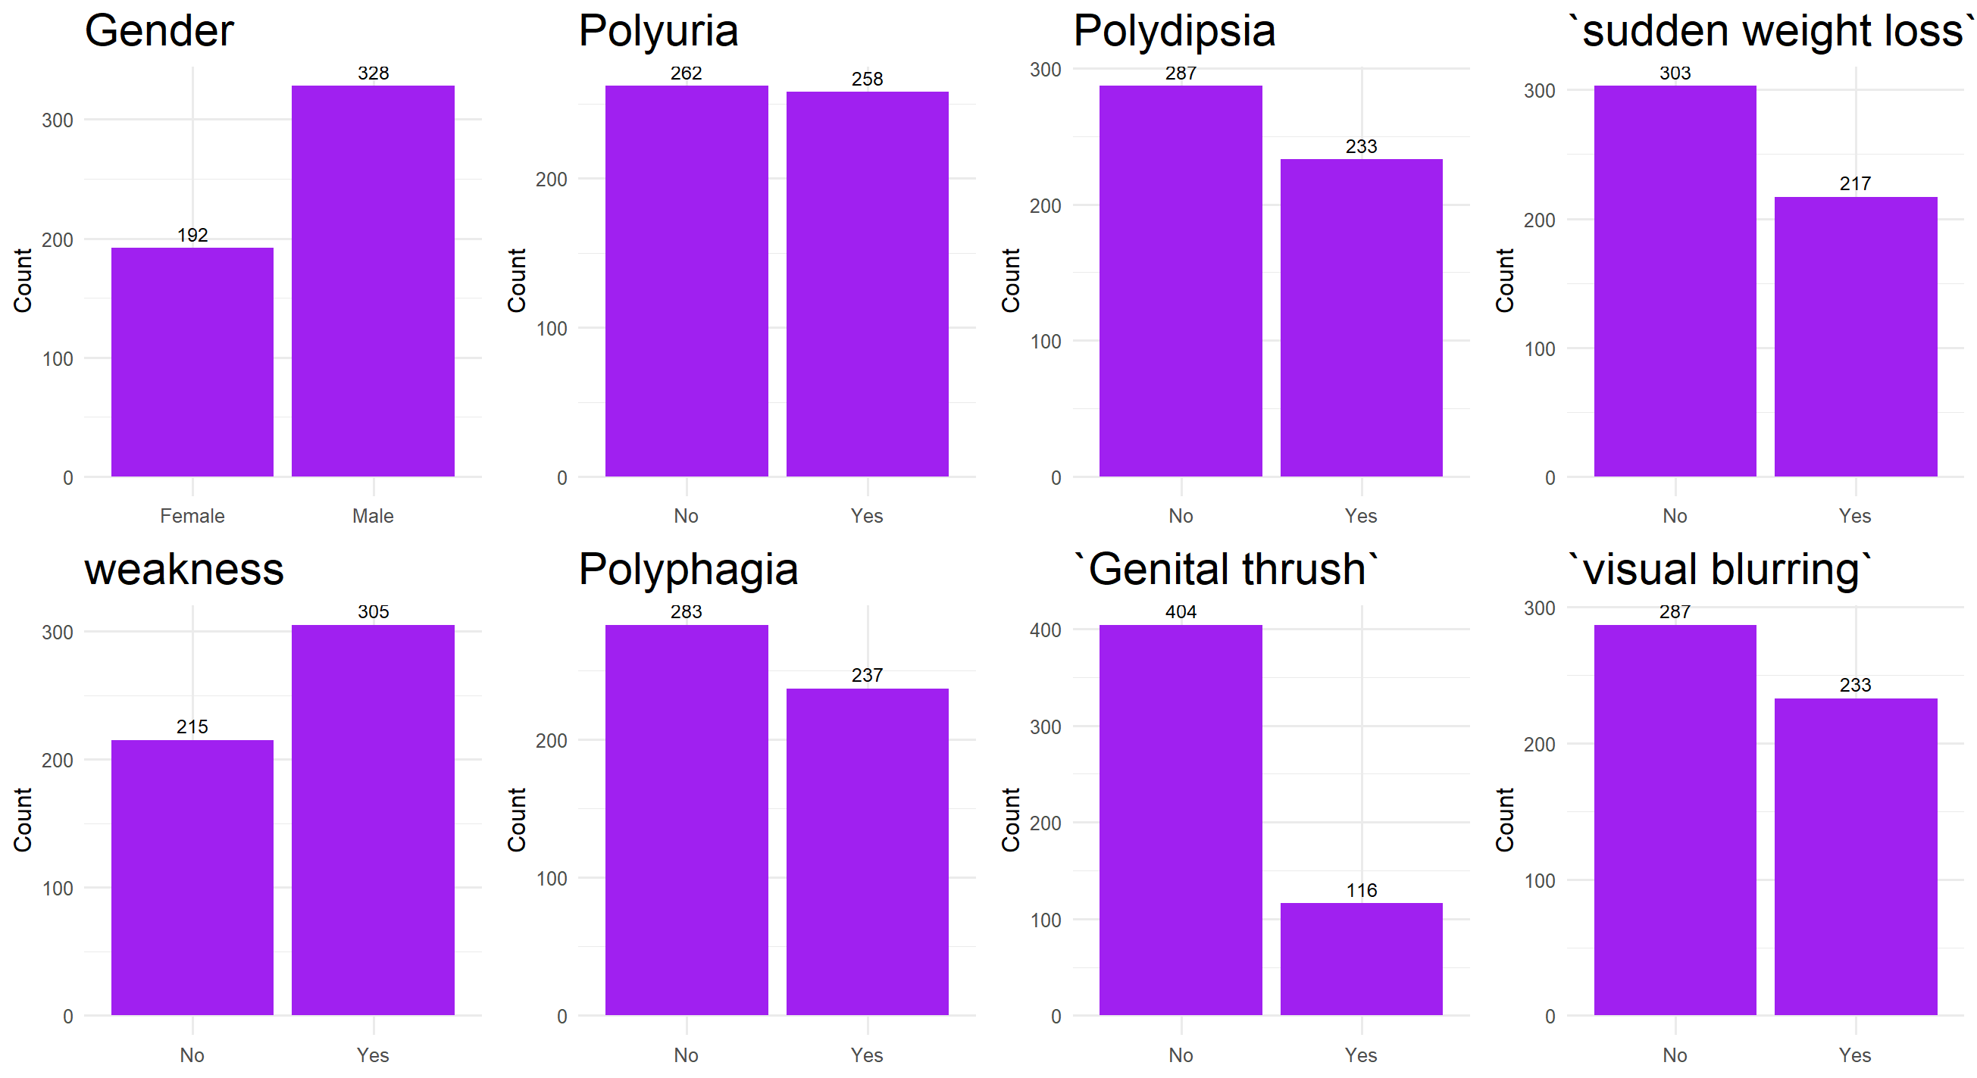

### 3.2 Continuous Variables

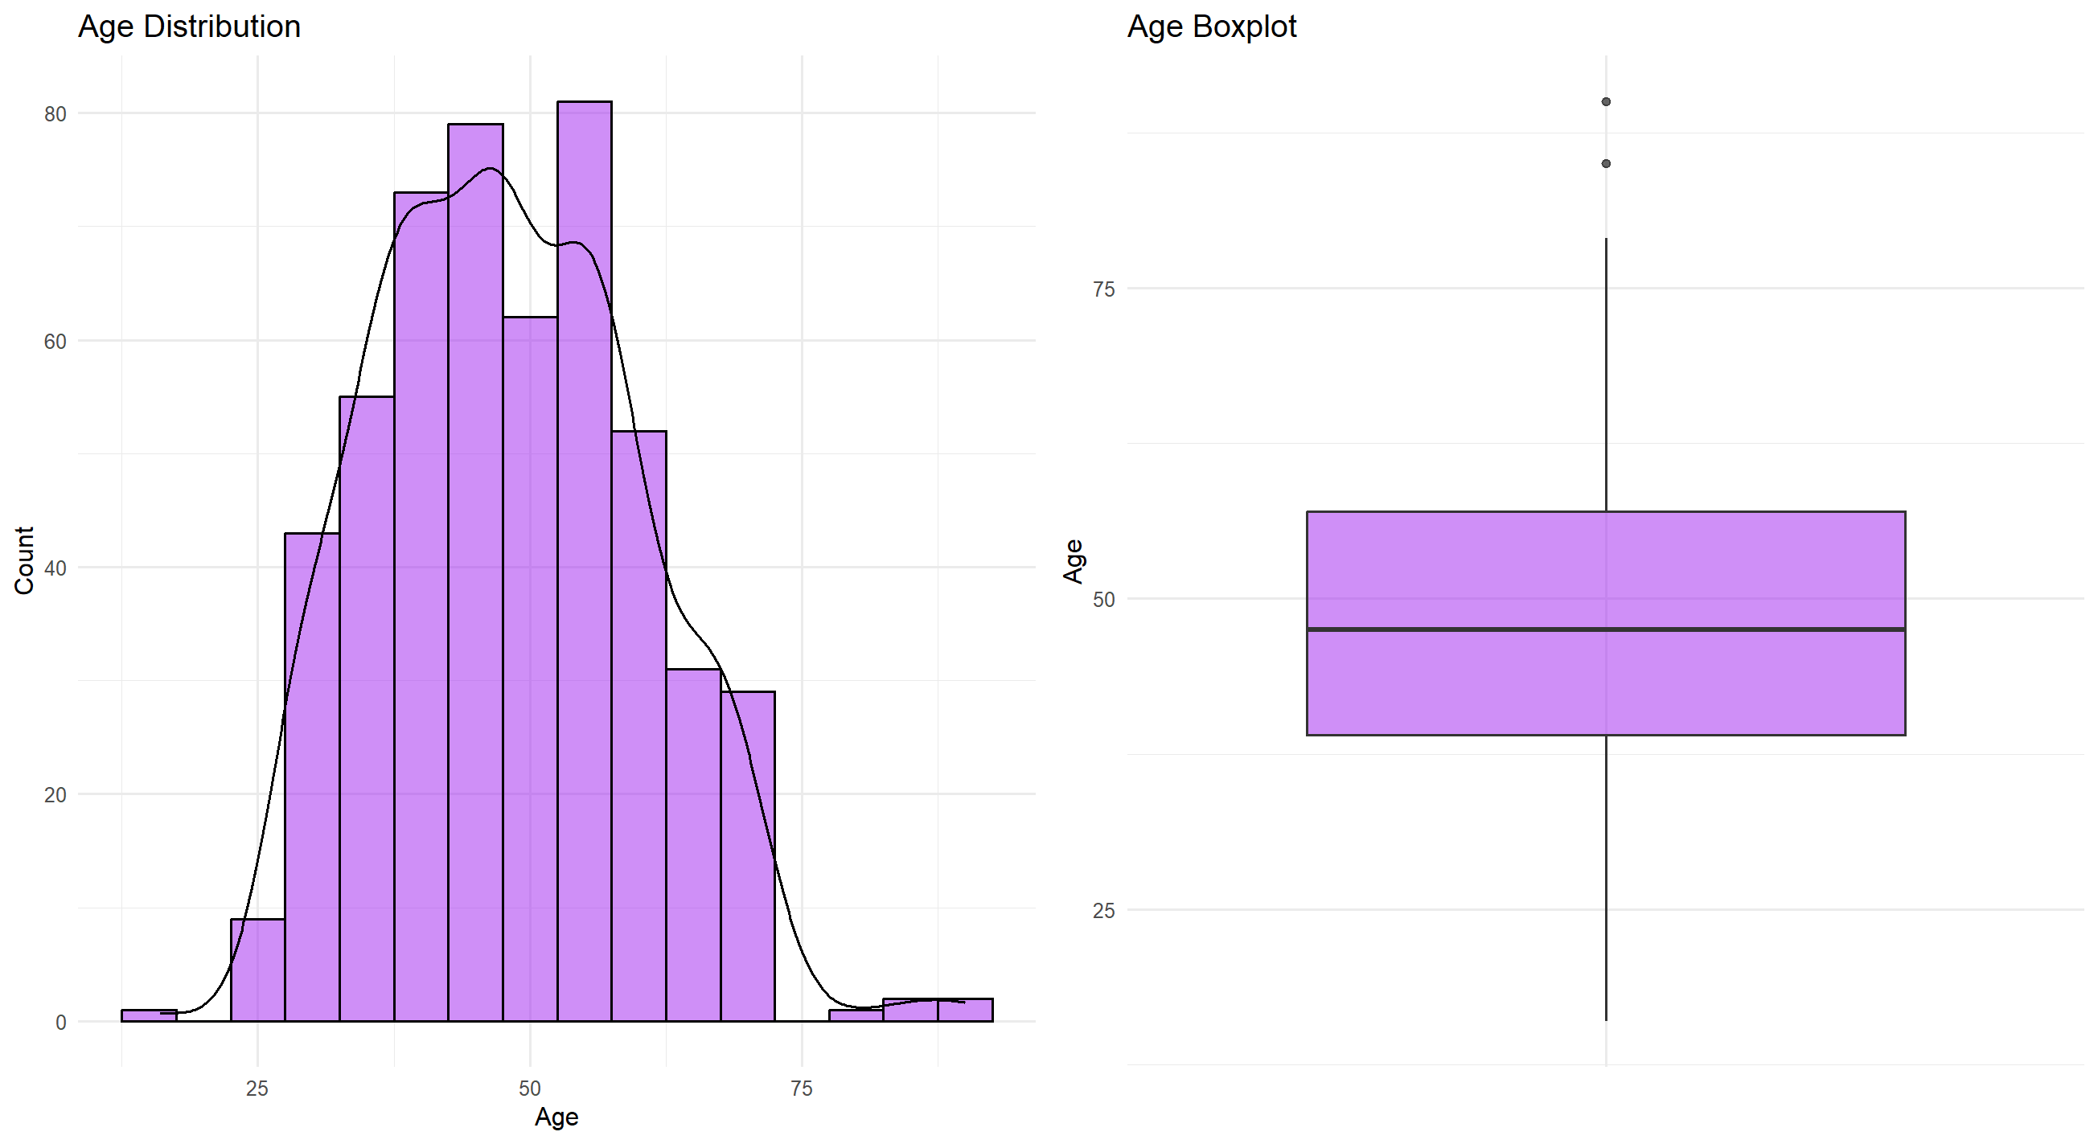

## 4. Baseline characteristics Table

|  |  |  |  |  |  |
| --- | --- | --- | --- | --- | --- |
| Characteristic | | Overall, N = 520*1* | Negative, N = 200*1* | Positive, N = 320*1* | p-value*2* |
| Age | | 48 (18) | 45 (18) | 48 (18) | 0.012 |
| Gender | 0 | 192 (37%) | 19 (9.5%) | 173 (54%) | <0.001 |
| 1 | 328 (63%) | 181 (91%) | 147 (46%) |
| Polyuria | 0 | 262 (50%) | 185 (93%) | 77 (24%) | <0.001 |
| 1 | 258 (50%) | 15 (7.5%) | 243 (76%) |
| Polydipsia | 0 | 287 (55%) | 192 (96%) | 95 (30%) | <0.001 |
| 1 | 233 (45%) | 8 (4.0%) | 225 (70%) |
| sudden weight loss | 0 | 303 (58%) | 171 (86%) | 132 (41%) | <0.001 |
| 1 | 217 (42%) | 29 (15%) | 188 (59%) |
| Weakness | 0 | 215 (41%) | 113 (57%) | 102 (32%) | <0.001 |
| 1 | 305 (59%) | 87 (44%) | 218 (68%) |
| Polyphagia | 0 | 283 (54%) | 152 (76%) | 131 (41%) | <0.001 |
| 1 | 237 (46%) | 48 (24%) | 189 (59%) |
| Genital thrush | 0 | 404 (78%) | 167 (84%) | 237 (74%) | 0.012 |
| 1 | 116 (22%) | 33 (17%) | 83 (26%) |
| visual blurring | 0 | 287 (55%) | 142 (71%) | 145 (45%) | <0.001 |
| 1 | 233 (45%) | 58 (29%) | 175 (55%) |
| Itching | 0 | 267 (51%) | 101 (51%) | 166 (52%) | 0.8 |
| 1 | 253 (49%) | 99 (50%) | 154 (48%) |
| Irritability | 0 | 394 (76%) | 184 (92%) | 210 (66%) | <0.001 |
| 1 | 126 (24%) | 16 (8.0%) | 110 (34%) |
| delayed healing | 0 | 281 (54%) | 114 (57%) | 167 (52%) | 0.3 |
| 1 | 239 (46%) | 86 (43%) | 153 (48%) |
| partial paresis | 0 | 296 (57%) | 168 (84%) | 128 (40%) | <0.001 |
| 1 | 224 (43%) | 32 (16%) | 192 (60%) |
| muscle stiffness | 0 | 325 (63%) | 140 (70%) | 185 (58%) | 0.005 |
| 1 | 195 (38%) | 60 (30%) | 135 (42%) |
| Alopecia | 0 | 341 (66%) | 99 (50%) | 242 (76%) | <0.001 |
| 1 | 179 (34%) | 101 (51%) | 78 (24%) |
| Obesity | 0 | 432 (83%) | 173 (87%) | 259 (81%) | 0.10 |
| 1 | 88 (17%) | 27 (14%) | 61 (19%) |

# 3.-Pima Indians Diabetes Database

## Feature description

**1. Id:** Unique identifier for each data entry.

1. **Pregnancies:** Number of times pregnant.
2. **Glucose:** Plasma glucose concentration over 2 hours in an oral glucose tolerance test.
3. **BloodPressure:** Diastolic blood p ressure (mm Hg).
4. **SkinThickness:** Triceps skinfold thickness (mm).
5. **Insulin:** 2-Hour serum insulin (mu U/ml).
6. **BMI:** Body mass index (weight in kg / height in m^2).
7. **DiabetesPedigreeFunction:** Diabetes pedigree function, a genetic score of diabetes.
8. **Age:** Age in years.
9. **Outcome:** Binary classification indicating the presence (1) or absence (0) of diabetes.

## Missing data rate: 9.43%

On these columns, a value of zero does not make sense and thus indicates missing value.

Following columns or variables have an invalid zero value:

Glucose

BloodPressure

SkinThickness

Insulin

BMI

So the missing data rate is 9.43%

## 3. Distribution Figures

### 3.1 Categorical Variables

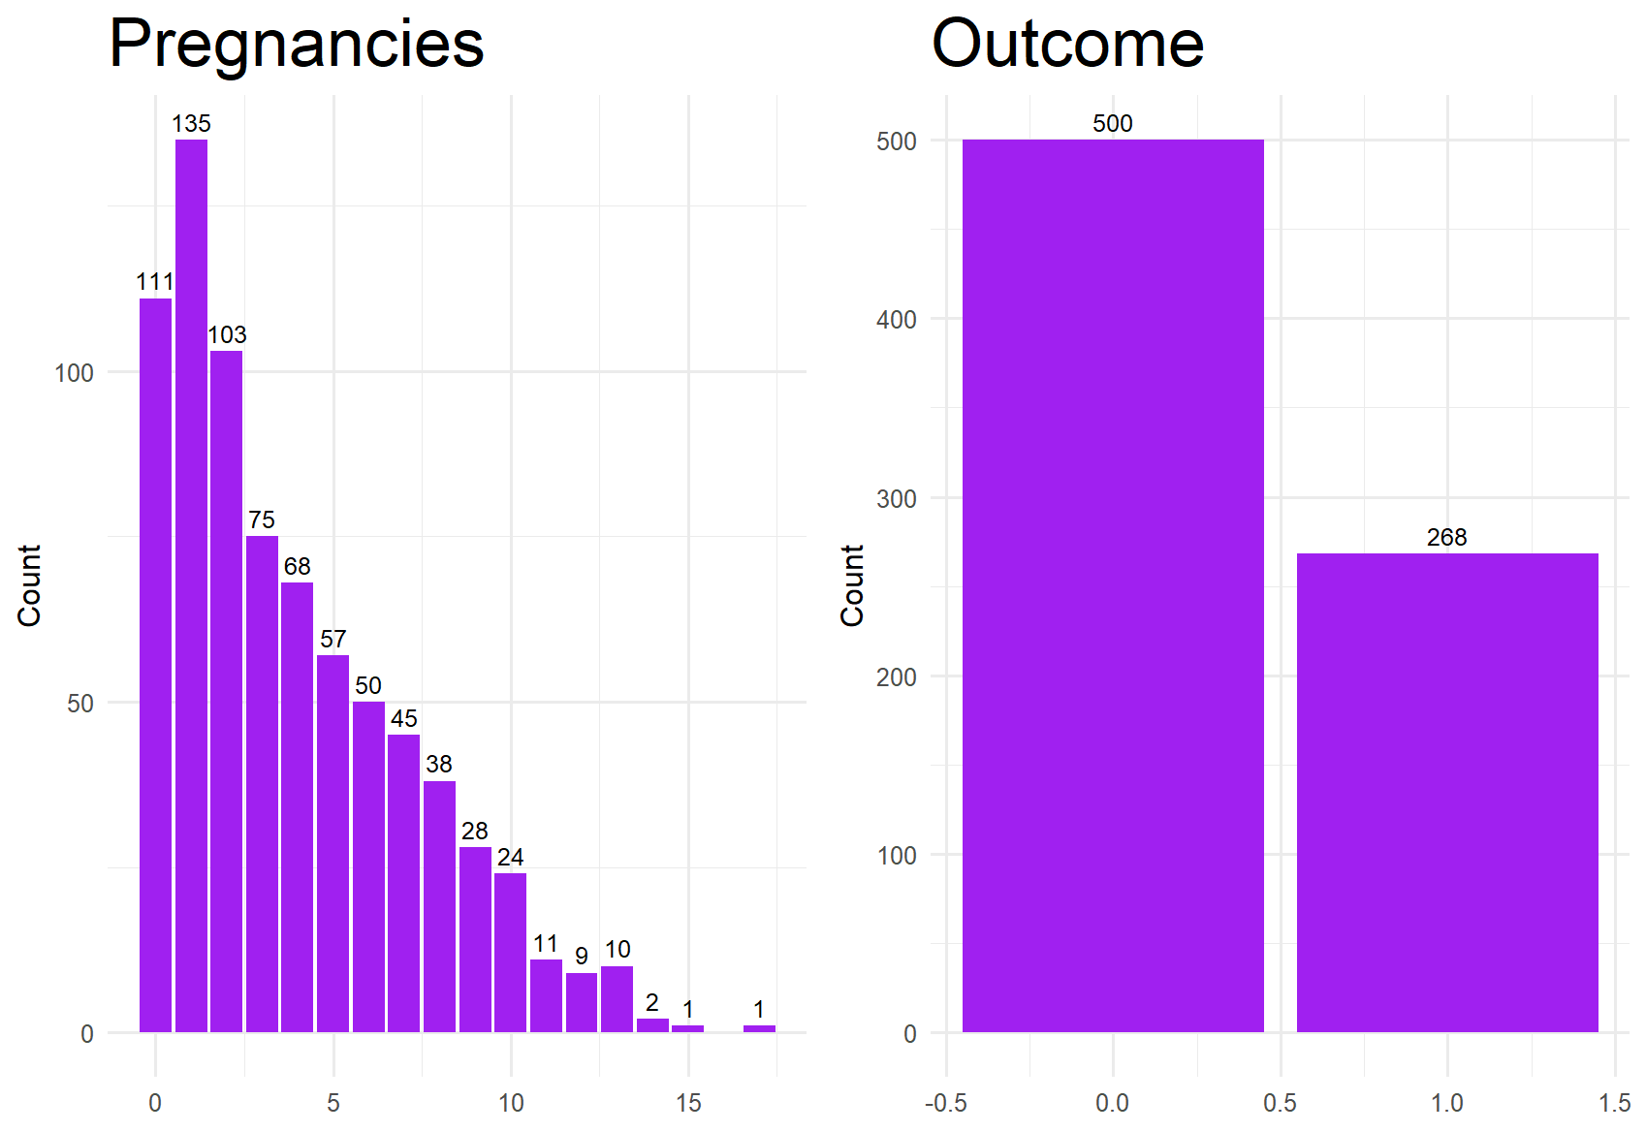

### 3.2 Continuous Variables

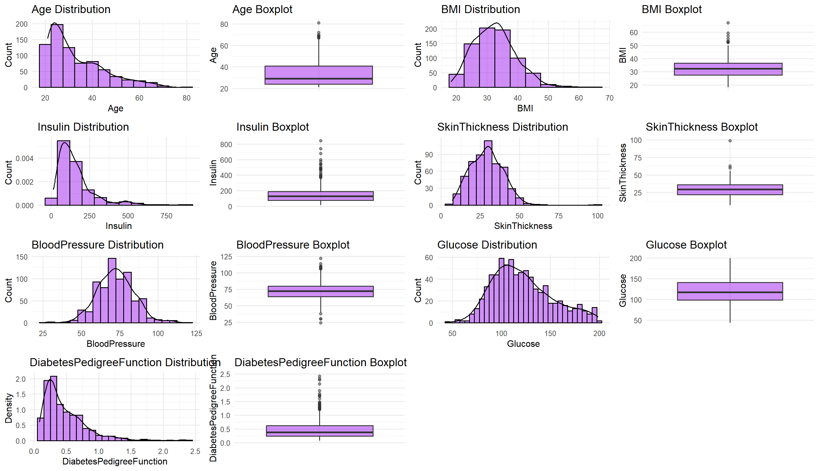

## 4. BASELINE CHARACTERISTICS Table

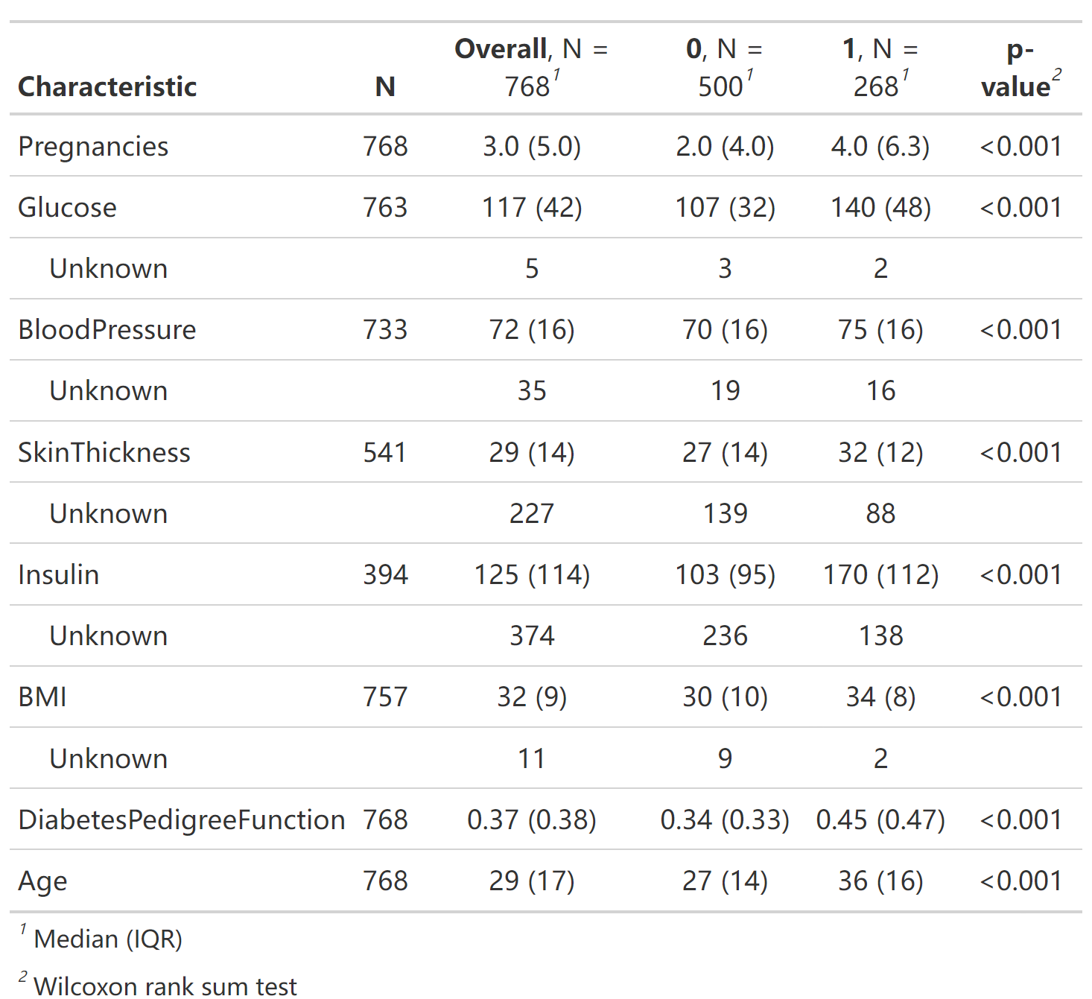

# 4-Multiclass Diabetes Dataset Iraqi

## 1. Missing data rate: 0

## 2. Distribution Figures

### 2.1 Categorical Variables

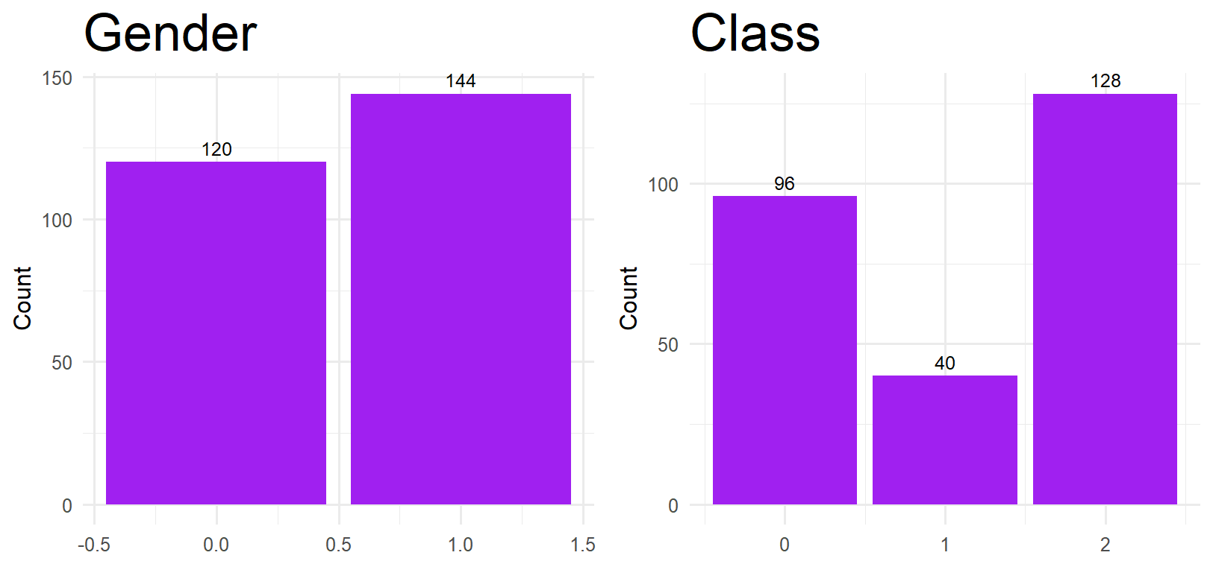

### 2.2 Continuous Variables

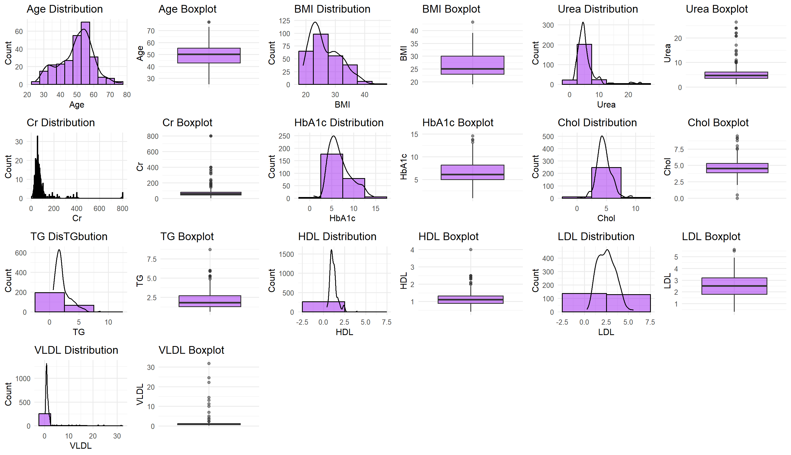

## BASELINE CHARACTERISTICS Table

| **Characteristic** | **N** | **Overall**, N = 264*1* | **0**, N = 96*1* | **1**, N = 40*1* | **2**, N = 128*1* | **p-value***2* |
| --- | --- | --- | --- | --- | --- | --- |
| Gender | 264 |  |  |  |  | <0.001 |
| 0 |  | 120 (45%) | 58 (60%) | 13 (33%) | 49 (38%) |  |
| 1 |  | 144 (55%) | 38 (40%) | 27 (68%) | 79 (62%) |  |
| AGE | 264 | 50 (12) | 44 (11) | 48 (12) | 55 (5) | <0.001 |
| Urea | 264 | 4.7 (2.5) | 4.4 (2.2) | 4.4 (1.6) | 5.1 (3.5) | <0.001 |
| Cr | 264 | 61 (36) | 55 (25) | 60 (21) | 70 (53) | 0.029 |
| HbA1c | 264 | 6.10 (3.20) | 4.90 (1.03) | 6.00 (0.20) | 8.40 (3.00) | <0.001 |
| Chol | 264 | 4.50 (1.43) | 4.20 (1.13) | 4.35 (1.00) | 4.85 (1.83) | <0.001 |
| TG | 264 | 1.80 (1.43) | 1.40 (0.73) | 1.85 (1.05) | 2.00 (1.80) | <0.001 |
| HDL | 264 | 1.10 (0.43) | 1.10 (0.40) | 1.00 (0.60) | 1.10 (0.50) | 0.7 |
| LDL | 264 | 2.50 (1.40) | 2.60 (1.40) | 2.50 (1.30) | 2.50 (1.75) | 0.4 |
| VLDL | 264 | 0.90 (0.63) | 0.70 (0.40) | 0.80 (0.65) | 1.10 (0.73) | <0.001 |
| BMI | 264 | 25.0 (7.0) | 22.0 (3.0) | 24.0 (2.0) | 30.0 (5.2) | <0.001 |
| *1* n (%); Median (IQR) | | | | | | |
| *2* Pearson’s Chi-squared test; Kruskal-Wallis rank sum test | | | | | | |

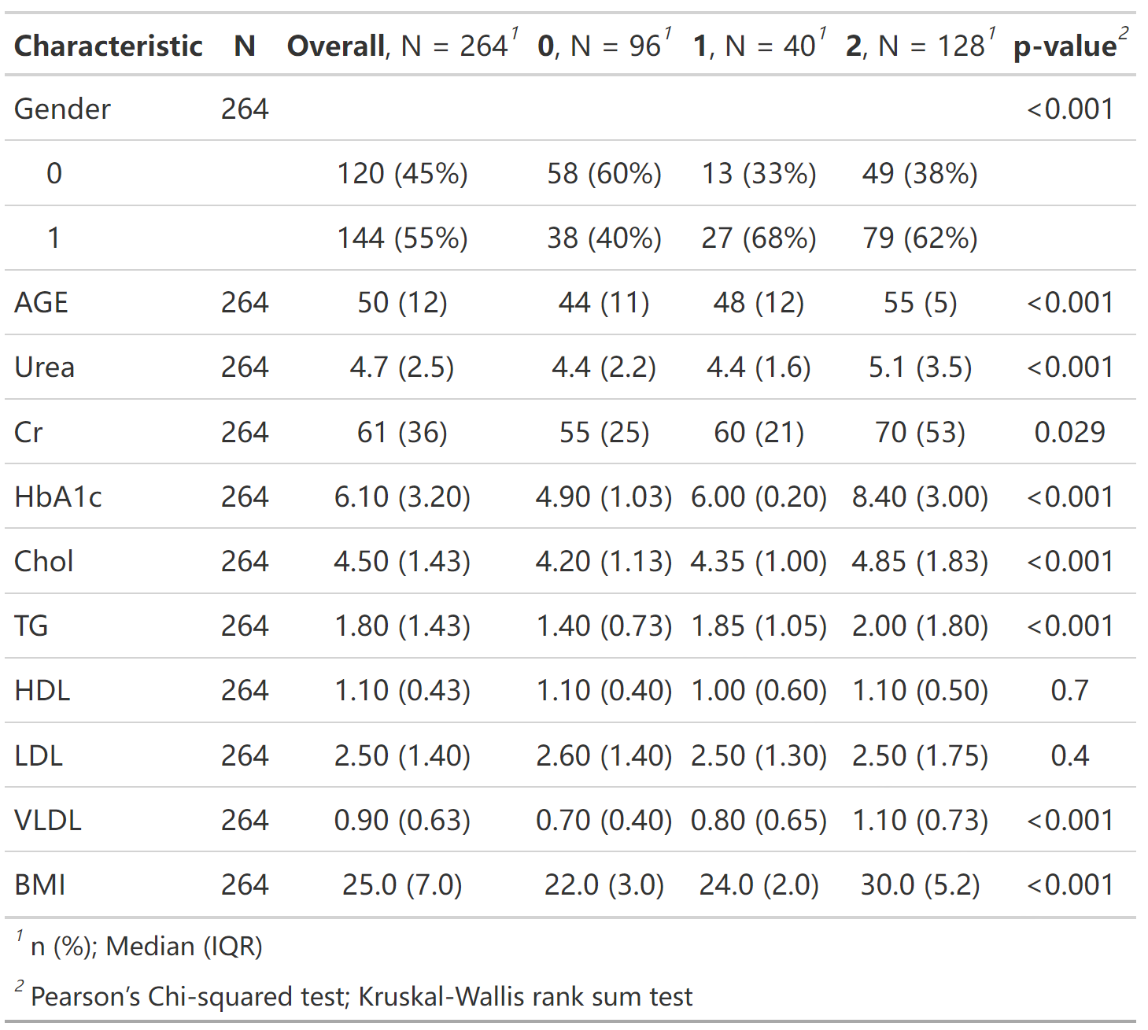

## 5、Heatmap

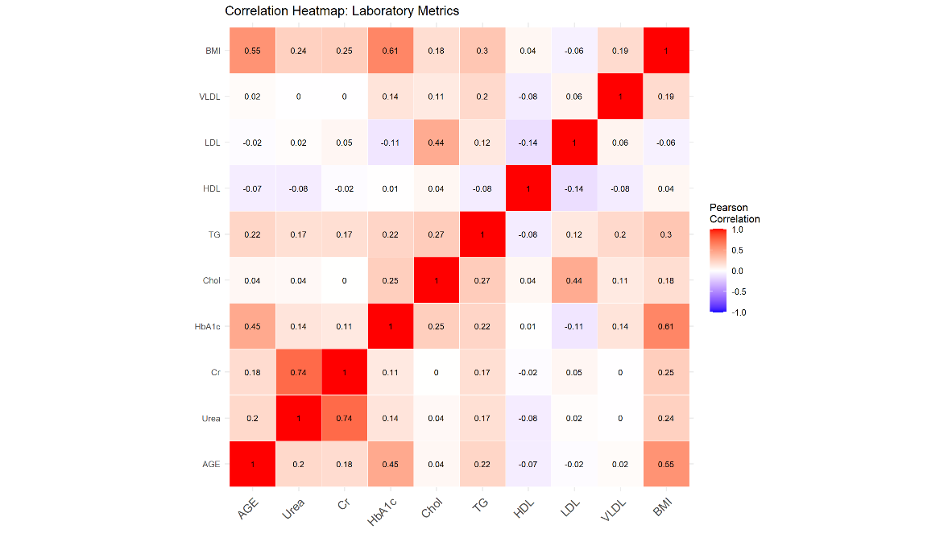

# 6-3 CDC2021

[**https://www.cdc.gov/brfss/annual_data/annual_2021.html**](https://www.cdc.gov/brfss/annual_data/annual_2021.html)

## Feature description

[**https://www.cdc.gov/brfss/annual_data/2021/pdf/codebook21_llcp-v2-508.pdf**](https://www.cdc.gov/brfss/annual_data/2021/pdf/codebook21_llcp-v2-508.pdf)

|  |  |  |
| --- | --- | --- |
| No. | Feature name | Feature description |
| 1 | GenHlth | 1 Excellent; 2 Very good;3 Good;4 Fair;5 Poor |
| 2 | MenHlth | Now thinking about your mental health, which includes stress, depression, and problems with emotions, for  how many days during the past 30 days was your mental health not good? |
| 3 | PhysHth | Now thinking about your physical health, which includes physical illness and injury, for how many days during the past 30 days was your physical health not good? |
| 4 | Education | 1 Never attended school or only kindergarten ;2 Grades 1 through 8 (Elementary) ;3 Grades 9 through 11 (Some high school) ;4 Grade 12 or GED (High school graduate) ;5 College 1 year to 3 years (Some college or technical school) ;6 College 4 years or more (College graduate) |
| 5 | Income | 1 Less than $10,000 ;2 Less than $15,000 ;3 Less than $20,000 ;4 Less than $25,000 ;5 Less than $35,000 ;6 Less than $50,000 ;7 Less than $75,000 ;8 Less than $100,000? ;9 Less than $150,000? ;10 Less than $200,000? ;11 $200,000 or more |
| 6 | NoDocbcCost | Was there a time in the past 12 months when you needed to see a doctor but could not because you could not afford it? |

## 2. Missing data rate: 0

## 3. Distribution Figures

### 3.1 Categorical Variables

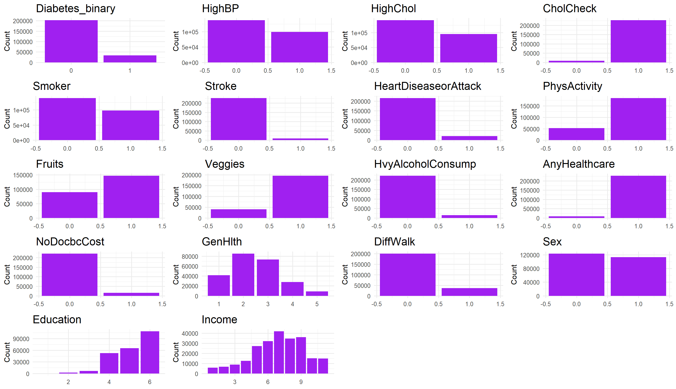

### 3.2 Continuous Variables

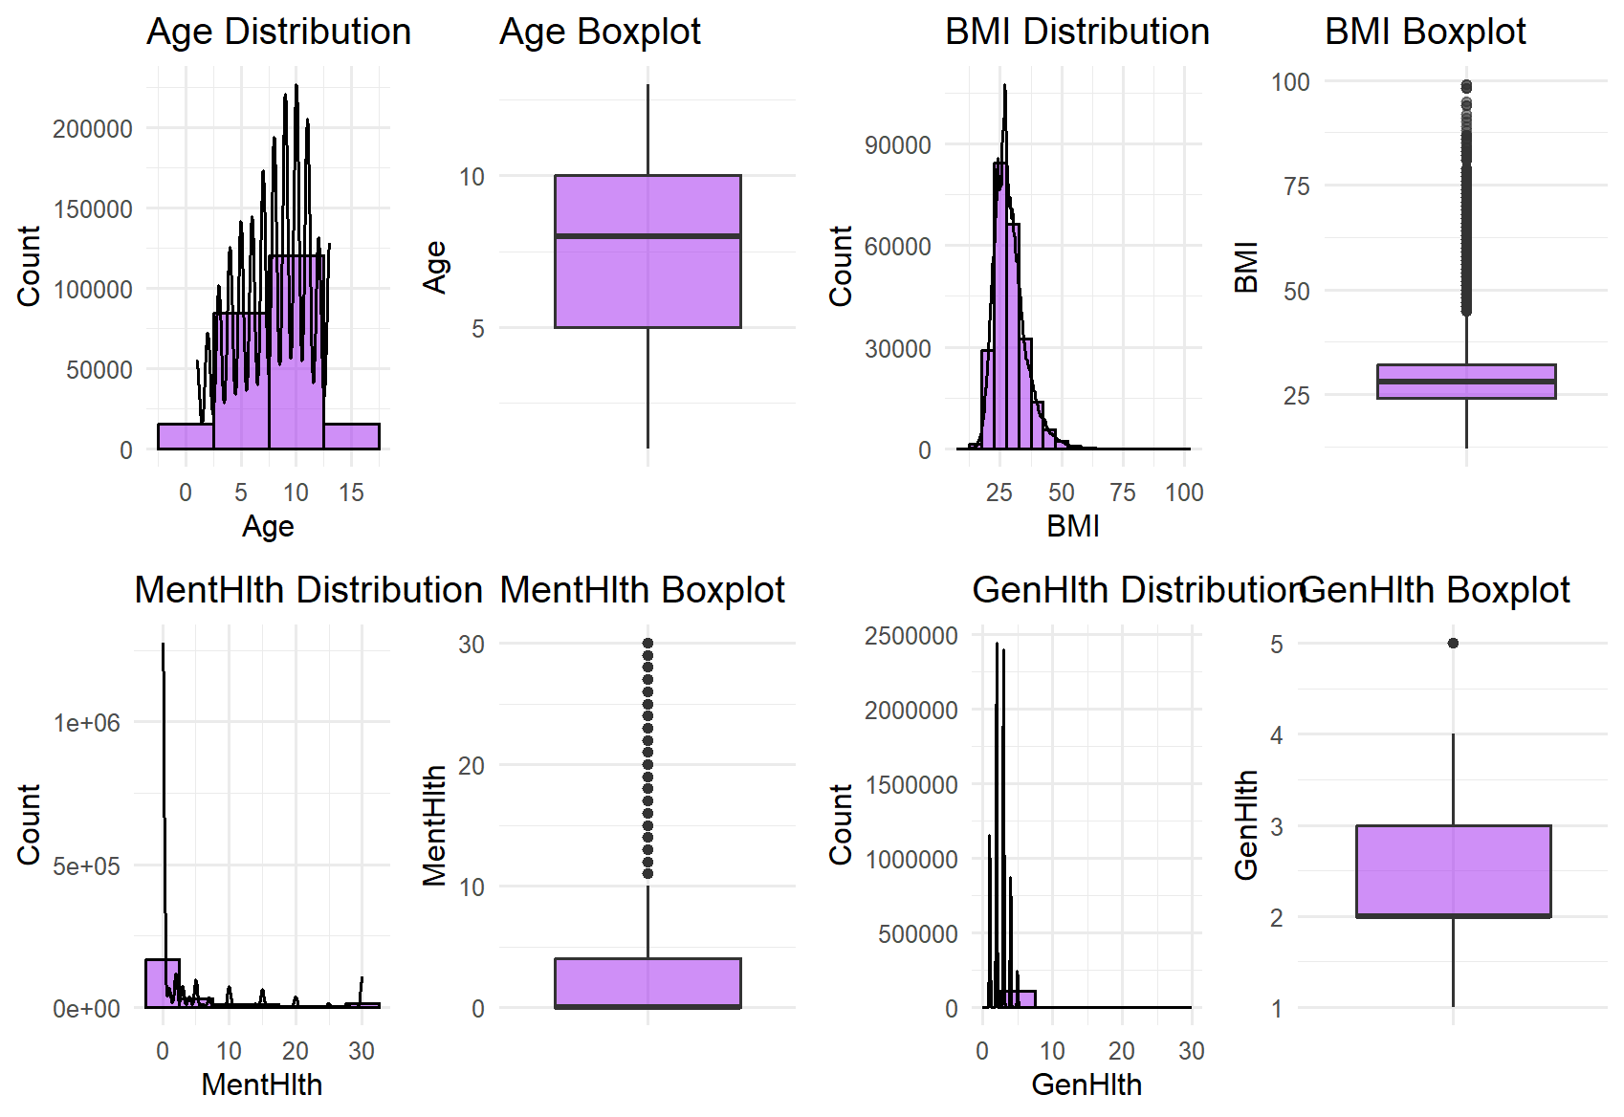

## 4. Baseline characteristics Table

| **Characteristic** | **N** | **Overall**, N = 236,378*1* | **0**, N = 202,810*1* | **1**, N = 33,568*1* | **p-value***2* |
| --- | --- | --- | --- | --- | --- |
| HighBP | 236,378 |  |  |  | <0.001 |
| 0 |  | 137,440 (58%) | 128,519 (63%) | 8,921 (27%) |  |
| 1 |  | 98,938 (42%) | 74,291 (37%) | 24,647 (73%) |  |
| HighChol | 236,378 |  |  |  | <0.001 |
| 0 |  | 141,340 (60%) | 129,240 (64%) | 12,100 (36%) |  |
| 1 |  | 95,038 (40%) | 73,570 (36%) | 21,468 (64%) |  |
| CholCheck | 236,378 |  |  |  | <0.001 |
| 0 |  | 8,664 (3.7%) | 8,497 (4.2%) | 167 (0.5%) |  |
| 1 |  | 227,714 (96%) | 194,313 (96%) | 33,401 (100%) |  |
| BMI | 236,378 | 28 (8) | 27 (7) | 31 (9) | <0.001 |
| Smoker | 236,378 |  |  |  | <0.001 |
| 0 |  | 138,991 (59%) | 121,567 (60%) | 17,424 (52%) |  |
| 1 |  | 97,387 (41%) | 81,243 (40%) | 16,144 (48%) |  |
| Stroke | 236,378 |  |  |  | <0.001 |
| 0 |  | 227,183 (96%) | 196,541 (97%) | 30,642 (91%) |  |
| 1 |  | 9,195 (3.9%) | 6,269 (3.1%) | 2,926 (8.7%) |  |
| HeartDiseaseorAttack | 236,378 |  |  |  | <0.001 |
| 0 |  | 215,920 (91%) | 189,325 (93%) | 26,595 (79%) |  |
| 1 |  | 20,458 (8.7%) | 13,485 (6.6%) | 6,973 (21%) |  |
| PhysActivity | 236,378 |  |  |  | <0.001 |
| 0 |  | 52,185 (22%) | 39,711 (20%) | 12,474 (37%) |  |
| 1 |  | 184,193 (78%) | 163,099 (80%) | 21,094 (63%) |  |
| Fruits | 236,378 |  |  |  | <0.001 |
| 0 |  | 89,526 (38%) | 75,664 (37%) | 13,862 (41%) |  |
| 1 |  | 146,852 (62%) | 127,146 (63%) | 19,706 (59%) |  |
| Veggies | 236,378 |  |  |  | <0.001 |
| 0 |  | 40,712 (17%) | 33,496 (17%) | 7,216 (21%) |  |
| 1 |  | 195,666 (83%) | 169,314 (83%) | 26,352 (79%) |  |
| HvyAlcoholConsump | 236,378 |  |  |  | <0.001 |
| 0 |  | 221,703 (94%) | 189,081 (93%) | 32,622 (97%) |  |
| 1 |  | 14,675 (6.2%) | 13,729 (6.8%) | 946 (2.8%) |  |
| AnyHealthcare | 236,378 |  |  |  | <0.001 |
| 0 |  | 8,847 (3.7%) | 8,024 (4.0%) | 823 (2.5%) |  |
| 1 |  | 227,531 (96%) | 194,786 (96%) | 32,745 (98%) |  |
| NoDocbcCost | 236,378 |  |  |  | <0.001 |
| 0 |  | 221,312 (94%) | 190,152 (94%) | 31,160 (93%) |  |
| 1 |  | 15,066 (6.4%) | 12,658 (6.2%) | 2,408 (7.2%) |  |
| GenHlth | 236,378 |  |  |  | <0.001 |
| 1 |  | 41,475 (18%) | 40,166 (20%) | 1,309 (3.9%) |  |
| 2 |  | 85,202 (36%) | 78,453 (39%) | 6,749 (20%) |  |
| 3 |  | 73,088 (31%) | 59,812 (29%) | 13,276 (40%) |  |
| 4 |  | 27,821 (12%) | 18,967 (9.4%) | 8,854 (26%) |  |
| 5 |  | 8,792 (3.7%) | 5,412 (2.7%) | 3,380 (10%) |  |
| MentHlth | 236,378 |  |  |  |  |
| 0 |  | 147,300 (62%) | 126,073 (62%) | 21,227 (63%) |  |
| 1 |  | 7,789 (3.3%) | 6,975 (3.4%) | 814 (2.4%) |  |
| 2 |  | 13,481 (5.7%) | 11,877 (5.9%) | 1,604 (4.8%) |  |
| 3 |  | 8,496 (3.6%) | 7,474 (3.7%) | 1,022 (3.0%) |  |
| 4 |  | 4,345 (1.8%) | 3,852 (1.9%) | 493 (1.5%) |  |
| 5 |  | 11,184 (4.7%) | 9,854 (4.9%) | 1,330 (4.0%) |  |
| 6 |  | 1,268 (0.5%) | 1,108 (0.5%) | 160 (0.5%) |  |
| 7 |  | 3,996 (1.7%) | 3,578 (1.8%) | 418 (1.2%) |  |
| 8 |  | 880 (0.4%) | 761 (0.4%) | 119 (0.4%) |  |
| 9 |  | 121 (<0.1%) | 101 (<0.1%) | 20 (<0.1%) |  |
| 10 |  | 8,340 (3.5%) | 7,174 (3.5%) | 1,166 (3.5%) |  |
| 11 |  | 58 (<0.1%) | 48 (<0.1%) | 10 (<0.1%) |  |
| 12 |  | 581 (0.2%) | 507 (0.2%) | 74 (0.2%) |  |
| 13 |  | 70 (<0.1%) | 61 (<0.1%) | 9 (<0.1%) |  |
| 14 |  | 1,434 (0.6%) | 1,234 (0.6%) | 200 (0.6%) |  |
| 15 |  | 7,239 (3.1%) | 6,088 (3.0%) | 1,151 (3.4%) |  |
| 16 |  | 104 (<0.1%) | 88 (<0.1%) | 16 (<0.1%) |  |
| 17 |  | 97 (<0.1%) | 84 (<0.1%) | 13 (<0.1%) |  |
| 18 |  | 143 (<0.1%) | 126 (<0.1%) | 17 (<0.1%) |  |
| 19 |  | 14 (<0.1%) | 11 (<0.1%) | 3 (<0.1%) |  |
| 20 |  | 4,327 (1.8%) | 3,565 (1.8%) | 762 (2.3%) |  |
| 21 |  | 243 (0.1%) | 191 (<0.1%) | 52 (0.2%) |  |
| 22 |  | 77 (<0.1%) | 70 (<0.1%) | 7 (<0.1%) |  |
| 23 |  | 50 (<0.1%) | 43 (<0.1%) | 7 (<0.1%) |  |
| 24 |  | 66 (<0.1%) | 59 (<0.1%) | 7 (<0.1%) |  |
| 25 |  | 1,600 (0.7%) | 1,340 (0.7%) | 260 (0.8%) |  |
| 26 |  | 54 (<0.1%) | 46 (<0.1%) | 8 (<0.1%) |  |
| 27 |  | 92 (<0.1%) | 75 (<0.1%) | 17 (<0.1%) |  |
| 28 |  | 416 (0.2%) | 342 (0.2%) | 74 (0.2%) |  |
| 29 |  | 191 (<0.1%) | 160 (<0.1%) | 31 (<0.1%) |  |
| 30 |  | 12,322 (5.2%) | 9,845 (4.9%) | 2,477 (7.4%) |  |
| PhysHlth | 236,378 | 0 (2) | 0 (2) | 0 (10) | <0.001 |
| DiffWalk | 236,378 | 36,390 (15%) | 24,982 (12%) | 11,408 (34%) | <0.001 |
| Sex | 236,378 |  |  |  | <0.001 |
| 0 |  | 123,431 (52%) | 107,328 (53%) | 16,103 (48%) |  |
| 1 |  | 112,947 (48%) | 95,482 (47%) | 17,465 (52%) |  |
| Age | 236,378 | 8.0 (5.0) | 8.0 (5.0) | 10.0 (3.0) | <0.001 |
| Education | 236,378 |  |  |  | <0.001 |
| 1 |  | 147 (<0.1%) | 106 (<0.1%) | 41 (0.1%) |  |
| 2 |  | 2,771 (1.2%) | 2,038 (1.0%) | 733 (2.2%) |  |
| 3 |  | 6,940 (2.9%) | 5,382 (2.7%) | 1,558 (4.6%) |  |
| 4 |  | 52,741 (22%) | 43,411 (21%) | 9,330 (28%) |  |
| 5 |  | 65,377 (28%) | 54,963 (27%) | 10,414 (31%) |  |
| 6 |  | 108,402 (46%) | 96,910 (48%) | 11,492 (34%) |  |
| Income | 236,378 |  |  |  | <0.001 |
| 1 |  | 5,866 (2.5%) | 4,471 (2.2%) | 1,395 (4.2%) |  |
| 2 |  | 6,880 (2.9%) | 5,016 (2.5%) | 1,864 (5.6%) |  |
| 3 |  | 8,857 (3.7%) | 6,785 (3.3%) | 2,072 (6.2%) |  |
| 4 |  | 12,704 (5.4%) | 9,946 (4.9%) | 2,758 (8.2%) |  |
| 5 |  | 27,172 (11%) | 22,017 (11%) | 5,155 (15%) |  |
| 6 |  | 32,036 (14%) | 26,800 (13%) | 5,236 (16%) |  |
| 7 |  | 41,830 (18%) | 36,068 (18%) | 5,762 (17%) |  |
| 8 |  | 34,790 (15%) | 30,908 (15%) | 3,882 (12%) |  |
| 9 |  | 36,101 (15%) | 32,677 (16%) | 3,424 (10%) |  |
| 10 |  | 15,193 (6.4%) | 14,058 (6.9%) | 1,135 (3.4%) |  |
| 11 |  | 14,949 (6.3%) | 14,064 (6.9%) | 885 (2.6%) |  |
| *1* n (%); Median (IQR) | | | | | |
| *2* Pearson’s Chi-squared test; Wilcoxon rank sum test | | | | | |

## 5. Heatmap

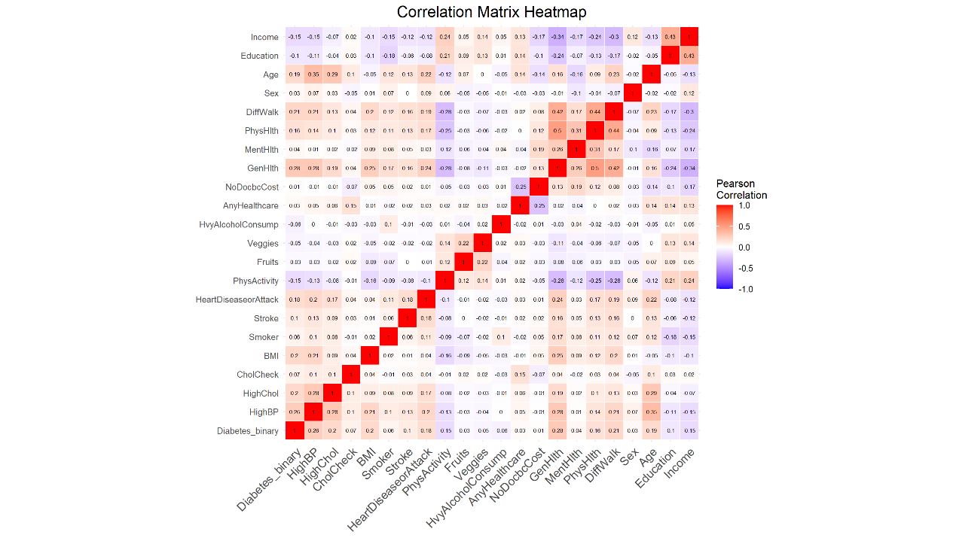

## 6. glm model

> fit.hyt_1 <- glm(clinical_data$Diabetes_binary ~ ., data = clinical_data[, fit_columns], family = 'binomial')

> summary(fit.hyt_1)

|  |  |  |  |  |
| --- | --- | --- | --- | --- |
|  | Estimate | Std.Error | zvalue | Pr(>|z|) |
| (Intercept) | -7.6900620 | 0.1058792 | -72.630 | <2e-16 |
| HighBP | 0.7246707 | 0.0148815 | 48.696 | <2e-16 |
| HighChol | 0.5644357 | 0.0137256 | 41.123 | <2e-16 |
| CholCheck | 1.4959448 | 0.0811486 | 18.435 | <2e-16 |
| BMI | 0.0583659 | 0.0009763 | 59.782 | <2e-16 |
| Smoker | -0.0571485 | 0.0135797 | -4.208 | 2.57e-05 |
| Stroke | 0.1796463 | 0.0262903 | 6.833 | 8.31e-12 |
| HeartDiseaseorAttack | 0.2757344 | 0.0187572 | 14.700 | <2e-16 |
| PhysActivity | -0.1907922 | 0.0151807 | -12.568 | <2e-16 |
| Fruits | -0.0313675 | 0.0137978 | -2.273 | 0.02300 |
| Veggies | -0.0297972 | 0.0168490 | -1.768 | 0.07698 |
| HvyAlcoholConsump | -0.7122919 | 0.0364324 | -19.551 | <2e-16 |
| AnyHealthcare | 0.1332263 | 0.0428577 | 3.109 | 0.00188 |
| NoDocbcCost | 0.0411650 | 0.0278723 | 1.477 | 0.13970 |
| GenHlth | 0.4880134 | 0.0083951 | 58.131 | <2e-16 |
| MentHlth | -0.0046156 | 0.0008641 | -5.341 | 9.23e-08 |
| PhysHlth | -0.0060301 | 0.0008252 | -7.308 | 2.72e-13 |
| DiffWalk | 0.1012116 | 0.0176360 | 5.739 | 9.53e-09 |
| Sex | 0.2785193 | 0.0136536 | 20.399 | <2e-16 |
| Age | 0.1215115 | 0.0027528 | 44.142 | <2e-16 |
| Education | -0.0312592 | 0.0074291 | -4.208 | 2.58e-05 |
| Income | -0.0499138 | 0.0032968 | -15.140 | <2e-16 |

# 7- 2016 Chinese diabetes dataset

## 1. Feature description

Features of Dataset: Age Gender BMI SBP (Systolic Blood Pressure) DBP (Diastolic Blood Pressure) FPG (Fasting Plasma Glucose) FFPG (Final Fasting Plasma Glucose) Cholesterol Triglyceride HDL (High-Density Lipoprotein) LDL (Low-Density Lipoprotein) ALT (Alanine Aminotransferase) BUN (Blood urea nitrogen) CCR (Creatinine Clearance) Smoking Status: (1: Current Smoker, 2: Ever Smoker, 3: Never Smoker) Drinking Status: (1: Current Drinker, 2: Ever Drinker, 3: Never Drinker) Family History of Diabetes: (1: Yes, 0: No) Diabetes

## Missing data rate: 3.79%

Compare with origin data , the number 4.860753 present missing data in this dataset.

## 3. Distribution Figures

### 3.1 Categorical Variables

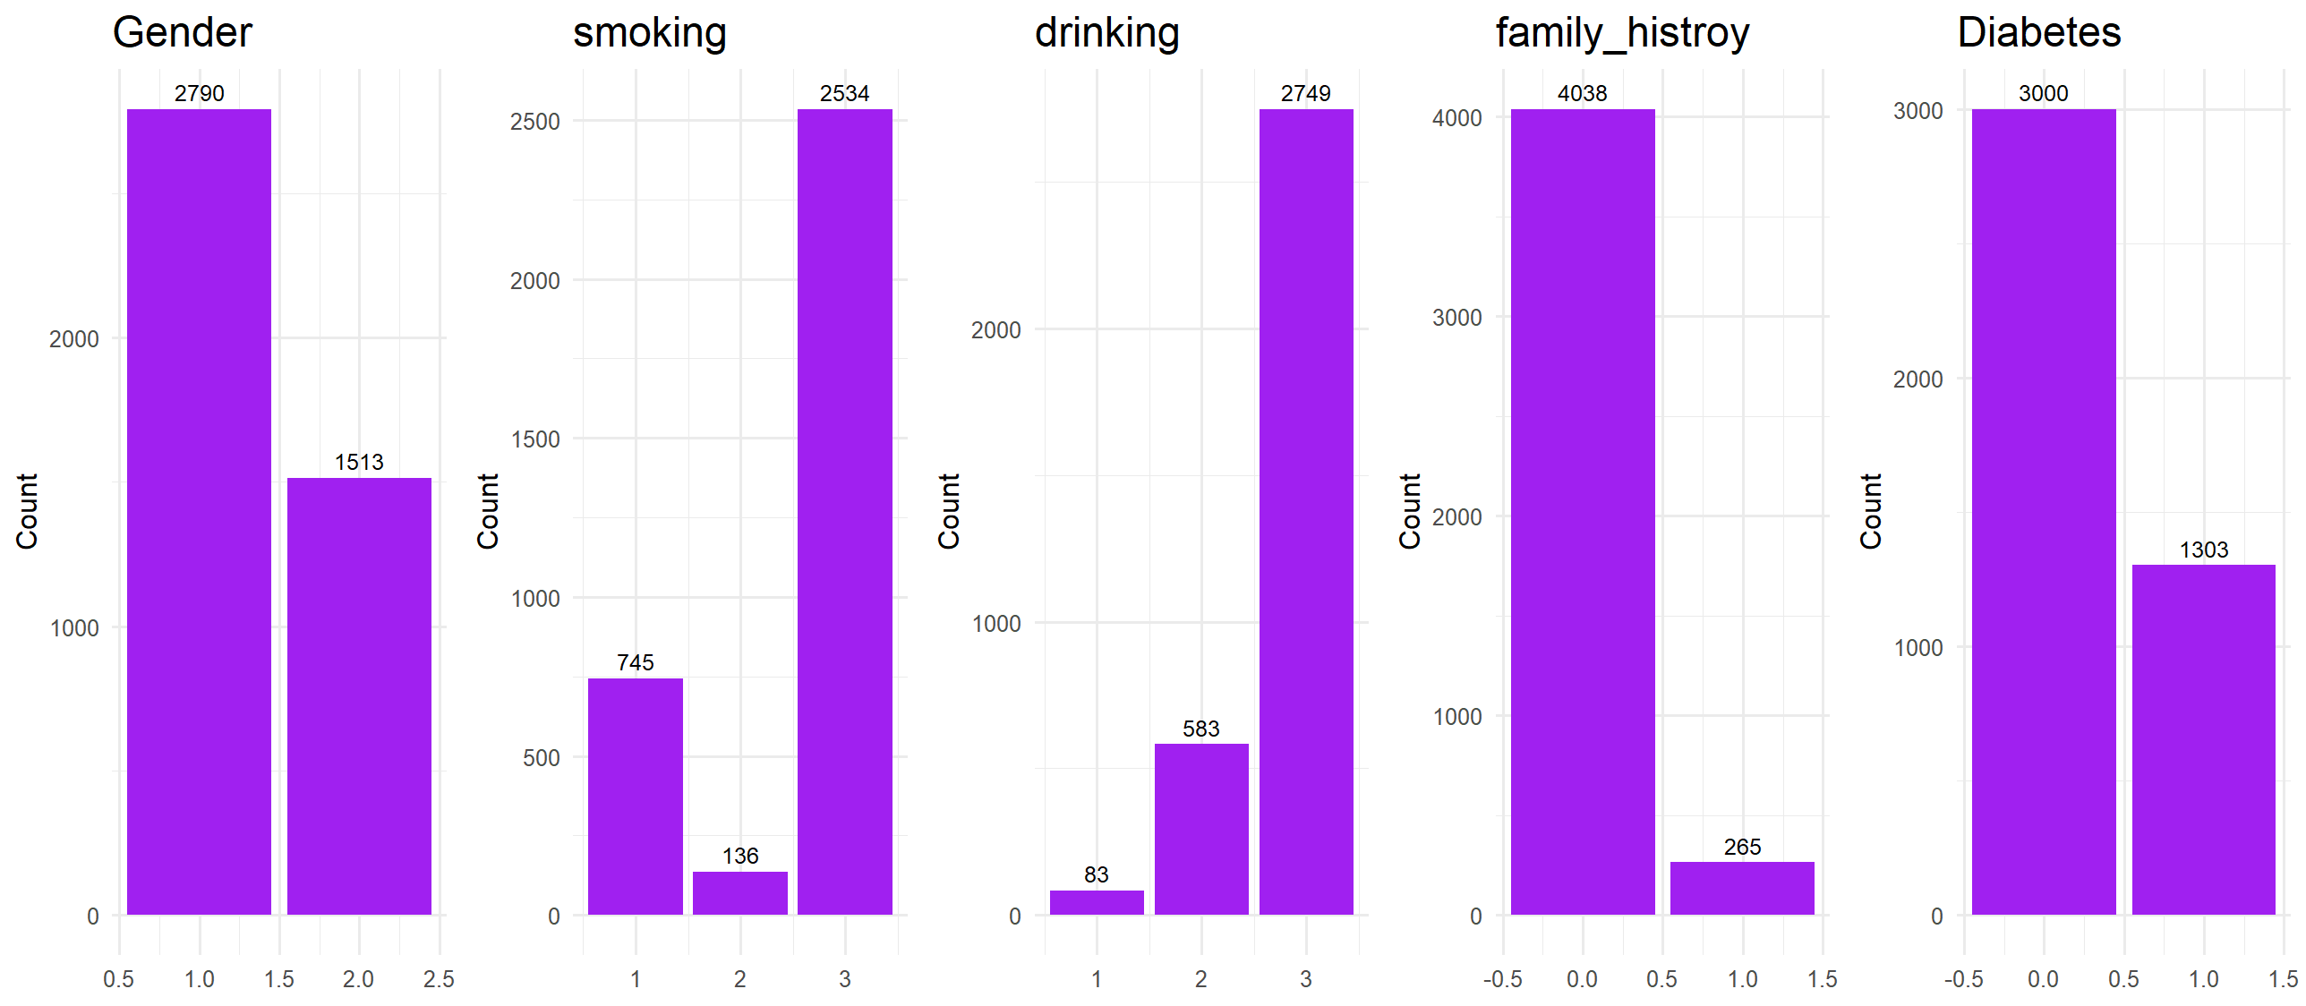

### 3.2 Continuous Variables

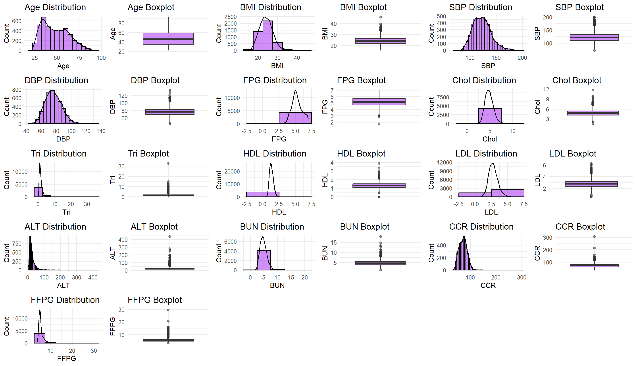

## 3.BASELINE CHARACTERISTICS Table

| **Characteristic** | **N** | **Overall**, N = 4,303*1* | **0**, N = 3,000*1* | **1**, N = 1,303*1* | **p-value***2* |
| --- | --- | --- | --- | --- | --- |
| Age | 4,303 | 46 (24) | 40 (18) | 60 (14) | <0.001 |
| Gender | 4,303 |  |  |  | 0.6 |
| 1 |  | 2,790 (65%) | 1,952 (65%) | 838 (64%) |  |
| 2 |  | 1,513 (35%) | 1,048 (35%) | 465 (36%) |  |
| BMI | 4,303 | 24.0 (4.6) | 23.4 (4.6) | 25.2 (4.3) | <0.001 |
| SBP | 4,303 | 122 (23) | 119 (21) | 130 (26) | <0.001 |
| DBP | 4,303 | 76 (14) | 75 (14) | 78 (17) | <0.001 |
| FPG | 4,303 | 5.14 (1.00) | 4.97 (0.74) | 5.96 (1.17) | <0.001 |
| Chol | 4,289 | 4.79 (1.23) | 4.71 (1.19) | 4.98 (1.21) | <0.001 |
| Unknown |  | 14 | 0 | 14 |  |
| Tri | 4,289 | 1.28 (1.07) | 1.18 (0.97) | 1.55 (1.25) | <0.001 |
| Unknown |  | 14 | 0 | 14 |  |
| HDL | 3,892 | 1.30 (0.41) | 1.31 (0.41) | 1.25 (0.40) | <0.001 |
| Unknown |  | 411 | 0 | 411 |  |
| LDL | 3,909 | 2.73 (0.91) | 2.69 (0.90) | 2.86 (0.90) | <0.001 |
| Unknown |  | 394 | 0 | 394 |  |
| ALT | 4,294 | 21 (17) | 20 (16) | 22 (18) | <0.001 |
| Unknown |  | 9 | 0 | 9 |  |
| BUN | 4,207 | 4.71 (1.66) | 4.60 (1.58) | 5.00 (1.78) | <0.001 |
| Unknown |  | 96 | 0 | 96 |  |
| CCR | 4,269 | 72 (22) | 73 (22) | 71 (21) | 0.004 |
| Unknown |  | 34 | 0 | 34 |  |
| FFPG | 4,303 | 5.30 (1.12) | 5.10 (0.64) | 6.69 (1.88) | <0.001 |
| smoking | 3,415 |  |  |  | <0.001 |
| 1 |  | 745 (22%) | 607 (20%) | 138 (33%) |  |
| 2 |  | 136 (4.0%) | 119 (4.0%) | 17 (4.1%) |  |
| 3 |  | 2,534 (74%) | 2,274 (76%) | 260 (63%) |  |
| Unknown |  | 888 | 0 | 888 |  |
| drinking | 3,415 |  |  |  | 0.005 |
| 1 |  | 83 (2.4%) | 74 (2.5%) | 9 (2.2%) |  |
| 2 |  | 583 (17%) | 535 (18%) | 48 (12%) |  |
| 3 |  | 2,749 (80%) | 2,391 (80%) | 358 (86%) |  |
| Unknown |  | 888 | 0 | 888 |  |
| family_histroy | 4,303 |  |  |  | 0.058 |
| 0 |  | 4,038 (94%) | 2,829 (94%) | 1,209 (93%) |  |
| 1 |  | 265 (6.2%) | 171 (5.7%) | 94 (7.2%) |  |
| *1* Median (IQR); n (%) | | | | | |
| 1. Wilcoxon rank sum test; Pearson’s Chi-squared test | | | | | |

# 8-Type 2 Diabetes

<https://www.kaggle.com/code/kerneler/starter-diabetes-dataset-2019-21f7fb99-b>

## 1. Feature description

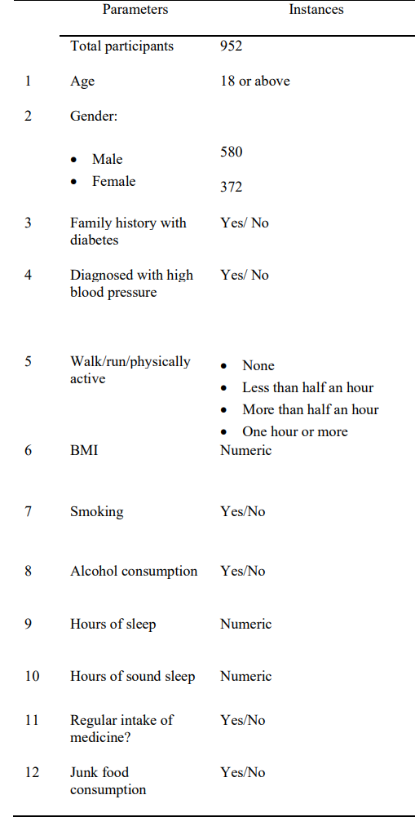

## Missing rate: 2.8%

## Distribution Figures

### 3.1 Categorical Variables

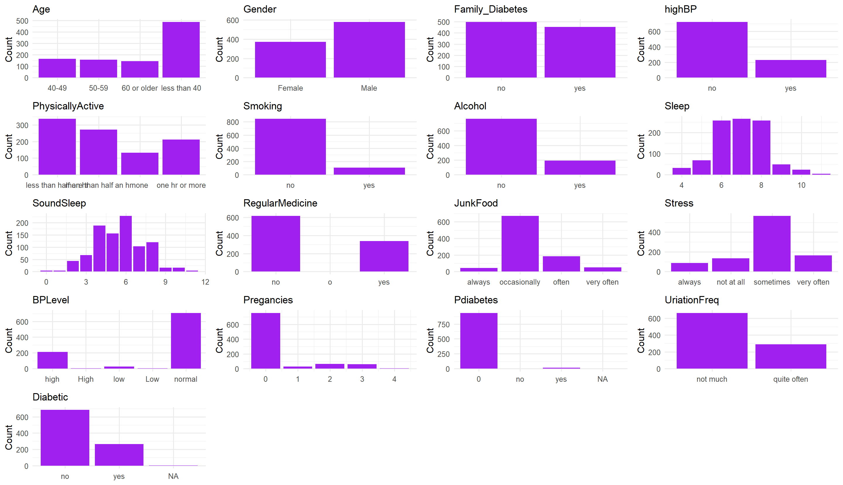

### Continuous Variables

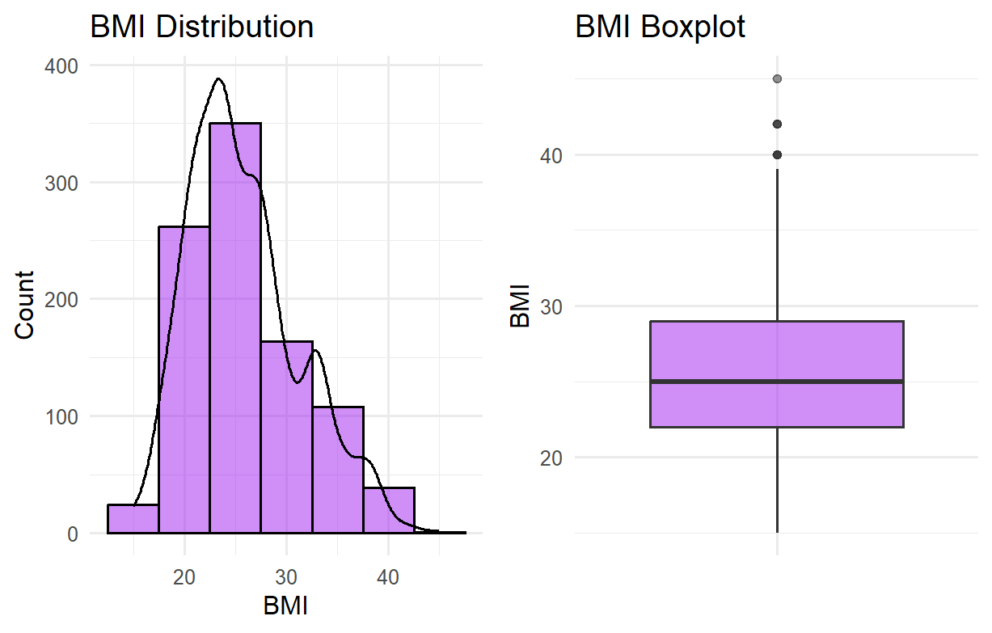

## BASELINE CHARACTERISTICS Table

| **Characteristic** | **N** | **Overall**, N = 951*1* | **no**, N = 685*1* | **yes**, N = 266*1* | **p-value***2* |
| --- | --- | --- | --- | --- | --- |
| Age | 951 |  |  |  | <0.001 |
| 40-49 |  | 164 (17%) | 114 (17%) | 50 (19%) |  |
| 50-59 |  | 156 (16%) | 84 (12%) | 72 (27%) |  |
| 60 or older |  | 144 (15%) | 32 (4.7%) | 112 (42%) |  |
| less than 40 |  | 487 (51%) | 455 (66%) | 32 (12%) |  |
| Gender | 951 |  |  |  | 0.236 |
| Female |  | 371 (39%) | 259 (38%) | 112 (42%) |  |
| Male |  | 580 (61%) | 426 (62%) | 154 (58%) |  |
| Family_Diabetes | 951 | 453 (48%) | 271 (40%) | 182 (68%) | <0.001 |
| highBP | 951 | 228 (24%) | 96 (14%) | 132 (50%) | <0.001 |
| PhysicallyActive | 951 |  |  |  | <0.001 |
| less than half an hr |  | 336 (35%) | 253 (37%) | 83 (31%) |  |
| more than half an hr |  | 271 (28%) | 207 (30%) | 64 (24%) |  |
| none |  | 132 (14%) | 77 (11%) | 55 (21%) |  |
| one hr or more |  | 212 (22%) | 148 (22%) | 64 (24%) |  |
| BMI | 948 | 25.0 (7.0) | 24.0 (7.0) | 26.0 (7.0) | <0.001 |
| Unknown |  | 3 | 2 | 1 |  |
| Smoking | 951 | 108 (11%) | 79 (12%) | 29 (11%) | 0.821 |
| Alcohol | 951 | 192 (20%) | 127 (19%) | 65 (24%) | 0.048 |
| Sleep | 951 |  |  |  |  |
| 4 |  | 32 (3.4%) | 12 (1.8%) | 20 (7.5%) |  |
| 5 |  | 68 (7.2%) | 44 (6.4%) | 24 (9.0%) |  |
| 6 |  | 256 (27%) | 191 (28%) | 65 (24%) |  |
| 7 |  | 263 (28%) | 202 (29%) | 61 (23%) |  |
| 8 |  | 256 (27%) | 180 (26%) | 76 (29%) |  |
| 9 |  | 48 (5.0%) | 36 (5.3%) | 12 (4.5%) |  |
| 10 |  | 24 (2.5%) | 16 (2.3%) | 8 (3.0%) |  |
| 11 |  | 4 (0.4%) | 4 (0.6%) | 0 (0%) |  |
| SoundSleep | 951 | 6.00 (3.00) | 6.00 (3.00) | 6.00 (3.00) | 0.776 |
| RegularMedicine | 951 |  |  |  | <0.001 |
| no |  | 614 (65%) | 564 (82%) | 50 (19%) |  |
| o |  | 1 (0.1%) | 1 (0.1%) | 0 (0%) |  |
| yes |  | 336 (35%) | 120 (18%) | 216 (81%) |  |
| JunkFood | 951 |  |  |  | 0.121 |
| always |  | 44 (4.6%) | 36 (5.3%) | 8 (3.0%) |  |
| occasionally |  | 671 (71%) | 470 (69%) | 201 (76%) |  |
| often |  | 184 (19%) | 142 (21%) | 42 (16%) |  |
| very often |  | 52 (5.5%) | 37 (5.4%) | 15 (5.6%) |  |
| Stress | 951 |  |  |  | <0.001 |
| always |  | 88 (9.3%) | 31 (4.5%) | 57 (21%) |  |
| not at all |  | 135 (14%) | 97 (14%) | 38 (14%) |  |
| sometimes |  | 564 (59%) | 450 (66%) | 114 (43%) |  |
| very often |  | 164 (17%) | 107 (16%) | 57 (21%) |  |
| BPLevel | 951 |  |  |  | <0.001 |
| high |  | 211 (22%) | 75 (11%) | 136 (51%) |  |
| High |  | 5 (0.5%) | 2 (0.3%) | 3 (1.1%) |  |
| low |  | 25 (2.6%) | 25 (3.6%) | 0 (0%) |  |
| Low |  | 3 (0.3%) | 3 (0.4%) | 0 (0%) |  |
| normal |  | 707 (74%) | 580 (85%) | 127 (48%) |  |
| Pregancies | 909 |  |  |  | <0.001 |
| 0 |  | 753 (83%) | 564 (87%) | 189 (72%) |  |
| 1 |  | 28 (3.1%) | 22 (3.4%) | 6 (2.3%) |  |
| 2 |  | 64 (7.0%) | 36 (5.6%) | 28 (11%) |  |
| 3 |  | 60 (6.6%) | 23 (3.6%) | 37 (14%) |  |
| 4 |  | 4 (0.4%) | 0 (0%) | 4 (1.5%) |  |
| Unknown |  | 42 | 40 | 2 |  |
| Pdiabetes | 950 |  |  |  | <0.001 |
| 0 |  | 935 (98%) | 681 (100%) | 254 (95%) |  |
| no |  | 1 (0.1%) | 1 (0.1%) | 0 (0%) |  |
| yes |  | 14 (1.5%) | 2 (0.3%) | 12 (4.5%) |  |
| Unknown |  | 1 | 1 | 0 |  |
| UriationFreq | 951 |  |  |  | 0.003 |
| not much |  | 663 (70%) | 497 (73%) | 166 (62%) |  |
| quite often |  | 288 (30%) | 188 (27%) | 100 (38%) |  |
| *1* n (%); Median (IQR) | | | | | |
| *2* Fisher’s exact test; Wilcoxon rank sum test | | | | | |

# 9-Gestational Diabetes

## Missing rate: 0

## Distribution Figures

### 2.1 Categorical Variables

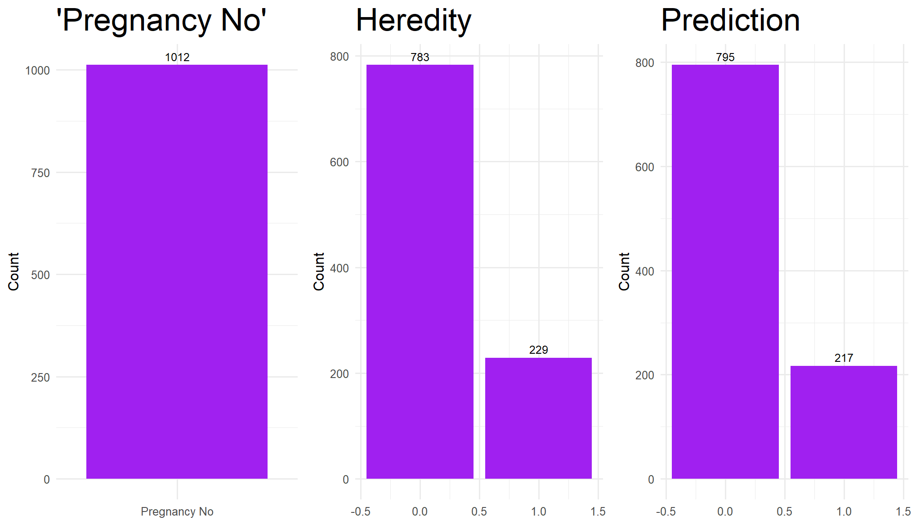

### 2.2 Continuous Variables

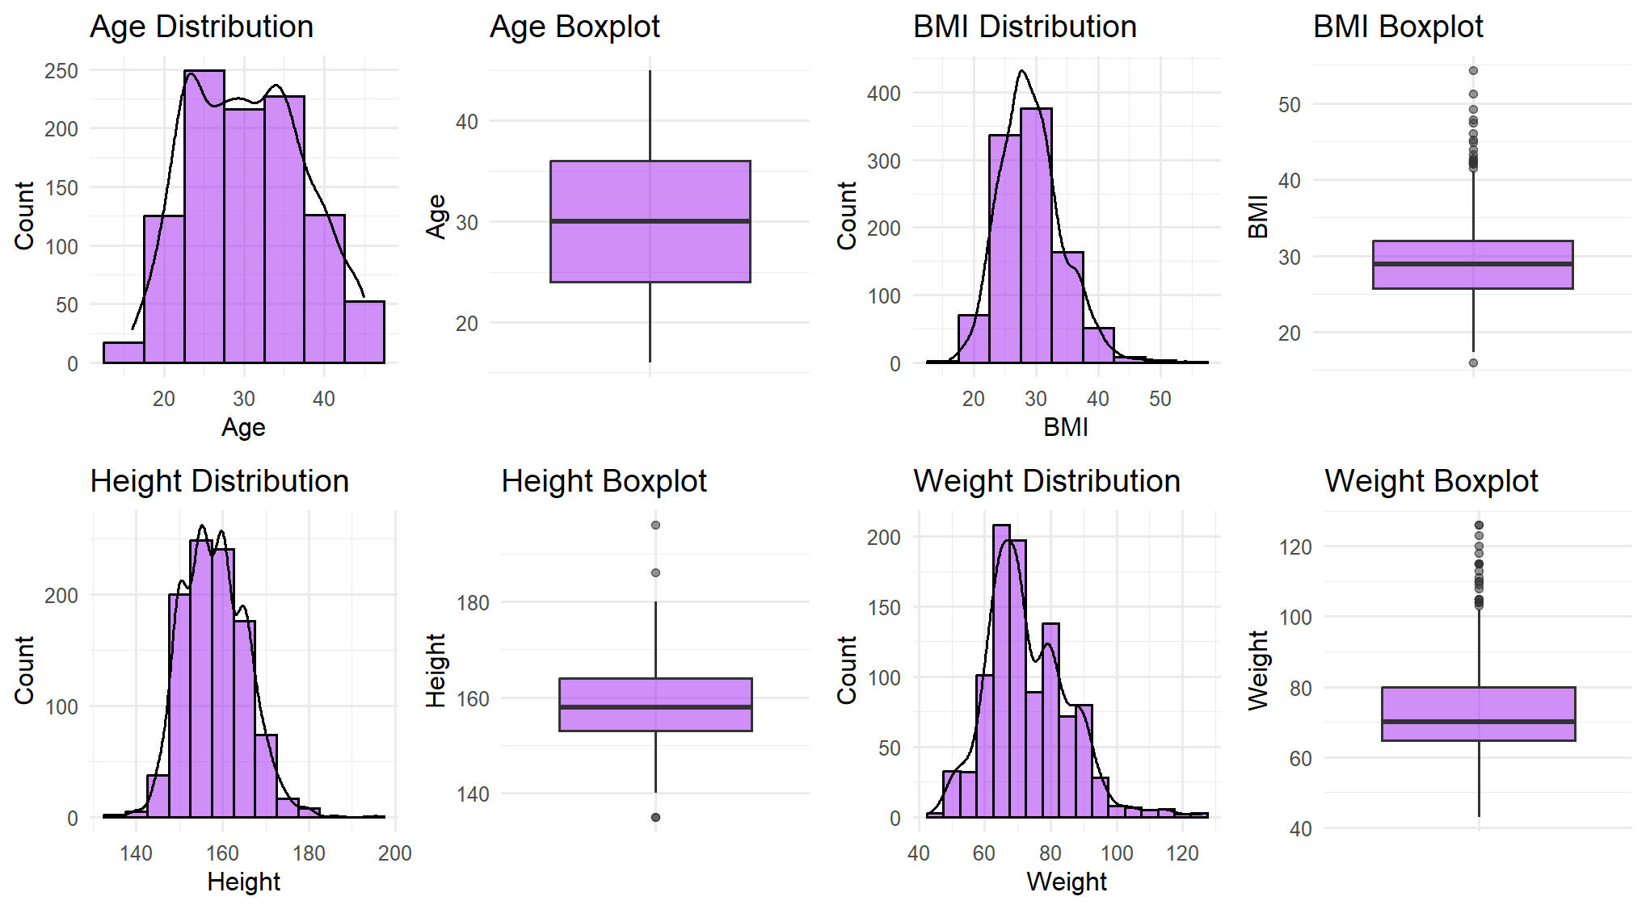

## BASELINE CHARACTERISTICS Table

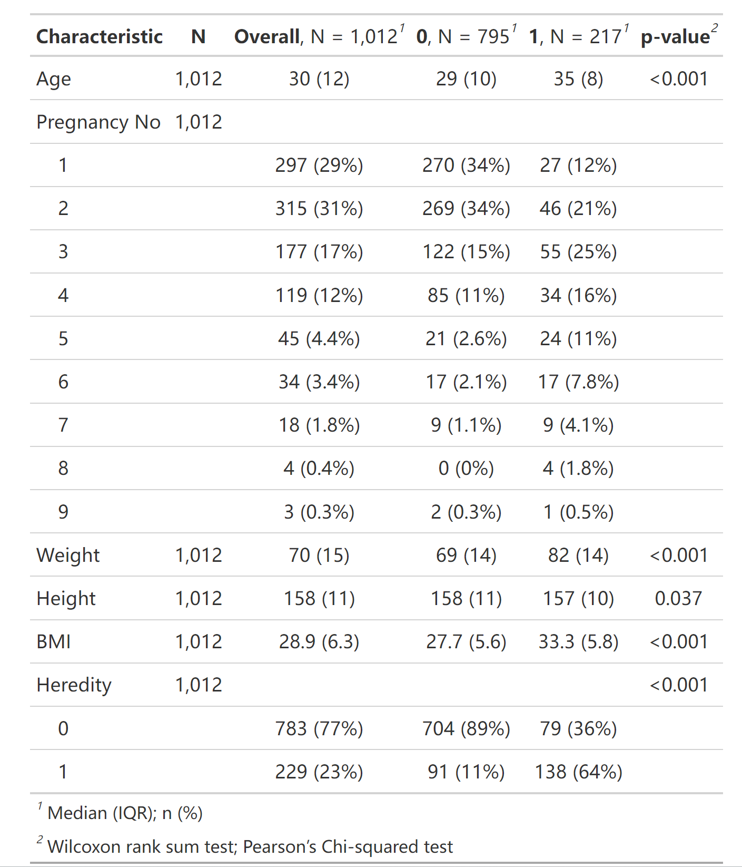

| **Characteristic** | **N** | **Overall**, N = 1,012*1* | **0**, N = 795*1* | **1**, N = 217*1* | **p-value***2* |
| --- | --- | --- | --- | --- | --- |
| Age | 1,012 | 30 (12) | 29 (10) | 35 (8) | <0.001 |
| Pregnancy No | 1,012 |  |  |  |  |
| 1 |  | 297 (29%) | 270 (34%) | 27 (12%) |  |
| 2 |  | 315 (31%) | 269 (34%) | 46 (21%) |  |
| 3 |  | 177 (17%) | 122 (15%) | 55 (25%) |  |
| 4 |  | 119 (12%) | 85 (11%) | 34 (16%) |  |
| 5 |  | 45 (4.4%) | 21 (2.6%) | 24 (11%) |  |
| 6 |  | 34 (3.4%) | 17 (2.1%) | 17 (7.8%) |  |
| 7 |  | 18 (1.8%) | 9 (1.1%) | 9 (4.1%) |  |
| 8 |  | 4 (0.4%) | 0 (0%) | 4 (1.8%) |  |
| 9 |  | 3 (0.3%) | 2 (0.3%) | 1 (0.5%) |  |
| Weight | 1,012 | 70 (15) | 69 (14) | 82 (14) | <0.001 |
| Height | 1,012 | 158 (11) | 158 (11) | 157 (10) | 0.037 |
| BMI | 1,012 | 28.9 (6.3) | 27.7 (5.6) | 33.3 (5.8) | <0.001 |
| Heredity | 1,012 |  |  |  | <0.001 |
| 0 |  | 783 (77%) | 704 (89%) | 79 (36%) |  |
| 1 |  | 229 (23%) | 91 (11%) | 138 (64%) |  |
| *1* Median (IQR); n (%) | | | | | |
| *2* Wilcoxon rank sum test; Pearson’s Chi-squared test | | | | | |